A.I.M.S. (AUTOMATED INTERVENTION AND MASTERY SYSTEM): A WEB- BASED EDUCATIONAL PLATFORM WITH AI-DRIVEN ASSESSMENT AND DYNAMIC REMEDIATION

A Capstone Project Presented to the
Faculty of the College of Computer Studies
Carlos Hilado Memorial State University
Alijis Campus, Bacolod City

In Partial Fulfillment
of the Requirements for the Degree
Bachelor of Science in Information Technology

By
Mikhoel Runo B. Orbigoso
Patrick R. Sagum
Maika T. Zambra

May 2026

TABLE OF CONTENTS
Page
Chapter 1 1
INTRODUCTION 1
Background of the Study 1
Objective of the Study 2
Significance of the Study 3
Scope and Limitation of the Study 4
Definition of Terms 6
Chapter 2 11
REVIEW OF RELATED LITERATURE AND STUDIES 11
Centralized Learning Portal with Material Distribution and Task Submission 11
AI-Powered Quiz Generator with Instructor Validation and Approval Controls 12
Automated Assessment and Grading Engine Supporting Teacher Validation 14
Dynamic Remedial Quiz Generator for Targeted Student Intervention 15
Mastery-Based Learning Module with Configurable Progression Locks 17
Synthesis 20
Chapter 3 23
METHODOLOGY 23
Research Design 23
System Development Life Cycle 24
Research Respondents 26
Sampling Technique 29
Data Gathering Instruments 30
Data Gathering Procedure 32
Validity of the Instrument 33
Reliability of the Instrument 33
Ethical Considerations 35
Operational Framework 35
Use Case Diagram 45
Data Dictionary 46
Hardware Requirements 73
Software Requirements 74
Time Table (Gantt Chart) 75
REFERENCES 77
APPENDICES 81
Appendix A.Letter to Beneficiaries 83
Appendix B.Beneficiary Awknowledgement 84
Appendix C.Data Privacy Form 86
Appendix D.Parent’s Waiver 87
Appendix E. Test Case 89
Appendix F. Evaluation Form 94

Chapter 1

INTRODUCTION

Background of the Study
Technology has become increasingly integrated in education systems to support instruction, assessment, and learner support. In particular, educational technologies powered by artificial intelligence (AI) have demonstrated potential to enable personalized learning, adaptive feedback, and more efficient assessment workflows that can help educators respond to diverse learner needs and improve academic performance (Merino-Campos, 2025; Marcos, 2026).
In the Philippine basic education context, the adoption of flexible learning modalities increased the use of technology in teaching and learning. However, persistent challenges such as the digital divide, uneven access to learning resources, inadequate infrastructure, and time-intensive manual processes for module distribution and assessment continue to affect many public schools (Bustillo & Aguilos, 2022; Balase & Paglinawan, 2025). Local evidence further indicates that limited connectivity and varying levels of digital competencies can prevent teachers and learners from maximizing the functionality of learning management systems and other digital tools (Colegado, 2025).
These conditions often result in fragmented workflows where learning materials, quiz creation, scoring, and follow-up interventions are handled through separate tools or manual procedures. Consequently, feedback and remediation may be delayed, and teachers may have limited capacity to provide targeted support for learners who have not yet mastered required competencies. A key research and implementation gap is the limited availability of a locally contextualized, integrated web-based platform for public secondary schools that unifies centralized module distribution, instructor-validated AI-assisted quiz generation, automated assessment with teacher validation, and dynamic remediation linked to mastery-based progression controls within a single system.
In response to this gap, the study presents A.I.M.S. (Automated Intervention and Mastery System), an AI-enabled web-based educational platform designed to support public school teachers by centralizing module distribution, enabling instructor-validated AI-powered quiz generation, automating the scoring of objective quiz items with teacher validation, and generating dynamic remedial quizzes linked to mastery-based progression locks. Through these integrated features, A.I.M.S. aims to reduce administrative workload, improve the timeliness of feedback and interventions, and strengthen instructional decision-making in public secondary school settings.

Objective of the Study
The general objective of the study is to design and develop a web-based application titled "A.I.M.S. (Automated Intervention and Mastery System): A Web-Based Educational Platform with AI-Driven Assessment and Dynamic Remediation."
Specifically, this study aims to :
1. Design and develop a web-based application with the following core technical features:
1.1. Centralized learning portal with material distribution and task submission;
1.2. AI-Powered Quiz Generator with instructor validation and approval controls;
1.3. Automated assessment and grading engine supporting teacher validation;
1.4. Dynamic remedial quiz generator for targeted student intervention and;
1.5. Mastery-based learning module with configurable progression locks.
2. Implement the developed system and conduct functional testing to verify the correct operation of the features and workflows.
3. Evaluate the system based on ISO/IEC 25010 standards in terms of:
3.1. Functional suitability
3.2. Performance efficiency
3.3. Usability
3.4. Compatibility
3.5. Reliability
3.6. Security
3.7. Maintainability
3.8. Portability

Significance of the Study
A.I.M.S. (Automated Intervention and Mastery System): A Web-Based Educational Platform with AI-Driven Assessment and Dynamic Remediation is marketed to be of substantial and positive importance to the following groupings:
Teachers. The system helps teachers centralize learning modules, collect task submissions with recorded timestamps, and streamline assessment through instructor-validated AI-assisted quiz drafting and automated scoring of objective quiz items. It also supports timely intervention by surfacing mastery status and pending remedial activities for teacher review and approval, thereby reducing administrative workload and allowing teachers to focus more on instruction delivery and learner support.
Students. A.I.M.S. enables students to access learning modules, submit tasks, and take assessments through a unified online portal. It provides immediate feedback for objective items, and when mastery is not achieved, it supports guided remediation through teacher-approved targeted remedial quizzes. This encourages self-directed learning and helps learners identify areas for improvement and mastery of content.
Researchers. The research offers empirical evidence concerning the use of the AI-based web-based learning systems in the Philippine public schools environment. The effectiveness of the system to enhance the learning results, improve the process of assessments, and assist personalized learning can be studied by the researchers as the part of the overall literature on educational technology and AI-assisted learning.
Future Researchers. The results and development experience of A.I.M.S. can be used as a base in the future studies of intelligent learning platforms. Researchers may extend on the structure of the system in future, add features or investigate other AI applications in education, creating new innovations to improve the teaching and learning experience in different teaching and learning environments.

Scope and Limitation of the Study
This study focuses on the design, development, and evaluation of A.I.M.S. (Automated Intervention and Mastery System): A Web-Based Educational Platform with AI-Driven Assessment and Dynamic Remediation, proposed for implementation at Hinigaran National High School as a public secondary school setting.
The system provides a centralized web-based platform for distributing learning materials, managing student submissions, monitoring learner progress, and supporting assessment processes. It includes an AI-powered quiz generator capable of producing assessment items from instructional content; however, all AI-generated quizzes require teacher validation before deployment to ensure alignment with DepEd curriculum standards and learning competencies.
A.I.M.S. also features an automated assessment and grading engine that supports automatic scoring for objective-type assessments such as multiple-choice, true-or-false, and identification questions. Subjective assessments, including essays and performance-based outputs, still require teacher review and manual evaluation.The platform further includes a dynamic remedial quiz generator that creates targeted remediation activities based on learner performance and mastery gaps, subject to teacher approval before release. In addition, the system implements mastery-based progression controls through configurable passing thresholds, progression locks, and instructor override features.
This study is limited to public secondary school implementation and is specifically tailored to the operational context of Hinigaran National High School. The system may require modifications before adaptation to private or tertiary institutions. Furthermore, while the platform utilizes generative Large Language Models (LLMs) for quiz generation, AI-generated outputs remain dependent on teacher supervision and validation. Advanced AI functionalities such as fully autonomous grading, predictive analytics, and adaptive learning beyond remediation are not covered in this study.

Definition of Terms
For a clearer understanding of the study, the following terms are defined both contextually based on existing literature and operationally as they are used in the context of A.I.M.S.
AI-Powered Quiz Generator. Contextually, this refers to the use of neural question generation techniques and natural language processing to automatically create educationally valuable assessment items from learning materials, ensuring both fluency and pedagogical relevance (Bulathwela et al., 2023).
Operationally, in this study, it refers to the module in A.I.M.S. that uses the Google Gemini API to draft objective quiz items (e.g., multiple-choice) from teacher-selected learning materials or prompts, including distractors and answer keys, and requires teacher review, editing, and approval before a quiz is deployed to students.
Automated Assessment and Grading Engine. Contextually, it refers to AI-assisted and automated assessment approaches that support the evaluation of structured student outputs and improve the efficiency of educational assessment workflows, while emphasizing validity, scope, and human oversight in actual instructional use (Ouyang et al., 2023; Gardner et al., 2021).
Operationally, it is the system component in A.I.M.S. that administers quizzes, records responses securely, and automatically computes preliminary scores for objective items. For responses requiring human judgment, it supports teacher validation using customizable rubrics before final scores are logged and made visible to students as feedback.
Centralized Learning Portal. Contextually, this is an integrated online platform within a learning management system that supports structured content delivery and access to learning resources, as well as course activities and assessments (Dahal & Manandhar, 2024).
Operationally, it is the centralized learning portal feature in A.I.M.S. that allows teachers to upload and organize learning materials and tasks by subject and grade level, enables students to securely access and download modules, and supports online task submission with automatic logging of submission timestamps for teacher review.
Mastery-Based Learning Module. Contextually, in competency-based education, this is a progression mechanism where students acquire knowledge and complete formative assessments, proceeding to new content only after demonstrating mastery of prerequisite material through corrective pathways and retesting (Persky & Hughes, 2022).
Operationally, it is the conditional progression feature in A.I.M.S. that restricts access to subsequent lessons until students meet a teacher-defined passing threshold on prerequisite assessments. When mastery is not achieved, progression remains locked until the learner completes teacher-approved remedial activities, unless the teacher manually overrides the lock.
Dynamic Remedial Quiz Generator. Contextually, this refers to an adaptive remediation mechanism that delivers targeted corrective assessment activities aligned with identified learning gaps to support mastery learning and timely intervention (Persky & Hughes, 2022).
Operationally, it is the A.I.M.S. component that generates targeted remedial quizzes based on a learner's assessment results and DepEd learning competencies using generative Large Language Models (LLMs). Remedial quizzes are saved as pending interventions and require instructor validation and approval before they are deployed to the student for re-assessment.
Instructor Validation. Contextually, it refers to the human review and approval step used to verify AI-assisted assessment outputs for relevance, accuracy, and pedagogical appropriateness before instructional use (Gardner et al., 2021; Gorgun & Bulut, 2024).
Operationally, it is the mandatory teacher review workflow in A.I.M.S. through which AI-generated quizzes and remedial interventions remain pending until the teacher edits, approves, or rejects them before release to students.
Objective Quiz Items. Contextually, these are structured assessment items with fixed or clearly delimited correct answers, such as multiple-choice questions, which are suitable for automated scoring and rapid feedback in digital learning environments (Alamoudi et al., 2025; Ouyang et al., 2023).
Operationally, they are the machine-scoreable quiz questions generated and administered by A.I.M.S., including multiple-choice items with predefined answer keys used for immediate preliminary scoring.
Progression Locks. Contextually, these are rule-based access controls in mastery learning environments that restrict advancement to subsequent content until learners satisfy prerequisite performance criteria or complete corrective activities (Persky & Hughes, 2022; Toti et al., 2023).
Operationally, they are the configurable access restrictions in A.I.M.S. that keep later lessons, activities, or materials unavailable until the learner meets the teacher-set mastery threshold or receives instructor override approval.
Teacher Override. Contextually, it refers to the instructor's discretionary authority in digital learning systems to supersede automated progression or intervention rules when professional judgment indicates a need for contextual adjustment or exception handling (Gardner et al., 2021; Persky & Hughes, 2022).
Operationally, it is the control in A.I.M.S. that allows teachers to manually unlock progression, release pending remedial activities, or finalize validated scores when learner context warrants an exception.
Remedial Intervention. Contextually, it refers to targeted follow-up instruction or assessment designed to address identified learning gaps after formative evaluation and support subsequent mastery achievement (Hegde et al., 2024; Jumao-as et al., 2025).
Operationally, it is the teacher-approved corrective activity in A.I.M.S., typically delivered as a remedial quiz linked to unmet competencies before reassessment and re-entry into the mastery progression flow.
ISO/IEC 25010. Contextually, it refers to a software product quality model that organizes system evaluation into core characteristics and measurable attributes for judging how well a software product satisfies defined quality requirements across different use contexts (Zhang et al., 2023).
Operationally, it is the standardized evaluation framework used by the researchers to rigorously assess A.I.M.S. system quality, effectiveness, and user satisfaction through surveys and functional testing during the validation phase.

Chapter 2

REVIEW OF RELATED LITERATURE AND STUDIES
This chapter presents related literature and studies from both local and foreign sources. These references provide relevant information and support the development of the present study.

Centralized Learning Portal with Material Distribution and Task Submission
A centralized learning portal serves as a core component of modern learning management systems (LMS), providing an organized digital environment for distributing instructional materials, managing submissions, and monitoring learner activities. Dahal and Manandhar (2024) described an LMS as a platform used for developing, delivering, and managing courses, learning resources, assessments, and learning activities. Their study emphasized that LMS implementation improves accessibility, content deliverability, and resource retrievability within educational environments.
However, the authors also explained that treating an LMS merely as a storage repository limits its effectiveness in supporting meaningful learning experiences. This highlights the importance of designing platforms that not only distribute materials but also support active instructional workflows, learner engagement, and assessment management.

In the Philippine educational setting, limited infrastructure and unequal access to learning materials continue to affect the effectiveness of digital learning implementation. Bustillo and Aguilos (2022) reported that many public school teachers still rely on manual distribution of printed modules due to technological and geographical constraints. The study identified challenges such as limited reproduction resources, inconsistent module distribution, and accessibility issues in remote areas.
The reviewed literature demonstrates the importance of centralized digital platforms capable of streamlining learning material distribution and improving educational accessibility in schools. Web-based module management systems address these limitations by allowing teachers to upload, organize, and update instructional resources electronically while enabling students to retrieve materials through a unified platform.
Simon et al. (2025) further explained that learning management systems function not only as repositories but also as active environments for information dissemination, assignment management, classroom interaction, and feedback delivery. Similarly, Dahal and Manandhar (2024) identified resource management, assessment integration, and learner engagement as critical success factors in LMS implementation.Collectively, the reviewed studies support the implementation of the centralized learning portal in A.I.M.S., which is designed to facilitate material distribution, digital task submission, and teacher-managed instructional workflows within a practical educational environment.

AI-Powered Quiz Generator with Instructor Validation and Approval Controls
Artificial intelligence has increasingly been utilized to assist teachers in generating assessment materials more efficiently. AI-powered quiz generators reduce the time required to create assessment items while supporting instructional preparation. However, AI-generated questions still require instructor review and approval to ensure accuracy, appropriateness, and alignment with intended learning competencies.
Bulathwela et al. (2023) conducted a comprehensive review of neural question generation systems used for educational purposes. Their study found that transformer-based neural question generation models are capable of producing linguistically coherent and pedagogically appropriate assessment items from source materials. These systems can generate various question formats, including multiple-choice, true-or-false, and short-answer questions, with quality approaching human-authored assessments when supported by adequate contextual information.
Recent developments in large language models (LLMs) further support the capability of AI-assisted assessment generation. Gorgun and Bulut (2024) explained that automated question generation systems efficiently produce large volumes of assessment items, although concerns regarding quality evaluation and usability remain significant barriers to implementation.
Similarly, Alamoudi et al. (2025) compared different LLM-based question generation approaches using semantic similarity, precision, recall, and F1-score metrics. Their findings revealed that while LLM-based generation approaches demonstrated strong performance, some generated outputs contained hallucinated or contextually irrelevant questions. This limitation emphasizes the necessity of instructor validation controls before assessment deployment.
Within the Philippine educational context, Balase and Paglinawan (2025) reported that teachers recognized learning management systems as beneficial for digital instruction and learner engagement. However, barriers such as unstable internet connectivity, limited technical support, digital literacy gaps, and workload management concerns continue to affect effective implementation.The reviewed studies reinforce the importance of designing A.I.M.S. as a teacher-assisted AI system rather than a fully autonomous assessment platform. In A.I.M.S., AI-generated quizzes remain subject to instructor validation and approval to ensure curriculum alignment, pedagogical relevance, and assessment quality before deployment to students.

Automated Assessment and Grading Engine Supporting Teacher Validation
Automated assessment systems are increasingly used to reduce manual checking time and provide immediate feedback in structured learning activities. Zampirolli et al. (2021) reported that automated assessment mechanisms improved instructional efficiency and supported continuous assessment processes in large-scale programming courses. Their findings showed that classes utilizing automated assessment achieved higher pass rates compared to those that relied solely on traditional assessment approaches.

Although the study focused on programming education, it demonstrates the effectiveness of automated evaluation systems in assessing structured and objective student outputs. This supports the inclusion of an automated assessment and grading engine within A.I.M.S.In the proposed system, automated checking is limited only to objective-type assessments such as multiple-choice, true-or-false, matching-type, and identification questions. This functionality reduces teachers’ manual checking workload while enabling students to receive immediate feedback regarding their performance.
However, subjective responses such as essays, open-ended answers, and performance-based outputs cannot be fully evaluated by the system. These assessment forms still require teacher review, validation, and manual grading to preserve fairness, instructional accuracy, and academic integrity.Gardner et al. (2021) emphasized that AI-enabled educational assessment should not replace human judgment entirely and must be evaluated in terms of validity and effectiveness. Similarly, Ouyang et al. (2023) explained that while automated assessment systems are widely utilized in both formative and summative learning environments, teacher supervision remains essential for maintaining assessment reliability and educational quality.
In Philippine educational settings, Colegado (2025) observed that teachers commonly utilize platforms such as Google Classroom and Quipper for assessment and content delivery. Nevertheless, implementation challenges such as unstable internet connectivity, unequal device access, and limited teacher preparation continue to affect system effectiveness.Collectively, these studies establish the importance of implementing A.I.M.S. as a practical instructional support system that strengthens assessment efficiency while preserving teacher authority in evaluating subjective learner outputs and validating academic results.

Dynamic Remedial Quiz Generator for Targeted Student Intervention
Beyond automated assessment, modern educational platforms increasingly incorporate remediation mechanisms to address learner deficiencies and improve academic performance. Dynamic remediation is a core element of mastery-oriented instruction, emphasizing corrective feedback, targeted intervention, and structured opportunities for retesting when learners fail to meet required performance thresholds.
Persky and Hughes (2022) explained that mastery learning frameworks rely heavily on systematic remediation processes to ensure that students achieve competency before progressing to succeeding lessons. Their review emphasized that effective remediation includes focused feedback, repeated assessment opportunities, and instructional support tailored to identified learning gaps.Similarly, Hegde et al. (2024) demonstrated that underperforming students significantly improved after participating in remediation activities that incorporated quizzes, assignments, guided review sessions, and competency-focused interventions. The study showed that targeted remediation strategies help strengthen student understanding by addressing specific areas of difficulty rather than repeating generalized instruction.Additional studies on adaptive learning environments further suggest that personalized remediation mechanisms improve learner engagement and retention by aligning intervention activities with individual student performance patterns. These approaches allow educational systems to provide more focused academic support while reducing unnecessary repetition of already-mastered competencies.
In the Philippine educational context, Jumao-as et al. (2025) investigated the effectiveness of a structured reading remediation program implemented in a DepEd elementary school in Ozamiz City, Misamis Occidental. Their findings revealed that students identified with frustrated reading levels significantly improved after undergoing systematic remediation activities. The study validated that competency-based intervention strategies can produce measurable academic gains within Philippine public school settings.
These studies establish the instructional value of remediation as an essential component of effective learning systems. In A.I.M.S., the proposed dynamic remedial quiz generator utilizes identified learner weaknesses to support the creation of targeted remedial assessments for teacher-reviewed intervention and reassessment. Rather than functioning as a fully automated corrective mechanism, the system is designed to assist teachers in delivering focused remediation while maintaining instructional oversight and validation.

Mastery-Based Learning Module with Configurable Progression Locks
Mastery-based learning is a pedagogical model grounded in the principle that all students can achieve academic proficiency when given sufficient time, appropriate instructional support, and the opportunity to demonstrate competency before progressing to subsequent content. Persky and Hughes (2022) conducted a comprehensive review of mastery learning principles and their practical application in varied educational contexts, finding that mastery-based instruction consistently outperformed traditional time-based delivery models in promoting long-term content retention, reducing achievement gaps, and improving student confidence. Their review emphasized that effective mastery learning frameworks require clearly defined performance thresholds, systematic corrective feedback mechanisms, and structured opportunities for retesting. Toti et al. (2023) further demonstrated that students in a mastery learning framework can prove mastery of individual units over multiple attempts, showing how progression can be tied to demonstrated competence rather than one-time completion. These principles provide the pedagogical basis for the proposed mastery-based learning module in A.I.M.S., where progression controls are used as a system design mechanism to enforce competency-based sequencing.
In the Philippine educational context, the sustained implementation of digital learning platforms is influenced by practical constraints that limit teachers' capacity to manage additional system processes. Balase and Paglinawan (2025) highlighted barriers to effective LMS integration in public schools, including unstable connectivity, limited technical support, digital literacy gaps, and workload management concerns. Accordingly, the mastery-based learning module in A.I.M.S. should be designed to support competency-based progression in a way that minimizes added teacher workload while maintaining clear performance thresholds and instructor oversight.
Empirical evidence from the Philippine basic education context further affirms the value of structured remediation in supporting learner progression. Jumao-as et al. (2025) investigated the effectiveness of a reading remediation program implemented in a DepEd elementary school in Ozamiz City, Misamis Occidental, finding that Grade 4 pupils identified as having frustrated reading levels through the Philippine Informal Reading Inventory (PHIL-IRI) advanced to the instructional reading level following the systematic remediation program. The study demonstrated a statistically significant improvement in reading comprehension, validating that targeted, competency-specific intervention embedded within a structured instructional cycle produces measurable learning gains. These findings support the rationale for linking learner progression in A.I.M.S. to demonstrated mastery and structured remediation, even though the platform's specific lock and override controls remain part of the system's implementation design.
Table 1
Matrix of Related Literature and Studies
RRL | Features
Studies/System | Centralized Learning Portal | AI-Powered Quiz Generator | Automated Grading Engine | Dynamic Remedial Quizzes | Mastery-Based Progression
Alamoudi, A., et al. (2025). Optimizing automated question generation for educational assessments. | ✗ | ✓ | ✗ | ✗ | ✗
Dahal, N., & Manandhar, S. (2024). The reality of e-learning: Success and failure of learning management system. | ✓ | ✗ | ✗ | ✗ | ✗
Bulathwela, S., et al. (2023). Review on neural question generation for education purposes. | ✗ | ✓ | ✗ | ✗ | ✗
Ouyang, F., et al. (2023). A systematic review of AI-driven educational assessment in STEM education. | ✗ | ✗ | ✓ | ✗ | ✗
Persky, A. M., & Hughes, K. (2022). A practical review of mastery learning. | ✗ | ✗ | ✗ | ✓ | ✓
Zampirolli, F. A., et al. (2021). An experience of automated assessment in a large-scale introduction programming course. | ✗ | ✗ | ✓ | ✗ | ✗
Bustillo, J., & Aguilos, M. (2022). The challenges of modular learning in the wake of COVID-19: A digital divide in the Philippine countryside revealed. | ✓ | ✗ | ✗ | ✗ | ✗
Balase, J., & Paglinawan, R. (2025). Voices from the field: Teachers’ narratives and reflections on integrating the DepEd LMS. | ✗ | ✓ | ✗ | ✗ | ✓
Colegado, J. (2025). Digital innovations in science education in the Philippines: A scoping review. | ✗ | ✗ | ✓ | ✗ | ✗
Jumao-as, R., et al. (2025). Reading remediation program and Grade 4 pupils’ reading comprehension. | ✗ | ✗ | ✗ | ✓ | ✓
Simon, J., et al. (2025). An assessment of learning management system use in higher education. | ✓ | ✗ | ✗ | ✗ | ✗
Gorgun, E., & Bulut, M. (2024). Exploring quality criteria and evaluation methods in automated question generation. | ✗ | ✓ | ✗ | ✗ | ✗
Gardner, J., et al. (2021). Artificial intelligence in educational assessment: Breakthrough? Or buncombe and ballyhoo? | ✗ | ✗ | ✓ | ✗ | ✗
Hegde, S., et al. (2024). Bridging knowledge gaps: Impact of remedial classes on first-year medical students in biochemistry. | ✗ | ✗ | ✗ | ✓ | ✗
Toti, D., et al. (2023). Teaching CS1 with a mastery learning framework. | ✗ | ✗ | ✗ | ✗ | ✓

Synthesis
The matrix of related literature and studies presents a comparative analysis of existing local and foreign systems in relation to the five integrated capabilities of the proposed A.I.M.S. platform: a centralized learning portal, AI-assisted quiz generation with instructor validation, automated assessment and grading, dynamic remedial quiz generation, and a mastery-based learning progression system.
Across the reviewed literature, a clear pattern emerges: existing systems tend to specialize rather than integrate. Learning management studies emphasize centralized content delivery and task submission but lack advanced AI-driven assessment functions (Dahal & Manandhar, 2024; Bustillo & Aguilos, 2022). In contrast, AI-based assessment research focuses on automated question generation and scoring mechanisms but often operates independently of full learning management environments and teacher approval workflows (Alamoudi et al., 2025; Ouyang et al., 2023). Meanwhile, remedial learning and mastery-based approaches highlight the importance of adaptive progression and intervention but are typically implemented as isolated modules rather than embedded within a complete academic platform (Persky & Hughes, 2022; Balase & Paglinawan, 2025).
This fragmentation shows that while each component of A.I.M.S. is supported by prior studies, they are rarely unified into a single, cohesive system. Existing platforms either prioritize content management, AI assessment, or adaptive learning—but not their integration. As a result, there is limited support for a continuous instructional cycle that connects content delivery, intelligent assessment, remediation, and mastery tracking within one environment.
For Philippine public secondary schools, this separation presents practical limitations. Teachers often use multiple disconnected tools, increasing workload and reducing efficiency in monitoring student progress. Students, on the other hand, experience inconsistent learning feedback and limited personalized intervention. These constraints highlight the need for a more integrated approach suited to local classroom realities, where resource efficiency and instructional support are critical.
In response, A.I.M.S. addresses this gap by unifying these functions into a single AI-driven platform that supports instructional delivery, assessment automation, targeted remediation, and competency-based progression. This integration is intended to streamline teacher workload, improve feedback speed, and strengthen student mastery tracking. Rather than introducing entirely new concepts, the system consolidates and operationalizes proven approaches into a coherent educational framework, thereby enhancing their practical applicability in the Philippine basic education context.

Chapter 3

METHODOLOGY
This chapter outlines the system design and development process used in creating
the system, detailing the methodologies, tools, and techniques employed to ensure the system meets its intended objectives.

Research Design
This study utilized a developmental-descriptive research design to achieve its objectives. The developmental design was employed in the creation of A.I.M.S. (Automated Intervention and Mastery System), a web-based educational platform that integrates artificial intelligence for assessment and dynamic remediation. This approach enabled the researchers to systematically design, develop, test, and refine the system based on the identified needs within the educational environment, particularly in public secondary schools where manual and fragmented instructional processes remain prevalent.
To support the system development process, the study adopted the Rapid Application Development (RAD) model as its Software Development Life Cycle (SDLC) methodology. The RAD model emphasizes iterative prototyping, continuous user feedback, and rapid system refinement, making it appropriate for educational platforms that require frequent user interaction and functionality testing. Through this methodology, the researchers were able to efficiently develop the system’s core features, including centralized learning management, AI-assisted quiz generation, automated assessment, dynamic remedial intervention, and mastery-based progression controls.
On the other hand, the descriptive research design was used to evaluate the developed system. The evaluation focused on determining the system’s quality and performance using standardized tools, particularly the ISO 25010 software quality model.
This includes assessing functionality suitability, performance efficiency, usability, compatibility, reliability, security, maintainability, and portability. In addition, structured test cases were utilized to validate system processes, ensuring that each feature operates according to its intended function. This combined approach allowed the researchers not only to develop the system but also to measure its effectiveness and acceptability among users.

System Development Life Cycle
The study adopted the Rapid Application Development (RAD) model, an iterative software development approach that emphasizes quick development, user feedback, and continuous improvement. The RAD model was selected because it is well-suited for projects that require fast prototyping and frequent revisions, especially in systems that involve user interaction such as educational platforms. According to existing studies, RAD improves development efficiency and ensures that user requirements are continuously addressed throughout the process.

Figure 1
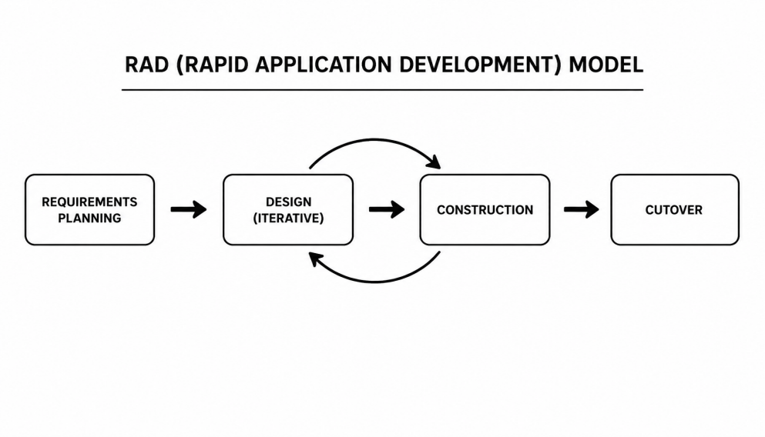
Rapid Application Development (RAD) Model
The RAD model consists of the following phases:
Requirements Planning Phase. This phase involved identifying and defining the system requirements based on the problems presented in Chapter 1 and supported by related literature in Chapter 2. The researchers conducted initial analysis of user needs to determine the scope of the system and establish its core objectives.
Key functionalities identified during this phase include module management, AI-powered quiz generation, adaptive remediation, and performance monitoring dashboards. This stage ensured that the system’s goals were clearly defined and aligned with user and institutional requirements.
User Design Phase. In this phase, the researchers developed early system prototypes to represent the proposed features and workflow of the system. Interface designs and user interaction flows were created to visualize system functionality.
Users and stakeholders were actively involved during this stage through feedback sessions. Their inputs were used to refine the system design, ensuring that the interface is intuitive, user-friendly, and aligned with actual educational needs. Iterative improvements were made based on user evaluation of prototypes.
Construction Phase. During this phase, the actual development of the system was carried out. Coding, database integration, and AI feature implementation were completed. Core functionalities such as automated grading, quiz generation, and performance tracking were developed and tested iteratively.
Cutover Phase. The final phase involved system testing, debugging, deployment, and user acceptance testing. The system underwent final validation using structured test cases to ensure that all functionalities performed as intended.
After successful testing, the system was deployed to selected users for evaluation. User training and orientation were conducted to ensure proper system utilization. Feedback gathered during this phase was used for final refinements and optimization of system performance.
The use of RAD allowed the researchers to produce a functional system within a limited timeframe while ensuring quality through continuous feedback and testing.

Research Respondents
The respondents of this study were divided into two (2) groups based on their roles in the evaluation process of the A.I.M.S. (Automated Intervention and Mastery System).
The first group consisted of five (5) Information Technology (IT) experts who participated in the functionality testing phase. Their role was to evaluate the technical performance, accuracy, reliability, and correctness of the system’s core functionalities, including user authentication, AI-powered quiz generation, automated grading, data handling, and overall workflow integrity through structured test case evaluation.
The second group consisted of twenty-five (25) respondents who participated in the software quality evaluation using the ISO/IEC 25010 Software Quality Model. The respondents were composed of five (5) IT experts, ten (10) teachers, and ten (10) students. The same IT experts involved in the functionality testing phase also participated in the software quality evaluation.
The respondents evaluated the system in terms of usability, performance efficiency, reliability, security, maintainability, compatibility, and overall user experience.Teachers and students served as the intended end-users of the platform, while the IT experts focused on assessing the system’s technical quality and operational performance.
During the test case evaluation, the IT experts executed predefined test cases covering major system functionalities such as module access, authentication, AI-assisted assessment generation, grading automation, and performance tracking. Results were recorded as either pass or fail, while remarks and observations were documented to identify errors, inconsistencies, or unexpected system behavior encountered during testing.

Table 2
Respondent Profile (Test Case)
Respondent | Age | Sex | Occupation | Device Used | Experience Level
R1 | 24 | Female | Employee | Laptop | Intermediate
R2 | 23 | Female | Employee | Laptop | Intermediater
R3 | 25 | Male | Employee | Laptop | Intermediate
R4 | 27 | Male | Employee | Laptop | Intermediate
R5 | 27 | Male | Employee | Laptop | Intermediate
The software quality evaluation of the A.I.M.S. (Automated Intervention and Mastery System) was conducted using the ISO/IEC 25010 Software Quality Model. A total of twenty-five (25) respondents were purposively selected based on their direct involvement in educational and technology-based learning environments to ensure a relevant and informed evaluation of the system.
The respondents consisted of five (5) IT experts (20%), ten (10) teachers (40%), and ten (10) students (40%). This composition ensured that the system was evaluated from both technical and end-user perspectives.
The IT experts assessed the system’s technical quality, including functionality, reliability, maintainability, and security. Teachers evaluated the system’s usability, instructional relevance, and effectiveness in supporting teaching and assessment tasks. Meanwhile, students assessed the platform in terms of usability, accessibility, and overall learning experience, particularly its AI-assisted quiz generation and remediation features.
The inclusion of these respondent groups ensured a comprehensive evaluation of the system’s software quality based on ISO/IEC 25010 standards. Table 3 presents the distribution of respondents involved in the software quality evaluation.
Table 3
Respondent Profile (Software Quality)
Category | No. of Respondents | Percentage (%)
IT Professional | 5 | 20%
Teachers | 10 | 40%
Students | 10 | 40%
Total | 25 | 100%

Sampling Technique
The study employed a purposive sampling technique, which is a type of non-probability sampling method. This technique was utilized because the researchers intentionally selected respondents who possess direct experience and involvement in educational and learning processes relevant to the evaluation of the A.I.M.S. (Automated Intervention and Mastery System).
Purposive sampling is appropriate when researchers select participants based on specific characteristics, knowledge, or experiences relevant to the objectives of the study (Etikan, Musa, & Alkassim, 2016). In this study, the selected respondents included teachers, students, and IT experts who are knowledgeable about educational systems and technology-based learning environments.
Through this approach, the researchers ensured that the respondents were capable of providing meaningful and informed feedback regarding the system’s functionality, usability, and overall performance. Consequently, the use of purposive sampling contributed to the reliability and relevance of the data collected during the system evaluation process.

Data Gathering Instruments
The data gathering instrument used in this study consisted of a structured evaluation tool composed of ten (10) test cases and a standardized survey questionnaire based on the ISO/IEC 25010:2011 Software Quality Model.
The structured test cases were developed based on the system objectives and were designed to evaluate the functionality of the A.I.M.S. (Automated Intervention and Mastery System). Each test case included the process flow, input data, expected output, and actual output to verify the correctness of specific system features. These test cases covered the major components of the system, including module uploading, AI-powered quiz generation, automated grading, mastery-lock progression, and performance dashboard functionality. The test cases ensured that the system operates correctly and meets the specified requirements.

Table 4
Test Case Result with Verbal Interpretation
Percentage of Passed Test Cases | Descriptive Rating | Interpretation
96% – 100% | Excellent | The system passed almost all test cases and functions correctly with minimal or no errors.
90% – 95% | Very Good | The system passed most test cases with only minor issues detected.
85% – 89% | Good | The system functions properly but requires some improvements in certain features.
80% – 84% | Fair | The system meets basic functional requirements but several issues need correction.
Below 80% | Poor | The system failed significant test cases and requires major revisions and debugging.

In addition, a standardized evaluation questionnaire based on the ISO/IEC 25010 software quality model was used to assess the system in terms of functional suitability, performance efficiency, usability, compatibility, reliability, security, maintainability, and portability. The ISO/IEC 25010 framework provided a comprehensive structure for evaluating software quality across multiple dimensions, ensuring a systematic assessment of the developed system.
The questionnaire utilized a five-point Likert scale, ranging from 1 – Excellent to 5 – Very Poor, to measure the respondents’ level of agreement regarding the system’s performance and usability. The instrument was designed to capture both quantitative assessments of system quality and qualitative perceptions of user experience, ensuring a comprehensive evaluation of the developed system in alignment with the study objectives.
Table 5
5-Point Likert Scale with Verbal Interpretation
Scale | Description | Interval | Interpretation
5 | Excellent | 5.00 – 4.51 | The system is complete and fully functional.
4 | Very Good | 4.50 – 3.51 | The system is complete and functional
3 | Good | 3.50 – 2.51 | The system is somewhat complete and functional.
2 | Poor | 2.50 – 1.51 | The system is incomplete and somewhat functional.
1 | Very Poor | 1.0 – 1.50 | The system is incomplete and nonfunctional.
Data Gathering Procedure
The data gathering process followed a systematic procedure. First, the researchers prepared and submitted a formal request for approval of the research title and secured permission from the selected school to conduct the study.
After obtaining approval, the researchers proceeded with the development of the A.I.M.S. platform following the RAD methodology. Once the system was completed, it underwent initial testing to ensure that all functionalities were working properly.
The system was then deployed to the selected respondents, who were given sufficient time to explore and use its features. During this phase, structured test cases were executed to validate system processes and ensure that each component functioned as intended.After system usage, the respondents were asked to answer the ISO 25010-based questionnaire. The collected data were then gathered, organized, and prepared for analysis to determine the overall evaluation of the system.
Validity of the Instrument
The instruments used in this study were based on established and widely accepted standards. The evaluation questionnaire was adapted from the ISO/IEC 25010 software quality model, an internationally recognized framework for assessing software systems and software quality characteristics. Similarly, the structured test cases were developed following standard software testing procedures to ensure that the core functionalities of the system were properly evaluated.
To ensure the appropriateness, clarity, and relevance of the instruments to the objectives of the study, the questionnaire and test cases were reviewed and refined under the guidance of the researchers’ adviser and technical experts. Since the instruments were derived from recognized standards and aligned with the objectives of the study, they were considered valid and appropriate for evaluating the A.I.M.S. platform.

Reliability of the Instrument
The reliability of the instruments is ensured through the use of standardized evaluation tools. The ISO 25010 model provides consistent criteria for assessing software quality, making it a reliable instrument for this study.
Additionally, the structured test cases follow a systematic and repeatable process, ensuring that the results are consistent when the same procedures are applied. As a result, the instruments used in this study are considered reliable for measuring the performance and quality of the A.I.M.S. platform.
Analysis/Statistical Treatment of Data
The responses collected from the participants were analyzed using the mean and performance average as statistical tools. These methods were used to summarize the evaluation results and provide a clear assessment of the system’s performance.
For the test case evaluation, the researchers utilized the performance average to measure the system’s functional effectiveness. A set of ten (10) test cases was administered to five (5) Information Technology (IT) experts. Each system function was evaluated and marked as “PASS” (P) if it operated correctly or “FAIL” (F) if it did not. This approach was used to determine the operational performance and overall completion rate of the system. Through this process, the strengths of the system and areas requiring improvement were identified.
Meanwhile, the results of the standardized questionnaire were analyzed using the weighted mean. A total of twenty-five (25) respondents participated in the software quality evaluation, and their responses were computed using the formula:
$$\bar{x}=\frac{\sum{X_{i}}}{N}$$
where:
x̄ = Mean score
∑Xi = Sum of all individual responses
N = Total number of respondents
Each evaluation criterion was rated using a five-point Likert scale with the following interpretations: 5 – Excellent, 4 – Very Good, 3 – Good, 2 – Poor, and 1 – Very Po0r. The computed mean values were interpreted to determine the system’s overall usability, acceptability, and effectiveness.

Ethical Considerations
This study strictly complied with the established ethical standards and considerations to ensure that the rights and well-being of the respondents who participated were protected and respected. Informed consent was distributed and obtained from each respondent to ensure that they understood the purpose, the procedure, and the risks involved in their participation.
The participation in this study was completely voluntary, and each respondent had the right to withdraw without any consequences. It is important to note that any personal or institutional data provided by the respondents during the evaluation of the system was handled with strict adherence to data privacy guidelines. The confidentiality of their data was strictly maintained and was not shared with any other parties without their consent. All the feedback that was gathered was solely used to improve A.I.M.S:(Automated Intervention and Mastery System): A Web- Based Educational Platform with AI-Driven Assessment and Dynamic Remediation, and remained inside the institution of Carlos Hilado Memorial State University.
Operational Framework
The A.I.M.S:(Automated Intervention and Mastery System): A Web- Based Educational Platform with AI-Driven Assessment and Dynamic Remediation, highlighting its main user- teacher and student interacts in the system.
Figure 2 illustrates the functioning of the Automated Intervention And Mastery System(A.I.M.S), which links teachers and students to the platform via the internet. Educators utilize the system to oversee courses and learning resources, verify quizzes generated by AI, track student participation, and receive analytics along with intervention alerts. Conversely, students can access educational materials, complete quizzes and assignments, and obtain grades, feedback, notifications, and updates regarding their academic progress. The A.I.M.S platform acts as the core system that manages user activities and communicates with the database. This database is responsible for storing and retrieving user information, course details, assessment data, grades, progress records, and activity logs. By facilitating this process, the system enhances learning management, automates assessment, tracks progress, and enables ongoing monitoring of student achievements.

Figure 2
Operational Framework
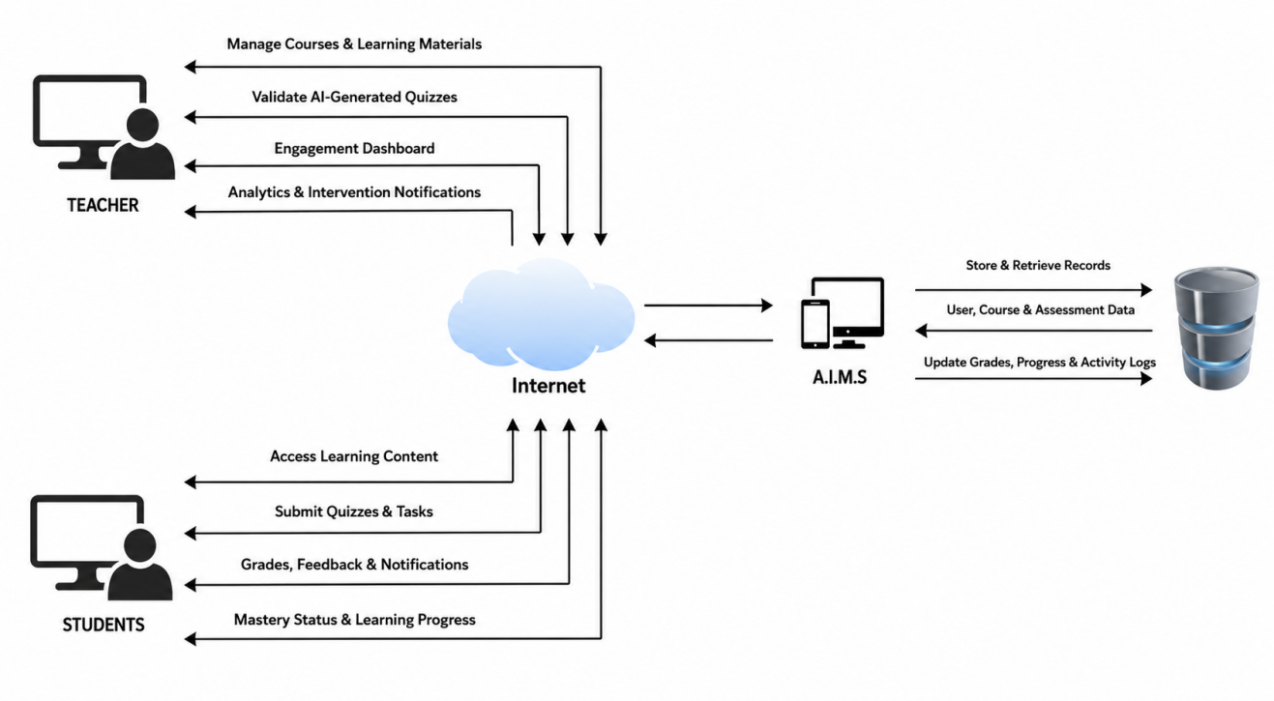
Context Diagram
Figure 3 presents the Level 0 or Context Diagram of the Automated Intervention and Mastery System (A.I.M.S). The diagram illustrates the interaction between the system and its two main external entities: the teacher and the student. Teachers provide learning materials and class configurations to the system, review generated AI quiz drafts, approve quizzes and subjective grades, and manage remedial approvals and lock overrides. In return, the system provides student performance reports and analytics to support monitoring and decision-making.
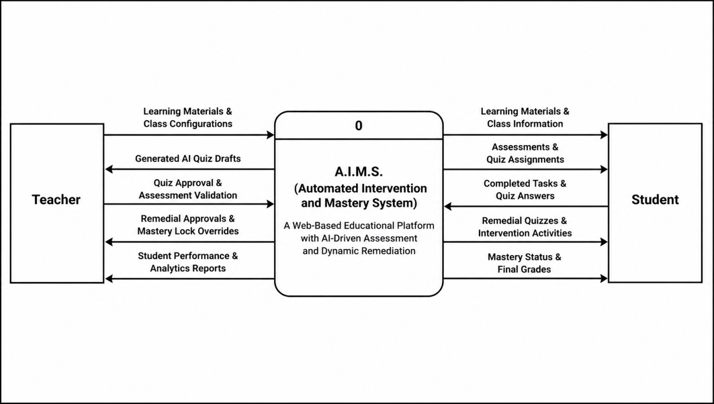
Students interact with the system by accessing learning materials and active assessments, submitting completed tasks and quiz answers, and participating in remedial activities when necessary. The system then processes the submitted data and provides mastery status and final grades to students. Overall, the diagram shows how A.I.M.S acts as the central platform that manages assessments, tracks student mastery, and supports both teaching and learning processes through automated monitoring and intervention features.
Figure 3
Context Diagram (Level 0)
Data Flow Diagram
Figure 4 illustrates the data flow within the A.I.M.S. (Automated Intervention and Mastery System) specifically in the Authentication and Class Management module. The process initiates with teachers and students accessing the platform through User Authentication, where their login credentials are validated against the Users Data Store and Refresh Tokens Data Store, ensuring secure and role-based access. Once authenticated, teachers can create and manage courses in Class Management, where they organize subject details, grading configurations, mastery-lock settings, and enrollment codes, with all generated information stored in the Courses Data Store and Topics Data Store for structured classroom organization. Meanwhile, students engage with Student Enrollment Management by submitting enrollment or class join codes to access specific courses. The system validates these codes through the Courses Data Store and logs successful enrollments in the Enrollments Data Store, allowing students to access learning materials, quizzes, and course activities. Overall, this Level 1 Data Flow Diagram effectively demonstrates how the A.I.M.S. platform facilitates authentication, class organization, and student enrollment through coordinated processes and data storage, ensuring secure access and efficient management of the web-based educational environment.
Overall, the Level 1 DFD illustrates how the A.I.M.S. platform manages secure authentication, course organization, and student enrollment through coordinated data processing and storage mechanisms. The diagram emphasizes the interaction between users and the system while ensuring efficient data handling, organized class management, and secure educational access within the web-based learning environment.

Figure 4
Authentication and Class Management Data Flow Diagram (Level 1)
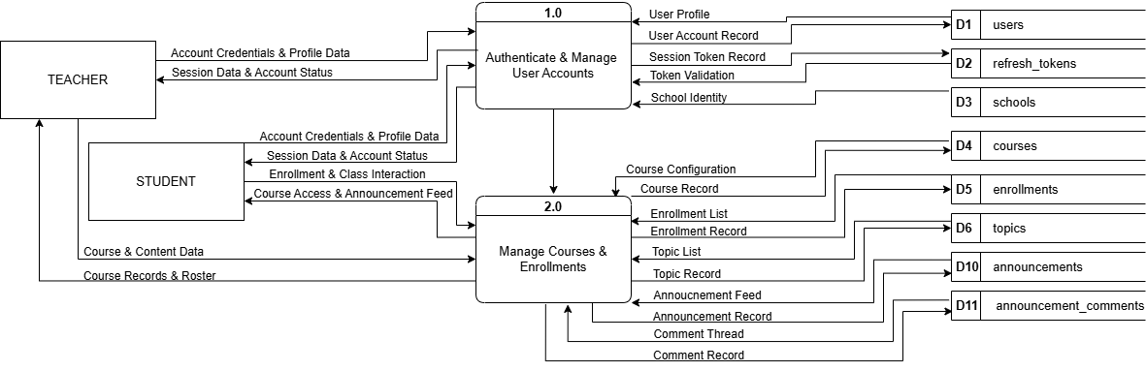

Figure 5
Content, Tasks, and Quizzes Data Flow Diagram (Level 1)
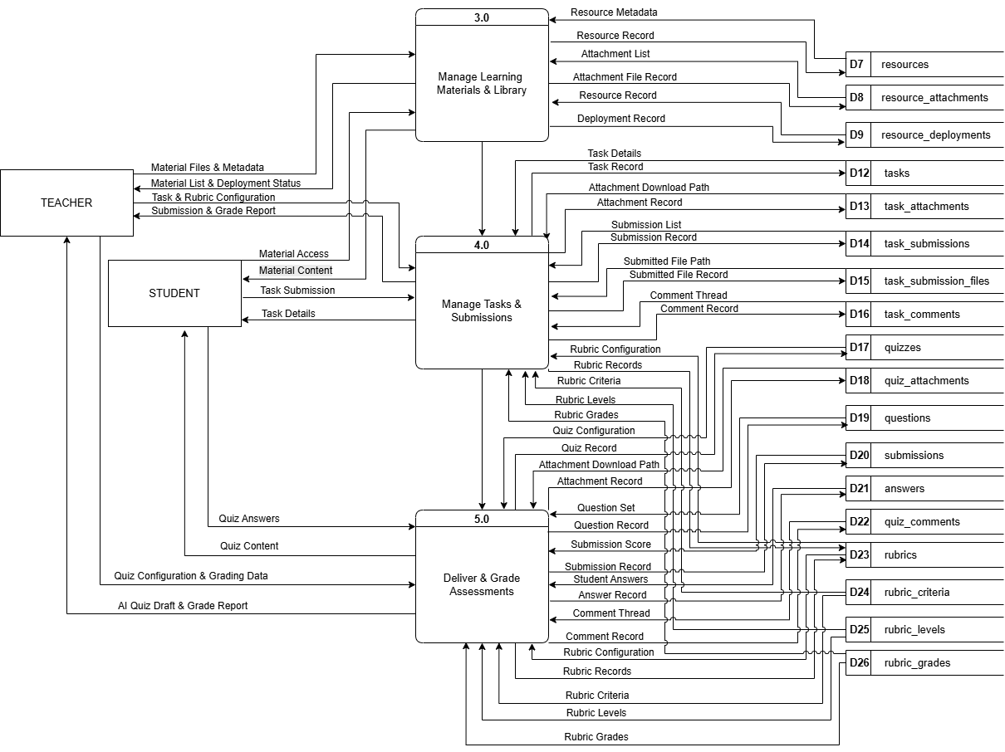

Figure 6
Remediation, Mastery, and Grading Data Flow Diagram (Level 1)
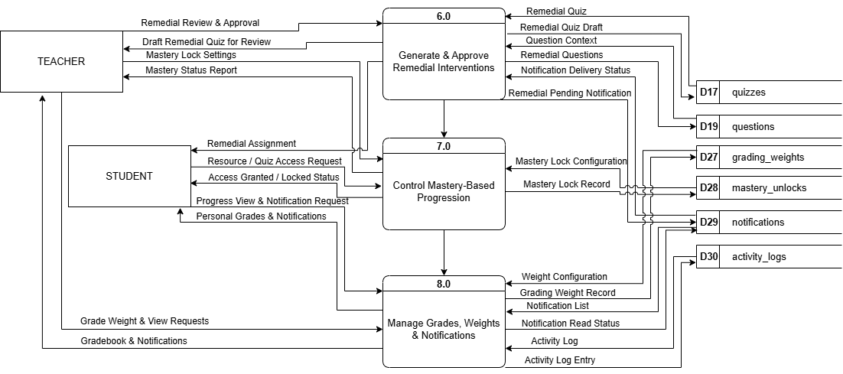
Entity Relationship Diagram
Figure 7 shows the Entity Relationship Diagram (ERD) of the A.I.M.S. (Automated Intervention and Mastery System).It illustrates how different parts of the A.I.M.S database are connected. The ERD was created to keep the data organized and accurate and the structure of the system’s database.

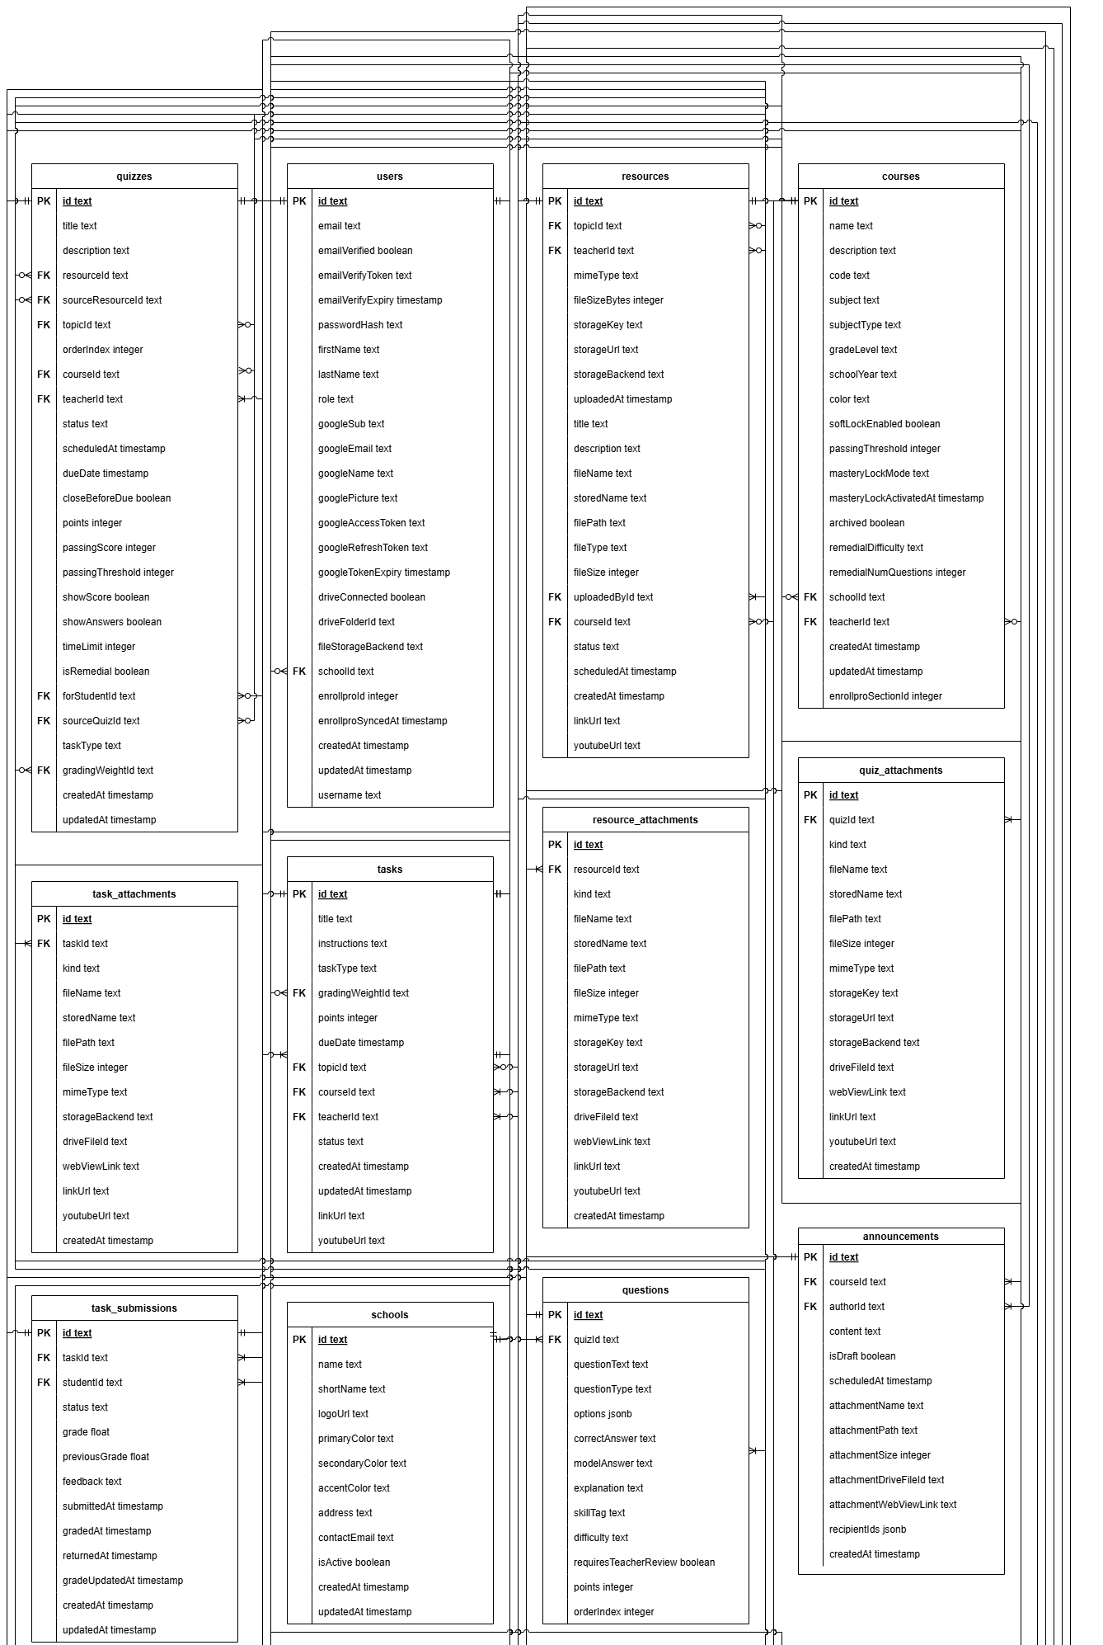
Figure 7
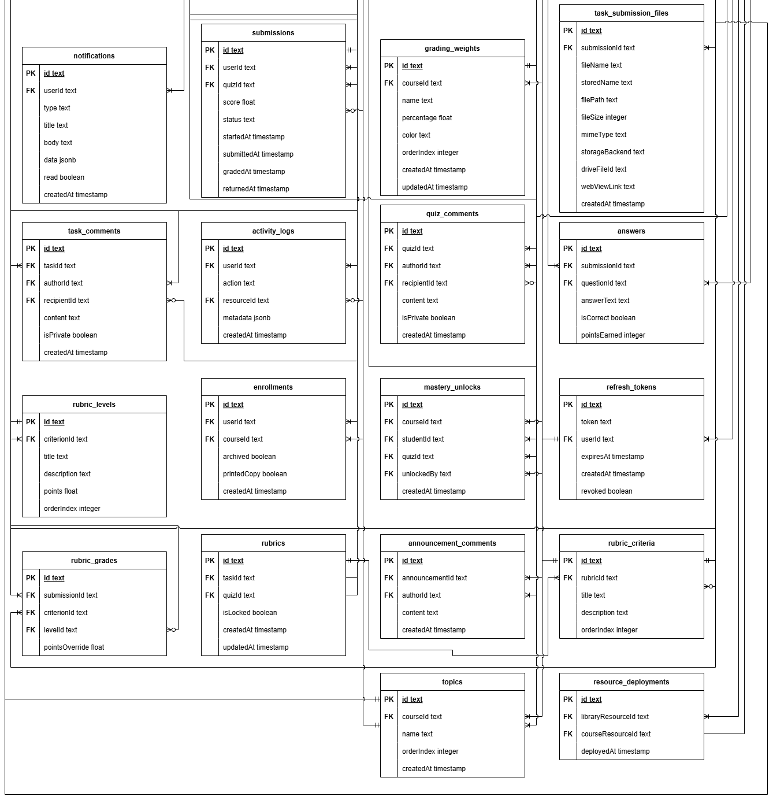
Entity Relationship Diagram

Use Case Diagram
Figure 8 illustrates the functional requirements of the system and the interaction between its two primary actors: the Teacher and the Student. It presents the core operational flow of the platform, ensuring the integration of instructional management and student engagement within a unified virtual learning environment.The Teacher serves as the primary administrator of the virtual classroom and is responsible for managing the overall learning structure. This includes the creation and management of classes, as well as handling student enrollment to properly organize class participants. In addition, the Teacher is in charge of curating instructional content by managing learning materials, assignments, and quizzes. The Teacher also oversees the assessment process by managing grades, which involves evaluating student outputs and providing feedback through the system.On the other hand, the Student interacts with the system as an active learner who participates in course activities and accesses instructional content. Students join designated classes and utilize the learning materials provided by the Teacher to support their academic activities. Their participation is demonstrated through the submission of tasks and completion of quizzes. Furthermore, Students are able to view their grades within the system, allowing them to monitor their academic performance and understand their progress throughout the course. This interaction completes the feedback loop between teaching and learning within the platform.

Figure 8
Use Case Diagram

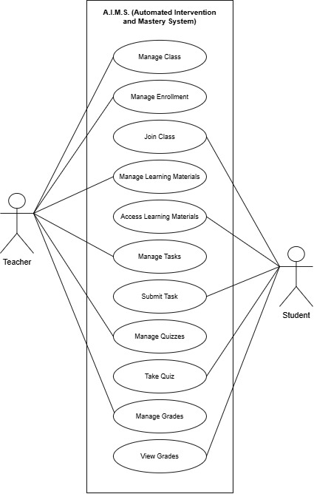

Data Dictionary
A data dictionary helps organize and explain the information stored in a database. It describes the data types, names, and purpose of each field, making it easier to understand and manage the system. It ensures everyone knows what each piece of data means and how it should be used.

Table 6
users
Field Name | Field Type | Length | Description
id | varchar | 36 | Unique user identifier (UUID v4)
email | varchar | 255 | Unique email address used for authentication
emailVerified | tinyint | 1 | Whether the email address has been verified
emailVerifyToken | varchar | 255 | One-time token sent for email verification
emailVerifyExpiry | datetime | - | Expiry datetime of the email verification token
passwordHash | varchar | 255 | Bcrypt-hashed local password
firstName | varchar | 255 | User first name
lastName | varchar | 255 | User last name
role | varchar | 50 | Access role: STUDENT or TEACHER
googleSub | varchar | 255 | Google OAuth unique subject identifier
googleEmail | varchar | 255 | Email from the linked Google account
googleName | varchar | 255 | Display name from the linked Google account
googlePicture | varchar | 255 | Profile photo URL from the linked Google account
googleAccessToken | varchar | 255 | OAuth2 access token for Google API calls
googleRefreshToken | varchar | 255 | OAuth2 refresh token for renewing access tokens
googleTokenExpiry | datetime | - | Expiry datetime of the current Google access token
driveConnected | tinyint | 1 | Whether Google Drive integration is active
driveFolderId | varchar | 255 | Root Google Drive folder ID for user file storage
fileStorageBackend | varchar | 50 | Storage backend in use: LOCAL or GDRIVE
schoolId | varchar | 36 | Foreign key referencing the user's school
employeeId | varchar | 255 | DepEd employee ID (teachers only, from EnrollPro)
enrollproId | int | 11 | EnrollPro internal teacher record ID
enrollproSyncedAt | datetime | - | Timestamp of the last successful EnrollPro sync
createdAt | datetime | - | Record creation timestamp
updatedAt | datetime | - | Timestamp of the last record update

Table 6 stores the complete profile and authentication credentials for every system user. It serves as the central identity record supporting three account types: students, teachers, and administrators. Authentication may be performed using a local email-and-password pair, a numeric DepEd employee ID (for teachers synced from EnrollPro), or a linked Google account via OAuth 2.0. Teachers synced from the EnrollPro integration have their enrollproId and employeeId populated for cross-system identification. Each user is scoped to a single school through the schoolId foreign key, enforcing the multi-tenant data isolation of the platform.

Table 7
refresh_tokens
Field Name | Field Type | Length | Description
id | varchar | 36 | Unique token record identifier
token | varchar | 255 | JWT refresh token string
userId | varchar | 36 | Foreign key to the token owner
expiresAt | datetime | - | Expiry datetime of the token (7 days from issuance)
createdAt | datetime | - | Token creation timestamp
revoked | tinyint | 1 | Whether the token has been revoked

Table 7 stores the JWT refresh tokens issued to users upon successful login. Each record is linked to a specific user and carries an expiry datetime. Tokens may be explicitly revoked on logout or when a password change is performed, enabling fine-grained session management. This design allows users to maintain persistent login sessions across multiple devices while still providing a mechanism for immediate session invalidation when required.

Table 8
schools
Field Name | Field Type | Length | Description
id | varchar | 36 | Unique school identifier
name | varchar | 255 | Full school name
shortName | varchar | 255 | Abbreviated school name used in UI headers
logoUrl | varchar | 255 | URL of the school logo image
primaryColor | varchar | 255 | Brand primary hex color
secondaryColor | varchar | 255 | Brand secondary hex color
accentColor | varchar | 255 | Brand accent hex color
address | text | - | Physical address of the school
contactEmail | varchar | 255 | School contact email address
isActive | tinyint | 1 | Whether the school tenant is currently active
createdAt | datetime | - | Record creation timestamp
updatedAt | datetime | - | Timestamp of the last record update

Table 8 stores the tenant records for each school using the AIMS platform. Every piece of user, course, and academic data in the system is scoped to a school record to enforce strict multi-tenant data isolation. Each school record contains branding configuration including primary, secondary, and accent colors along with a logo URL, which are applied throughout the user interface for that tenant. Contact and address information are also stored for administrative reference.

Table 9
courses
Field Name | Field Type | Length | Description
id | varchar | 36 | Unique course identifier
name | varchar | 255 | Course display name
description | text | - | Optional course description
code | varchar | 255 | Unique join code for student enrollment
subject | varchar | 255 | Subject label (e.g., English, Math)
subjectType | varchar | 50 | DepEd subject category classification
gradeLevel | varchar | 255 | Target grade level (e.g., Grade 10)
schoolYear | varchar | 255 | Academic school year label
color | varchar | 255 | Hex color used for the course card display
softLockEnabled | tinyint | 1 | Whether mastery soft-lock gating is active
passingThreshold | int | 11 | Minimum percentage score required to pass quizzes
masteryLockMode | varchar | 50 | Mastery enforcement mode: PROSPECTIVE or RETROACTIVE
masteryLockActivatedAt | datetime | - | Datetime mastery lock was first activated
archived | tinyint | 1 | Whether the course has been archived
remedialDifficulty | varchar | 255 | Default difficulty for AI-generated remedial quizzes
remedialNumQuestions | int | 11 | Override for number of questions in remedial quizzes
schoolId | varchar | 36 | Foreign key to the owning school
teacherId | varchar | 36 | Foreign key to the teacher who owns the course
createdAt | datetime | - | Record creation timestamp
updatedAt | datetime | - | Timestamp of the last record update

Table 9 stores the subject classes created by teachers. Each course has a unique enrollment code that students use to join. Courses support DepEd grading categories, configurable mastery-lock gating that prevents students from accessing future quizzes until they pass prerequisite ones, and AI-powered remedial quiz generation. The course belongs to a school and a teacher, and aggregates all quizzes, tasks, resources, topics, and student enrollments associated with that class.

Table 10
enrollments
Field Name | Field Type | Length | Description
id | varchar | 36 | Unique enrollment record identifier
userId | varchar | 36 | Foreign key to the enrolled student
courseId | varchar | 36 | Foreign key to the course enrolled in
archived | tinyint | 1 | Whether this enrollment has been archived
printedCopy | tinyint | 1 | Whether the student's grade sheet has been printed
createdAt | datetime | - | Enrollment timestamp

Table 10 is a junction table that records which students are enrolled in which courses. A student may be enrolled in multiple courses and a course may have many enrolled students. A unique constraint on the (userId, courseId) pair prevents duplicate enrollment records. Archived enrollments are soft-deleted rather than permanently removed, preserving historical grading data while hiding the student from active course rosters.

Table 11
topics
Field Name | Field Type | Length | Description
id | varchar | 36 | Unique topic identifier
courseId | varchar | 36 | Foreign key to the parent course
name | varchar | 255 | Topic name (unique within a course)
orderIndex | int | 11 | Display sort order within the course
createdAt | datetime | - | Record creation timestamp

Table 11 allows teachers to organize course content into named topic or unit groupings. Quizzes, tasks, and resources can be tagged to a topic so that students see them grouped by chapter or theme rather than in a flat list. Each topic has a configurable display order within its parent course, and topic names are unique within a course to prevent duplication.

Table 12
resources
Field Name | Field Type | Length | Description
id | varchar | 36 | Unique resource identifier
title | varchar | 255 | Resource display title
description | text | - | Optional description of the resource
topicId | varchar | 36 | Foreign key to the parent topic
courseId | varchar | 36 | Foreign key to the parent course
teacherId | varchar | 36 | Foreign key to the owning teacher
uploadedById | varchar | 36 | Foreign key to the user who uploaded the resource
fileType | varchar | 50 | File type classification: PDF, DOCX, or TXT
fileName | varchar | 255 | Original uploaded file name
storedName | varchar | 255 | File name as stored on disk or in storage
filePath | varchar | 255 | Relative storage path for local files
fileSize | int | 11 | File size in bytes
mimeType | varchar | 255 | MIME type of the uploaded file
storageKey | varchar | 255 | Storage provider object key
storageUrl | varchar | 255 | Public or signed URL of the stored file
storageBackend | varchar | 50 | Storage backend used: LOCAL or GDRIVE
linkUrl | varchar | 255 | External hyperlink URL (link-type resources)
youtubeUrl | varchar | 255 | YouTube video URL (video-type resources)
status | varchar | 50 | Publication status: DRAFT, SCHEDULED, or PUBLISHED
scheduledAt | datetime | - | Datetime to auto-publish a scheduled resource
uploadedAt | datetime | - | Datetime the file was first uploaded
createdAt | datetime | - | Record creation timestamp

Table 12 stores the learning materials that teachers upload or link for student access. Resources may be uploaded files (PDF, DOCX, TXT), external hyperlinks, or YouTube video embeds. Files are stored either locally on the server or on Google Drive, depending on the teacher's configured storage backend. Resources support scheduling for deferred publication and may be linked to a specific topic or quiz to provide contextual reading material before or during an assessment.

Table 13
resource_attachments
Field Name | Field Type | Length | Description
id | varchar | 36 | Unique attachment identifier
resourceId | varchar | 36 | Foreign key to the parent resource
kind | varchar | 50 | Attachment kind: FILE, LINK, or YOUTUBE
fileName | varchar | 255 | Original file name
storedName | varchar | 255 | Stored file name on disk
filePath | varchar | 255 | Relative path of the stored file
fileSize | int | 11 | File size in bytes
mimeType | varchar | 255 | MIME type of the file
storageKey | varchar | 255 | Storage provider object key
storageUrl | varchar | 255 | URL of the stored file
storageBackend | varchar | 50 | Storage backend: LOCAL or GDRIVE
driveFileId | varchar | 255 | Google Drive file ID
webViewLink | varchar | 255 | Google Drive web view URL
linkUrl | varchar | 255 | External hyperlink URL
youtubeUrl | varchar | 255 | YouTube video URL
createdAt | datetime | - | Attachment creation timestamp

Table 13 stores supplementary files or links attached to a resource record. Unlike the primary resource file, attachments are additional supporting materials added to enrich the resource. Attachments may be uploaded files from local storage or Google Drive, external hyperlinks, or YouTube video links. Each attachment is uniquely associated with its parent resource record.

Table 14
resource_deployments
Field Name | Field Type | Length | Description
id | varchar | 36 | Unique deployment record identifier
libraryResourceId | varchar | 36 | Foreign key to the original library resource
courseResourceId | varchar | 36 | Foreign key to the course-scoped resource copy (unique)
deployedAt | datetime | - | Timestamp when the resource was deployed

Table 14 tracks when a library-level resource has been deployed (copied) into a specific course. This enables teachers to build a shared resource library and reuse materials across multiple courses without duplication of content. The deployedAt timestamp records when the deployment occurred, and the courseResourceId is unique to ensure a library resource is deployed to a given course only once.

Table 15
quizzes
Field Name | Field Type | Length | Description
id | varchar | 36 | Unique quiz identifier
title | varchar | 255 | Quiz title
description | text | - | Optional quiz description or instructions
courseId | varchar | 36 | Foreign key to the parent course
teacherId | varchar | 36 | Foreign key to the teacher who created the quiz
topicId | varchar | 36 | Foreign key to the parent topic
resourceId | varchar | 36 | Resource linked to this quiz
sourceResourceId | varchar | 36 | Source resource used for AI quiz generation
orderIndex | int | 11 | Sort order within the course or topic
status | varchar | 50 | Quiz status: DRAFT, PUBLISHED, CLOSED, or ARCHIVED
scheduledAt | datetime | - | Datetime to automatically publish the quiz
dueDate | datetime | - | Submission due date
closeBeforeDue | tinyint | 1 | Whether the quiz auto-closes at the due date
points | int | 11 | Total point value of the quiz
passingScore | int | 11 | Minimum score (%) required to pass the quiz
passingThreshold | int | 11 | Threshold used for mastery-lock evaluation
showScore | tinyint | 1 | Whether students can see their score after submission
showAnswers | tinyint | 1 | Whether correct answers are revealed after submission
timeLimit | int | 11 | Time limit in minutes (NULL means unlimited)
isRemedial | tinyint | 1 | Whether this is an AI-generated remedial quiz
forStudentId | varchar | 36 | Target student for a personalised remedial quiz
sourceQuizId | varchar | 36 | Source quiz this remedial was generated from
taskType | varchar | 50 | DepEd grading category for this quiz
gradingWeightId | varchar | 36 | Foreign key to the grading weight category
createdAt | datetime | - | Record creation timestamp
updatedAt | datetime | - | Timestamp of the last record update

Table 15 stores all quiz records in the system. Quizzes may be manually authored by a teacher or AI-generated as remedial assessments for students who did not meet the passing threshold on a previous quiz. Each quiz supports a configurable time limit, due date, point value, and DepEd grading category. The mastery-lock feature uses the passingThreshold value to determine whether a student may proceed to subsequent quizzes in the course. Remedial quizzes carry a forStudentId and sourceQuizId that link them back to the target student and the original quiz that triggered generation.

Table 16
quiz_attachments
Field Name | Field Type | Length | Description
id | varchar | 36 | Unique attachment identifier
quizId | varchar | 36 | Foreign key to the parent quiz
kind | varchar | 50 | Attachment kind: FILE, LINK, or YOUTUBE
fileName | varchar | 255 | Original file name
storedName | varchar | 255 | Stored file name on disk
filePath | varchar | 255 | Relative path of the stored file
fileSize | int | 11 | File size in bytes
mimeType | varchar | 255 | MIME type of the file
storageKey | varchar | 255 | Storage provider object key
storageUrl | varchar | 255 | URL of the stored file
storageBackend | varchar | 50 | Storage backend: LOCAL or GDRIVE
driveFileId | varchar | 255 | Google Drive file ID
webViewLink | varchar | 255 | Google Drive web view URL
linkUrl | varchar | 255 | External hyperlink URL
youtubeUrl | varchar | 255 | YouTube video URL
createdAt | datetime | - | Attachment creation timestamp

Table 16 stores files or links attached to a quiz by the teacher to provide reference materials during the assessment. Attachments may be uploaded documents, external hyperlinks, or YouTube videos, and may be stored locally or on Google Drive. This allows teachers to include context-setting materials or data tables that students need to view in order to answer the quiz questions.

Table 17
questions
Field Name | Field Type | Length | Description
id | varchar | 36 | Unique question identifier
quizId | varchar | 36 | Foreign key to the parent quiz
questionText | text | - | Question prompt text
questionType | varchar | 50 | Type: MULTIPLE_CHOICE, TRUE_FALSE, SHORT_ANSWER, IDENTIFICATION, ENUMERATION
options | json | - | Answer choices array (for multiple choice / true-false)
correctAnswer | varchar | 255 | Correct answer string or choice key
modelAnswer | text | - | Model answer or rubric for open-ended questions
explanation | text | - | Explanation shown to the student after submission
skillTag | varchar | 255 | Learning skill or competency tag
difficulty | varchar | 255 | Difficulty level: EASY, MEDIUM, or HARD
requiresTeacherReview | tinyint | 1 | Whether the question requires manual teacher grading
points | int | 11 | Point value of the question
orderIndex | int | 11 | Display order within the quiz

Table 17 stores the individual questions that belong to each quiz. The system supports five question types: multiple choice, true/false, short answer, identification, and enumeration. Multiple-choice questions store their options in the options JSON field. Questions carry optional metadata such as difficulty level and a skill tag used by the AI engine when generating remedial quizzes. Questions that require manual teacher grading (open-ended types) have the requiresTeacherReview flag set to true.

Table 18
submissions
Field Name | Field Type | Length | Description
id | varchar | 36 | Unique submission identifier
userId | varchar | 36 | Foreign key to the student who made the submission
quizId | varchar | 36 | Foreign key to the submitted quiz
score | decimal | - | Computed percentage score
status | varchar | 50 | Status: IN_PROGRESS, SUBMITTED, GRADED, RETURNED, MISSING, or EXCUSED
startedAt | datetime | - | Datetime the student started the quiz
submittedAt | datetime | - | Datetime the student submitted the quiz
gradedAt | datetime | - | Datetime the submission was graded
returnedAt | datetime | - | Datetime the graded submission was returned to the student

Table 18 records each student's quiz attempt, tracking the full lifecycle from the moment the student opens the quiz to grading and score return. The score is stored as a decimal percentage computed upon grading. A submission with a MISSING status indicates the student did not submit by the due date, while EXCUSED means the teacher has waived the requirement. Each quiz-student pair results in at most one active submission record.

Table 19
answers
Field Name | Field Type | Length | Description
id | varchar | 36 | Unique answer identifier
submissionId | varchar | 36 | Foreign key to the parent submission
questionId | varchar | 36 | Foreign key to the answered question
answerText | text | - | Student-provided answer text
isCorrect | tinyint | 1 | Whether the answer was marked correct (NULL = pending review)
pointsEarned | int | 11 | Points awarded for this answer

Table 19 stores the individual answers that a student provided for each question in a quiz submission. The isCorrect flag is populated automatically for objective question types (multiple choice, true/false, identification) and remains NULL for questions that require manual teacher review. The pointsEarned field supports partial credit and is set during the grading process. A unique constraint on (submissionId, questionId) ensures each question is answered only once per submission.

Table 20
tasks
Field Name | Field Type | Length | Description
id | varchar | 36 | Unique task identifier
title | varchar | 255 | Task title
instructions | text | - | Task instructions shown to students
taskType | varchar | 50 | DepEd grading category: ASSIGNMENT, WRITTEN_WORK, or PERFORMANCE_TASK
gradingWeightId | varchar | 36 | Foreign key to the grading weight category
points | int | 11 | Maximum point value
dueDate | datetime | - | Submission due date
topicId | varchar | 36 | Foreign key to the parent topic
courseId | varchar | 36 | Foreign key to the parent course
teacherId | varchar | 36 | Foreign key to the teacher who created the task
status | varchar | 50 | Task status: DRAFT, PUBLISHED, or CLOSED
linkUrl | varchar | 255 | Linked external URL
youtubeUrl | varchar | 255 | Linked YouTube video URL
createdAt | datetime | - | Record creation timestamp
updatedAt | datetime | - | Timestamp of the last record update

Table 20 stores the performance tasks and written work assignments created by teachers. Unlike quizzes, tasks require students to upload files as their response, which the teacher then grades manually—optionally using a rubric. Tasks support configurable point values, DepEd grading categories, and due dates. Each task belongs to a course and may be categorized under a topic for organized display in the student's classwork view.

Table 21
task_attachments
Field Name | Field Type | Length | Description
id | varchar | 36 | Unique attachment identifier
taskId | varchar | 36 | Foreign key to the parent task
kind | varchar | 50 | Attachment kind: FILE, LINK, or YOUTUBE
fileName | varchar | 255 | Original file name
storedName | varchar | 255 | Stored file name on disk
filePath | varchar | 255 | Relative path of the stored file
fileSize | int | 11 | File size in bytes
mimeType | varchar | 255 | MIME type of the file
storageBackend | varchar | 50 | Storage backend: LOCAL or GDRIVE
driveFileId | varchar | 255 | Google Drive file ID
webViewLink | varchar | 255 | Google Drive web view URL
linkUrl | varchar | 255 | External hyperlink URL
youtubeUrl | varchar | 255 | YouTube video URL
createdAt | datetime | - | Attachment creation timestamp

Table 21 stores files, links, or YouTube videos attached to a task by the teacher to provide supplementary information, rubrics, or reference materials for students. Attachments may be served from local storage or Google Drive. These materials are visible to all enrolled students when they open the task detail page.

Table 22
task_submissions
Field Name | Field Type | Length | Description
id | varchar | 36 | Unique task submission identifier
taskId | varchar | 36 | Foreign key to the submitted task
studentId | varchar | 36 | Foreign key to the submitting student
status | varchar | 50 | Status: ASSIGNED, SUBMITTED, RETURNED, GRADED, MISSING, or EXCUSED
grade | decimal | - | Current grade or score
previousGrade | decimal | - | Previous grade before the most recent update
feedback | text | - | Teacher feedback text
submittedAt | datetime | - | Datetime the student submitted
gradedAt | datetime | - | Datetime the submission was graded
returnedAt | datetime | - | Datetime the graded work was returned to the student
gradeUpdatedAt | datetime | - | Datetime the grade was last modified
createdAt | datetime | - | Record creation timestamp
updatedAt | datetime | - | Timestamp of the last record update

Table 22 records each student's submission for a task. A unique constraint on (taskId, studentId) ensures only one submission record exists per student per task. The record tracks the complete grading lifecycle from initial assignment through submission, grading, and return. The grade and previousGrade fields allow teachers to update scores while preserving a history of changes. Teacher feedback is stored alongside the grade for direct communication with the student.

Table 23
task_submission_files
Field Name | Field Type | Length | Description
id | varchar | 36 | Unique file record identifier
submissionId | varchar | 36 | Foreign key to the parent task submission
fileName | varchar | 255 | Original uploaded file name
storedName | varchar | 255 | Stored file name on disk
filePath | varchar | 255 | Relative path of the stored file
fileSize | int | 11 | File size in bytes
mimeType | varchar | 255 | MIME type of the uploaded file
storageBackend | varchar | 50 | Storage backend: LOCAL or GDRIVE
driveFileId | varchar | 255 | Google Drive file ID
webViewLink | varchar | 255 | Google Drive web view URL
createdAt | datetime | - | File upload timestamp

Table 23 stores the individual files uploaded by a student as part of a task submission. A single task submission may have multiple files attached. Files are stored in either the local server file system or on Google Drive depending on the student's configured storage backend. The table preserves file metadata including the original name, size, MIME type, and the storage key or Drive file ID required to retrieve the file.

Table 24
rubrics
Field Name | Field Type | Length | Description
id | varchar | 36 | Unique rubric identifier
taskId | varchar | 36 | Foreign key to the task this rubric is attached to (unique)
quizId | varchar | 36 | Foreign key to the quiz this rubric is attached to (unique)
isLocked | tinyint | 1 | Whether the rubric is locked from further editing
createdAt | datetime | - | Record creation timestamp
updatedAt | datetime | - | Timestamp of the last record update

Table 24 stores scoring rubrics that may be attached to either a task or a quiz. Each rubric contains an ordered set of criteria defining the dimensions of evaluation. Each criterion in turn defines multiple performance levels with associated descriptors and point values. Once grading has begun on a rubric, it may be locked to prevent modifications that would retroactively alter existing grades.

Table 25
rubric_criteria
Field Name | Field Type | Length | Description
id | varchar | 36 | Unique criterion identifier
rubricId | varchar | 36 | Foreign key to the parent rubric
title | varchar | 255 | Criterion title (e.g., Content, Grammar)
description | text | - | Optional description of what is being evaluated
orderIndex | int | 11 | Display sort order within the rubric

Table 25 stores the individual criteria within a rubric, representing the specific dimensions evaluated when grading a student's work. Examples of criteria include Content, Grammar, Organization, and Presentation. Each criterion has a title, an optional description clarifying what is being evaluated, and a display order index for rendering the rubric in a consistent layout.

Table 26
rubric_levels
Field Name | Field Type | Length | Description
id | varchar | 36 | Unique level identifier
criterionId | varchar | 36 | Foreign key to the parent rubric criterion
title | varchar | 255 | Level title (e.g., Excellent, Satisfactory)
description | text | - | Descriptor text for this performance level
points | decimal | - | Point value awarded at this level
orderIndex | int | 11 | Display sort order within the criterion

Table 26 defines the performance levels for each rubric criterion. Typical levels include Excellent, Satisfactory, Developing, and Beginning, each carrying a descriptor text and a point value used to compute the student's score. Levels are ordered within their parent criterion for consistent display from highest to lowest performance.
Table 27
rubric_grades
Field Name | Field Type | Length | Description
id | varchar | 36 | Unique rubric grade record identifier
submissionId | varchar | 36 | Foreign key to the task submission being graded
criterionId | varchar | 36 | Foreign key to the rubric criterion being evaluated
levelId | varchar | 36 | Selected performance level (NULL = no level selected)
pointsOverride | decimal | - | Manual point override, ignoring the level's default points

Table 27 Records the rubric evaluation outcome for each criterion in a student's task submission. For each criterion a specific performance level is selected, and an optional pointsOverride field allows the teacher to award a custom score that differs from the level's default point value. A unique constraint on (submissionId, criterionId) ensures each criterion is scored only once per submission.

Table 28
grading_weights
Field Name | Field Type | Length | Description
id | varchar | 36 | Unique grading weight identifier
courseId | varchar | 36 | Foreign key to the parent course
name | varchar | 255 | Category name (e.g., Written Works, Performance Tasks)
percentage | decimal | - | Weight as a percentage (e.g., 25.0 for 25%)
color | varchar | 255 | Hex color used for this category in grade charts
orderIndex | int | 11 | Display sort order within the course
createdAt | datetime | - | Record creation timestamp
updatedAt | datetime | - | Timestamp of the last record update

Table 2 defines the DepEd grading weight categories for each course. Common categories include Written Works (25%), Performance Tasks (50%), and Quarterly Assessment (25%), mirroring the DepEd K-12 grading policy. These weights are applied by the grading engine to compute a student's final transmuted grade from raw quiz and task scores. Category names are unique within a course to prevent duplicate weight entries.

Table 29
mastery_unlocks
Field Name | Field Type | Length | Description
id | varchar | 36 | Unique unlock record identifier
courseId | varchar | 36 | Foreign key to the course where the unlock applies
studentId | varchar | 36 | Foreign key to the student whose access is unlocked
quizId | varchar | 36 | Foreign key to the quiz being unlocked
unlockedBy | varchar | 36 | Foreign key to the teacher who granted the unlock
createdAt | datetime | - | Datetime the unlock was granted

Table 29 records teacher-granted overrides that allow a specific student to access a mastery-locked quiz within a course. When mastery-lock gating is enabled, students who have not met the passing threshold on prerequisite quizzes are blocked from proceeding. This table stores exceptions manually granted by the teacher. A unique constraint on (courseId, studentId, quizId) ensures each unlock is issued only once per student per quiz per course.

Table 30
task_comments
Field Name | Field Type | Length | Description
id | varchar | 36 | Unique comment identifier
taskId | varchar | 36 | Foreign key to the parent task
authorId | varchar | 36 | Foreign key to the user who wrote the comment
recipientId | varchar | 36 | Foreign key to the intended recipient (optional)
content | text | - | Comment body text
isPrivate | tinyint | 1 | Whether the comment is private
createdAt | datetime | - | Comment creation timestamp

Table 30 stores comments attached to tasks, enabling direct communication between teachers and students about task instructions, clarifications, or feedback. Comments may be marked private, meaning they are visible only to the author and the specified recipient. This supports both class-wide discussion and private teacher-to-student feedback within the context of a specific task.

Table 31
quiz_comments
Field Name | Field Type | Length | Description
id | varchar | 36 | Unique comment identifier
quizId | varchar | 36 | Foreign key to the parent quiz
authorId | varchar | 36 | Foreign key to the user who wrote the comment
recipientId | varchar | 36 | Foreign key to the intended recipient (optional)
content | text | - | Comment body text
isPrivate | tinyint | 1 | Whether the comment is private
createdAt | datetime | - | Comment creation timestamp

Table 31 stores comments attached to quizzes, mirroring the task comment design for quiz-related communication. Teachers may post clarifications about quiz instructions, and students may ask questions. Private comments are visible only to the author and specified recipient, enabling direct teacher-to-student feedback within the context of a specific quiz.

Table 32
announcements
Field Name | Field Type | Length | Description
id | varchar | 36 | Unique announcement identifier
courseId | varchar | 36 | Foreign key to the parent course
authorId | varchar | 36 | Foreign key to the teacher who created the announcement
content | text | - | Announcement body text
isDraft | tinyint | 1 | Whether the announcement is still a draft
scheduledAt | datetime | - | Datetime to auto-publish the announcement
attachmentName | varchar | 255 | Name of the attached file
attachmentPath | varchar | 255 | Storage path of the attached file
attachmentSize | int | 11 | File size in bytes
attachmentDriveFileId | varchar | 255 | Google Drive file ID for the attachment
attachmentWebViewLink | varchar | 255 | Google Drive web view URL for the attachment
recipientIds | json | - | JSON array of targeted student user IDs (NULL = all students)
createdAt | datetime | - | Record creation timestamp

Table 32 stores course announcements posted by teachers to keep enrolled students informed. Announcements support a draft mode for editing before publication and a scheduling feature for deferred release at a specified datetime. A single file attachment may be included for supplementary documents. The recipientIds JSON field enables teachers to target announcements at a specific subset of students rather than the entire class.

Table 33
announcement_comments
Field Name | Field Type | Length | Description
id | varchar | 36 | Unique comment identifier
announcementId | varchar | 36 | Foreign key to the parent announcement
authorId | varchar | 36 | Foreign key to the user who wrote the comment
content | text | - | Comment body text
createdAt | datetime | - | Comment creation timestamp

Table 33 stores replies to course announcements from both teachers and students. This creates a threaded discussion channel around each announcement, allowing students to ask questions or react to posted information. All comments on an announcement are visible to all enrolled students, fostering open class communication.

Table 34
activity_logs
Field Name | Field Type | Length | Description
id | varchar | 36 | Unique activity log entry identifier
userId | varchar | 36 | Foreign key to the user who performed the action
action | varchar | 255 | Action performed (e.g., VIEW, DOWNLOAD)
resourceId | varchar | 36 | Foreign key to the resource that was acted upon
metadata | json | - | Additional contextual metadata for the action
createdAt | datetime | - | Datetime the action was recorded

Table 34 provides an audit trail of user interactions with resources in the system. Actions such as viewing or downloading a learning material are recorded with the acting user's identity and a timestamp. The metadata JSON field stores additional contextual information such as the resource title or file name, supporting analytics and monitoring of student engagement with course materials.

Table 35
notifications
Field Name | Field Type | Length | Description
id | varchar | 36 | Unique notification identifier
userId | varchar | 36 | Foreign key to the recipient user
type | varchar | 50 | Notification type (e.g., REMEDIAL_PENDING)
title | varchar | 255 | Short notification title
body | text | - | Notification body text
data | json | - | Optional JSON payload with contextual data
read | tinyint | 1 | Whether the notification has been read
createdAt | datetime | - | Notification creation timestamp

Table 35 stores in-app notifications sent to users to alert them of important events. The primary notification type is REMEDIAL_PENDING, which notifies a student that an AI-generated remedial quiz has been created for them following a failing score. Each notification tracks its read status so the UI can display an unread badge count. The optional data JSON field carries contextual information such as a quiz ID or course ID that the application uses to navigate the user to the relevant content when the notification is tapped.
Hardware and Software Requirements
This section outlines the hardware and software requirements essential for the effective operation of A.I.M.S. (Automated Intervention And Mastery System): A Web- Based Educational Platform With Ai-Driven Assessment And Dynamic Remediation.

Hardware Requirements
To ensure the reliable performance of A.I.M.S. (Automated Intervention And Mastery System): A Web- Based Educational Platform With Ai-Driven Assessment And Dynamic Remediation, the baseline hardware configurations and technical standards are detailed below:

Table 36
Hardware Components and Specification
Components | Minimum Specification | Recommended Specification
Server CPU | AMD Ryzen 5 (3000 Series+) or Intel Core i5 (10th Gen+) | Intel Xeon or AMD EPYC (12+ Cores)
Server RAM | 8 GB DDR4 | 16 GB to 32 GB DDR4/DDR5
Server Storage | 256 GB HDD / SSD | 1 TB NVMe SSD (RAID 1 Configuration)
Network (ISP) | 25 Mbps stable Symmetric connection | 100 Mbps to 1 Gbps Symmetric Fiber
Teachers | Intel Core i3 (8th Gen) or AMD Ryzen 3, 8 GB RAM | Intel Core i5 (11th Gen) or AMD Ryzen 5, 12 GB RAM
Learner / Guardian (Mobile) | Android 10.0+ / iOS 15.0+, 4 GB RAM | Android 13.0+ / iOS 17.0+, 6 GB RAM

Software Requirements
To implement the A.I.M.S. (Automated Intervention and Mastery System), specific software components are needed for its web-based learning environment, AI-driven assessments, and database management. The primary server must use a stable operating system like Windows 10/11, Ubuntu Linux, or other compatible platforms for web services and database operations. For database management, PostgreSQL or MySQL is required to securely store user accounts, course records, quizzes, assessment results, mastery progress, and learning resources. The backend needs the Node.js runtime for server-side logic, AI quiz generation, automated grading, and dynamic remediation. To manage deployment and performance, Docker and Docker Compose can containerize services. Nginx or Apache Web Server will act as a reverse proxy and web server to handle user requests and serve frontend assets. The system uses JWT (JSON Web Token) authentication and bcrypt encryption for secure login, password hashing, and role-based access for teachers and students. Git is employed for version control and collaborative development to support ongoing updates and maintenance. On the client side, teachers and students only need a modern web browser like Google Chrome, Mozilla Firefox, Microsoft Edge, or Safari to access the A.I.M.S. platform. A stable internet connection is also necessary for real-time interaction, online assessments, AI-generated quizzes, and access to learning materials.

Time Table (Gantt Chart)
Figure 9. Gantt Chart for A.I.M.S (Automated Intervention and Mastery System) The Gantt chart above shows the duration of the project in developing the A.I.M.S (Automated Intervention and Mastery System) for the whole duration of the semester, from the requirement planning phase to documentation phase. A Gantt chart helps visualize the different stages involved with the development of a web-based educational platform such as this one.
Figure 9
Gantt Chart
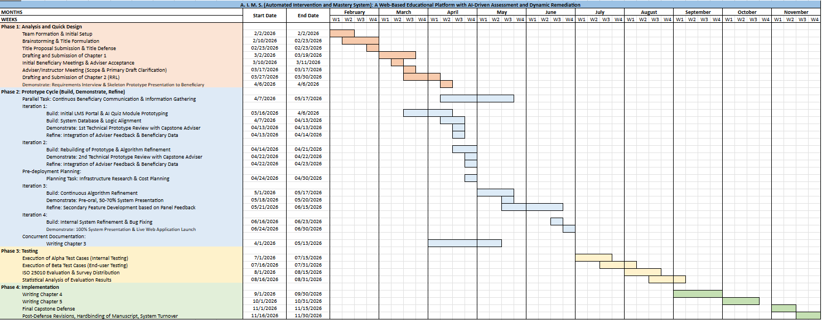

REFERENCES
Alamoudi, S., Al Khuzayem, L. A., & Jamal, A. (2025). Optimizing automated question generation for educational assessments: A semantic analysis of LLMs with structured and unstructured ontologies. Engineering, Technology & Applied Science Research, 15(3), 23664–23671. https://doi.org/10.48084/etasr.10662
Balase, M. M. H., & Paglinawan, J. L. (2025). Voices from the field: Teachers' narratives and reflections on integrating the DepEd Learning Management System (LMS) in teaching and professional development. International Journal of Scientific and Management Research, 8(10), 147–159. https://doi.org/10.37502/ijsmr.2025.81011
Bulathwela, S., Pérez-Ortiz, M., Holloway, C., Cukurova, M., & Shawe-Taylor, J. (2023). Review on neural question generation for education purposes. International Journal of Artificial Intelligence in Education, 33(4), 691–717. https://doi.org/10.1007/s40593-023-00374-x
Bustillo, E., & Aguilos, M. (2022). The challenges of modular learning in the wake of COVID-19: A digital divide in the Philippine countryside revealed. Education Sciences, 12(7), 449. https://doi.org/10.3390/educsci12070449
Colegado, J. C. (2025). Digital innovations in science education in the Philippines: A scoping review of teaching practices and tools. International Journal of Research and Innovation in Social Science, 9(3S), 6549–6556. https://doi.org/10.47772/IJRISS.2025.903SEDU0479
Dahal, N., & Manandhar, N. (2024). The reality of e-learning: Success and failure of learning management system. Advances in Mobile Learning Educational Research, 4(1), 903–910. https://doi.org/10.25082/amler.2024.01.001
Gardner, J., O'Leary, M., & Yuan, L. (2021). Artificial intelligence in educational assessment: 'Breakthrough? Or buncombe and ballyhoo?' Journal of Computer Assisted Learning, 37(5), 1207–1216. https://doi.org/10.1111/jcal.12577
Gorgun, G., & Bulut, O. (2024). Exploring quality criteria and evaluation methods in automated question generation: A comprehensive survey. Education and Information Technologies, 29(18), 24111–24142. https://doi.org/10.1007/s10639-024-12771-3
Hegde, S. V., Shetty, P. P., Senthilkumar, M., Kandimalla, R., Bernhardt, G. V., Pinto, J. R. T., Mahadevan, R., Kotian, S. M., & Rashmi, K. S. (2024). Bridging knowledge gaps: Impact of remedial classes on first-year medical students in biochemistry - a cross-sectional study. BMC Medical Education, 24(1), Article 1375. https://doi.org/10.1186/s12909-024-06243-y
International Organization for Standardization. (2011). Systems and software engineering—Systems and software Quality Requirements and Evaluation (SQuaRE)—System and software quality models (ISO/IEC Standard No. 25010:2011). https://www.iso.org/standard/35733.html
Jumao-as, J., Fuentes, J. L., Lacar, L., Fuertes, G. J., Erag, C., & Tagaylo, C. (2025). Reading remediation program and Grade 4 pupils' reading comprehension. Asian Journal of Education and Social Studies, 51(6), 365–377. https://doi.org/10.9734/ajess/2025/v51i62000
Marcos, L. T. (2026). A systematic review on artificial intelligence in education: Opportunities, challenges, and ethical implications. Preprints. https://doi.org/10.20944/preprints202601.0448.v1
Merino-Campos, C. (2025). The impact of artificial intelligence on personalized learning in higher education: A systematic review. Trends in Higher Education, 4(2), Article 17. https://doi.org/10.3390/higheredu4020017
Ouyang, F., Dinh, T. A., & Xu, W. (2023). A systematic review of AI-driven educational assessment in STEM education. Journal for STEM Education Research, 6(3), 383–426. https://doi.org/10.1007/s41979-023-00112-x
Persky, A. M., & Hughes, M. L. (2022). A practical review of mastery learning. American Journal of Pharmaceutical Education, 86(10), Article 8906. https://doi.org/10.5688/ajpe8906
Simon, P. D., Jiang, J., Fryer, L. K., King, R. B., & Frondozo, C. E. (2025). An assessment of learning management system use in higher education: Perspectives from a comprehensive sample of teachers and students. Technology, Knowledge and Learning, 30(2), 741–767. https://doi.org/10.1007/s10758-024-09734-5
Toti, G., Chen, G., & Gonzalez, S. (2023). Teaching CS1 with a mastery learning framework: Impact on students' learning and engagement. In Proceedings of the 2023 Conference on Innovation and Technology in Computer Science Education V. 1 (pp. 540–546). https://doi.org/10.1145/3587102.3588844
Zampirolli, F. A., Borovina Josko, J. M., Venero, M. L. F., Kobayashi, G., Fraga, F. J., Goya, D., & Savegnago, H. R. (2021). An experience of automated assessment in a large-scale introduction programming course. Computer Applications in Engineering Education, 29(5), 1284–1299. https://doi.org/10.1002/cae.22385

Zhang, C., Li, B., Wang, L., Xu, H., & Shao, T. (2023). A hierarchical model for quality evaluation of mixed source software based on ISO/IEC 25010. International Journal of Software Engineering and Knowledge Engineering, 33(2), 181-205. https://doi.org/10.1142/S021819402250070X

APPENDICES

Appendix A
LETTER TO BENEFICIARIES


Appendix B

BENEFICIARY ACKNOWLEDGEMENT



Appendix C
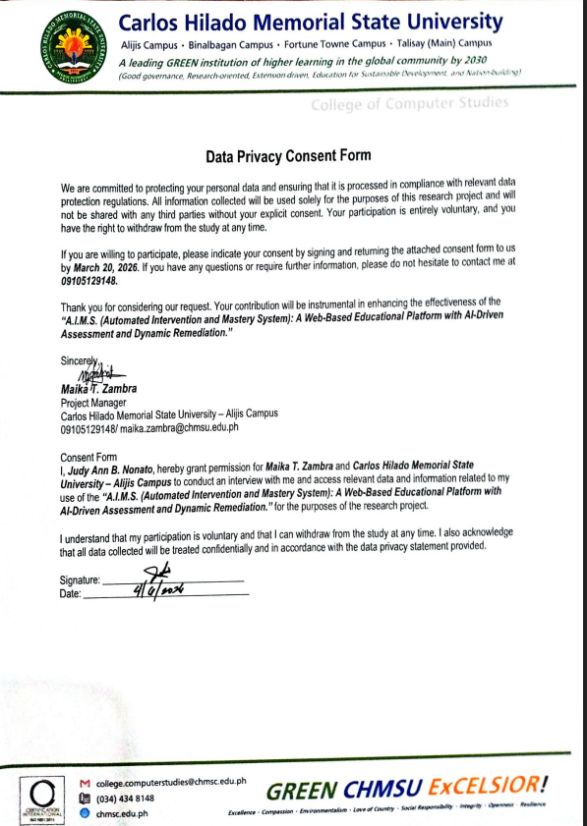
DATA PRIVACY CONSENT FORM

Appendix D
PARENT’S WAIVER


Appendix E

RESEARCH INSTRUMENT

Test Case
Direction: Below are the functional test cases designed to evaluate the performance and reliability of the A.I.M.S system. Please execute each scenario carefully following the provided Test Steps and Test Data.
For each item, kindly record the Actual Result observed during testing and indicate the Status by marking it as Pass (if the expected result is met) or Fail (if a discrepancy occurs). Use the Remarks column to provide additional context or specific details regarding the test outcome.

Rating Scale:
Percentage of Passed Test Cases | Descriptive Rating | Interpretation
96% – 100% | Excellent | The system passed almost all test cases and functions correctly with minimal or no errors.
90% – 95% | Very Good | The system passed most test cases with only minor issues detected.
85% – 89% | Good | The system functions properly but requires some improvements in certain features.
80% – 84% | Fair | The system meets basic functional requirements but several issues need correction.
Below 80% | Poor | The system failed significant test cases and requires major revisions and debugging.

Test Case no. | Test Scenario / Objective | Test Description | Preconditions | Test Steps | Test Data | Actual Result | Status (PASS/FAIL) | Remarks
TC-01 | User Authentication | Verify if the user can successfully log into the system using valid credentials. | User account is already registered in the system database. | 1. Open the login page.  2. Enter valid email and password.  3. Click the Login button. | Registered email and correct password | User is authenticated successfully and redirected to the appropriate dashboard based on role. | To be recorded | Valid login credentials accepted successfully.
TC-02 | User Authentication | Verify if the system rejects invalid login credentials. | User account exists in the system database. | 1. Open the login page.  2. Enter registered email.  3. Enter incorrect password.  4. Click Login. | Registered email and invalid password | System denies access and displays an invalid credentials message. | To be recorded | Invalid login attempt handled properly.
TC-03 | Class Management | Verify if the teacher can successfully create a new class. | Teacher account is authenticated and active. | 1. Navigate to Class Management.  2. Click Create Class.  3. Enter class details.  4. Save the class. | Course name, subject, grade level, school year, passing threshold | System creates the class successfully and generates a unique enrollment code. | To be recorded | Class creation functionality operates correctly.
TC-04 | Student Enrollment | Verify if a student can join a class using a valid enrollment code. | Student account is authenticated and class already exists. | 1. Open student dashboard.  2. Select Join Class.  3. Enter enrollment code.  4. Submit request. | Valid enrollment/join code | Student is successfully enrolled and class appears in the student dashboard. | To be recorded | Enrollment process completed successfully.
TC-05 | Learning Material Uploading | Verify if the teacher can upload valid learning materials. | Teacher account is authenticated and class is available. | 1. Open course page.  2. Select Upload Material.  3. Attach file and input details.  4. Publish material. | PDF/DOCX/TXT file with title and topic | System uploads and stores the file successfully under the selected class/topic. | To be recorded | Learning material upload performed successfully.
TC-06 | AI-Assisted Quiz Generation | Verify if the system can generate AI-assisted quiz drafts from uploaded learning materials. | Learning material is already uploaded to the course. | 1. Open Quiz Management.  2. Select uploaded resource.  3. Click Generate Quiz.  4. Wait for AI processing. | Selected resource file and quiz generation request | System generates quiz draft with objective questions and answer keys for teacher validation. | To be recorded | AI-generated quiz draft created successfully.
TC-07 | Quiz Validation and Approval | Verify if the teacher can validate and approve AI-generated quizzes. | AI-generated quiz draft already exists. | 1. Open generated quiz draft.  2. Review generated questions.  3. Edit if necessary.  4. Click Approve and Publish. | Approved quiz draft | Quiz status changes to approved/published and becomes accessible to students. | To be recorded | Teacher validation and publishing process successful.
TC-08 | Student Quiz Submission and Automated Grading | Verify if the system records quiz submissions and automatically grades objective questions. | Published quiz is available to enrolled students. | 1. Student opens quiz.  2. Answer objective questions.  3. Submit completed quiz. | Quiz answers for multiple-choice/true-false items | System records submission and automatically computes objective score. | To be recorded | Automated grading function operates correctly.
TC-09 | Dynamic Remedial Quiz Generation | Verify if the system generates remedial quiz recommendations for students who fail to meet mastery thresholds. | Student completed quiz with score below passing threshold. | 1. Student submits quiz.  2. System evaluates score.  3. Detect failed mastery threshold.  4. Generate remedial recommendation. | Quiz score below passing threshold | System generates remedial quiz recommendation pending teacher approval. | To be recorded | Remedial generation workflow functions properly.
TC-10 | Mastery-Based Progression Lock | Verify if the system restricts access to succeeding lessons when mastery requirements are not met. | Student failed prerequisite assessment and mastery lock is enabled. | 1. Student attempts to access next lesson/activity.  2. System evaluates mastery status.  3. Check progression eligibility. | Student with failed prerequisite assessment | System restricts access to succeeding lesson/activity until mastery requirement is met or teacher override is applied. | To be recorded | Mastery-lock mechanism enforced successfully.

Appendix F
RESEARCH INSTRUMENT

Evaluation Form
A.I.M.S. (AUTOMATED INTERVENTION AND MASTERY SYSTEM): A WEB- BASED EDUCATIONAL PLATFORM WITH AI-DRIVEN ASSESSMENT AND DYNAMIC REMEDIATION
Direction: Below are the statements that will measure the software product quality of a System Project using the ISO/IEC 25010: 2011 standard.
Kindly read the item carefully and please check (/) the appropriate box for each statement that corresponds to the answer you selected using the scale below:
Rating scale:
Code | Interpretation | Description
5 | Excellent | 4.51 – 5.00. The system is complete and fully functional.
4 | Very Good | 3.51 – 4.50. The system is complete and functional.
3 | Good | 2.51 – 3.50 The system is somewhat complete and functional.
2 | Poor | 1.51 – 2.50. The system is incomplete and somewhat functional.
1 | Very Poor | 1.50 - below. The system is incomplete and non-functional.

A. Functional Suitability | 5 | 4 | 3 | 2 | 1
- Functional completeness. Degree to which the set of functions covers all the specified tasks and user objectives.
- Functional correctness. Degree to which a product or system provides the correct results with the needed degree of precision.
- Functional appropriateness. Degree to which the functions facilitate the accomplishment of specified tasks and objectives.
Total Score / Mean Score

B. Performance Efficiency | 5 | 4 | 3 | 2 | 1
- Time Behavior. The response and processing times and throughput rates of a product or system, when performing its functions meet requirements.
- Resource Utilization. The amount and types of resources used by the system, when performing its functions, meet requirements.
- Capacity. The maximum limits of a product or system parameter meet requirements.
Total Score / Mean Score

C. Usability | 5 | 4 | 3 | 2 | 1
- Appropriateness recognizability. Degree to which users can recognize whether a product or system is appropriate for their needs.
- Learnability. degree to which a product or system can be used by specified users to achieve specified goals of learning to use the product or system with effectiveness, efficiency, freedom from risk and satisfaction in a specified context of use.
- Operability. Degree to which a product or system has attributes that make it easy to operate and control.
- User error protection. Degree to which a system protects users against making errors.
- User interface aesthetics. Degree to which a user interface enables pleasing and satisfying interaction for the user.
- Accessibility. Degree to which a product or system can be used by people with the widest range of characteristics and capabilities to achieve a specified goal in a specified context of use.
Total Score / Mean Score

D. Compatibility | 5 | 4 | 3 | 2 | 1
- Co-existence. Degree to which a product can perform its required functions efficiently while sharing a common environment and resources with other products, without detrimental impact on any other product.
- Interoperability. Degree to which two or more systems, products or components can exchange information and use the information that has been exchanged.
Total Score / Mean Score

E. Reliability | 5 | 4 | 3 | 2 | 1
- Maturity. Degree to which a system, product or component meets needs for reliability under normal operation.
- Availability. Degree to which a system, product or component is operational and accessible when required for use.
- Fault tolerance. Degree to which a system, product or component operates as intended despite the presence of hardware or software fault
- Recoverability. Degree to which, in the event of an interruption or a failure, a product or system can recover the data directly affected and re-establish the desired state of the system.
Total Score / Mean Score

F. Security | 5 | 4 | 3 | 2 | 1
- Confidentiality. Degree to which a product or system ensures that data are accessible only to those authorized to have access.
- Integrity. Degree to which a system, product or component prevents unauthorized access to, or modification of, computer programs or data.
- Non-repudiation. degree to which actions or events can be proven to have taken place, so that the events or actions cannot be repudiated later.
- Accountability. Degree to which the actions of an entity can be traced uniquely to the entity.
- Authenticity. Degree to which the identity of a subject or resource can be proved to be the one claimed.
Total Score / Mean Score

G. Maintainability | 5 | 4 | 3 | 2 | 1
- Modularity. Degree to which a system or computer program is composed of discrete components such that a change to one component has minimal impact on other components.
- Reusability. Degree to which an asset can be used in more than one system, or in building other assets.
- Analysability. Degree of effectiveness and efficiency with which it is possible to assess the impact on a product or system of an intended change to one or more of its parts, or to diagnose a product for deficiencies or causes of failures, or to identify parts to be modified.
- Modifiability. Degree to which a product or system can be effectively and efficiently modified without introducing defects or degrading existing product quality.
- Testability. Degree of effectiveness and efficiency with which test criteria can be established for a system, product or component and tests can be performed to determine whether those criteria have been met.
Total Score / Mean Score

H. Portability | 5 | 4 | 3 | 2 | 1
- Adaptability. Degree to which a product or system can effectively and efficiently be adapted for different or evolving hardware, software or other operational or usage environments.
- Installability. Degree of effectiveness and efficiency with which a product or system can be successfully installed and/or uninstalled in a specified environment.
- Replaceability. Degree to which a product can replace another specified software product for the same purpose in the same environment.
Total Score / Mean Score
Overall Score and Mean Score

___________________________________________________
Signature

