**FINAL ASSIGNMENT FOR AEM**

1)Create a Experience Fragment that contains Header And Footer

Header

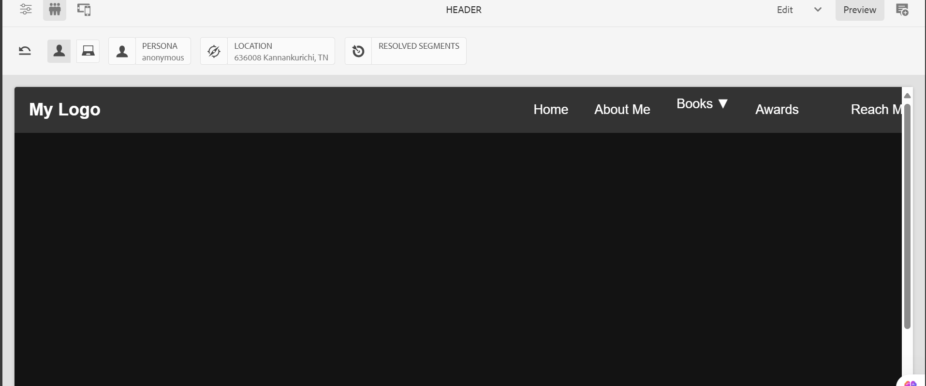

Footer

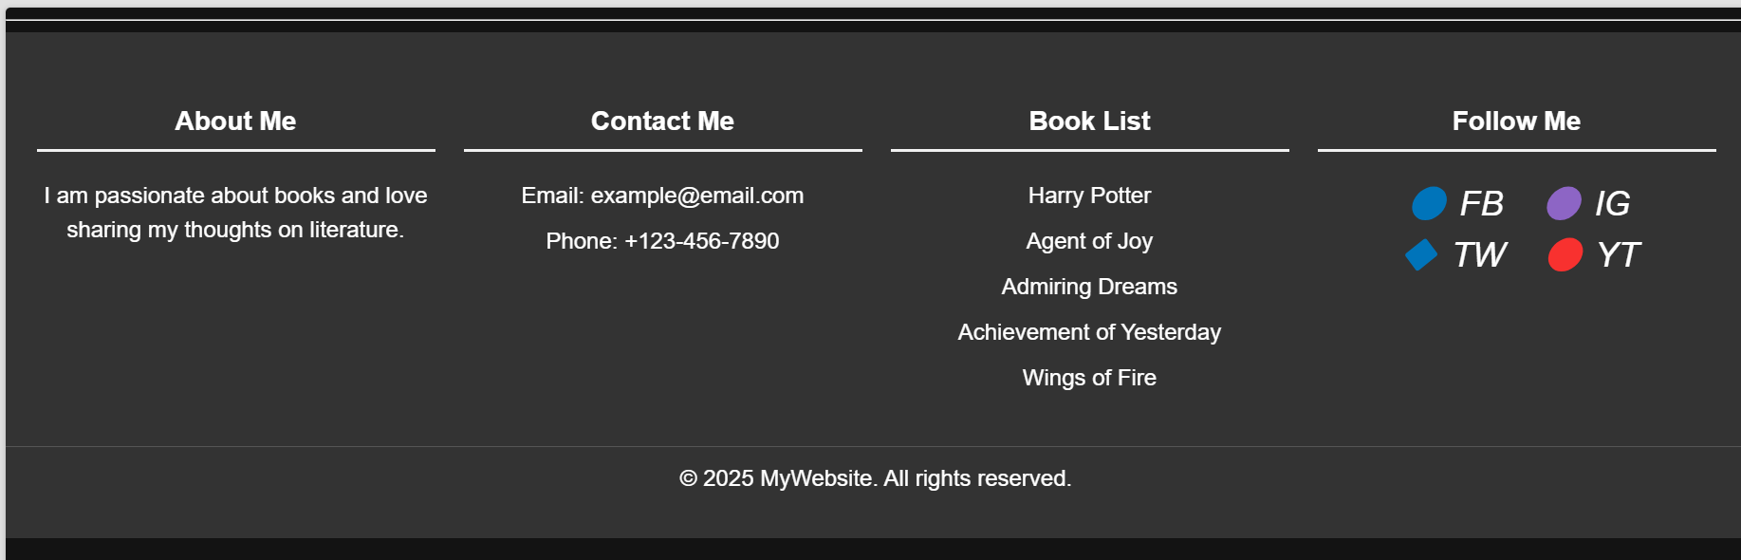

2)Create Template for book that contains title ,text and Image

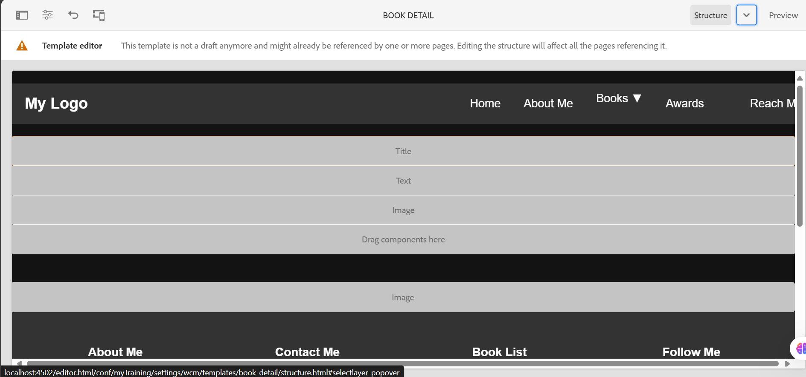

3)Create Home Page, About Page, Book Page and Reach me in the hierarchy like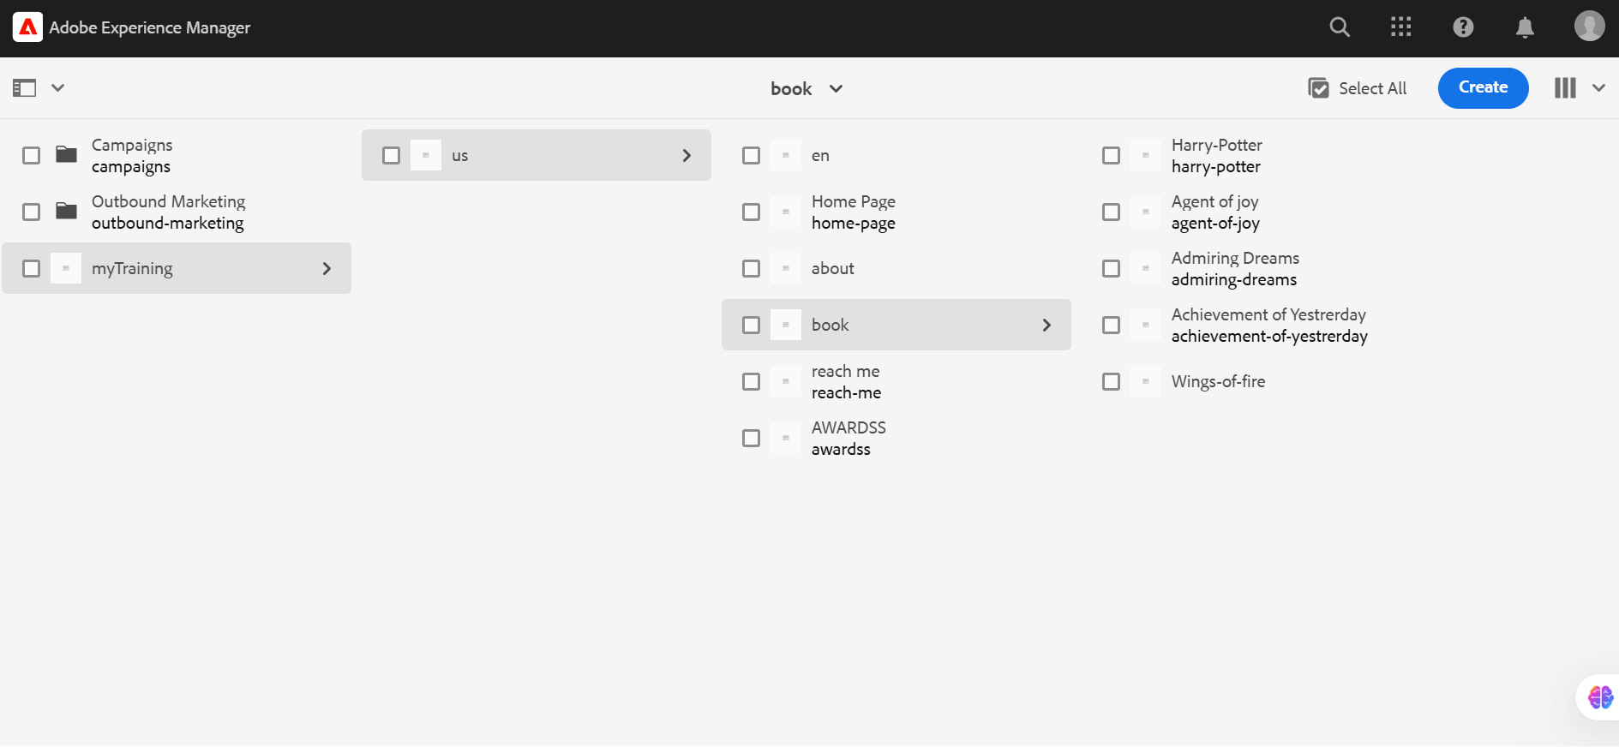

Home Page:

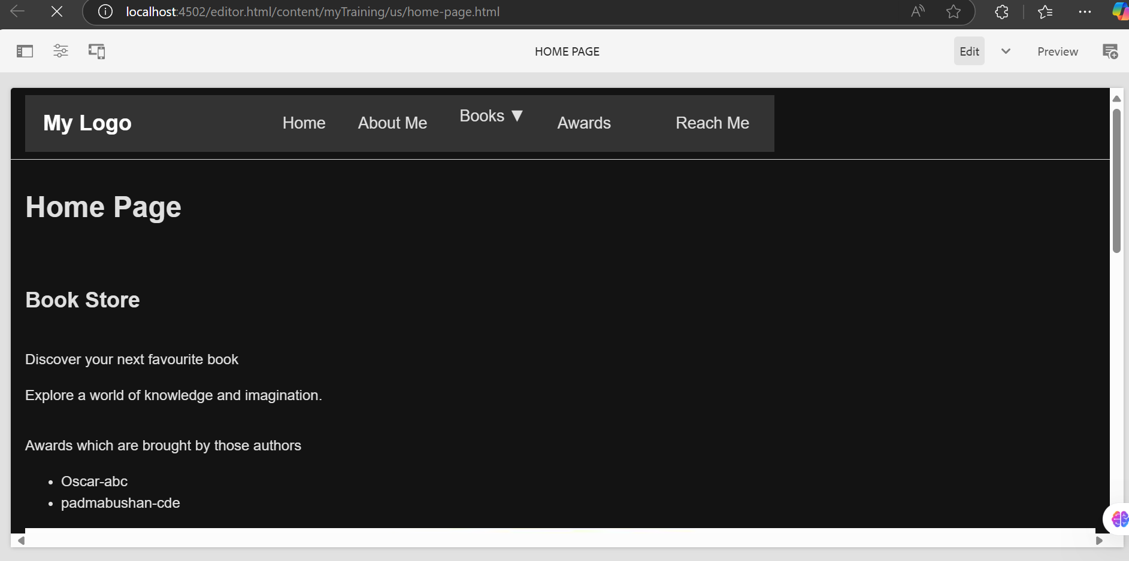

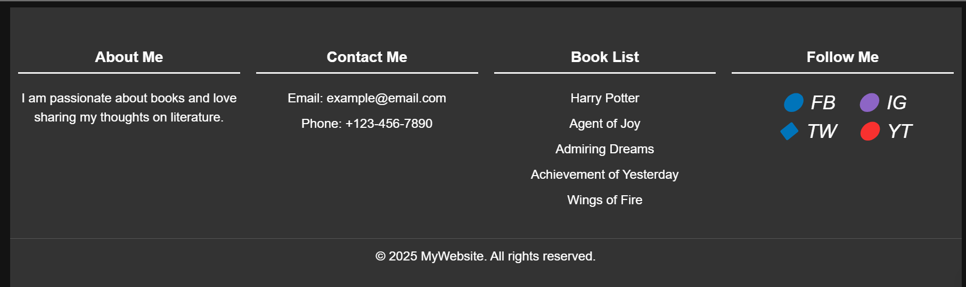

About Page:

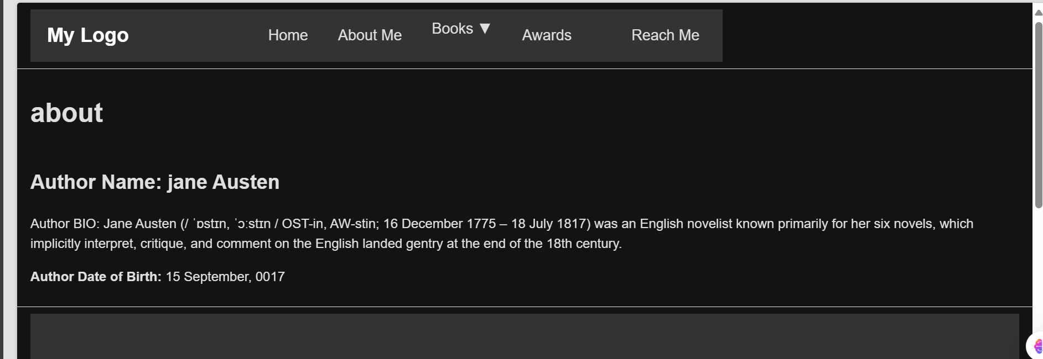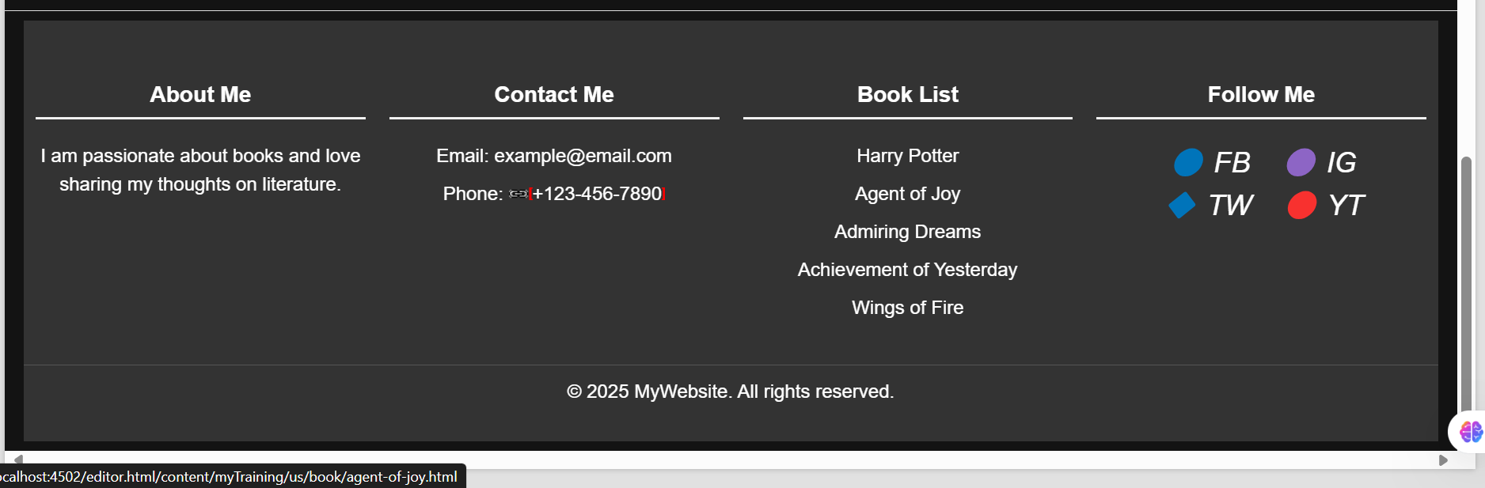

Book Page:

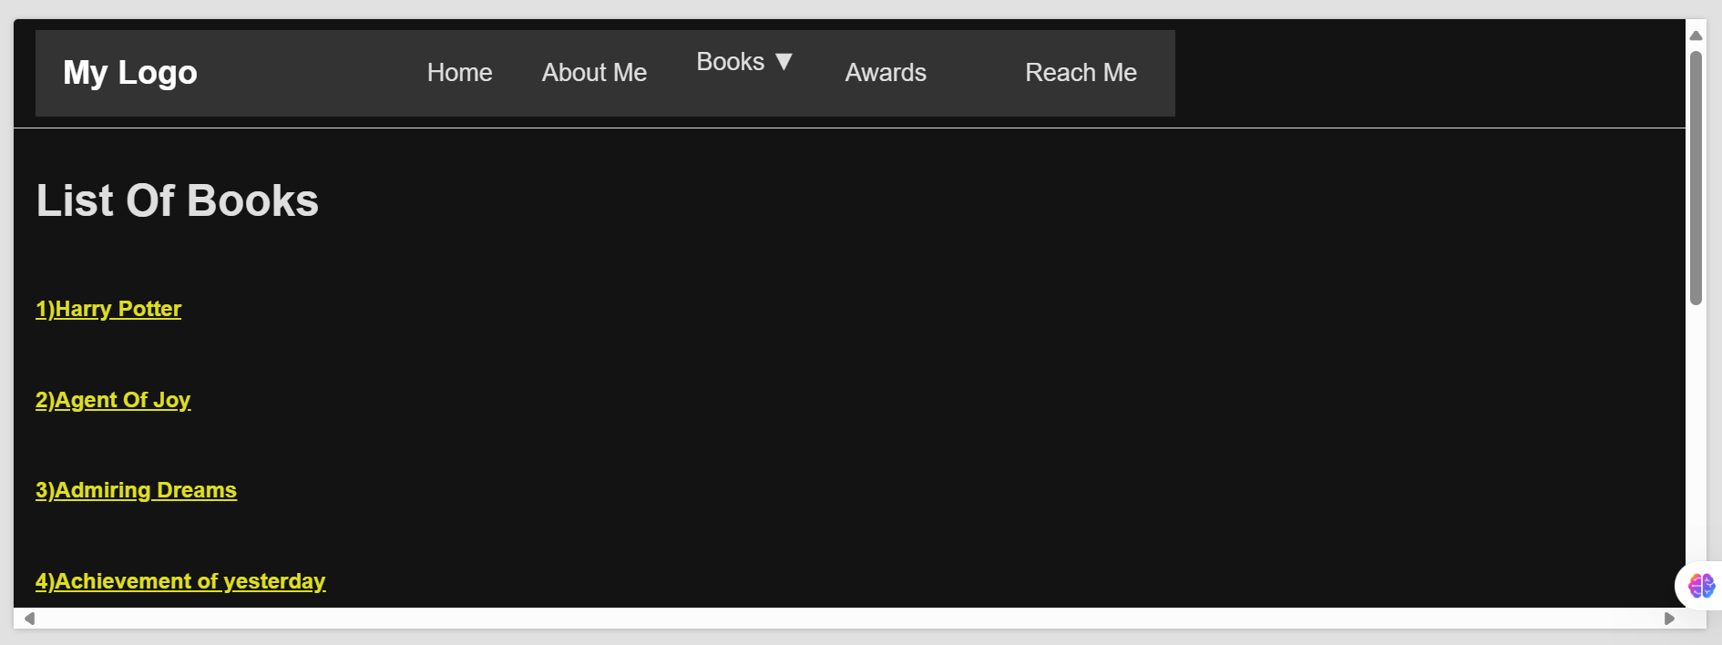

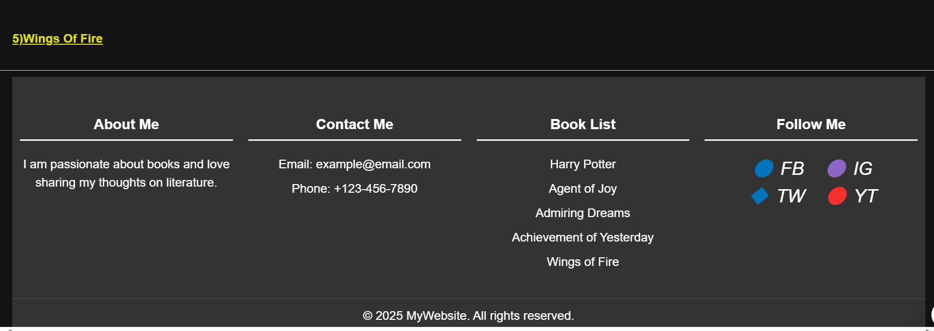

Harry-Potter Book:

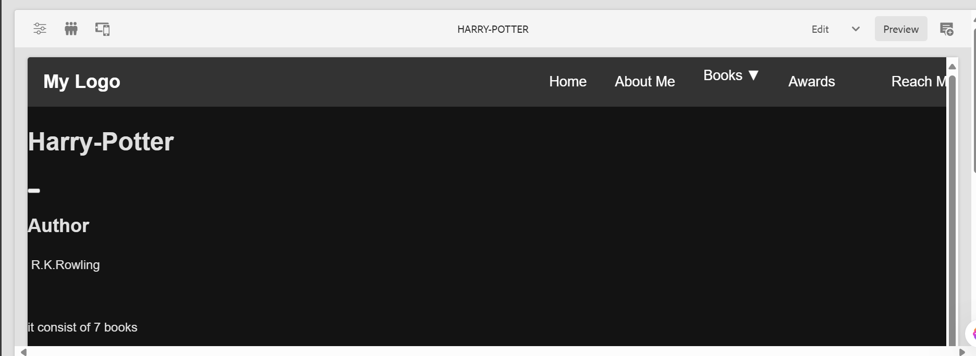

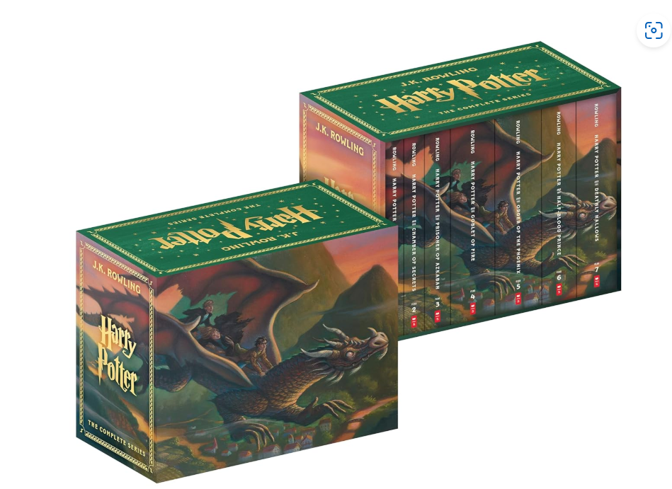

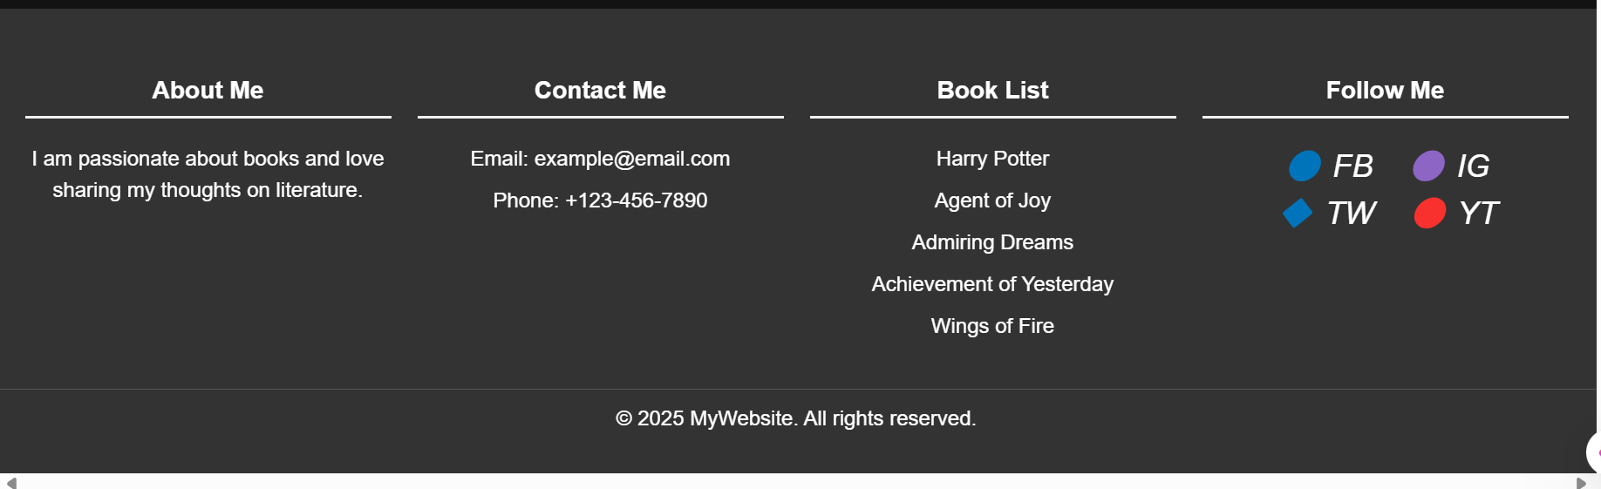

Agent Of Joy:

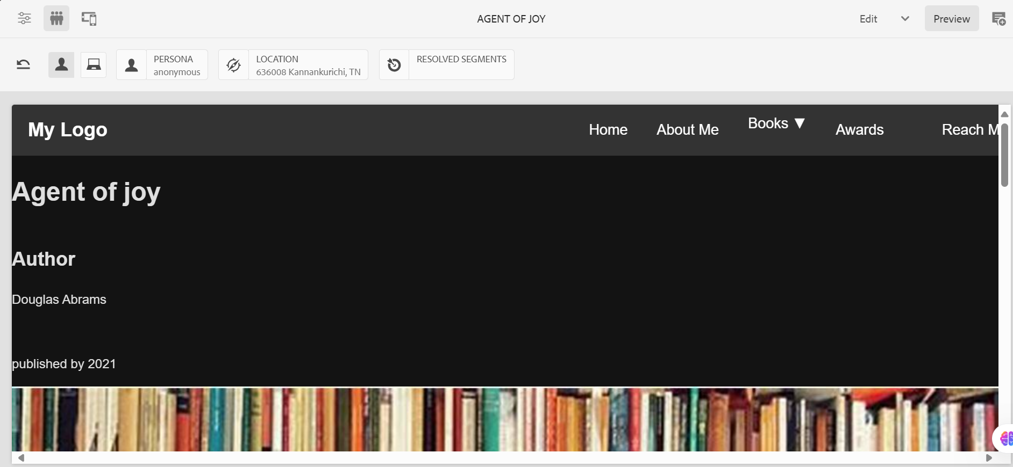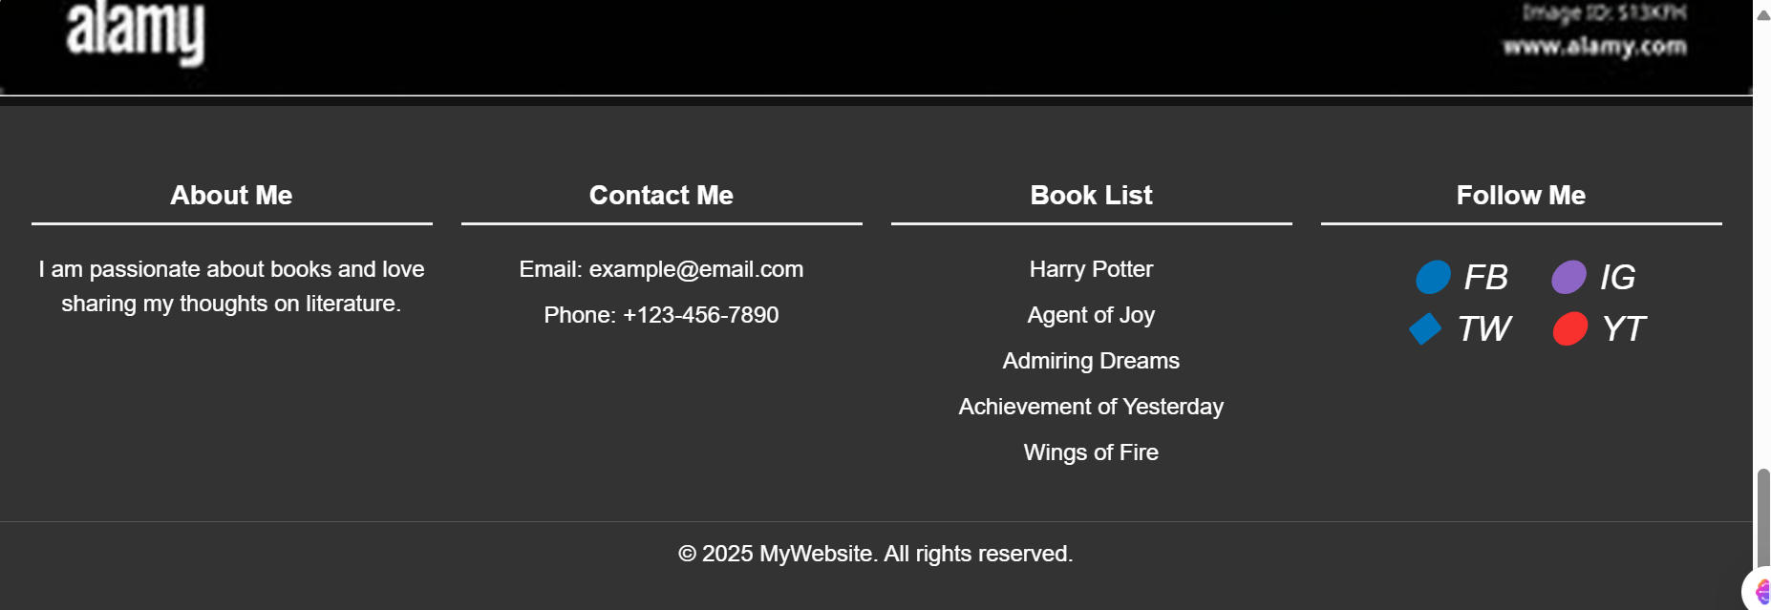

Admiring Dreams:

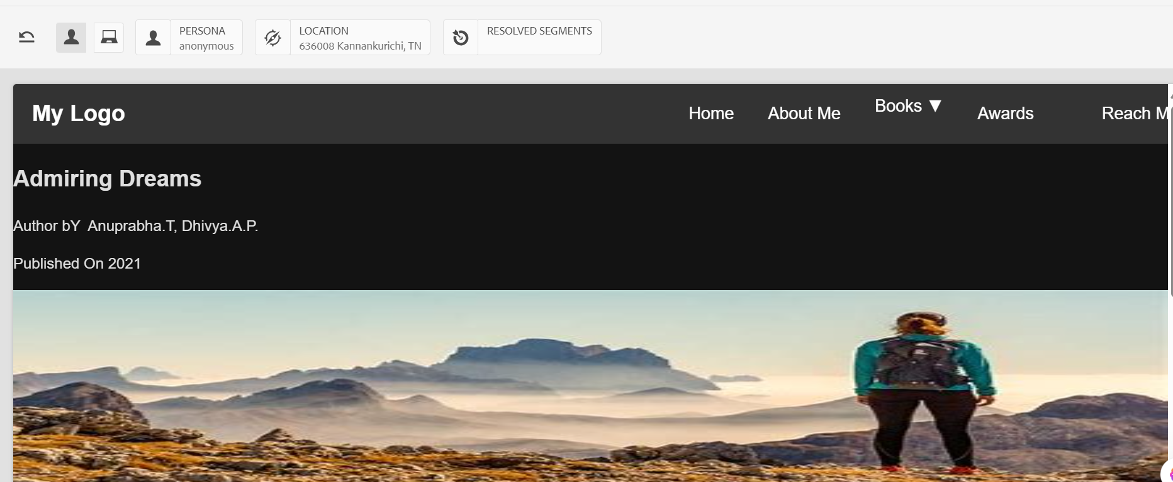

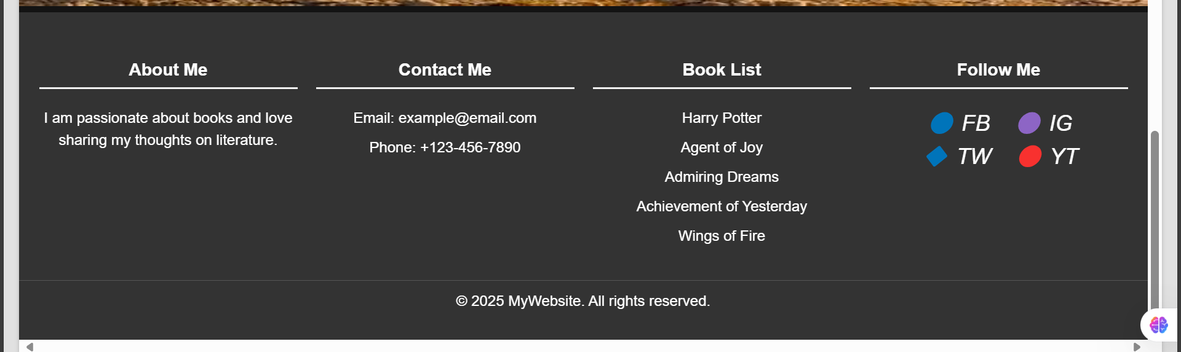

Wings of fire

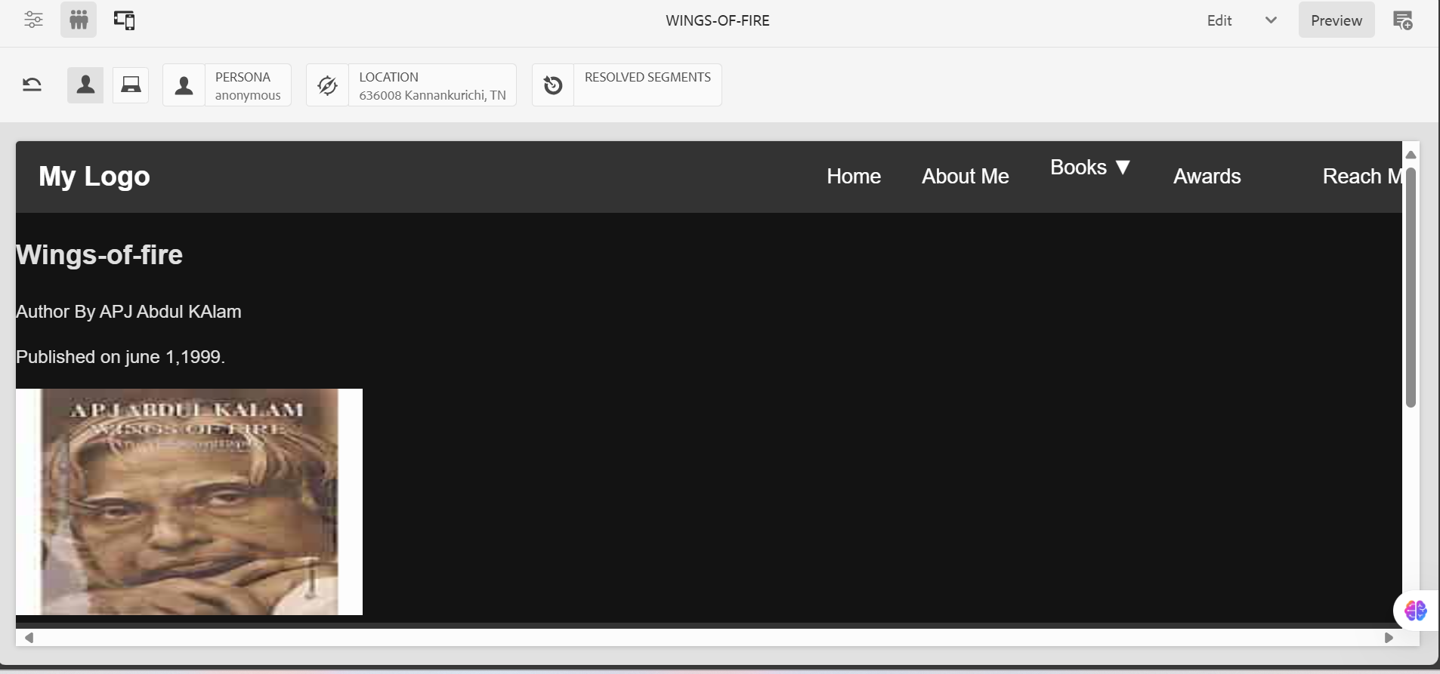

Reach ME:

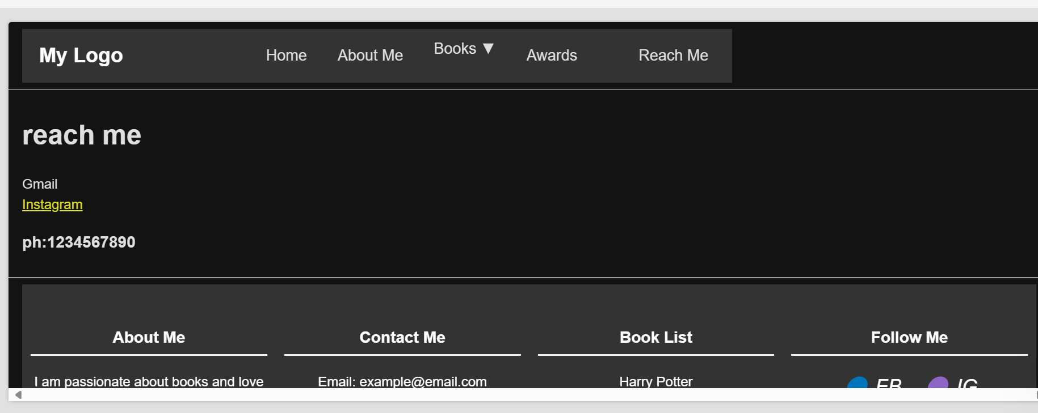

Awards Page:

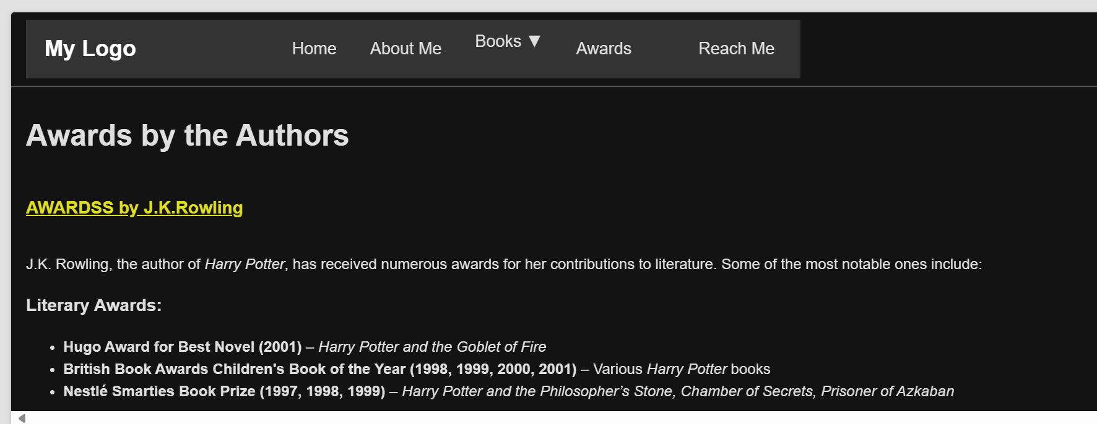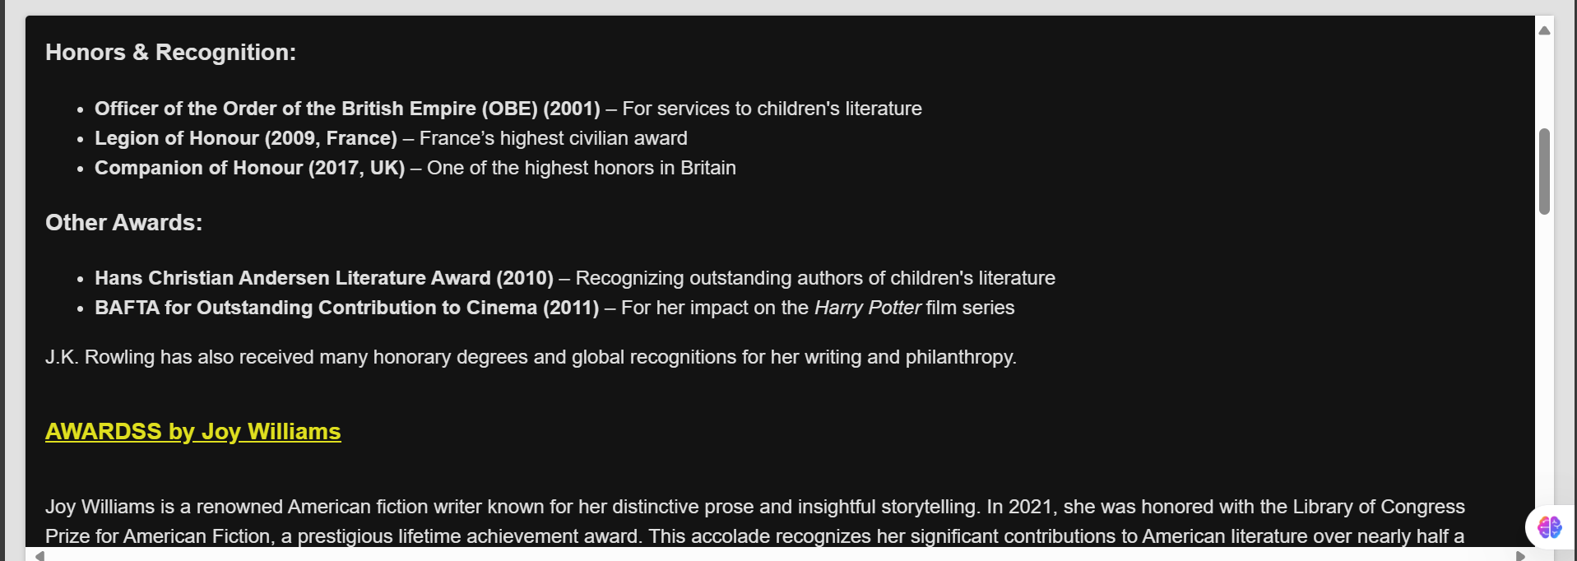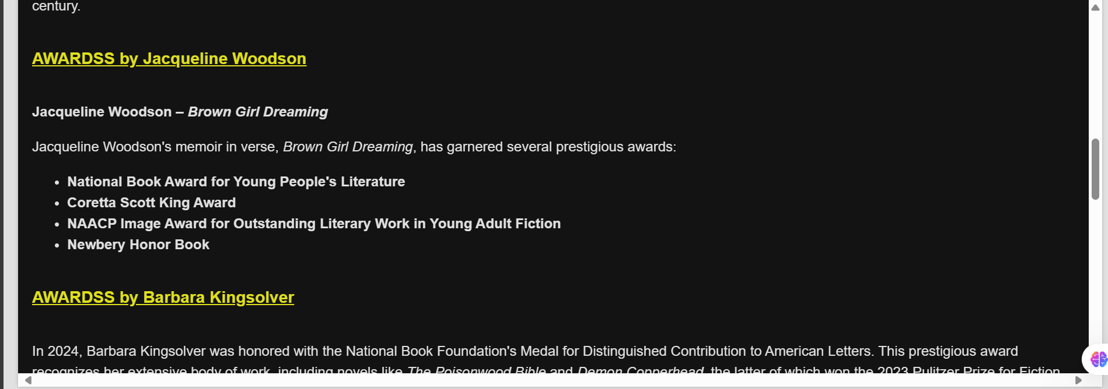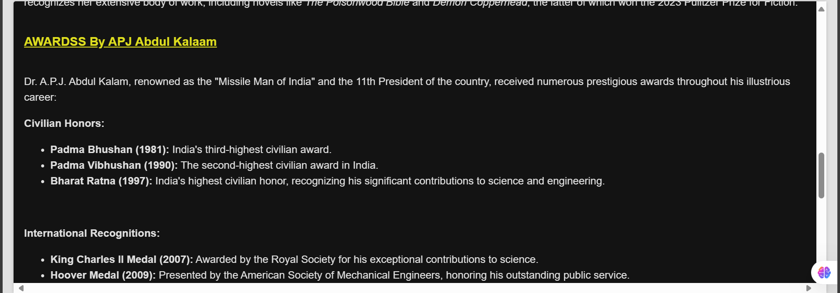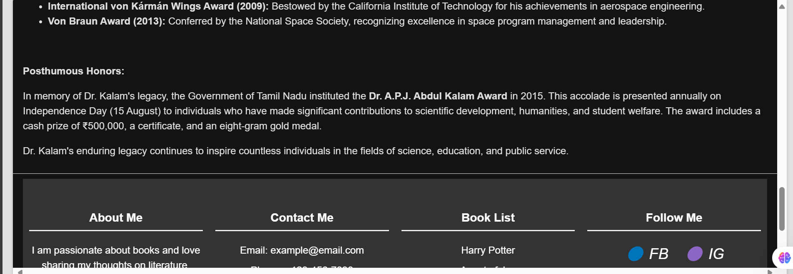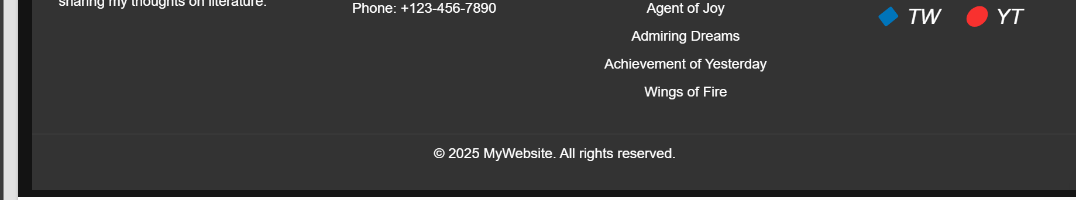

Experience Fragment Consist Of

1)Header

2)Footer

For Header I created a Header component that contains home page,about, book , reach me and awards.

<body>

<div class="header">

<div class="logo">My Logo</div>

<div class="nav">

<a href="/content/myTraining/us/home-page.html">Home</a>

<a href="/content/myTraining/us/about.html">About Me</a>

<div class="dropdown">

<a href="/content/myTraining/us/book.html" class="dropbtn">Books ▼</a>

<div class="dropdown-content">

<a href="http://localhost:4502/editor.html/content/myTraining/us/book/harry-potter.html">Harry Potter</a>

<a href="http://localhost:4502/editor.html/content/myTraining/us/book/agent-of-joy.html">Agent of Joy</a>

<a href="http://localhost:4502/editor.html/content/myTraining/us/book/admiring-dreams.html">Admiring Dreams</a>

<a href="http://localhost:4502/editor.html/content/myTraining/us/book/achievement-of-yestrerday.html">Achievement of Yesterday</a>

<a href="http://localhost:4502/editor.html/content/myTraining/us/book/Wings-of-fire.html">Wings of Fire</a>

</div>

</div>

<a href="http://localhost:4502/editor.html/content/myTraining/us/awardss.html">Awards<a>

<a href="/content/myTraining/us/reach-me.html">Reach Me</a>

</div>

</div>

<style>

body {

margin: 0;

font-family: Arial, sans-serif;

}

.header {

display: flex;

justify-content: space-between;

align-items: center;

background-color: #333;

padding: 10px 20px;

width:100%

}

.logo {

color: white;

font-size: 24px;

font-weight: bold;

}

.nav {

display: flex;

gap: 20px;

}

.nav a {

color: white;

text-decoration: none;

font-size: 18px;

padding: 8px;

}

.nav a:hover {

text-decoration: underline;

}

/* Dropdown styling */

.dropdown {

position: relative;

display: inline-block;

}

.dropbtn {

color: white;

text-decoration: none;

font-size: 18px;

padding: 8px;

}

.dropdown-content {

display: none;

position: absolute;

background-color: black;

min-width: 160px;

box-shadow: 0px 4px 8px rgba(0, 0, 0, 0.2);

z-index: 1;

}

.dropdown-content a {

color: black;

padding: 10px 12px;

display: block;

text-decoration: none;

}

.dropdown-content a:hover {

background-color: #ddd;

}

.dropdown:hover .dropdown-content {

display: block;

}

</style>

</body>

For Footer I also use footer component

<!DOCTYPE html>

<html lang="en">

<head>

<meta charset="UTF-8">

<meta name="viewport" content="width=device-width, initial-scale=1.0">

<title>Footer Design</title>

<style>

body {

margin: 0;

font-family: Arial, sans-serif;

}

.footer {

background-color: #333;

color: white;

padding: 20px 0;

text-align: center;

}

.footer-container {

display: flex;

justify-content: space-around;

flex-wrap: wrap;

max-width: 1200px;

margin: auto;

}

.footer-section {

flex: 1;

min-width: 200px;

margin: 10px;

}

.footer-section h3 {

border-bottom: 2px solid #f1f1f1;

padding-bottom: 5px;

}

.footer-section ul {

list-style: none;

padding: 0;

}

.footer-section ul li {

margin: 8px 0;

}

.footer-section a {

color: white;

text-decoration: none;

}

.social-icons {

margin-top: 10px;

}

.social-icons a {

margin: 0 10px;

display: inline-block;

color: white;

font-size: 24px;

}

.footer-bottom {

text-align: center;

margin-top: 10px;

padding: 10px;

border-top: 1px solid #555;

}

</style>

</head>

<body>

<footer class="footer">

<div class="footer-container">

<!-- About Me Section -->

<div class="footer-section">

<h3>About Me</h3>

<p>I am passionate about books and love sharing my thoughts on literature.</p>

</div>

<!-- Contact Me Section -->

<div class="footer-section">

<h3>Contact Me</h3>

<ul>

<li>Email: <a href="mailto:example@email.com">example@email.com</a></li>

<li>Phone: <a href="tel:+1234567890">+123-456-7890</a></li>

</ul>

</div>

<!-- Book List Section -->

<div class="footer-section">

<h3>Book List</h3>

<ul>

<li><a href="http://localhost:4502/editor.html/content/myTraining/us/book/harry-potter.html">Harry Potter</a></li>

<li><a href="http://localhost:4502/editor.html/content/myTraining/us/book/agent-of-joy.html">Agent of Joy</a></li>

<li><a href="http://localhost:4502/editor.html/content/myTraining/us/book/admiring-dreams.html">Admiring Dreams</a></li>

<li><a href="http://localhost:4502/editor.html/content/myTraining/us/book/achievement-of-yestrerday.html">Achievement of Yesterday</a></li>

<li><a href="http://localhost:4502/editor.html/content/myTraining/us/book/Wings-of-fire.html">Wings of Fire</a></li>

</ul>

</div>

<!-- Social Media Section -->

<div class="footer-section">

<h3>Follow Me</h3>

<div class="social-icons">

<a href="#"><i>🔵 FB</i></a>

<a href="#"><i>🟣 IG</i></a>

<a href="#"><i>🔷 TW</i></a>

<a href="#"><i>🔴 YT</i></a>

</div>

</div>

</div>

<div class="footer-bottom">

&copy; 2025 MyWebsite. All rights reserved.

</div>

</footer>

</body>

</html>