**Saravanan.K**

**InnovateX – Conference - Website**

***HomePage***

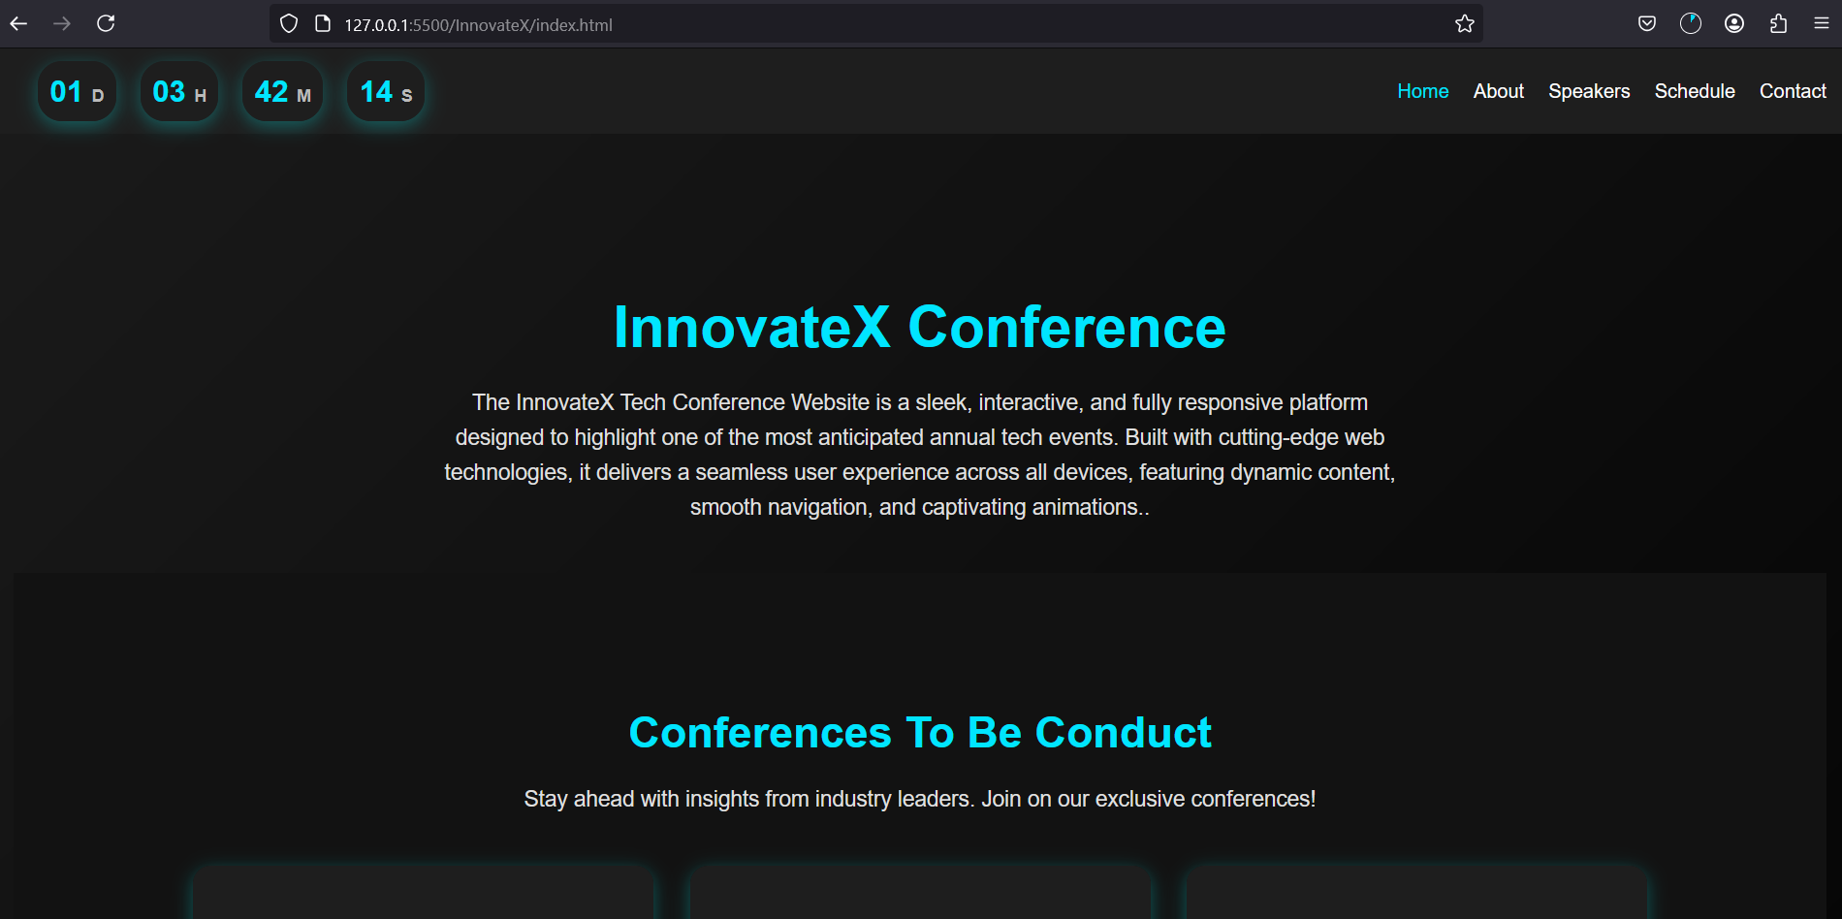

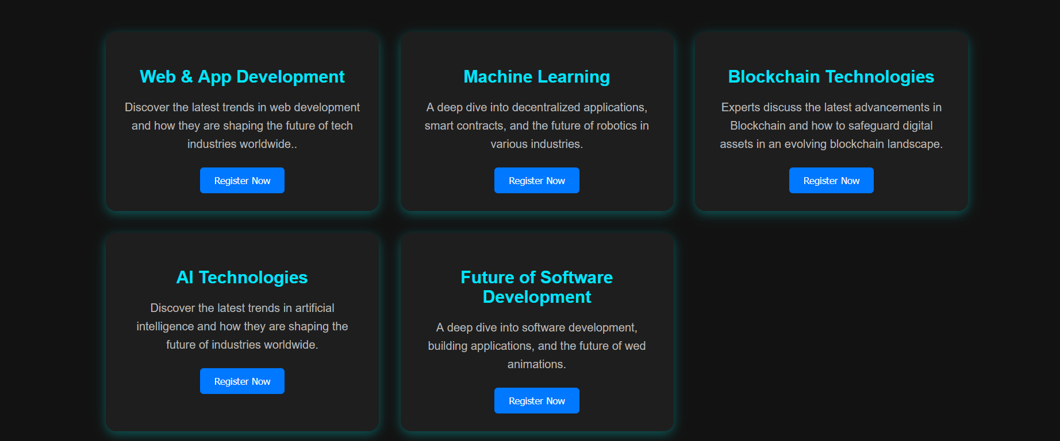

***About Page***

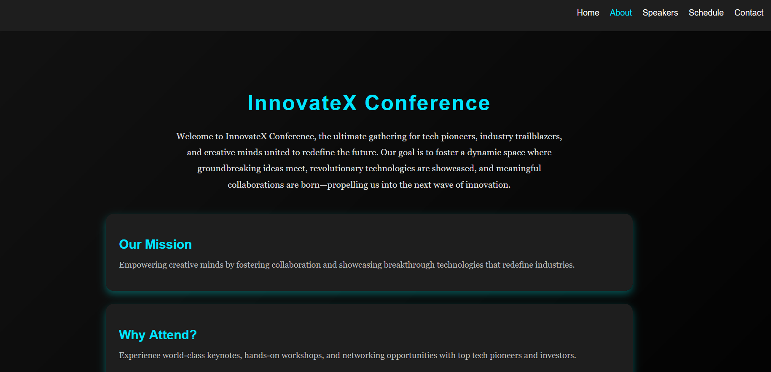

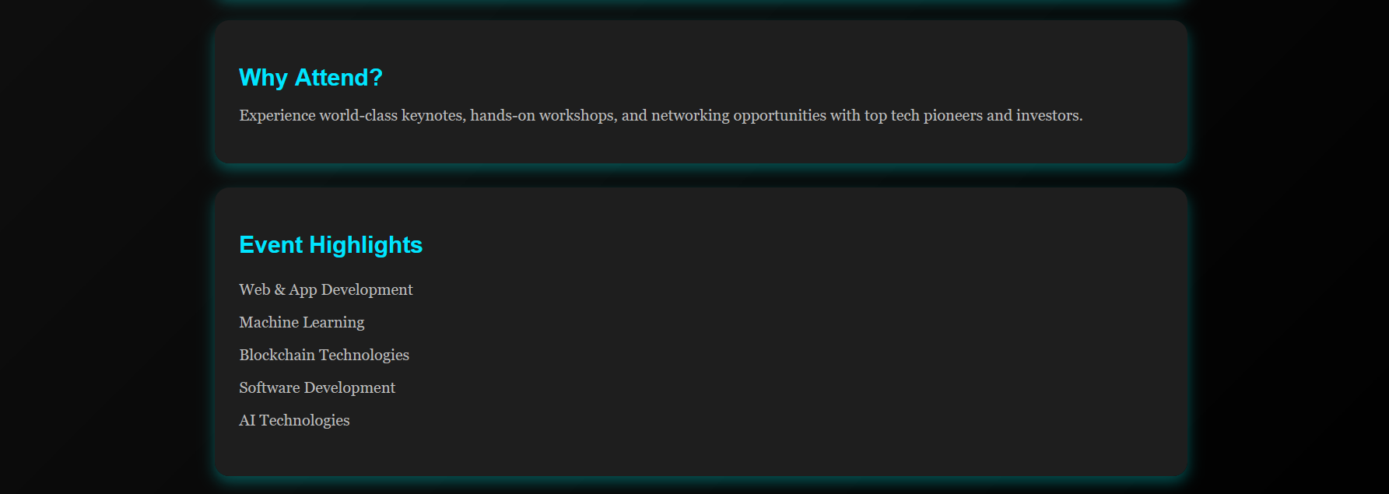

***Speakers Page***

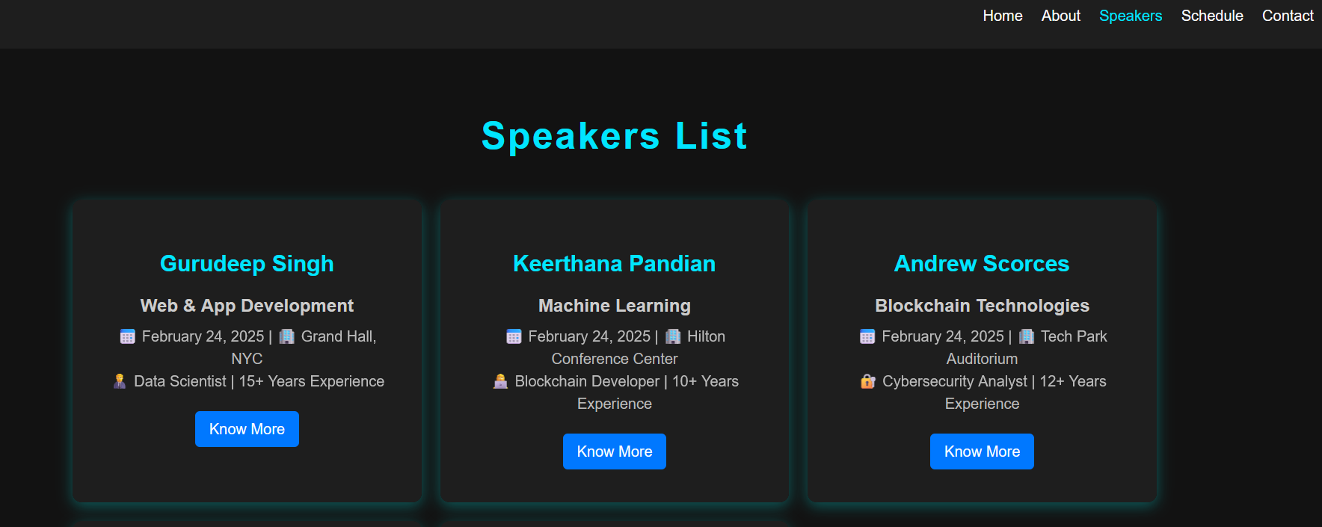



***Schedule Page***

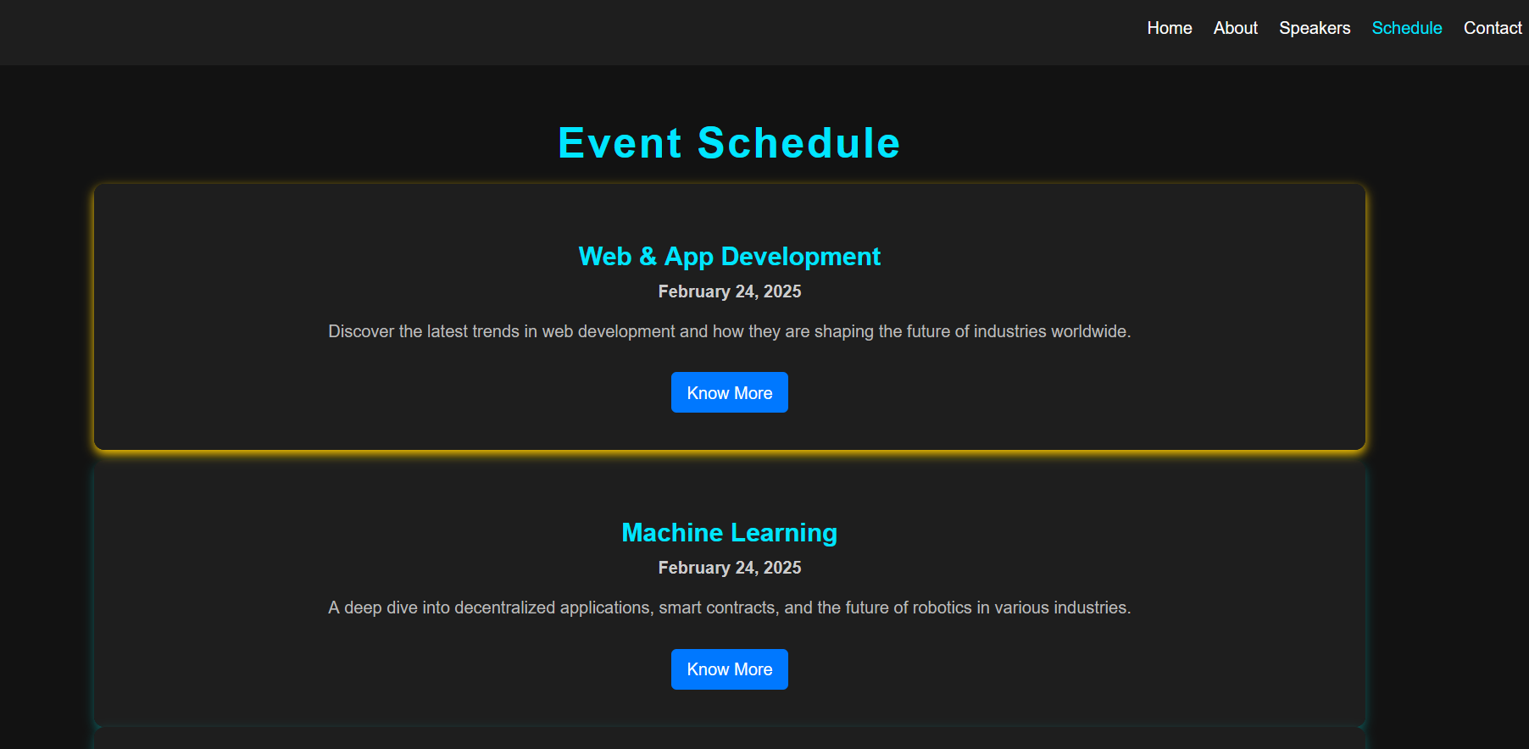

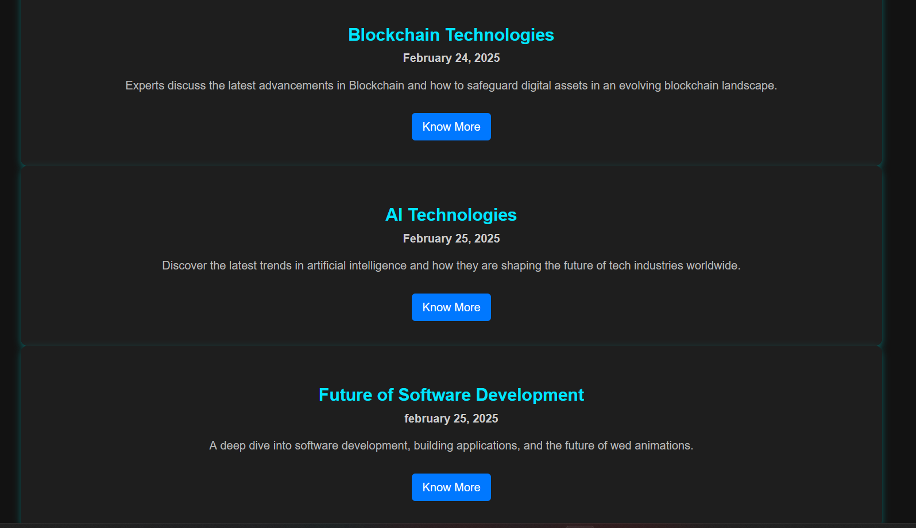

***Contact Page***

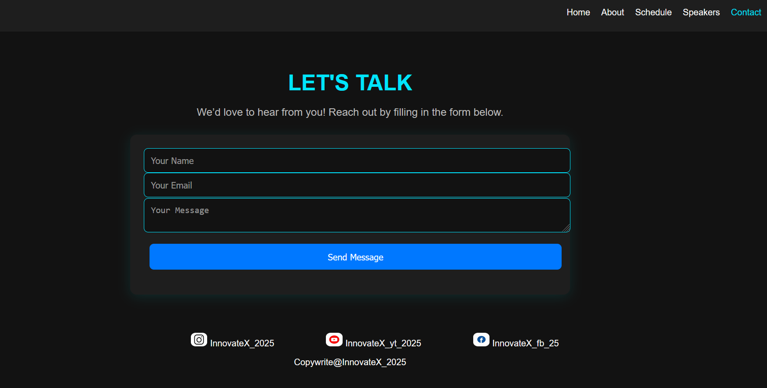

This is the website which is developed for a conference called “**InnovateX**”. In this website I have developed 5 pages.

Home page displays the countdown and the conference are going to conduct.

About page displays the content of the Conference.

Speakers page displays the speakers who conduct the conference.

Schedule page displays the course details and date of the conference.

Finally a contact page which has a message box for getting message from the user.