**Test Management System**

**A MINI PROJECT REPORT**

**Submitted by**

**Group/Team No: G1*4/T9***

**Sahil Bansal (2210992208)**

**Sahil Bhatti (2210992209)**

**Sahil (2210992210)**

**Sahil (2210992211)**

**in partial fulfillment for the award of the degree of**

**BACHELEOR OF ENGINEERING**

***in***

**COMPUTER SCIENCE & ENGINEERING**



**CHITKARA UNIVERSITY**

**CHANDIGARH-PATIALA NATIONAL HIGHWAY**

**RAJPURA (PATIALA) PUNJAB-140401 (INDIA)**

May 2023

**Table of Content**

|  |  |  |
| --- | --- | --- |
| **S. No.** | **Section** | **Page No.** |
| 1 | Introduction | 3 |
| 2 | Problem Statement | 4 |
| 3 | Technical Details | 5 |
| 4 | Key Features | 6 |
| 5 | Benefits of test management system | 7 |
| 6 | Challenges of test management System | 8 |
| 7 | Project Highlight | 9-10 |
| 8 | How to use? | 11 |
| 9 | Conclusion | 12 |

**INTRODUCTION**

Test management system is a software tool that helps in managing and organizing the testing process of a software project. It provides a centralized platform for test planning, execution, and reporting.

The main aim of a test management system is to improve the efficiency and effectiveness of the testing process by providing features like test case management, test execution tracking, and defect management.

**Problem Statement**

The Online Test Management System helps in conducting and maintaining the exams online in a proficient manner. It also provides:

1. Better Time Management

2. Online Access

3. No Unauthenticated Access

4. Facilities

5. Accuracy

6. Security

7. Efficiency1629

**Technical Detail**

Using HTML and CSS, you would need to use a number of technologies and approaches to create a Test Management System, such as:

**HTML**: Every website, including Google, is built on top of Hypertext Markup Language. Using HTML tags, you would need to construct the page's structure.

**CSS**: Flowing Templates are utilized to style the HTML content. Your Test management system would get its colors, fonts, and layout from CSS.

**Design that responds**: Test management system is responsive, which means that it works with a variety of screen sizes. You would have to involve media questions in CSS to make a responsive plan that changes with various gadgets.

**Flexbox**: Flexbox is a CSS layout module that makes creating responsive and flexible layouts simpler. It would be used to align page elements like the search bar and buttons.

**Fonts from Google:** Google Textual styles is a library of free web text styles that you can use to style your text. To use the same fonts as Google, you can include Google Fonts in your HTML and CSS..

**Key Features**

A test management system comes with a wide range of features that help in streamlining the testing process. Some of the key features include test case management, test execution tracking, and defect management.

Other important features of a test management system include requirement management, traceability matrix, and integration with other tools like test automation and project management tools.

**Benefits of Test Management System**

Since you are planning to switch to the management software, there are certain features that you might consider while looking for the software which may help you with improving the quality assurance process. It will not only fasten up the entire process but will also make it much more reliable.

1. Should be sound enough to manage the requirements

2. Test cases can be edited, created, and executed.

3. Smart enough to track bugs

4. Tracking coverage while mapping the test requirements

5. Full support regarding test case template

6. Smart enough to link bugs during test execution

7. Customized reporting mechanism

8. Provides full coverage testing

**Challenges of Test Management System**

In the initial days of software development, test case management seems irrelevant. Still, gradually as the development process speeds up, one realizes how hard it is becoming to manage the quality of the system manually. As these tools and automation processes have their own perks, there are a few aspects that might result negatively.

1. Challenging to test the entire program: Such tools primarily purpose to do testing regarding specific scenarios and not to test the whole system. Test case management won’t scale well if you are not sure about the cases you need to work around and do not have enough of the related information.

2. Underestimating time, cost, and effort: When you are introducing a new tool in your system, you need to have relevant training regarding it. If you are not sure about the ways through which you are going to achieve the beneficial outcomes, then you are wasting your time and resources.

3. Miscalculating efforts to achieve essential goals: Deep understanding is required to start working with such tools. Initially, one needs to work around in a much more careful way. Anything new involves time, and while your team works around it in the initial phase, you need to set attainable and realistic goals to make the process smooth and to overcome the challenges which might occur. As it would be your first try with the tool so there would be chances that you are not able to make the most out of the entire process.

4. Efforts to Maintain Results: Most people consider that the tool will do the entire job itself, and you are not required to maintain the records or results generated. Underestimating the efforts, you need to put in during the test case management may result in an irrelevant or failed scenario.

5. Depending way too much on the tool: Purpose of test management tools is to make the process consistent, easy, and efficient, but it does not mean that you entirely depend upon it for testing purposes. There are certain features for which the tool is designed, and it is supposed to work around the set targets. These automated tools are helpful, but it does require a particular skill set and level of intelligence from its user to get the job done. You can expect a test case management tool to do test designing.

**Project Highlight**



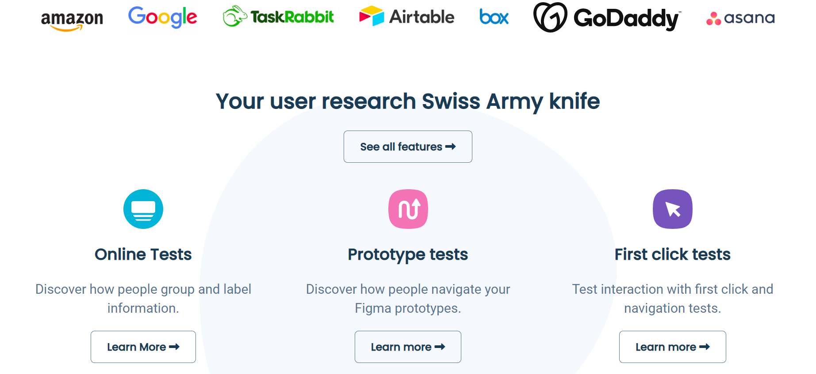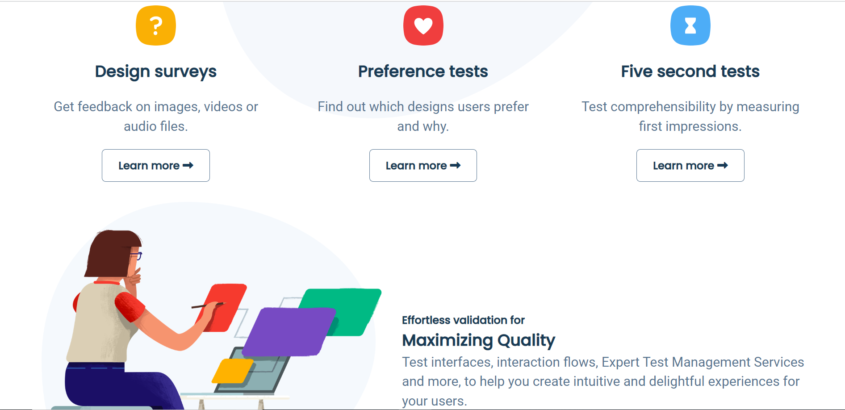

**How to use?**

To ensure the success of a test management system, it is important to follow best practices such as defining clear testing objectives, creating a comprehensive test plan, and regularly reviewing and updating the testing process.

It is also important to involve all stakeholders in the testing process and to use automation tools wherever possible to increase efficiency and accuracy.

**Conclusion**

In conclusion, a test management system is an essential tool for managing and organizing the testing process of a software project. It helps in improving the efficiency and effectiveness of the testing process by providing features like test case management, test execution tracking, and defect management.

By following the best practices and overcoming the challenges, organizations can successfully implement and use a test management system to improve the quality of their software and reduce the testing time and cost.