**3x3x3: PLL Recognition Guide**

**EPLLs**

**Category 0: Two 3x1 Blocks**

solved: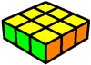

I hope you can recognize this.

**Category 1: One 3x1 Block**

**Ua: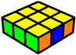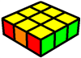Ub:** 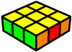 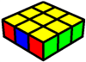

When the block is on the left:

-It's Ub when an opposite edge colour is on the right

-It's Ua when an adjacent edge colour is on the right

When the block is on the right:

-It's Ua when an opposite edge colour is on the left

-It's Ub when an adjacent edge colour is on the left

**Category 2: No 3x1 Blocks & One Opposite Colour Edge**

**Ua:** 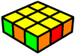  **Ub: 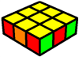 H:**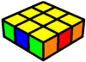

-It's Ua when an opposite edge colour is on the right

-It's Ub when an opposite edge colour is on the left

-It's H when an opposite edge colour is on each side

**Category 3: No 3x1 Blocks & No Opposite Colour Edge**

**Ua: 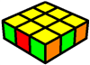Ub: 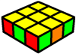Z:** 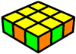 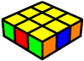

When a single colour appears three times:

-It's Ua when the edge of that colour is on the right

-It's Ub when the edge of that colour is on the left

Otherwise:

-It's Z

**Diagonal CP**

**Category 1: Two Blocks**

**V: 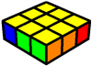 Y: 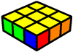Na: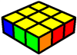Nb:**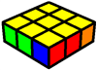

-It's V when the blocks are both on the inside

-It's Y when the blocks are both on the outside

-It's Na when the inner corner is part of a left block

-It's Nb when the inner corner is part of a right block

**Category 2: One Block**

**V: 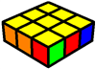, 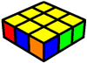Y:** 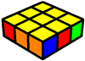 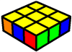

-It's V when there’s a block on the outside

-It's Y when there’s a block on the inside

**Category 3: No Blocks**

**V: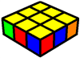Y: 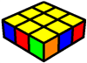E:** 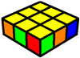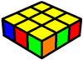

-It's V when there’s a checker pattern on the inside

-It's Y when there’s a checker pattern on the outside

-It's E when there’s no checker pattern at all

**Adjacent CP – Two Blocks**

**Category 1: One 3x1 Block & One 2x1 Block**

**Ja: 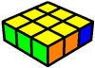 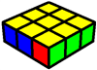Jb:** 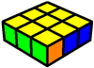 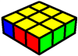

When the 3x1 block is on the left:

-It's Ja when the 2x1 block is on the inside

-It's Jb when the 2x1 block is on the outside

When the 3x1 block is on the right:

-It's Jb when the 2x1 block is on the inside

-It's Ja when the 2x1 block is on the outside

**Category 2: One Outer 2x1 Block and One Inner 2x1 Block**

**Ja: 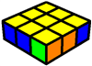 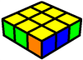Jb:**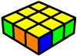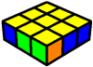

-It's Ja when the 2x1 block on the outside is on the left

-It's Jb when the 2x1 block on the outside is on the right

**Category 3: Two Inner 2x1 Blocks**

**Aa: 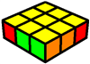Ab:** 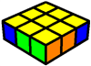

-It's Aa when the outer corner on the right is opposite

-It's Ab when the outer corner on the left is opposite

**Adjacent CP – Headlights, One Block**

**Category 1: Inner Block**

**T: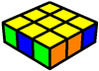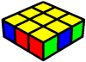Ra: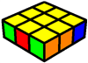Rb:** 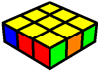

When the edge in between the headlights is adjacent:

-It's Ra when the block is on the right

-It's Rb when the block is on the left

Otherwise:

-It's T

**Category 2: Outer Block**

**Aa: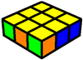Ab: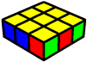Ga: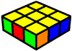Gc:** 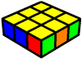

When only three unique colours are visible:

-It's Aa when the block is on the right

-It's Ab when the block is on the left

Otherwise:

-It's Ga when the block is on the right

-It's Gb when the block is on the left

**Adjacent CP – No Headlights, One Block**

**Category 1: One 3x1 Block**

**F:**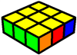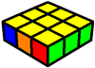

-It's F

**Category 2: Inner Block**

**Ga: 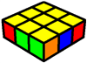Gc: 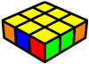Gb: 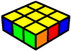Gd:**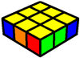

When the corner beside the block is adjacent:

-It's Ga when the block is on the left

-It's Gc when the block is on the right

Otherwise:

-It's Gb when the block is on the left

-It's Gd when the block is on the right

**Category 3: Outer Block & Opposite Corner**

**Gb: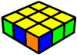Gd: 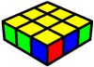Aa: 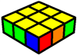Ab:**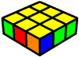

When only three unique colours are visible:

-It's Gb when the block is on the right

-It's Gd when the block is on the left

Otherwise:

-It's Aa when the block is on the left

-It's Ab when the block is on the right

**Category 4: Outer Block & Adjacent Corner**

**Ra: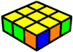Rb: 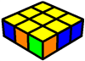T:**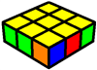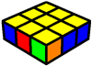

When only three unique colours are visible:

-It's Ra when the block is on the right

-It's Rb when the block is on the left

Otherwise:

-It's T

**Adjacent CP – Headlights, No Blocks**

**Category 1: Opposite Edge In Between Headlights**

**Gb: 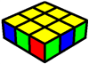 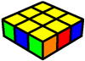Gd**: 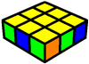 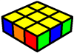

When only three unique colours are visible:

-It's Gb when the block is on the left

-It's Gd when the block is on the right

Otherwise:

-It's Gb when the block is on the right

-It's Gd when the block is on the left

**Category 2: Adjacent Edge In Between Headlights**

**Ra: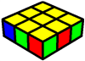Rb:**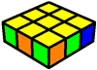

**Ga: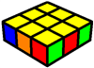Gc: 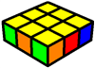 Aa: 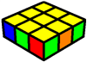Ab:** 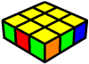

When only three unique colours are visible:

-It's Ra when the headlights are on the left

-It's Rb when the headlights are on the right

Otherwise:

-It's Ga when the headlights are on the right and the outer left corner is adjacent

-It's Gc when the headlights are on the left and the outer right corner is adjacent

-It's Aa when the headlights are on the right and the outer left corner is opposite

-It's Ab when the headlights are on the left and the outer right corner is opposite

**Adjacent CP – No Headlights, No Blocks**

**F:**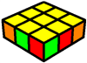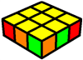

**Ga: 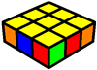Gc:** 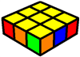 **Ra: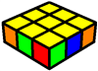Rb:** 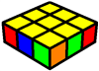

When only three unique colours are visible:

-It's F

Otherwise:

-It's Ga when an opposite outer corner is on the right

-It's Gc when an opposite outer corner is on the left

-It's Ra when an opposite inner corner is on the right

-It's Rb when an opposite inner corner is on the left