Instructions on How to Perform a Membrane-Molecule Interaction Simulation and Potential Mean Force (PMF) Calculation by Umbrella Sampling
The following steps covers the procedure of conducting membrane simulation and calculate the potential mean force (PMF):

Molecule Creation and .PDB/MOL2 files:

  - Install Pymol Software from this link https://pymol.org/2/.
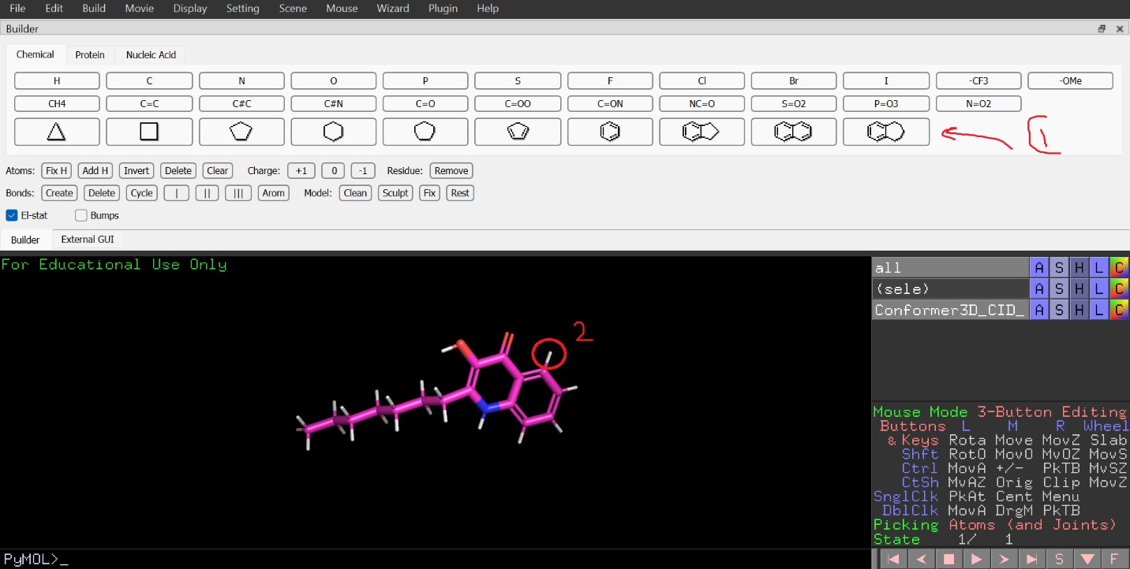
  - Start from importing PQS molecule from https://pubchem.ncbi.nlm.nih.gov/compound/2- Heptyl-3-hydroxy-4-quinolone. Then, edit the molecule by removing and adding bonds. This could be achieved by selecting the desired component and clicking on the hydrogen atom to add, as shown in Fig.1.

Figure 1: editing a molecule: 1) select a group 2) click on hydrogen atom to add the group.
  - Once editing is finished, type in pymol command bar the following command after selecting any atom to identify the Chain ID. Make sure that the selecting state on the bottom right is on chains.
alter (sele), chain = ‘A’
sort
  - From File, select Export Molecule. Make sure that the selection is on sele, then save the file as both .pdb and .MOL2 for later use. Give a different name for each file.

CHARMM-GUI
CHARMM-GUI is a web-based graphical user interface for preparing complicated biomolecular systems for molecular simulations (http://www.charmm-gui.org). CHARMM-GUI generates input files for some software such as GROMACS, AMBER, LAMMPS^{[1]}. The following steps will help obtain the most important input files (see next page):

  - Create an account on CHARMM-GUI. Once logged in, from Input Generator, point on the Membrane Builder and select Bilayer Builder.
  - From Protein/Membrane System, upload the .pdb that was generated in the first step. Make sure that PDB is selected in the PDB format. Then, select Next Step at the bottom right of the interface.
Tip: It is better to change the name from a default (UNL) to something distinguishable.
  - In Model/Chain Selection Option, check the Hetero box and click Next Step.
  - Check the Reading Hetero Chain Residue box, then upload the .MOL2 file in the MOL2 field. Please follow the above Tip before uploading the file to avoid errors. Click Next Step.
  - In Orientation Options, choose Use PDB Orientation. Also, in Positioning Option, check Translate Molecule along Z axis and type 30 Angstrom as an initial distance of the molecule from the membrane. However, this step is not important because the translation distance can be edited from .gro files that will be generated later. Click Next Step.
  - Now, under System Size Determination Options, Heterogeneous must be automatically selected. Next, make sure the box type is Rectangular, and the length Z based on water thickness is 22.5. For membrane components, choose Numbers of lipid components, emphasizing on the point that the XY Dimension Ratio is 1.
  - For our membrane, in the lower leaflet, we will choose POPE from PE list and POPG from PG list. The # of Lipid on Lowerleaflet for POPE and POPG is 64 and 29, respectively.
  - Choose LPS for the upper leaflet. Double click on LPSA and choose Pseudomonas aeruginosa as a specie. Then, select type 4 for Lipid A and none for the core. After that, select -1 for both phosphate charges and click on Next Step. Finally, type 37 in # of Lipid on Upperleaflet field.
  - Hit Show the system info button. You will see information of the generated membrane on the right-hand side of the window. If it displays the error as shown in Fig.2, then change the surface area of LPS. After that, hit that button again to generate and check the updated information. In this case we chose the surface area of 150.
  - Click Next Step.
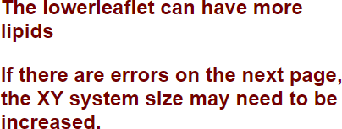
  - In Component Building Options field, check Include Ions box. Then select Monte- Carlo as an Ion Placing Method.
  - Choose NaCl in Basic Ion Types, and let the Concentration be 0.15. Then, hit Calculate Solvent Composition button.
  - Select Ca⁺² as an ion type for neutralizing Lipid A, and do not care

much about the Core since we
selected none in LPS Selection step. Hence, it has no effect in this stage.
Figure 2: The error from different leaflet area.

  - Selected Next Step for this step and Step 4.
  - In Step 5, make sure you select GROMACS under Input Generation Options, and Generate grid information for PME FFT automatically and NPT ensemble under Equilibration Options. Moreover, under the same field, set the Temperature 310.15
K. Click Next Step.
  - Finally, download the generated files by CHARMM-GUI and save them in order to be used in GROMACS.

GROMACS, Molecule Insertion and Equilibration.
In order to install GROMACS, we need to apply the following steps:
  - Install GROMACS source code and regression test from the following link. Once installed, better extract them in a directory and name it gromacs. https://manual.gromacs.org/2021.3/download.html
  - type the following command in the Terminal after installing C/C++ and CMake:
tar xfz gromacs-2021.3.tar.gz cd gromacs-2021.3
mkdir build cd build
cmake .. - DCMAKE_INSTALL_PREFIX=/path/to/directory - DREGRESSIONTEST_PATH=/home/to/directory/regressiontests-2021.3 - DGMX_GPU=CUDA -DGMX_FFT_LIBRARY=mkl -
DMKL_INCLUDE_DIR=/data/IntelCompiler/mkl/include - DMKL_LIBRARIES=/data/IntelCompiler/mkl/lib/intel64/libmkl_rt.so make
make check
sudo make install

Once installed, we can proceed to use GROMACS for different applications. In our case, we already have an equilibrated membrane, and we need to insert different molecules into that membrane. To do this, we will need to follow these steps:

- Extract water, SOD, CAL, CLA from the membrane using the following command:
gmx editconf -f Membrane.gro -n index.ndx -o water.gro
(other components fall into same procedure).
- Extract the molecule from previously generated CHARMM-GUI input files with the same command as above. In this case, use Step5_input.gro in -f flag, and the index.ndx in -n flag from the downloaded input files, NOT the membrane’s one. These files are found in gromacs folder of the downloaded zip file. Name It molecule.gro, for instance.
- After extraction, add water molecules to the membrane using the following command: gmx insert-molecules -f Membrane.gro -ci water.gro -nmol 2200 - try 100 -o Memb_water.gro -scale 1.0
(-try and -scale are usually changed to fix any error.)

- Similarly, add SOD and CLA using the following command, respectively:
gmx insert-molecules -f Memb_water.gro -ci SOD.gro -nmol 6 -try
10 -o Memb_water_SOD.gro -scale 1.0
gmx insert-molecules -f Memb_water_SOD.gro -ci CLA.gro -nmol 6 - try 10 -o Memb_water_SOD_CLA.gro -scale 1.0
- Change the initial orientation of the molecule such that the head is pointing down, perpendicular to the membrane from the command below.
gmx editconf -f molecule.gro -o MOL.gro -rotate 0 0 -90
- Insert the extracted molecule into the membrane following the same procedure as above:
gmx insert-molecules -f Memb_water_SOD_CLA.gro -ci MOL.gro -nmol
1 -try 10 -o Memb_set.gro -scale 1.0
- Make a new index using make_ndx command from GROMACS, as follows:
gmx make_ndx -f Memb_set.gro -o memb_set.ndx
do this:
2 | 3 | 4
name 19 MEMB
5 | 6 | 7 | 8
Name 20 SOLV q
- From the produced index, select specific groups and include them in a new index file: gmx select -s Memb_set.gro -n memb_set.ndx -on memb_set_new.ndx do this:
19 => hit enter => 20 => hit enter => 9 => hit enter => 0 => hit enter => Ctrl+D

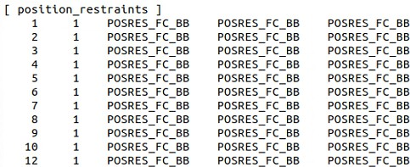
- Now, before jumping into equilibration process, we need to make sure that the molecule is restrained by checking the

Figure 3: position restrain of the molecule.
topology file
molecule_RingDN.itp, as shown in Fig.3. This variable is determined in each .mdb file .i.e., step6.0_minimization.mdp, step6.1_equilibration.mdp through step6.6_equilibration.mdp, and step7_production.mdp, as can be seen in Fig.4. Hence, precautions
are taken that the molecule does not move while equilibrating. Moreover, it is better to change the name from DPOSRES to DMOLPOSRES to reduce confusion, as illustrated in Fig.5.
Figure 4: the assigned value of the molecule POSRES in each step, which is 1000 in this example.
a) b) c)
Figure 5: an example of changing from POSRES to MOLPOSRES: a) as showin in topolgy file .itp, b) adding MOL to - POSRES, and c) the new define line as presented in each .mdp file to restrain the molecule.

- Use the parameters shown in the figure below to prepare NPT equilibration step. Each sub-step will run for 20 ns.
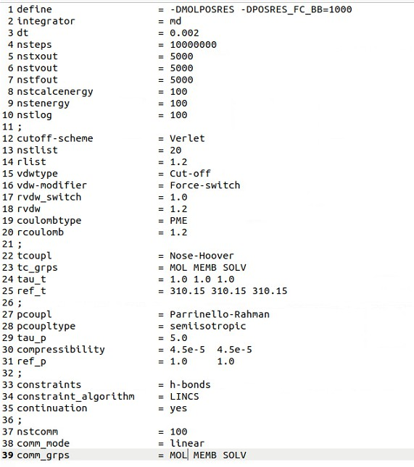
Figure 6: NPT equilibration parameters for step7_production.
- Note: The names in tc_grps and comm_grps must match the ones in topol.top file.
- Note: Arrange the names in topol.top file such that it matches the ones in Memb_set.gro.
- Important: Change the position of the molecule from Memb_set.gro before running the equilibration process (step7).
- Finally, use the README file to generate the equilibration shell script. Replace the existed
set “string” variables with proper ones as shown in the following figure:
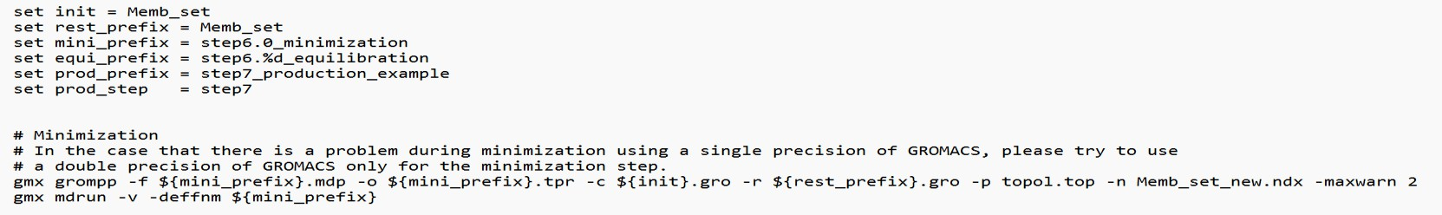
Figure 7: NPT equilibration shell script with an example of proper set “string” variables.

Potential Mean Force (PMF) Calculation
  - Use the water.gro file but change the content from TIP3 to SOL2, hence the file’s name. Similarly, copy and paste TIP3.itp but change the content to SOL2 and save it as SOL2.itp.
  - Insert SOL2.gro into Memb_set.gro using the command below:
gmx insert-molecules -f Memb_set.gro -ci SOL2.gro -nmol 1 -try
10 -o pull.gro -scale 1.0
if you face any error, try to change either -scale or -try as mentioned.
  - Make an index file that includes SOL2 using this command:
gmx make_ndx -f pull.gro -o pull.ndx
  - Make sure that topol.top include the new inserted molecule, which is SOL2, and located the same order as in pull.gro file.
  - Now restrain the molecule by adding the lines illustrated in Fig.6 to SOL2.itp file, knowing that POSRES_FC_BB value is defined in step8_pull.mdp.
  - The following .mdp example serves as a reference for simulation parameters for each step of pulling process. Name it step8_pull.mdp, for example.
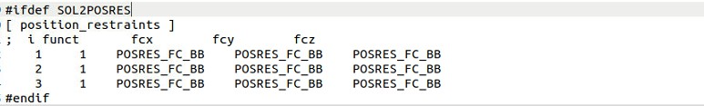
Figure 8: SOL2 position restrain command lines as to be added to SOL2.itp.
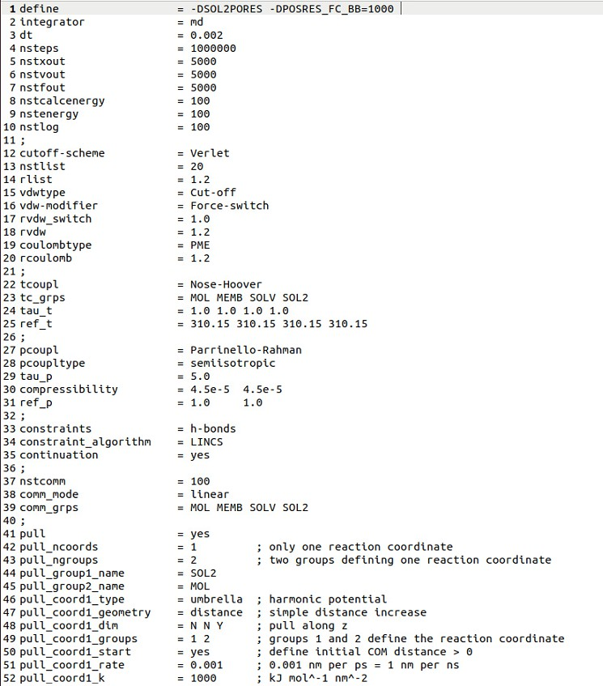
Figure 9: NPT equilibration parameters for pulling process.

  - Run SMD simulation by adding the lines shown Fig.10 to the shell script generated from step 3.k.
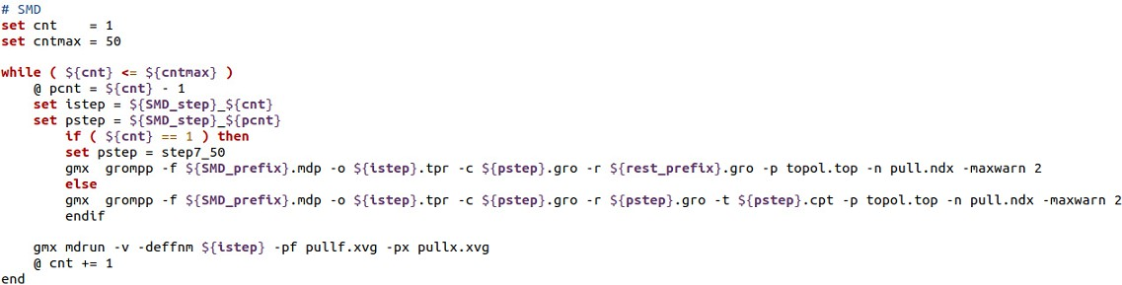
Figure 10: the script to run SMD simulation.
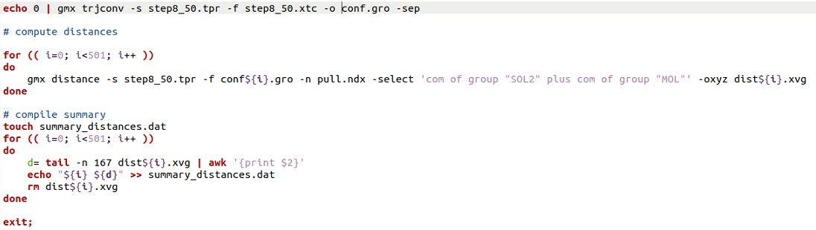
  - Use the latest file from SMD simulation and insert it into the following script shown in Fig.11 to extract the frame from .xtc file^{[2]}.
Figure 11: frame extraction script.
  - Make note of the configurations to be used for umbrella sampling, based on the desired spacing^{[2]}. Revise summary_distances.dat file to select appropriate spacing^{[2]}.
  - Sample the COM distance along the z-axis with the desired spacing. For example, if we choose 0.2 nm spacing along a 4.5 nm COM distance, we will need to generate 23 input files from individual coordinate files^{[2]}. This can be achieved by using the following command for 23 times in a separate shell script^{[2]}. You can use the NPT equilibration file from step (f) in each window.
gmx grompp -f step8_pull.mdp -c conf#.gro -p topol.top -r conf#.gro
-n pull.ndx -o umb1.tpr
Then mdrun each window in the same shell script of (step j):
gmx mdrun -deffnm umb1
  - In step8_pull.mdp, change pull_coord1_rate to 0.0, and run the following command for each equilibrated configuration (step j), respectively, on the same script file:
gmx grompp -f step8_pull.mdp -c ubm1.gro -t umb1.cpt -p topol.top -r ubm1.gro -n pull.ndx -o umbrella1.tpr
Then mdrun:
gmx mdrun -deffnm umbrella1
  - Start extracting for PMF from each window using the following command. you will need .tpr and .xvg files from each window with different names to pass Weighted Histogram Analysis Method (WHAM)^{[3]}.
gmx wham -it ubmrella*.dat -if umbrella*_pullf.dat -o -hist -unit kCal

Appendix

SBATCH
In case of using the high-performance machines, type in the following SBATCH characteristics at the beginning of the shell script file:
# Set jon parameters #SBATCH --job-name=name
#SBATCH --output="name.%j.out" #SBATCH -p gpucompute
#SBATCH -t 122:00:00
#SBATCH --exclusive #SBATCH --nodes=1 #SBATCH --gres=gpu:1
#SBATCH --ntasks-per-node=28

Use the following GPU specification with mdrun of both # Production and # SMD: gmx mdrun -ntomp 6 -ntmpi 4 -nb gpu -pme gpu -npme 1 -ntomp_pme 10 -v
...

VMD
It is a molecular visualization program for displaying, animating, and analyzing large biomolecular systems using 3-D graphics and built-in scripting^{[4]}. You can install VMD using the command below:
      - Download VMD from: https://www.ks.uiuc.edu/Development/Download/download.cgi?PackageNam e=VMD
      - Open Terminal and type the following:
tar -zxvf vmd........ cd vmd
./configure cd src
sudo make install

MATLAB
To plot any .xvg file on MATLAB, apply the following steps:
      - Change the file extension from .xvg to .txt.
      - From home, under the VARIABLE tab, select Import File. Locate your text file (.txt) that contains the data.
      - Import window opens. From Imported Data, select Numeric Matrix as an output type. Then click Import green check.
      - Close the window and type the following script with variables of your choice:
x = Filename(:,1);
y = Filename(:,2);
plot (x,y,"LineWidth",2); xlabel
ylable title

Results
the following link has the former results from IDS presentation https://drive.google.com/drive/folders/1BDhB4XtP0zsTdAMfyRtcxv_P8diHIpQ0?usp=s haring

References
- https://www.ncbi.nlm.nih.gov/pmc/articles/PMC5403596/
- http://www.mdtutorials.com/gmx/umbrella/06_umbrella.html
- http://www.mdtutorials.com/gmx/umbrella/07_analysis.html
- https://www.ch.cam.ac.uk/computing/software/vmd

Disclaimer
This Manual guarantees the most important steps for conducting bilayer simulations. However, steps (h) to (l) from PMF Calculations were cited from gromacs tutorial website but it serves our example. These steps are subject to change to completely fulfill our mission. Please be advised that all updated steps will be added to this manual and later posted on GitHub.

