Aim
The primary aim of this program is to establish a remote command and control channel between a client machine and a server machine. Specifically, the client (the machine to be controlled, usually the one behind a firewall) initiates a connection to the listening server (the controller), allowing the server to execute arbitrary shell commands on the client machine remotely.

Algorithm
Server (server.py)
- Initialize: Create a TCP socket and bind it to a specified host and port.
- Listen: Start listening for incoming connections.
- Accept: When a connection arrives, accept it, establish a dedicated thread (handle_client) for that connection, and wait for more connections.
- Interact: Inside handle_client:
  - Prompt the user for a command.
  - Send the command over the socket to the client.
  - Receive the command output (and the client's current directory prompt) from the client.
  - Print the received output.
  - Repeat until the command is 'quit'.

Client (client.py)
- Initialize: Create a TCP socket.
- Connect: Initiate a connection to the server's specified host and port (this is the "reverse" part).
- Receive: Start a loop to continuously receive a command from the server.
- Execute:
  - If the command is 'quit', break the loop.
  - If the command starts with 'cd ', change the current working directory (os.chdir).
  - Otherwise, execute the command using a subprocess (subprocess.Popen), capturing both standard output and standard error.
- Send: Combine the command's output with the client's current directory prompt and send it back to the server.
- Repeat until the connection is closed.

Source Code
Client.py

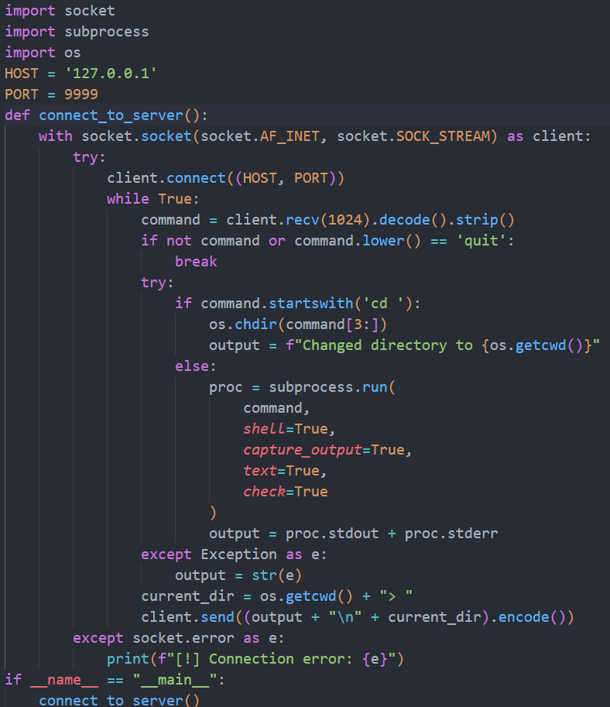

Server.py
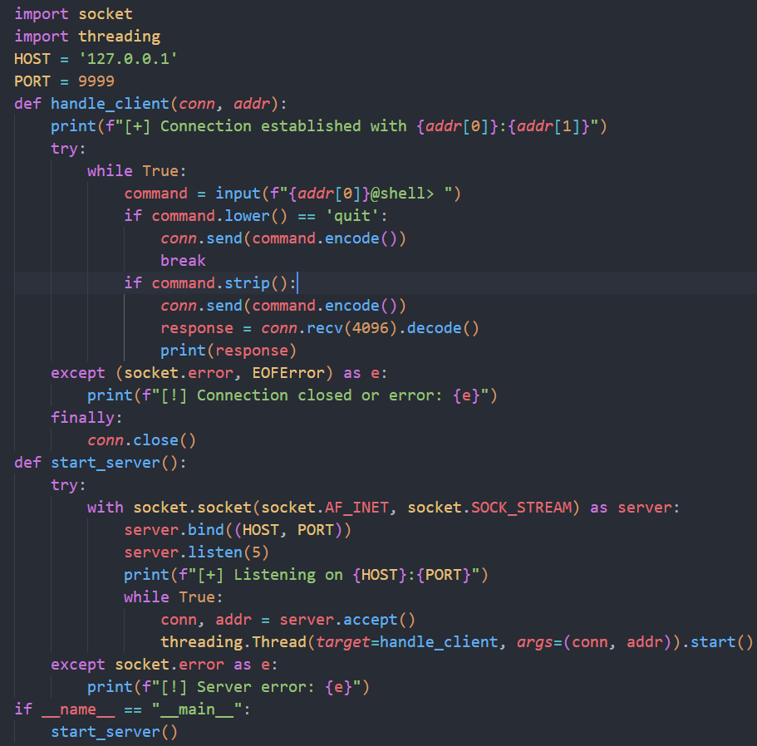

Result
The successful execution of this program results in a fully interactive shell session where the server user can remotely execute operating system commands on the client machine.
