**Aim**

The aim of this script is to **measure the Round-Trip Time (RTT)**, or network latency, between the local machine and a specified target server (google.com:80). It performs a series of connection attempts and calculates the time taken for a successful TCP handshake (SYN, SYN-ACK, ACK) in milliseconds, then reports the minimum, maximum, and average RTT over the measured attempts.

**Algorithm**

1. **Import necessary libraries**: Import the socket module for network connections and the time module for measuring duration.
2. **Define parameters**: Set the host (google.com), port (80), and count (number of connection attempts, 4). Initialize an empty list called times to store the RTTs.
3. **Loop through attempts**: Iterate for the number specified by count.
4. **Connect and measure**:
   * Create a new TCP socket (socket.socket()).
   * Record the start time.
   * Attempt to **connect** to the host and port.
   * If successful, record the end time, close the socket, calculate the RTT in milliseconds, store it in the times list, and print the result.
   * If the connection **fails** (e.g., due to a timeout or refusal), print "Request timed out."
5. **Calculate statistics**: After the loop finishes, if any successful RTTs were recorded:
   * Calculate and print the **Minimum RTT** from the times list.
   * Calculate and print the **Maximum RTT** from the times list.
   * Calculate and print the **Average RTT** from the times list.

**Soucre Code**

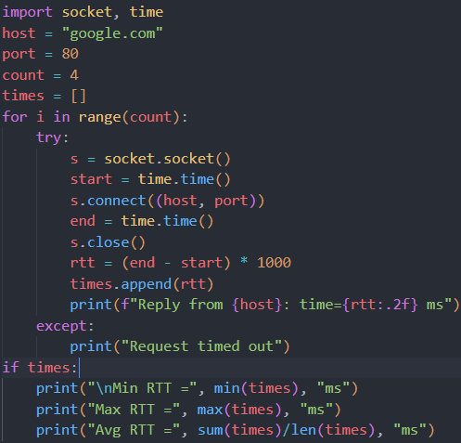

**Result (Sample Output)**

This is a simulated output demonstrating a typical execution of the script with varied network latency.

