*“*Heaven’s Light is Our Guide”



**Rajshahi University of Engineering & Technology**

**Department of Computer Science & Engineering**

# Assignment

**Course Code : CSE 3209**

**Course Title : Digital Signal Processing**

|  |  |
| --- | --- |
| **Submitted By-**  **Name: Sajidur Rahman Tarafder**  **Department : CSE**  **Roll No : 2003154**  **Section : C**  **Session:2020-21** | **Submitted To-**  **Md. Farukuzzaman Faruk Assistant Professor**  **Department of CSE, RUET** |

**Introduction:**

Electroencephalography (EEG) records electrical activity of the brain using electrodes placed on the scalp. The signal is rich in neural information, encompassing multiple frequency bands such as delta, theta, alpha, and beta waves. This assignment focuses on analyzing an EEG signal by applying the Discrete Fourier Transform (DFT) to identify and reconstruct brainwave activity in the frequency domain, especially targeting the alpha (8–12 Hz) and beta (13–30 Hz) bands.

**Motivation:**

EEG analysis is a cornerstone of modern neuroscience and neurology. It helps diagnose disorders such as epilepsy, sleep disorders, and brain injuries. By applying DFT, we can analyze the frequency composition of EEG signals, identify brain activity patterns, and potentially detect abnormalities. This motivated the use of DFT for understanding the underlying dynamics of EEG signals.

**Background Study:**

EEG signals are typically non-stationary and complex. In the time domain, they are hard to interpret due to overlapping frequencies. Transforming the signal to the frequency domain using DFT allows for easier interpretation of its constituent frequencies. Frequency-domain analysis helps isolate specific brainwave bands for further study.

**Social and Economic Impact:**

Improved EEG analysis enhances the accuracy of diagnosing neurological conditions, potentially reducing the burden on healthcare systems. It can aid in early detection of diseases, lower diagnostic costs, and open up possibilities in brain computer interfaces and mental health monitoring, contributing to societal well-being and economic growth.

**Related Mathematical Studies:**

The Discrete Fourier Transform (DFT) of a sequence:

$$X\left[k\right]= \sum_{n=0}^{N-1}{x\left[n\right]}⋅e^{-j2πkn/N}$$

The Inverse DFT (IDFT) is given by:

$$x\left[n\right]=\frac{1}{N}\sum_{k=0}^{N-1}{x[k]}⋅e^{j2πkn/N}$$

These transforms convert the signal between 5me and frequency domains, enabling the decomposi5on and reconstruc5on of signals based on frequency components.

**Theory:**

The DFT decomposes a discrete signal into its sinusoidal components. EEG signals contain various frequency bands corresponding to different cognitive or neurological states:

* **Alpha (8–12 Hz):** Relaxed, awake state
* **Beta (13–30 Hz):** Active thinking, attention
* **Theta/Delta:** Sleep or deep meditation

By analyzing these bands, we can isolate and study specific aspects of brain function.

**Implementation:**

**Tools Used:**

* **Python libraries:** pandas, numpy, matplotlib, scipy.fft

**Steps:**

1. Load EEG signal from a CSV file.
2. Visualize the signal in the time domain.
3. Compute the DFT using a custom DFT function.
4. Plot the frequency spectrum and identify alpha and beta ranges.
5. Apply a band-pass filter in the frequency domain to isolate alpha and beta components.
6. Reconstruct the filtered signal using the Inverse FFT.
7. Visualize the reconstructed signal.

**Original EEG Signal Code Segment:**

|  |
| --- |
| **import pandas as pd**  **import numpy as np**  **import matplotlib.pyplot as plt**  **from scipy.fft import fft, ifft, fftfreq**  **df = pd.read_csv("EEG.csv")**  **data = df.values**  **EEG = data[:4096] if data.ndim == 1 else data[:4096, 0]**  **sampling_rate = 2048 # sampling rate**  **# EEG Signal**  **time = np.arange(len(EEG)) / sampling_rate**  **plt.figure(figsize=(17, 7))**  **plt.plot(time, EEG,color='orange')**  **plt.title("EEG Signal")**  **plt.xlabel("Time(s)")**  **plt.ylabel("Amplitude")**  **plt.grid()**  **plt.show()**  **# DFT**  **def DFT(*signal*):**  **N = len(signal)**  **dft_result = np.zeros(N, dtype=complex)**  **for k in range(N):**  **for n in range(N):**  **dft_result[k] += signal[n] * np.exp(-2j * np.pi * k * n / N)**  **return dft_result**  **# DFT Frequencies**  **def Frequencies(*N*, *sampling_rate*):**  **return np.fft.fftfreq(N, d=1/sampling_rate)**  **# DFT values**  **values = DFT(EEG)**  **frequencies = Frequencies(len(EEG), sampling_rate** |

**Original EEG Signal Output:**

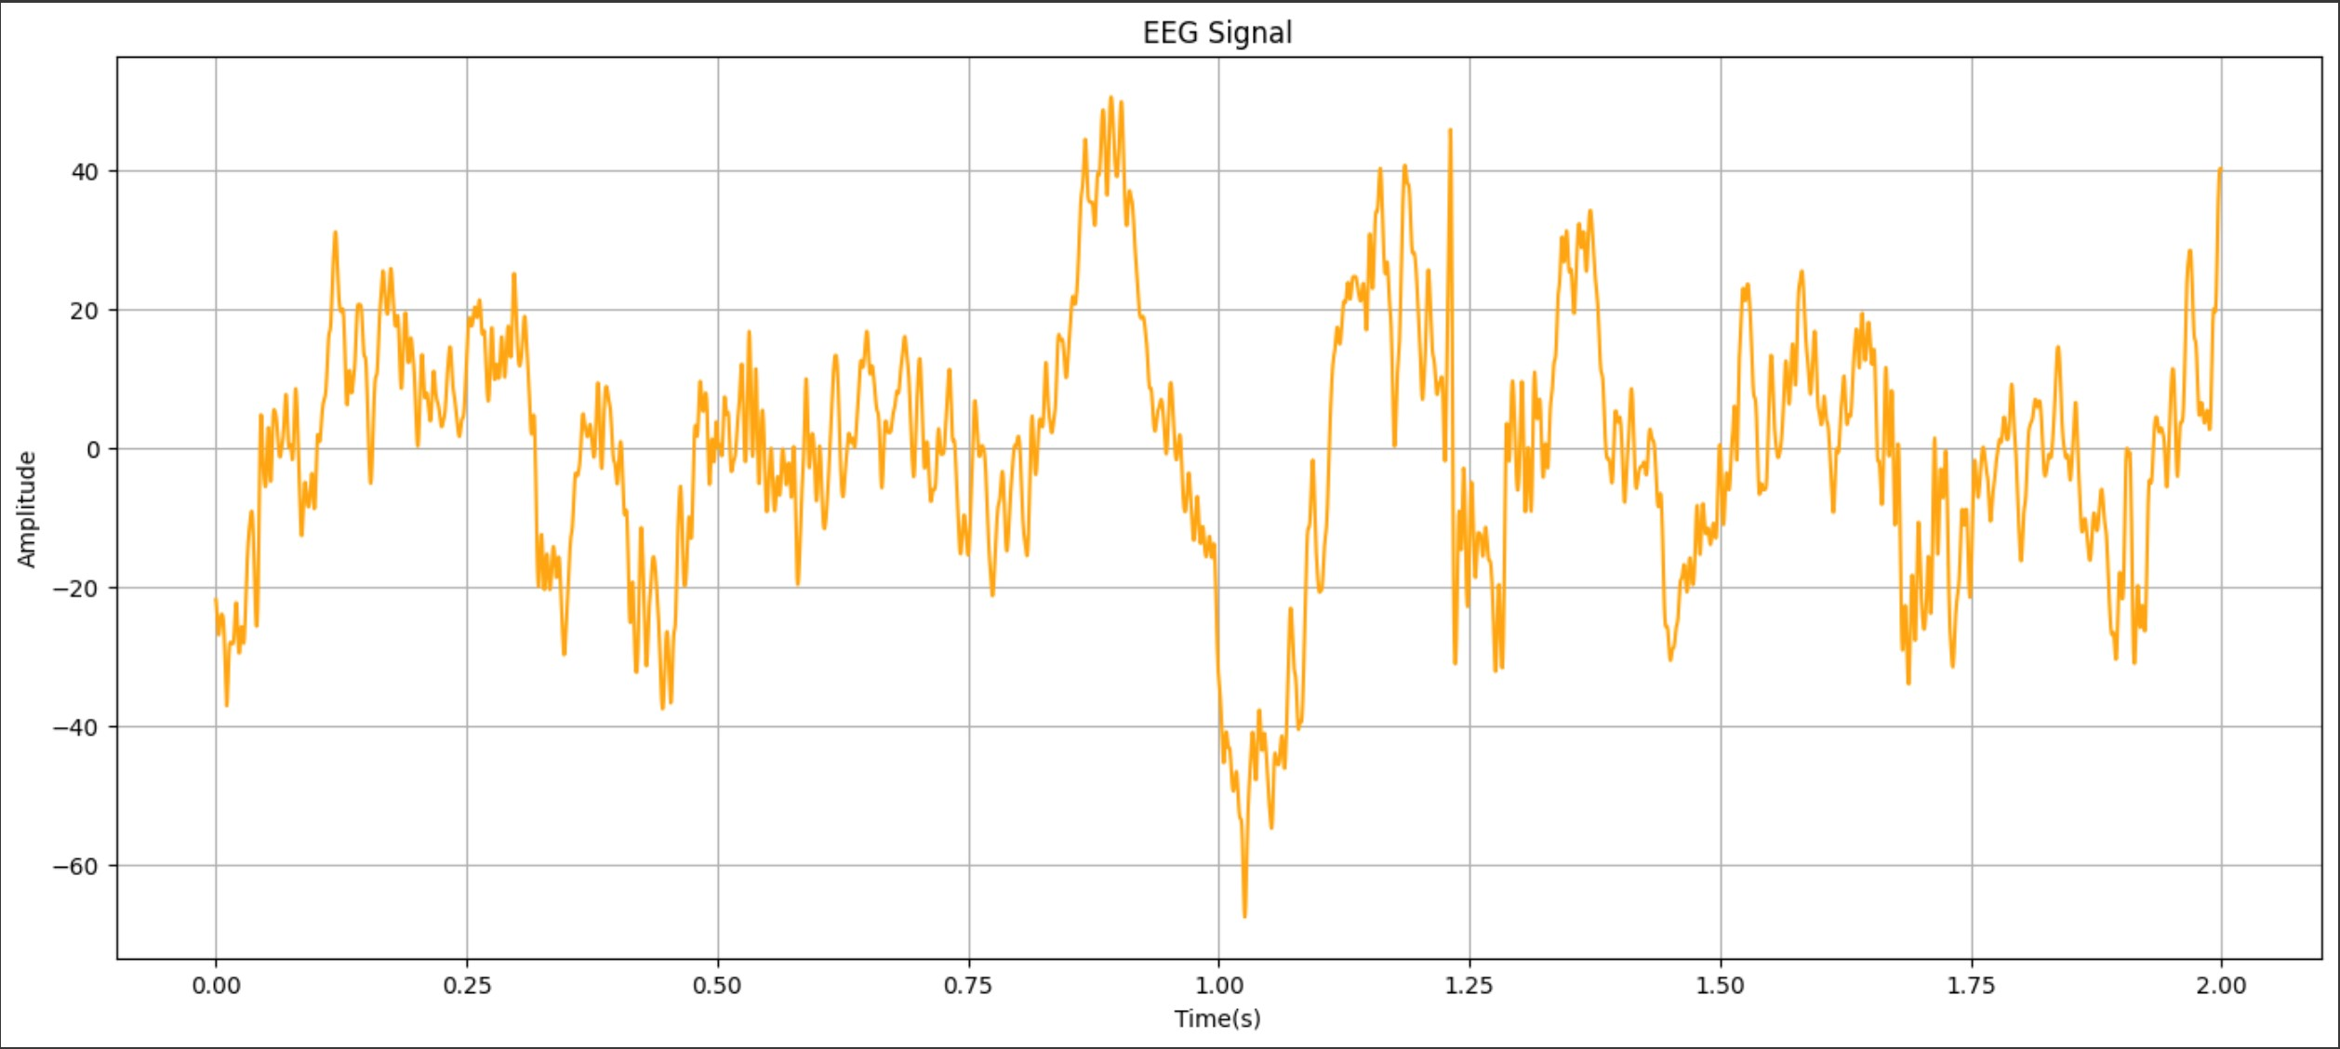

**Frequency Spectrum Code Segment:**

|  |
| --- |
| **# Magnitude Spectrum**  **n = len(EEG)**  **magnitude = np.abs(values[:n // 2])**  **freqs = frequencies[:n // 2]**  **plt.figure(figsize=(15, 4))**  **plt.plot(freqs, magnitude, label="EEG Frequency Spectrum", color='black')**  **# Alpha Wave (8–12 Hz)**  **plt.axvspan(8, 12, color='blue', alpha=0.3, label='Alpha Band (8–12 Hz)')**  **# Beta Wave (13–30 Hz)**  **plt.axvspan(13, 30, color='orange', alpha=0.3, label='Beta Band (13–30 Hz)')**  **plt.title("Frequency Spectrum of EEG Signal with Alpha & Beta Bands")**  **plt.xlabel("Frequency (Hz)")**  **plt.ylabel("Magnitude")**  **plt.xlim(0, 100)**  **plt.grid()**  **plt.legend()**  **plt.show()** |

**Frequency Spectrum Output:**

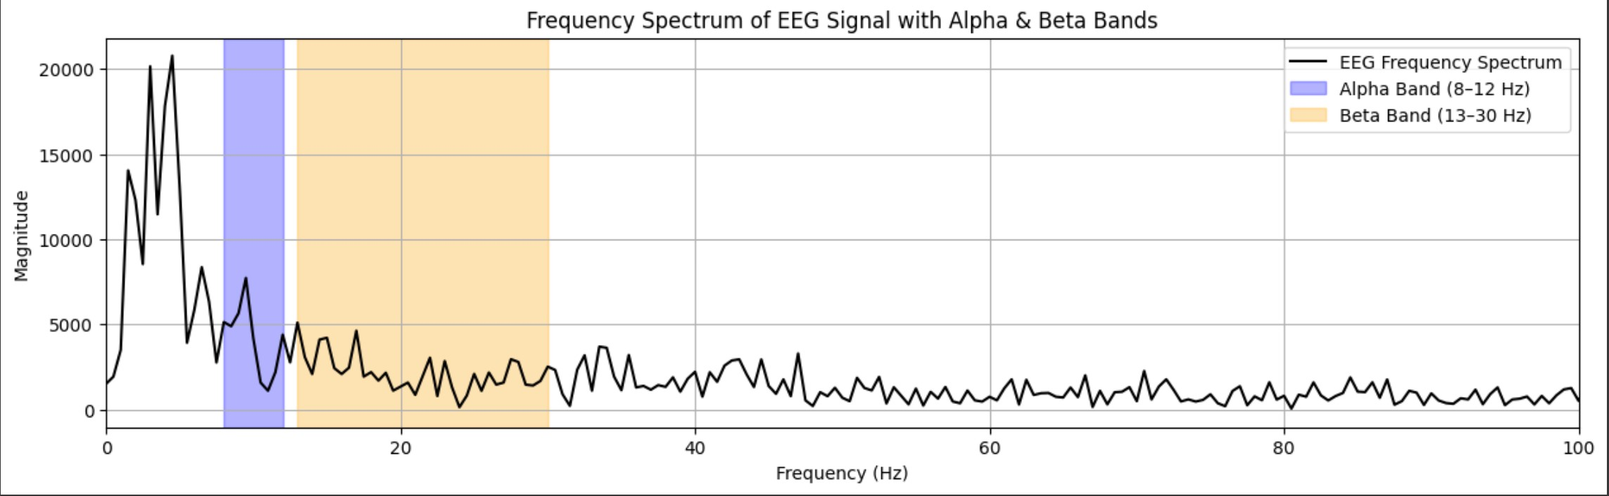

**Reconstruction of EEG Signal Using Alpha, Beta Code:**

|  |
| --- |
| **# Band-Pass Filter**  **def band_filter(*values*, *frequencies*, *f_low*, *f_high*):**  **fft = np.copy(values)**  **for i in range(len(frequencies)):**  **freq = abs(frequencies[i])**  **if not (f_low <= freq <= f_high):**  **fft[i] = 0**  **return fft**  **alpha_fft = band_filter(values, frequencies, 8, 12)**  **alpha_signal = ifft(alpha_fft).real**  **beta_fft = band_filter(values, frequencies, 13, 30)**  **beta_signal = ifft(beta_fft).real**  **combined_fft = band_filter(values, frequencies, 8, 30)**  **reconstructed_signal = ifft(combined_fft).real**  **# Reconstruct the signal**  **plt.figure(figsize=(12, 4))**  **plt.plot(time, reconstructed_signal, color='orange')**  **plt.title("Reconstructed EEG Signal Using Alpha and Beta Waves")**  **plt.xlabel("Time (s)")**  **plt.ylabel("Amplitude")**  **plt.grid()**  **plt.show()** |

**Reconstruction of EEG Signal Using Alpha, Beta Output:**

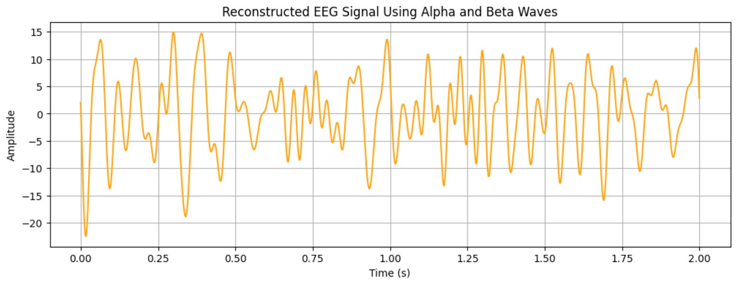

**Results:**

**Original EEG Signal:**

A plot of the EEG signal over time shows a fluctuating waveform typical of neural activity.

**Frequency Spectrum:**

The DFT reveals the presence of frequency components with noticeable magnitude peaks in the alpha and beta ranges.

**Alpha & Beta Band Highlighting:**

The bands are highlighted on the frequency spectrum plot for clear visualization.

**Reconstructed EEG Signal:**

* After filtering out the alpha and beta bands and reconstructing the signal:
* The new signal is smoother.
* It emphasizes oscillations relevant to the selected frequency bands.
* Demonstrates successful frequency isolation and signal reconstruction.

**Conclusion:**

This assignment successfully demonstrated the application of DFT to EEG signals. The process enabled:

* Frequency decomposition of complex EEG data.
* Isolation of brainwave bands (alpha and beta).
* Reconstruction of filtered signals for further analysis.

The project highlights how frequency-domain analysis is instrumental in interpreting biological signals and lays a foundation for advanced applications in neuroscience, medical diagnostics, and cognitive technology.