*“*Heaven’s Light is Our Guide”

Rajshahi University of Engineering & Technology

Department of Computer Science & Engineering

Assignment

Course Code : CSE 3210

Course Title : Digital Signal Processing Sessional

|  |  |
| --- | --- |
| Submitted By-  Name: Sajidur Rahman Tarafder  Department : CSE  Roll No : 2003154  Section : C  Session:2020-21 | Submitted To-  Md. Farukuzzaman Faruk  Assistant Professor  Department of CSE, RUET |

Introduction:

Digital Signal Processing (DSP) is a vital tool for transforming and analyzing real-world signals like audio. In this assignment, we use a convolution-based low-pass filter to reduce high-frequency noise in an audio file. We demonstrate the effectiveness of a moving average filter using Python, Librosa, and SciPy by filtering a noisy .wav file and visualizing the outcome.

Motivation:

Low-pass filtering is foundational in DSP and has broad applications:

* Noise reduction in audio and communication systems
* Smoothing and signal shaping in audio editing tools
* Practical understanding of DSP through real-time

implementation

This task reinforces the theoretical knowledge of filtering using hands-on coding and waveform analysis.

Background Study:

Convolution in Signal Processing:

Convolution is used in signal processing to apply transformations like filtering. In audio processing, it modifies the input signal by convolving it with a filter kernel to alter frequency characteristics.

Low-Pass Filters (LPF):

An LPF allows low-frequency components to pass while suppressing high-frequency noise. A moving average LPF averages neighboring sample values, which smoothens rapid changes and attenuates noise.

Social and Economic Impact:

Societal Benefits:

* Hearing aids: Enhance speech clarity
* Music production: Noise suppression and quality

improvement

* Telecommunications: Improved voice clarity

Economic Importance:

* Entertainment: Clean audio improves user experience in

music, games, and films

* VoIP: Better signal quality enhances communication
* Medical tech: Filters in hearing devices rely on DSP

Related Mathematical Studies:

Discrete-Time Convolution:

The convolution of discrete-time signals is represented as:

$$y\left[n\right]= \sum_{\left\{k=-∞\right\}}^{\left\{∞\right\}}{x[k]}⋅h\left[n - k\right]$$

Where x[n] is the input, h[n] is the impulse response, and y[n] is the output.

Moving Average Filter:

A basic LPF is defined as:

$$h\left[n\right]=\frac{1}{N} , if 0≤n≤N$$

$$=0 , otherwise$$

This filter suppresses rapid variations and highlights the overall trend of the signal.

Theory:

Working procedure of the filter:

* Each output sample is the average of n = 201 neighboring

samples.

* This smoothens the waveform, reducing sharp transitions.
* The longer the filter, the stronger the noise suppression.

Expected Outcomes:

* Time domain: Smooth waveform, lower sharpness
* Auditory: Less hiss and harshness, more muffled tone

Implementation:

Tools Used:

* Python 3
* Librosa for loading audio
* SciPy for convolution
* Matplotlib for visualization
* Jupyter/Colab for execution

Steps Performed:

1. Loaded "Signal.wav" and trimmed it to 10 seconds.
2. Defined a low-pass filter with kernel size 201.
3. Applied convolution to the signal using mode='same'.
4. Played both original and filtered signals.
5. Plotted waveform comparison.

Code:

|  |
| --- |
| import librosa  import numpy as np  import matplotlib.pyplot as plt  from scipy.signal import convolve  from IPython.display import Audio  # Signal  audio_data, sampling_rate = librosa.load("Signal.wav", sr=None)  duration_sec = 10  audio_data = audio_data[:sampling_rate * duration_sec]  # Low-Pass Filter  n = 201  Filter = np.ones(n) / n  Output_Signal = convolve(audio_data, Filter, mode='same')  Time = np.linspace(0, len(audio_data) / sampling_rate, len(audio_data))  print("Original Noisy Audio Signal:")  display(Audio(data=audio_data, rate=sampling_rate))  print("Filtered Audio Signal:")  display(Audio(data=Output_Signal, rate=sampling_rate))  # Plotting Signals  plt.figure(figsize=(15, 7))  # Original Signal  plt.subplot(2, 1, 1)  plt.plot(Time[:sampling_rate // 10], audio_data[:sampling_rate // 10], color='orange')  plt.title("Original Audio Signal (Noisy)")  plt.xlabel("Time (seconds)")  plt.ylabel("Amplitude")  plt.grid(True)  # Filtered Signal  plt.subplot(2, 1, 2)  plt.plot(Time[:sampling_rate // 10], Output_Signal[:sampling_rate // 10], color='red')  plt.title("Filtered Audio Signal (Low-Pass Filter)")  plt.xlabel("Time (seconds)")  plt.ylabel("Amplitude")  plt.grid(True)  plt.tight_layout()  plt.show() |

Output:

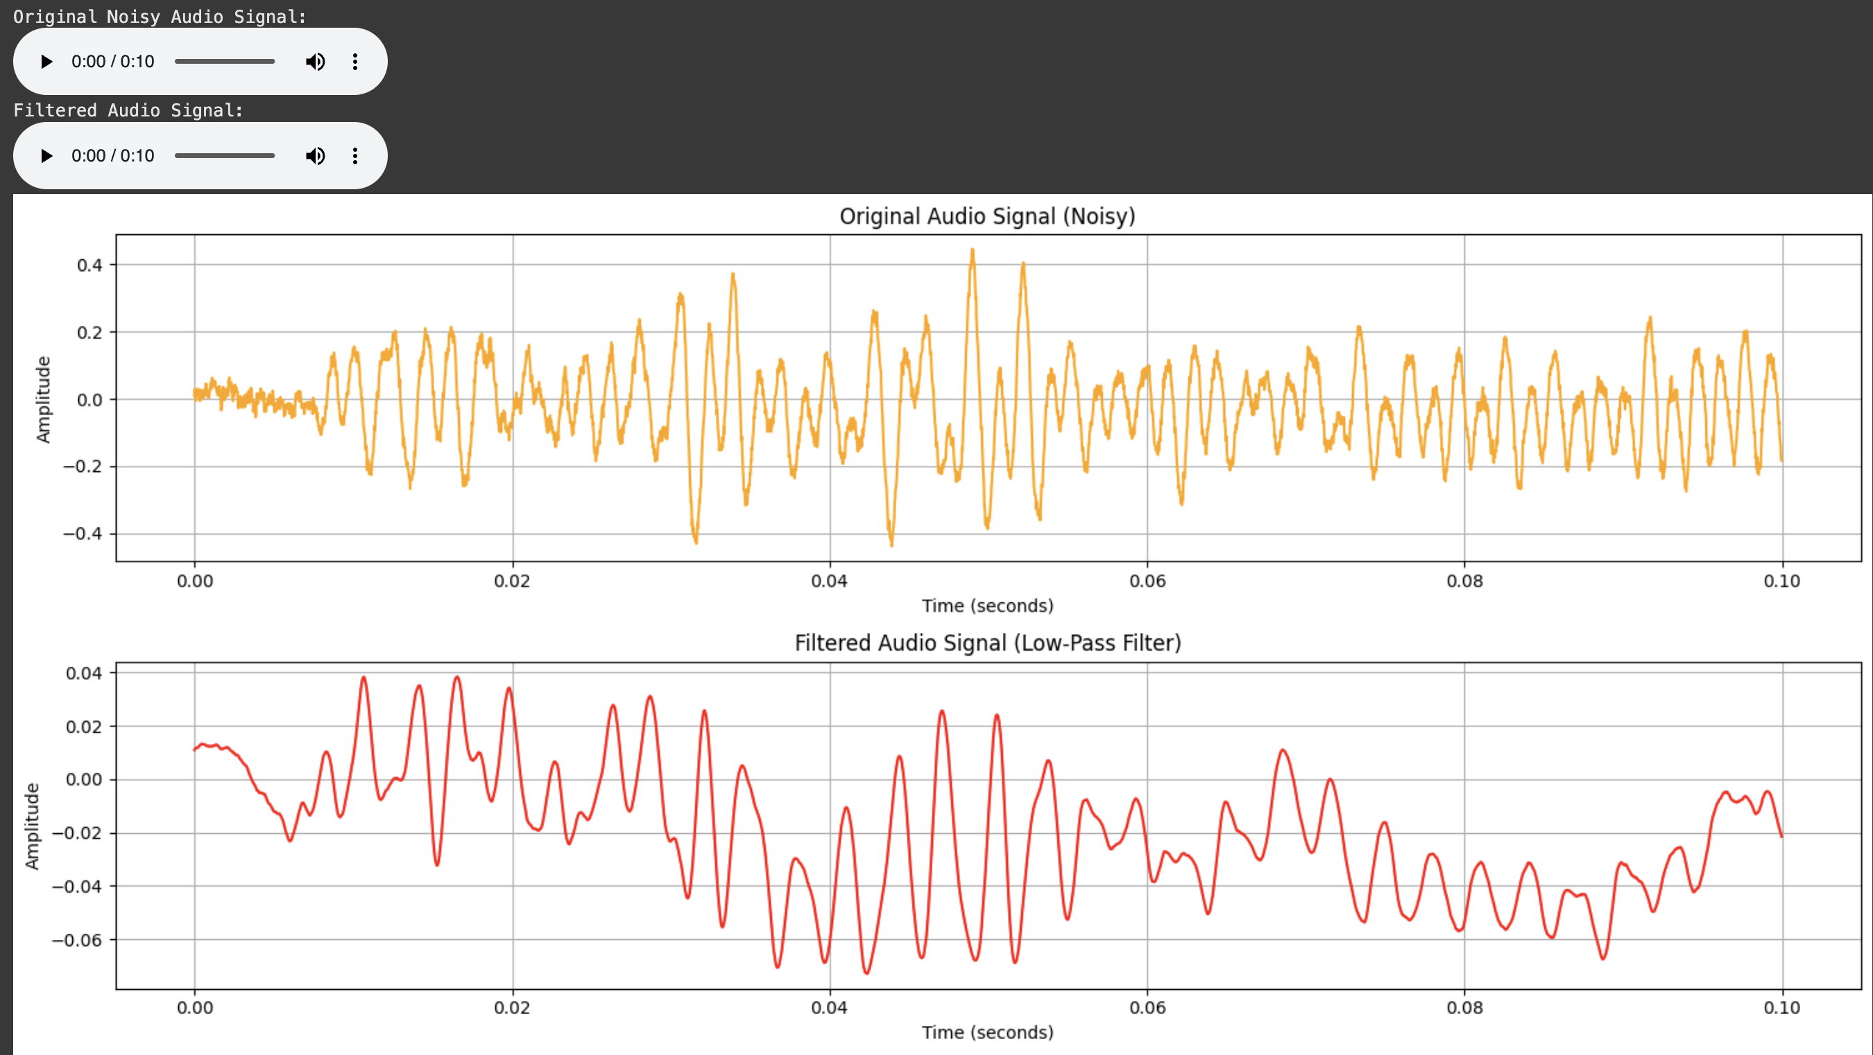

Conclusion:

This experiment demonstrated:

* Implementation of a simple LPF using convolution
* Effective reduction of high-frequency noise in real audio
* Clear auditory and visual improvements
* Strong connection between DSP theory and practice