**WEEK-5**

**NAME-SANCHIT JAIN**

**BATCH-B-7**

**ENROLL-21103192**

**1.** #include <iostream>

using namespace std;

class Complex

{

    int real;

    int img;

public:

    Complex()

    {

        real = 1;

        img = 1;

    }

    Complex(int n1, int n2)

    {

        real = n1;

        img = n2;

    }

    friend Complex operator+(Complex c1, Complex c2);

    void displaynumber()

    {

        cout << "Complex Number you entered " << real << " + " << img << "i" << endl;

    }

};

Complex operator+(Complex c1, Complex c2)

{

    Complex temp;

    temp.real = c1.real + c2.real;

    temp.img = c1.img + c2.img;

    return temp;

}

int main()

{

    Complex c1(11, 2);

    Complex c2(4, 36);

    Complex c3;

    c1.displaynumber();

    c2.displaynumber();

    c3 = c1 + c2;

    c3.displaynumber();

    return 0;

}

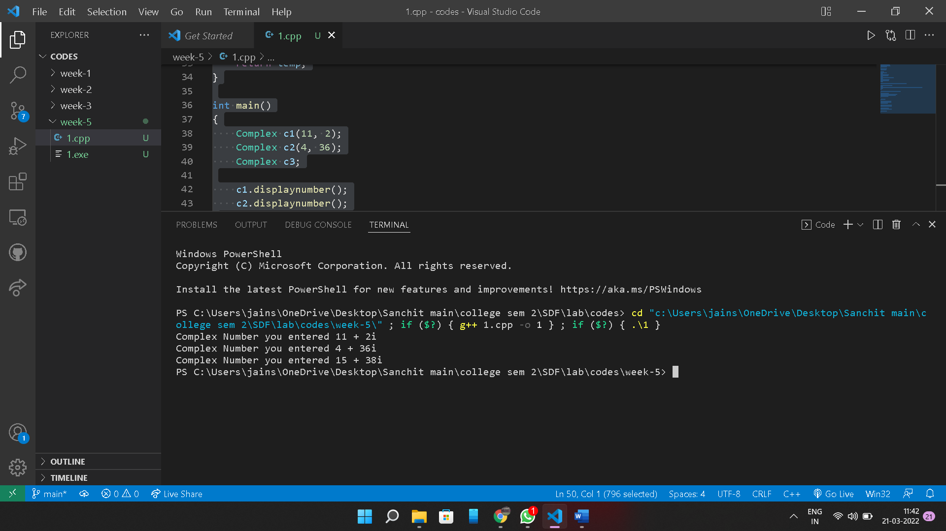

**2.** #include <iostream>

using namespace std;

class Box

{

    int capacity;

public:

    Box() {}

    Box(double capacity)

    {

        this->capacity = capacity;

    }

    bool operator<(const Box &obj)

    {

        if (capacity < obj.capacity)

        {

            return true;

        }

        else

        {

            return false;

        }

    }

};

int main()

{

    Box b1(10);

    Box b2(5);

    if (b2 < b1)

    {

        cout << "Box 1 have more capacity then Box 2" << endl;

    }

    else

    {

        cout << "Box 2 have more capacity then Box 1" << endl;

    }

    return 0;

}

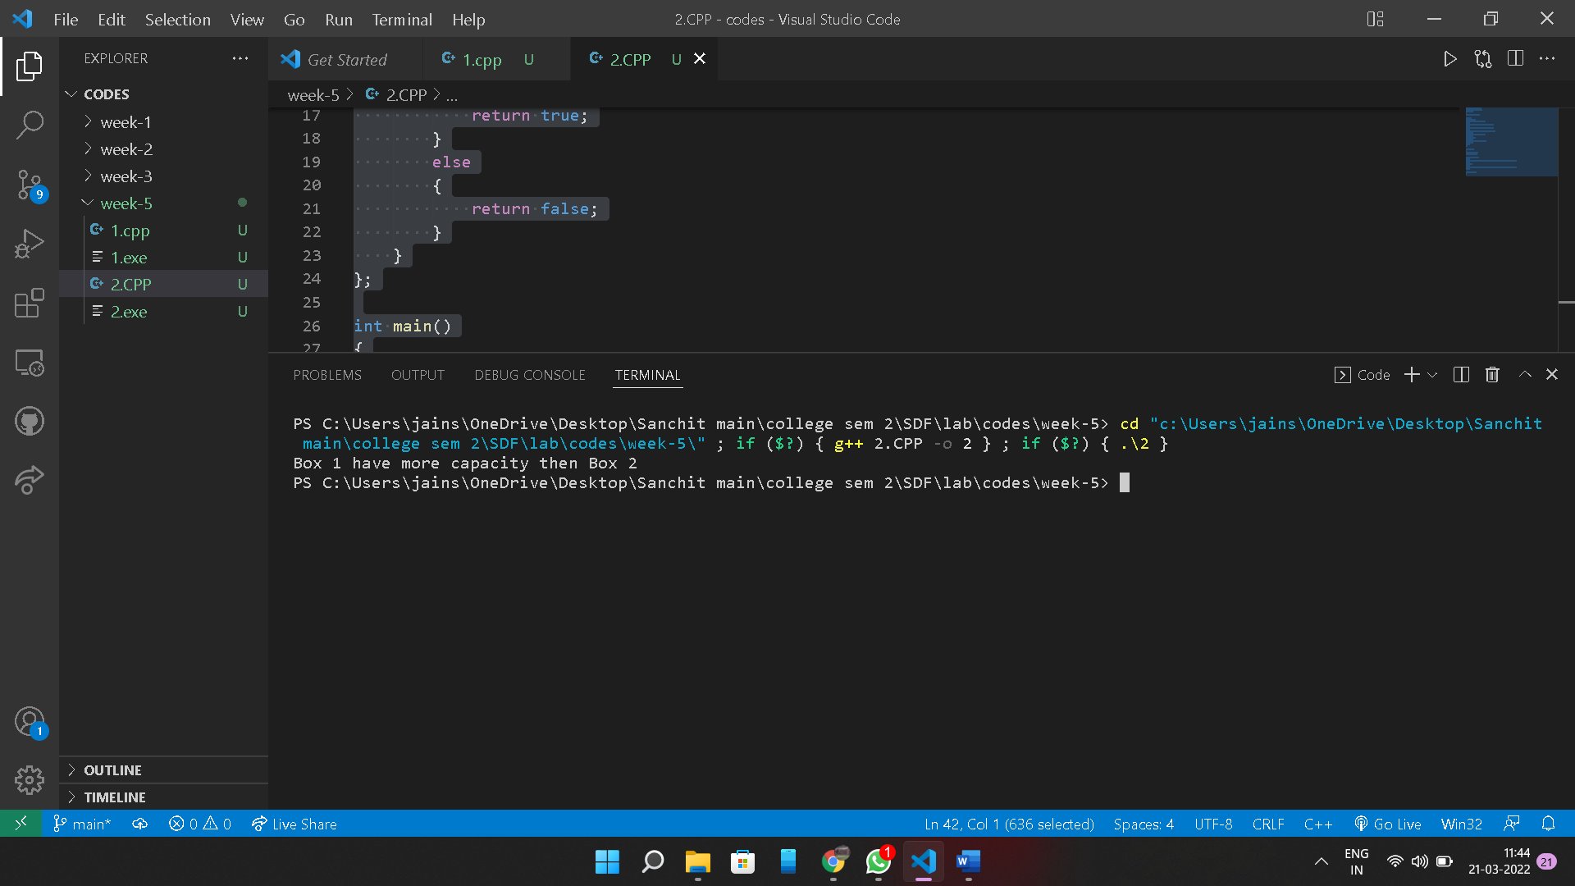

3.#include <iostream>

using namespace std;

class Time

{

    int hours;

    int minutes;

public:

    Time()

    {

        hours = 0;

        minutes = 0;

    }

    Time(int h, int m)

    {

        hours = h;

        minutes = m;

    }

    void displayTime()

    {

        cout << "H: " << hours << " M:" << minutes << endl;

    }

    Time operator++()

    {

        cout << "inside preincrement\n";

        ++minutes;

        if (minutes >= 60)

        {

            ++hours;

            minutes -= 60;

        }

        return *this;

    }

    Time operator++(int)

    {

        cout << "post increment\n";

        Time Temp(hours, minutes);

        ++minutes;

        if (minutes >= 60)

        {

            ++hours;

            minutes -= 60;

        }

        return Temp;

    }

};

int main()

{

    Time T1(10, 60), T2(10, 40);

    Time T3;

    T3 = ++T1;

    T3.displayTime();

    ++T1;

    T1.displayTime();

    T3 = T2++;

    T3.displayTime();

    T2.displayTime();

    T2++;

    T2.displayTime();

    return 0;

}

