CHAPTER 1
INTRODUCTION
Online hotel reservations are a popular method for booking hotel rooms. Travelers can book rooms on a computer by using online security to protect their privacy and financial information and by using several online travel agents to compare prices and facilities at different hotels. Prior to the Internet, travelers could write, telephone the hotel directly, or use a travel agent to make a reservation. Nowadays, online travel agents have pictures of hotels and rooms, information on prices and deals, and even information on local resorts. Many also allow reviews of the traveler to be recorded with the online travel agent. Online hotel reservations are also helpful for making last minute travel arrangements. Hotels may drop the price of a room if some rooms are still available. There are several websites that specialize in searches for deals on rooms.
The online booking system works all the time. It also increases your sales because you are not limited to your working hours. This gives freedom to potential visitors to book a room anytime and anywhere they want. Show that 24*7 online reservation system considerably increases the number of hotel bookings. Hassle free management of bookings Hotel reservation system will make your work more effective. They all are wanted to be tied to a waiting a mail or phone call of a guest. A second major benefit of online hotel reservation system, you can easily promote your business through the social media online to create a page or start a campaign and sell packages, add-ons online. Let customers choose the package they want. You can generate a business from here or increase the income.
.
.

CHAPTER 2
REQUIREMENT ANALYSIS

In this section the various requirements that are essential for this project are specified.
Requirements have to be fulfilled for successful execution of the project. The purpose, scope
along with hardware and software requirements is given below:

2.1 HARDWARE REQUIREMENTS
Minimum hardware specification
- Microprocessor : Intel i5 core processor
- Main memory : 4.00 GB RAM
- Monitor : 1024x768displayresolution
- System Type : 64-bit Operating System

2.2 SOFTWARE REQUIREMENTS
Minimum software specification
- Operating system : Windows 10
- Server : Xampp Server
- Frontend : HTML, CSS
- Backend : PHP, MySQL, JS

CHAPTER 3
SOFTWARE REQUIREMENT SPECIFICATION
This document details the requirements for Online hotel room booking website for the academic year. The software requirement shall be specified for all the models used in website. A software requirement specification (SRS) in a complete description of the behavior of the system to be developed. It includes a set of use cases that describes all the interactions the user will have with the software. Use cases are also known as functional requirements. In addition to use cases the SRS also contains non functional or supplementary requirements.
A functional is described as a set of inputs, behavior and outputs. Functional requirements may be calculation, technical details, data manipulation and processing and other specific functionality that defines what a system is supposed to accomplish.

  - Introduction to web
Web consists of billions of clients and server connected through wires and wireless networks. The web clients make requests to web server. The web server receives the request, finds the resources and returns the response to the client. When a server answers a request, it usually sends some type of content to the client. The client uses web browser to send request to the server. The server often sends response to the browser with a set of instructions written in Hyper Text Mark-up Language (HTML). All browsers know how to display HTML page to the client.

  - HTML
Hypertext Markup Language (HTML) is the standard markup language for creating web pages and web applications. HTML describes the structure of Web pages using markup. HTML elements are the building blocks of HTML pages.HTML elements are represented by tags.HTML tags label pieces of content such as "heading", "paragraph", "table", and so on. Browsers do not display the HTML tags, but use them to render the content of the page.

  - PHP
PHP is a general-purpose server-side scripting language originally designed for Web development to produce dynamic Web pages. It is one of the first developed server-side scripting languages to be embedded into an HTML source document, rather than calling an external file to process data. Ultimately, the code is interpreted by a Web server with a PHP processor module which generates the resulting Web page. It also has evolved to include a command-line interface capability and can be used in standalone graphical applications. PHP can be deployed on most Web servers and also as a standalone shell on almost every operating system and platform free of charge. A competitor to Microsoft's Active Server Pages (ASP) server-side script engine and similar languages, PHP is installed on more than 20 million Web sites and 1 million Web servers. In this application, PHP is used for interacting the webpage with database. Through PHP, the user can meet the server through the HTML page. Using PHP, we can store and retrieve the information from the database using the PHP commands.

  - JavaScript
JavaScript (sometimes abbreviated JS) is a prototype-based scripting language that is dynamic, weakly typed, general purpose programming language and has first-class functions. It is a multi-paradigm language, supporting object-oriented, imperative, and functional programming styles. JavaScript was formalized in the ECMA Script language standard and is primarily used in the form of client-side JavaScript, implemented as part of a Web browser in order to provide enhanced user interfaces and dynamic websites. This enables programmatic access to computational objects within a host environment. JavaScript's use in applications outside Web pages for example in PDF documents, site-specific browsers, and desktop widgets is also significant. In this application, JavaScript is used for validation purpose like text box validation, email validation, phone number validation. JavaScript is the good tool for validating the web- applications.
Server-Side JavaScript Meanwhile, Netscape also introduced the language for server-side scripting in Netscape Enterprise Server, first released in December, 1994.

  - XML
Extensible Mark-up Language (XML) is a mark-up language that defines a set of rules for encoding documents in a format that is both human-readable and machine-readable. It is defined in the XML 1.0 Specification produced by the W3C, and several other related specifications, all gratis open standards. The design goals of XML emphasize simplicity, generality, and usability over the Internet. It is a textual data format with strong support via Unicode for the languages of the world. Although the design of XML focuses on documents, it is widely used for the representation of arbitrary data structures, for example in web services. Many application programming interfaces (APIs) have been developed for software developers to use to process XML data, and several schema systems exist to aid in the definition of XML-based languages. As of 2009, hundreds of XML-based languages have been developed, including RSS, Atom, SOAP, and XHTML. XML-based formats have become the default for many office-productivity tools, including Microsoft Office (Open Office) OpenOffice.org and LibreOffice (Open Document), and Apple's iWork. XML has also been employed as the base language for communication protocols, such as XMPP.

  - MySQL
MySQL ("My S-Q-L", officially "My Sequel") is the world's most used relational database management system (RDBMS) that runs as a server providing multi-user access to a number of databases. It is named after developer Michael Widenius daughter, my. The SQL phrase stands for Structured Query Language.
The MySQL development project has made its source code available under the terms of the GNU General Public License, as well as under a variety of proprietary agreements. MySQL was owned and sponsored by a single for-profit firm, the Swedish company MySQL AB, now owned by Oracle Corporation. Free-software-open source projects that require a full featured database management system often use MySQL. For commercial use, several paid editions are available, and offer additional functionality. Applications which use MySQL databases include: TYPO3, Joomla, Word Press, phpBB, Drupal and other software built on the LAMP software stack. MySQL is also used in many high-profile, large-scale World Wide Web products, including Wikipedia, Google (though not for searches), Facebook, and Twitter.

Uses of MySQL
- MySQL is a popular choice of database for use in web applications, and is a central component of the widely used LAMP open source web application software stack—LAMP is an acronym for "Linux, Apache, MySQL, Perl/PHP/Python".
- MySQL is an open source database management system and is used in some of the most frequently visited websites on the Internet, including Flickr, Nokia.com, YouTube and as previously mentioned, Wikipedia, Google, Facebook and Twitter.

3.7 Functional Requirements
Functional Requirements defines a function of a software system and how the system must behave when presented with specific inputs or conditions, these may include calculations, data manipulation and processing and other specific functionality. It may be appropriate to partition the functional requirements into sub functions or sub processes. This does not imply that the architecture or software design will also be partitioned in that way. The two-common means of specifying functional requirements are functional decomposition and use cases.
Fundamental actions in functional requirements include:
- Validity checks on the inputs
- Exact sequence of operations
- Response to abnormal situations, including overflow and communication facilities
- Effect of parameters
- Relationship of output to inputs
- Input/output sequences
CHAPTER 4
ANALYSIS AND DESIGN
The System Architecture is the process of applying various techniques and principles for the purpose of defining the process or system in sufficient detail to permit its physical realization. The design specification describes the features of the system, components or elements of the system and their appearance to end-user.

4.1 Fundamental design concepts
A set of fundamental design concepts provide the software designer with a foundation from which more sophisticated design concepts provide the necessary frame work for getting it right. The fundamental design concepts such as abstraction, refinement, modularity, software architecture, control hierarchy, structural portioning data structure, software procedure and the information hiding are applied in this project to getting it right as per the specification.

4.2 Purpose
To manage the online hotel booking website. It helps customer to take book a room from anywhere. This project also helps in administrative work such as keep information of customers and various information’s.
4.3 Description
- Admin side
    - Manage Rooms
    - Manage Accommodation
    - Manage Reservation
    - Manage Customers Check-IN and Check-OUT
    - Manage Users
So basically in admin side we can add or remove rooms, manage the types of the accommodations provided, accept or discard the reservations, generate the reports and manage the users.
- Public Side
    - Home
    - Room and Rates
    - About Us
    - Contact Us
    - Manage Booking
    - Reservation Details
    - Submit Reservation
    - Login and Logout
This is basically the user side where user will see a very responsive home page where they will be doing all their procedures. They can see rooms and the services along with the rates. They can read about the website in about us section. They will have a personal cart where their selected rooms will go temporarily. Before any transaction user need to login or register and also after finishing booking they will have the option to logout.

CHAPTER 5
IMPLEMENTATION
The implementation phase of any project developed is the most phases as it yields the final solution, which solves the problem. The implementation phase involves actual Materialization of ideas, which is expressed in the analysis document and developed in the design. Implementation should be perfect mapping of the design document in a suitable programming language in order to achieve the necessary final product. The factors concerning the programming language and platform chosen are described in the following section.

Implementation Requirements
Implementation of any software is always preceded by important decisions regarding selection of platform, the language used, etc. These decision often influenced by several factors such as the real environment in which the system works, the speed that is required the security concerns, and implementation specific details. There are two major implementation decisions that have made before the implementation of this project they are as follows:
- The language chosen for this project is MySQL.
- Operating System used: Microsoft windows XP and above versions.
SOURCE CODE:
5.1 HOME PAGE CODE

<header class="masthead">
<div class="container h-100">
<div class="row h-100 align-items-center justify-content-center text-center">
<div class="col-lg-10 align-self-end mb-4">
<div class="card" id="filter-book">
<div class="card-body">
<div class="container-fluid">
<form action="index.php?page=list" id="filter" method="POST">
<div class="row">
<div class="col-md-3">
<label for="">Chech-in Date</label>
<input type="text" class="form-control datepicker" name="date_in" autocomplete="off">
</div>
<div class="col-md-3">
<label for="">Chech-out Date</label>
<input type="text" class="form-control datepicker" name="date_out" autocomplete="off">
</div>

<div class="col-md-3">
<br>
<button style="border-radius:15px;" class="btn-btn-block btn-primary mt-3">Check Availability</button>
</div>

</div>
</form>
</div>
</div>
</div>
</div>

</div>
</div>
</header>
<section class="page-section">
</section>
<div id="portfolio">
<div class="container-fluid p-0">
<div class="row no-gutters">
<?php
include'admin/db_connect.php';
$qry = $conn->query("SELECT * FROM room_categories order by rand() ");
while($row = $qry->fetch_assoc()):
?>
<div class="col-lg-4 col-sm-6">
<a class="portfolio-box" href="#">
<img class="img-fluid" src="assets/img/<?php echo $row['cover_img'] ?>" alt="" />
<div class="portfolio-box-caption">
<div class="project-category text-white-30"><?php echo "$ ".number_format($row['price'],2) ?> per day</div>
<div class="project-name"><?php echo $row['name'] ?></div>
</div>
</a>
</div>
<?php endwhile; ?>

</div>
</div>
</div>

5.2 Admin Page
<style>
.custom-menu {
z-index: 1000;
position: absolute;
background-color: #ffffff;
border: 1px solid #0000001c;
border-radius: 5px;
padding: 8px;
min-width: 13vw;
}
a.custom-menu-list {
width: 100%;
display: flex;
color: #4c4b4b;
font-weight: 600;
font-size: 1em;
padding: 1px 11px;
}
span.card-icon {
position: absolute;
font-size: 3em;
bottom: .2em;
color: #ffffff80;
}
.file-item{
cursor: pointer;
}
a.custom-menu-list:hover,.file-item:hover,.file-item.active {
background: #80808024;
}
table th,td{
/*border-left:1px solid gray;*/
}
a.custom-menu-list span.icon{
width:1em;
margin-right: 5px
}
.candidate {
margin: auto;
width: 23vw;
padding: 0 10px;
border-radius: 20px;
margin-bottom: 1em;
display: flex;
border: 3px solid #00000008;
background: #8080801a;

}
.candidate_name {
margin: 8px;
margin-left: 3.4em;
margin-right: 3em;
width: 100%;
}
.img-field {
display: flex;
height: 8vh;
width: 4.3vw;
padding: .3em;
background: #80808047;
border-radius: 50%;
position: absolute;
left: -.7em;
top: -.7em;
}

.candidate img {
height: 100%;
width: 100%;
margin: auto;
border-radius: 50%;
}
.vote-field {
position: absolute;
right: 0;
bottom: -.4em;
}
</style>
</div>
</div>
</div>
</div>

5.3 Login Page

<!DOCTYPE html>
<html lang="en">

<head>
<meta charset="utf-8">
<meta content="width=device-width, initial-scale=1.0" name="viewport">

<title>Admin | SanS Hotel</title>

<?php include('./header.php'); ?>
<?php include('./db_connect.php'); ?>
<?php
session_start();
if(isset($_SESSION['login_id']))
header("location:index.php?page=home");

$query = $conn->query("SELECT * FROM system_settings limit 1")->fetch_array();
foreach ($query as $key => $value) {
if(!is_numeric($key))
$_SESSION['setting_'.$key] = $value;
}
?>

</head>
<style>
body{
width: 100%;
height: calc(100%);
/*background: #007bff;*/
}

#login-right .card{
margin: auto
}
.logo {
margin: auto;
font-size: 8rem;
background: white;
padding: .5em 0.8em;
border-radius: 50% 50%;
color: #000000b3;
}
#login-left {
background: url(../assets/img/<?php echo $_SESSION['setting_cover_img'] ?>);
background-repeat: no-repeat;
background-size: cover;
}
</style>

<body>

<main id="main" class=" alert-info">
<div id="login-left">
<!-- == You can logo or image herre == -->
<!-- <div class="logo">
<i class="fa fa-poll-h"></i>
</div> -->
</div>
<div id="login-right">
<div class="card col-md-8">
<div class="card-body">
<form id="login-form" >
<div class="form-group">
<label for="username" class="control-label">Username</label>
error:err=>{
console.log(err)
$('#login-form button[type="button"]').removeAttr('disabled').html('Login');

},
success:function(resp){
if(resp == 1){
location.href ='index.php?page=home';
}else if(resp == 2){
location.href ='voting.php';
}else{
$('#login-form').prepend('<div class="alert alert-danger">Username or password is incorrect.</div>')
$('#login-form button[type="button"]').removeAttr('disabled').html('Login');
}
}
})
})
</script>
</html>

CHAPTER 6
TESTING
Software Testing is a process of executing program within the intent of finding an error. Software testing is a critical element of software quality assurance and represents the ultimate review of system specification, design, coding. Testing is last chance to uncover the error defects in the software and facilities delivery of quality system.
The aim of testing stage is to discover defects/error by testing individual program components. These components may be functions, objects or modules. During system testing these components are integrated from the complete system. Test data are inputs which have been devised to test the system where as test cases are inputs to test the systems and the outputs are predicted from these inputs if the system operates according to its specification. This is to examine the behavior in a cohesive system. The test cases are selected to ensure that the system behavior can be examined in all possible combinations of conditions.

6.1 Unit Testing
A graphical user interface (GUI) is a type of user interface item that allows people to interact with programs more programs easily. A GUI offers graphical icons, and visual indicators, as opposed to text-based interfaces, typed command labels or text navigation to fully represent the information and actions available to a user. The actions are usually performed through direct manipulation of the graphical elements. The actions are usually performed through direct manipulation of the graphical elements. The principal objectives of testing are to
- Verify the functionalities of the module under test
- Verify its structural coverage
- Check code for functional match with the design and data transformation
- Find i undiscovered errors
- Ensure the quality of software
The test cases in unit testing are as follows:

Table 6.1: Unit test case 1
Test case ID | Unit test case 1
Description | Appointment booking page
Input | Customer details
Expected output | Booking Successful!!
Actual result/remarks | Got the expected output
Passed(?) | Yes

Table 6.2: Unit test case 2
Test case ID | Unit test case 2
Description | Admin login page
Input | Username and password
Expected output | Admin page
Actual result/remarks | Got the expected output
Passed(?) | Yes

Table 6.3: Unit test case 3
Test case ID | Unit test case 3
Description | Viewing customer bookings
Input | Updating the status
Expected output | Accepted or rejected
Actual result/remarks | Got the expected output
Passed(?) | Yes

Table 6.4: Unit test case 4
Test case ID | Unit test case 4
Description | Services
Input | Add new services
Expected output | Added Successfully!!
Actual result/remarks | Got the expected output
Passed(?) | Yes

Table 6.5: Unit test case 5
Test case ID | Unit test case 5
Description | Admin dashboard
Input | Customer Details
Expected output | Displays all the details related to booking and billing
Actual result/remarks | Got the expected output
Passed(?) | Yes

6.2 Integration Testing
Integration testing is the process of combining components of the software and tested progressively until the entire system has been integrated. Integration testing address issues associated with the dual problems of verification and program construction. After the software has been integrated a set of high order testes are conducted.
The main objective in this testing process is to take unit tested modules and builds a program structure that has been dictated by a design.

6.3 System Testing
The entire project system is tested. The reference document for this process is the requirements document, and the goal as to see if software meets its requirements.
Testing is the last phase of the project. This is the stage where it shows whether the system and database is working as desired. Otherwise, further rectification is required.
CHAPTER 7
SNAPSHOTS

7.1 HOME PAGE
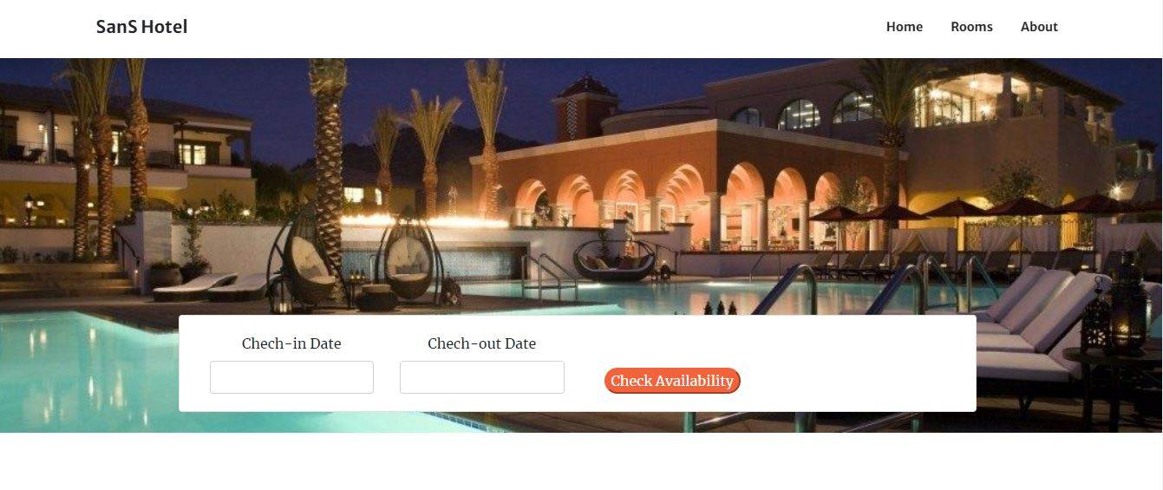
Fig7.1 Home Page view

7.2 ADMIN PAGE

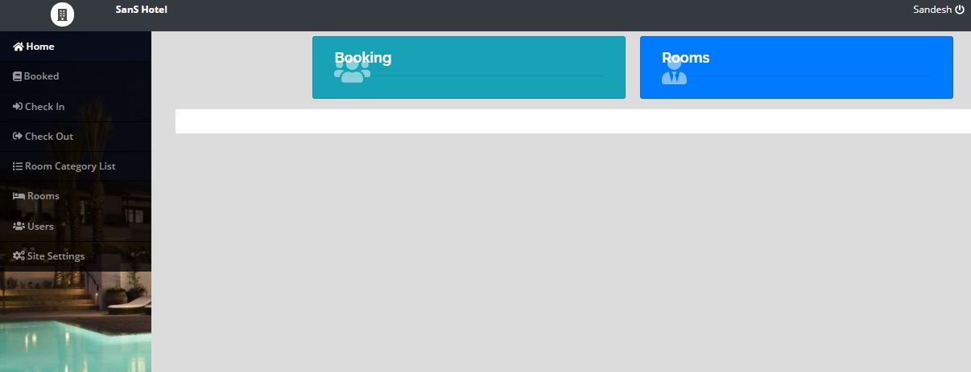
Fig7.2 Admin Page

7.3 ROOM’S PAGE
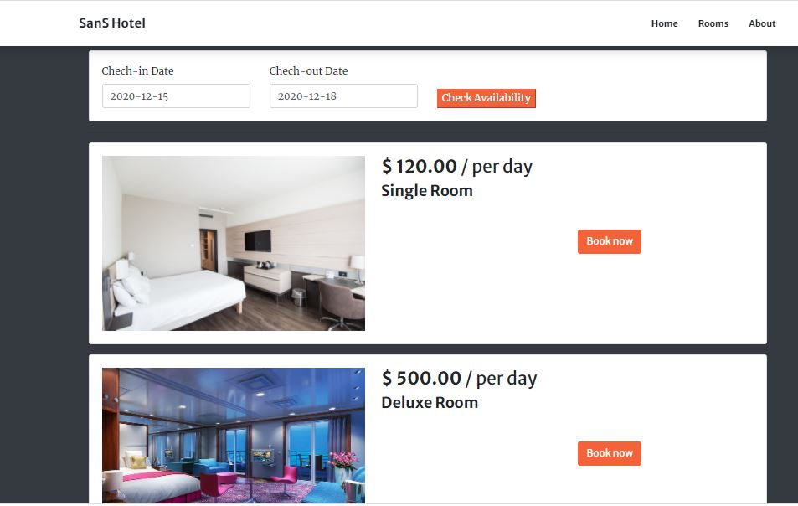

Fig7.3 Room details page

7.4 ROOM MODIFACTION PAGE

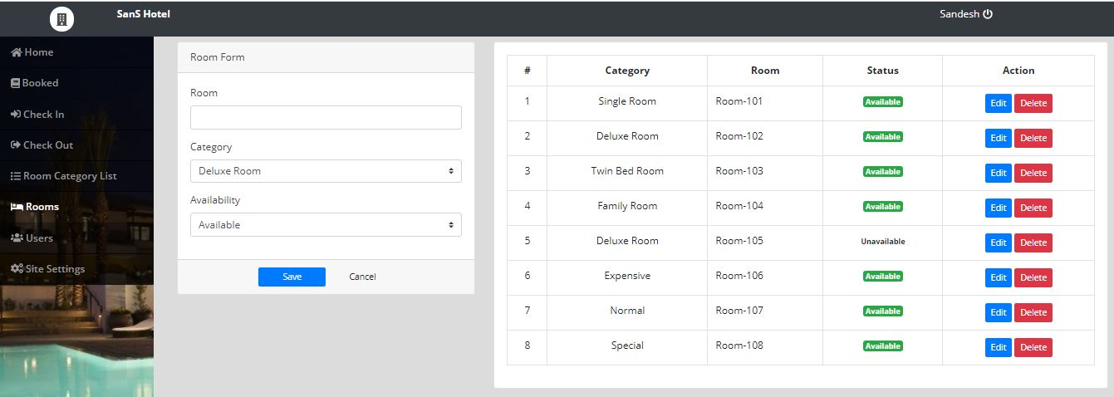

Fig7.4 Room modification page

7.5 SITE SETTING PAGE

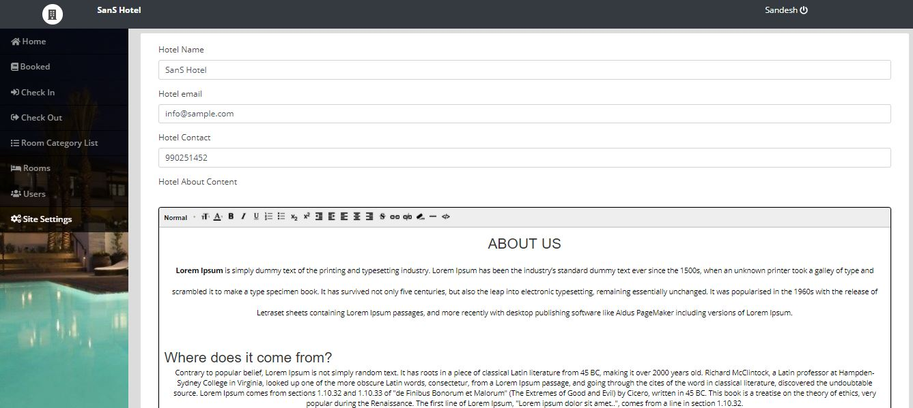

Fig7.5 site setting page

CONCLUSION

The project entitled “Online Hotel booking website” is developed using HTML, CSS and JavaScript as front end and SQL database in back end to computerize the process of online management of customers and bookings of hotel. This project covers only the basic features required. This web application involves almost all the features of the online booking. The future implementation will be online help for the customers and chatting with website administrator. The project greatly helped in understanding the various phases in website development and exposure to a new developer platform using PHP, HTML and database MySQL.

BIBLIOGRAPHY
Books Referred
- Robin Nixon, “Learning PHP, MySQL &JavaScript with jQuery, CSS and HTML5”, 4thEdition, O’Reilly Publications, 2015. (ISBN:978-9352130153)
- Luke Welling, Laura Thomson, “PHP and MySQL Web Development”, 5th Edition, Pearson Education, 2016. (ISBN:978-9332582736)
- Nicholas C Zakas, “Professional JavaScript for Web Developers”, 3rd Edition, Wrox/Wiley India, 2012. (ISBN:978-8126535088)
- David Sawyer Mcfarland, “JavaScript & jQuery: The Missing Manual”, 1st Edition, O’Reilly/Shroff Publishers & Distributors Pvt Ltd, 2014 (ISBN:9789351108078)
- Zak Ruvalcaba Anne Boehm, “Murach's HTML5 and CSS3”, 3rdEdition, Murachs/Shroff Publishers & Distributors Pvt Ltd, 2016. (ISBN:978-9352133246)

Websites
www.php.net/
http://www.google.com
http://www.w3schools.com

