**Qube Shooter**

**Planning**

**Document**

Contents

User Interface Mock-Ups 2

Main Menu 2

Main Game Stage 3

Screen Size & Aspect Ratio 6

Software Requirements 6

Deployment Methods 7

Platform Specific Features and Constraints 7

VR 7

PC 7

Methods for Handling Cross-Platform Issues 8

Identification of any environmental considerations 8

How Extended Reality Is Used in Games 8

History of VR 9

Target Markets and Demographics of VR 10

List of Successful competing VR Products 10

Chosen VR Technology 10

Physiological Constraints of the Platform 10

Haptic Feedback 11

Optimization and Performance Considerations 11

Market Size 11

Technical Specifications 11

Expected Issues and Proposed Solutions 11

Bibliography 12

# User Interface Mock-Ups

## Main Menu

The main menu brings attention towards the game, so it is can be interacted with the player. The title screen will be displaying a ‘PLAY’ button which will explode on being interacted by player. The options will be displayed on the top left of the screen, as a cog. For VR players, they only need to press the menu button on the controller.

Figure 1.0   
Displays the Main Menu screen.  
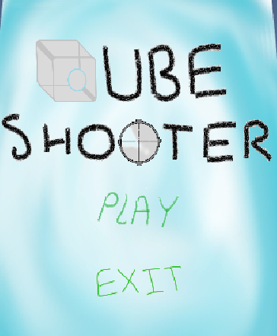

Figure 1. Main Menu

## Main Game Stage

The main game stage is where the player will spend most of their time. The player will be displayed a score meter (refer to Figure 5), a timer (refer to Figure 6), and the main playing arena. The main playing arena is displayed below.   
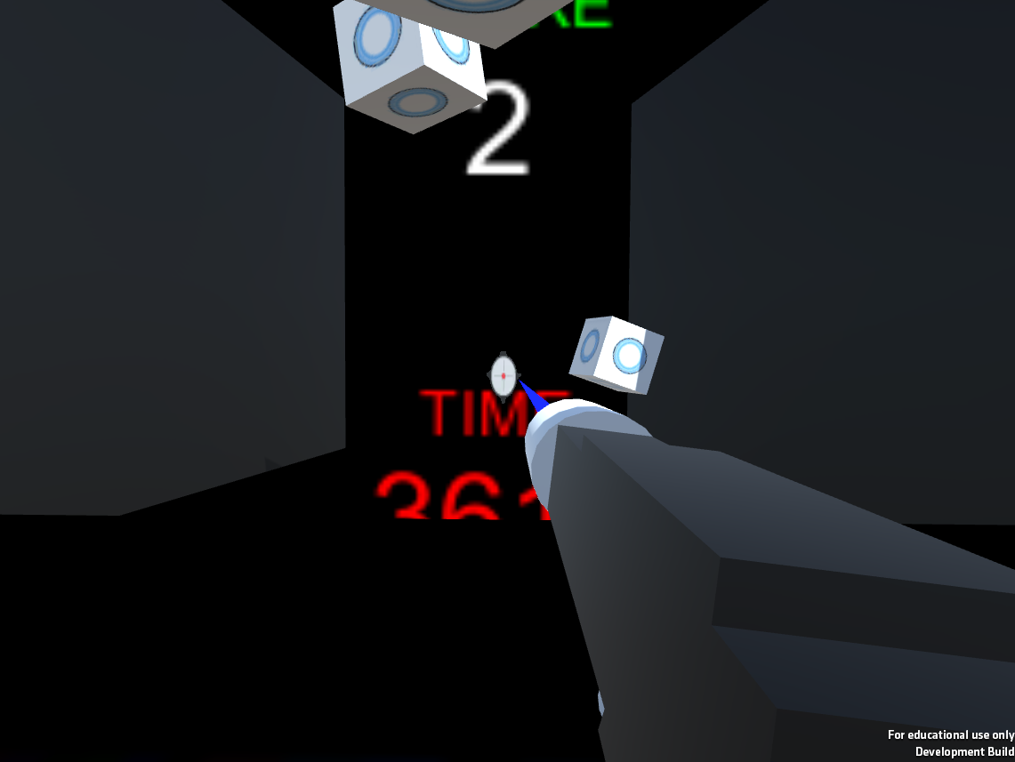

Figure 2.PC Game

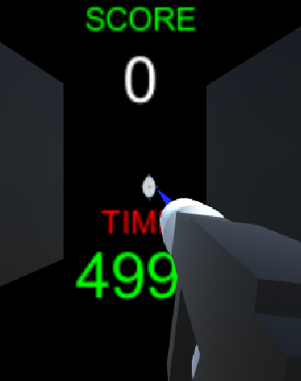

Figure 3.PC Game Example 2

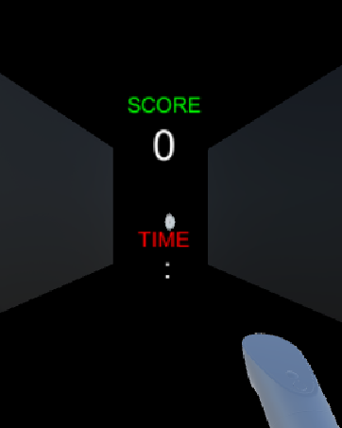

Figure 4. VR Game



Figure 5. Score Displayed



Figure 6. Timer Displayed

The game entices the player through using the bright and flashy colours, especially with the addition of VR. The player uses the given toy gun, to shoot the Mechanical Cubes. They will be increasing in speed from the increments of 5 from player score.

**Feeling Constricted**The Player at times will feel constricted at times during playing the VR version. This problem is only natural since the player will feel locked in this world not able to move. The measures taken to address this issue is to create a scene of darkness with a few lights inside the arcade shelter. This gives player motive to not move around, and stay inside of the lit place.

# Screen Size & Aspect Ratio

|  |  |  |
| --- | --- | --- |
| PLATFORM | SCREEN SIZE | ASPECT RATIO |
| PC | FullScreen and Windowed | 1980/720 |
| OCULUS | 2,560×1,440 LCD | 16:10 |

# Software Requirements

Minimum Software Requirements-

* 8 GB RAM
* 1280 AMD Radeon
* Windows 10 and 8

# Deployment Methods

The game can be installed by the Inno setup created installer. The installer installs the game correctly into the designed folder through Inno setup and to access the VR game, User needs to run game’s .APK file.

# Platform Specific Features and Constraints

## VR

|  |  |
| --- | --- |
| Features | Constraints |
| * VR allows players to escape reality and adventure through a virtual world of fantasy. This benefits the player in gaining knowledge, and experience through a safer environment. * VR is able to create free movement which is able to allow the player to be in full control of the entire game. The given ability of full control to player makes them more interested in the physics of this world and behavior of objects. | * The player must **feel** they are in the world. Some of the constraints many beginner VR developers fall into is not able to create a relatable world and interesting world. The world may not entice all players, making them more distant to the concept of another reality and more towards fake reality. * VR allows the user to be able to interact with nearly all objects, but there are relative constraints placed on those interactions. The player may not move beyond the control of their given controller, VR is still in development to create a free hand controller to interact. |

## PC

|  |  |
| --- | --- |
| Features | Constraints |
| * Games created in PC are the basic standard of many developers’ standpoint. The creation of games in PC allow the players to play games with a wide variety of controls. The controls may include the entirety of the keyboard, but increase with combinations using the mouse. | * Games created in PC hold a large variety of unique controls and give players and developers more choices with controls. The user-input created in PC games have better response, with the PC specification of hardware being better than most consoles. |

# Methods for Handling Cross-Platform Issues

|  |  |
| --- | --- |
| Issues | Methods For Handling |
| Screen HUD & GUI Design | The development of the game in both PC and VR makes the creation of HUD more complicated. The measures taken to avoid player nausea and sickness in VR, are to create a diegetic HUD. Such features like ‘Score’, ‘Targets’ and ‘Timer’ will be world objects present in the game. This will eliminate the nauseous effect on the player. |
| Camera Movement | The camera used in the VR headset, is directed and manipulated through the player’s view point. The player uses the controller to point at things in the VR world to interact with the world. In PC the world is interacted through a fixed camera being controlled by a mouse, in a fixed location (TPS). This problem will be fixed by adding in an algorithm which checks if the mouse is used, if used it will lock the screen as if a PC player is playing. Otherwise if a VR controller is used it will free the mouse from the middle of the screen. |

## Identification of any environmental considerations

|  |  |
| --- | --- |
| Game storage memory leaks | The build of the game upon creation creates many assets and objects in game. The game can cause memory leaks if memory not correctly disposed of. The objects in this game, only use the minimum amount. At one point only five objects will be able to be target, and after timer runs out the objects get disposed of. |
| Ethical Issues With Shooting Game | The Game does not promote the active use of guns, and does not entice the player into becoming comfortable with shooting guns. The game allows the player to shoot targets in a virtual world. To avoid the realism of gun violence and the use of guns in a harmful way, the targets are fun cubes. They are chosen to be cubes, to create a differentiation between people and objects. |

# How Extended Reality Is Used in Games

Extended Reality is an umbrella term for all immersive technologies, which includes AR, VR and MR. These technologies extend the reality we experience by either mixing the virtual and real world, or creating an entire virtual fake world.   
  
**Augmented Reality (AR)**  
Virtual information and objects are placed on the real world, this can be seen through either an object being mapped on a camera. This will give the effect of the VR sprite in the real world, this example is profoundly used in the late released game Pokémon Go. You may also find such an experience through AR glasses, screens, tablets and smartphones.

**Virtual Reality (VR)**The user is placed into a completely virtual world, which can be interacted with and is completely separate to the real world. This allows the player to live and experience moments most players aren’t able to experience in the real world, like stepping on the Moon. This requires the individual to put on a VR headset or head-mounted display to get a 360-degree view of an artificial world, making them believe they are in this world.

**Mixed Reality (MR)**

This is comprised of digital and real-world objects, which coexist to create a mixed reality experience. This hybrid reality requires an MR headset and lot more processing power than VR or AR. Such examples like the HoloLens allows player to place digital objects into the room you are standing in and give you the ability to interact with the digital objects in correspondence with real objects.

# History of VR

In 1965, Ivan Sutherland devised his concept of the VR goggles and envisaged a virtual world viewed through an HMD with 3D sound and tactile feedback. It also was connected to a computer that created simulations in real time, and allowed the user to interact with objects in a realistic way. Ivan created the “Sword of Damocles”, which was developed with an HMD connected to a computer, but was very unwieldy and uncomfortable. It needed to be suspended from the ceiling and user was strapped into it to be shown primitive computer-generated graphics with objects in wireframe rooms.

After many failed and close attempts by the gaming industry Sega, Jaron Lanier was working to create several innovations for VR. This is where his company launched the EyePhone, a headset that linked with a wearable input device used to track finger and hand movements. In 1987, the LCD screens in the glasses had a refresh rate of five or six frames per second, but even in its entirety wasn’t perfect. Though the VR was not perfect, the combination of head-mounted 3D video and haptic response through a custom controller inspired many next generations to experiment with such technology.

Many years later, the usage of headsets with inbuilt faster refresh rates and 3D videos with clear view became a norm for VR. A number of companies made headsets for the PC market in the late 1990s and early 2000s, which were typically bulky with low-resolution screens and less accurate head tracking. Though with the introduction of CyberMaxx, the manufacturers had integrated slightly more complex technology.

The VR gaming industry began expanding in 2012, when Oculus had raised $2.5M on Kickstarter. The use of 1080p OLED displays for each eye, IR-driven position locations systems with accuracy to less than a millimeter. Some examples of such Oculus games include space shooter ‘Elite: Dangerous’ and brilliant indie party game ‘Keep Talking and Nobody Explodes’.

The latest rendition of the VR scheme lies with the ‘Project Morpheus’ which is Sony’s entry into the VR world. This console uses positional LEDs that interface with the PlayStation Camera to monitor head movements, boasting full 360-degree mobility.

# Target Markets and Demographics of VR

Research displays the demographics of the VR embraces the younger generations more than the older. This is in favor of the younger audience, as many young adults would love to experience the virtual world. Though many young adults from a variety of surveys are more likely to use VR for games, there has been an increase in older generation’s consumption with VR. This creates a balanced target audience for VR allowing it to be used and played for all ages, making it more flexible and commercially advantageous.

# List of Successful competing VR Products

* PlayStation VR
* Oculus Rift
* HTC Vive

# Chosen VR Technology

The chosen VR technology is Oculus GO, because of personal preference and a few determining factors. The client has proposed the game to be created in VR, so Oculus is used due to its overwhelming fame over the last few months. The Oculus contains the correct project handlers; it works with the gaming engine Unity which is used to create the game. Due to ease of access and ease of use the Oculus is used, as well as its highly effective flexibility in components.

## Physiological Constraints of the Platform

The VR platform allows the player to not only envision the virtual world but be part of through the game’s intractable gun and targets. The game immerses the player into believing they are in a retro arcade game. Though these come hand in hand when moved over to PC, some constraints include-

|  |  |
| --- | --- |
| Constraints | Solutions |
| Player Immovable | The player will be immovable throughout the game; this was a choice made by the developer to further build on the arcade playstyle. Many retro games only had the one controller that can be aimed, and didn’t have many movement controls shared with the player. |

### Haptic Feedback

Haptic feedback is not supported in this game, as it will be highly dangerous if the player could feel being hit, and felt the realism of firing a handheld gun.

**Potential**

Haptic feedback has huge potential in many applications, it could simulate moving in a train, and making player feel the wind. It could lead VR to include the taste, smell and other senses in the mix, to bring realism into the world.

## Optimization and Performance Considerations

The Game ‘Qube Shooter’ uses few objects and sets skybox to dark, to create the environment. The use of less objects in scene reduces memory consumption and storage. The use of storage is managed by only spawning five enemy objects at once, and once reset they are destroyed preventing memory leakage. The graphics used for the game aren’t super in detail and high resolution with detailed texture, allowing the game to use less storage and processing speed when rendering in these objects. This is created due to the lack of processing speed in VR, because many high end gaming PC’s are better than most VR products in processing speed.

## Market Size

The amount of people with the Oculus Go, increases the amount of people in the market that will be more likely to buy and play ‘Qube Shooter’. Research reports that Oculus Go has sold over one million units since its launch in May 2018.

# Technical Specifications

The Oculus Go is kitted with a Qualcomm Snapdragon 821 processor with a 5.5-inch, 2560 x 1440 WQHD fast-switch LCD display. This becomes 1280 x 1440 per eye, and fast-switch allows pixel color to change faster, and cuts down on motion blur and motion sickness. In addition, the refresh rate can vary between 60 to 72 Htz depending on use.

**Controller**

The controller is designed with a directional touchpad, with shortcut buttons for Home and Back, with one trigger. The 2.3-ounce, 4.4 x 1.5 x 2.2-inch, matte plastic slate-gray controller, with a touchpad at the top. As well as a plastic trigger at the rear of the controller designed for the index finger.

**Battery Life**

Oculus Go can last up to 2.5 hours depending on the use.

# Expected Issues and Proposed Solutions

|  |  |
| --- | --- |
| Issues | Proposed Solutions |
| Developer has never worked with debugging and building on VR | Can be solved by looking up Canvas Tutorials, YouTube tutorials, and Visual Studio commands that works with VR. These can be used to infer how to create and build with VR. |
| Ray Cast never implemented in VR | Ray Cast can be implemented, and will be found by searching on Canvas Tutorials, Visual Studios 2017 commands. These commands will allow the use of Ray casts and will help determine which commands required to implement Ray Casting. |
| Memory storage needs to be kept at a minimum, and might increase | This memory leak can cause several problems, so one of the solutions is to create a fixed amount of obstacles. This will then not only reuse existing objects as targets, but create objects only when needed, making processing speed faster. |

# Bibliography

Marr, Bernard. “What Is Extended Reality Technology? A Simple Explanation For Anyone.” *Forbes*, Forbes Magazine, 12 Aug. 2019, www.forbes.com/sites/bernardmarr/2019/08/12/what-is-extended-reality-technology-a-simple-explanation-for-anyone/#5090f26f7249.

Jenson, K. Thor. “The History of Virtual Reality Video Games.” *Geek.com*, 15 Apr. 2016, www.geek.com/news/the-history-of-virtual-reality-games-1652225/.

“Who to Target With Virtual Reality Marketing.” *Interactive 3D Content Services for AR and VR*, VIZ 360, 31 Jan. 2019, www.viz360.com/virtual-reality-marketing-target-audience/.

Fogel, Stefanie. “Oculus Expected to Sell 1.3 Million Quest Units in 2019, SuperData Believes.” *Variety*, 24 Jan. 2019, variety.com/2019/gaming/news/superdata-extended-reality-report-1203115821/.

Smith, Sherri L. “Oculus Go Review: The First Stand-Alone VR Headset Is a Winner.” *Tom's Guide*, Tom's Guide, 18 Dec. 2018, www.tomsguide.com/us/oculus-go,review-5368.html.