DEPARTMENT OF PHYSICS

UNIVERSITY OF COLOMBO

PH 3039 - Data Acquisition Laboratory

2022



**Weather Station**

Name: D.P. Sasindu Dilhara

Index: s14811

Date: 15/09/2022

ABSTRACT

Weather monitoring deals with tracking, and possible prediction of the weather conditions of a geographical area. The system is built around a collection of different sensors and a microcontroller. The primary goal is to create a low cost, adaptable system for storing measured data, it is an advanced and efficient solution for connection to the internet. The ESP32 microcontroller is in the series of low power and low cost on chip microcontroller which comes up with already integrated dual mode Bluetooth and Wi-Fi. DHT11 sensor is used to get the temperature and humidity data, BMP 180 is used to get pressure and altitude data, and to get luminosity data, LDR is used. Then weather data will be recorded on google sheet and analyzes them with Grafana and creates the dashboard.

**TABLE OF CONTENTS**

1 INTRODUCTION 1

1.1 Subtopic 1 1

1.2 Subtopic 2 1

2 THEORY 2

3 METHODOLOGY 3

4 RESULTS AND ANALYSIS 4

5 DISCUSSION 5

6 CONCLUSION 6

7 REFERENCES 7

**TABLE OF FIGURES**

Figure 1‑1 Distances between the best fit line (Source: www.abc.com) 1

**LIST OF TABLES**

# INTRODUCTION

Weather stations have become quite popular nowadays, as they can forecast everything regarding weather more accurately, unlike older devices.

It is a low cost, adaptable device that collects data in real time, related to the weather and environment using different sensors. Commonly measured environmental variables include temperature, light, relative humidity, rain and wind.

It Instantly provides alerts regarding abnormal changes in the weather and can share these weather data on various devices by connecting the weather station to a WIFI network.

Various electronic devices(sensors) can be connected via a network and then data can be retrieved for analysis and processing

The system is a development of weather reporting with an ESP 32 which serves as the central microcontroller. The sensors are linked to it with digital and analog pins. Esp32 receives readings from sensors in the environment and process them before displaying their results on the ESP serial monitor.

(The Esp32 system-on-chip microcontroller supports WIFI 802.11 b/g/n, dual mode Bluetooth and a variety of peripherals. The 8266A, is essentially a two-core processor that can be clocked up to 240 MHz Additionally, it has a 4MB flash memory, an increase in the number of GPIO pins from 17 to 36, and 16 additional PWM channels. The processor comprises a total of two central cores (the Extensa LX6 processor, made with 40 nm technology). Individual CPU cores can be manipulated. Data and instructions can be stored in the 520 KB of on-chip SRAM. For example, the ESP32-Wrover SOC module has 4 MB of external SPI flash and an extra 8 MB of SPI PSRAM for use in custom applications (Pseudo-static RAM). Depending on the board type, we can employ varying amounts of SPI, I2S, I2C, CAN, UART, Ethernet MAC, and IR. A temperature sensor and a touch sensor are also included as standard equipment)

Weather data read by BME280 will be recorded on google sheet.

# THEORY

A weather station is a building, on land or at sea, that has tools and apparatus for measuring atmospheric conditions, which it uses to study the weather and climate and to give data for weather forecasts. ESP32 can measure the usual weather parameters; like temperature, humidity, air pressure, wind direction and speed. For this, the sensor should be connected externally.

## Esp32 Wi-Fi Bluetooth module

The chip was created by Espressif Systems and is known as ESP32. This gives embedded devices connectivity for Wi-Fi and, in some models, dual-mode Bluetooth. The manufacturer frequently refers to modules and development boards that contain this chip as "ESP32" even though it is only the chip in theory.

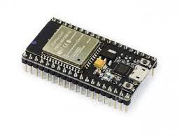

Figure ESP32 Wi-Fi Module

(Source:https://www.google.com/search?q=esp32+module&source=lnms&tbm=isch&sa=X&ved=0ahUKEwiMgMyqz5v6AhWnx3MBHfnfAcwQ_AUIBigB&biw=995&bih=422)

In ESP32 used “Tensilica Xtensa LX6” microprocessor. There are filters, power amplifiers, low-noise receive amplifiers. The ESP32 as a standalone chip or as a full featured development board.

The ESP32 is more powerful and faster than Arduino. It has a 32-bit microcontroller and 10 internal capacitive touch sensors. Specific static pins are designated for the ADC (analog to digital converter) and DAC (digital to analog converter) functionalities. The pins that will be used for UART, I2C, SPI, PWM, etc. can be chosen; all you need to do is designate them in the code. The multiplexing function of the ESP32 chip makes this possible.

### ESP32 power consumption

When not in use, the ESP32 can go into a power-saving mode called "sleep mode," which saves all data to RAM. Any unneeded peripherals are now turned off, and the RAM is given enough power to maintain its contents. ESP32 has light sleep mode and deep sleep mode. ESP32 when the deep sleep mode it has a more power consumption than light sleep mode.

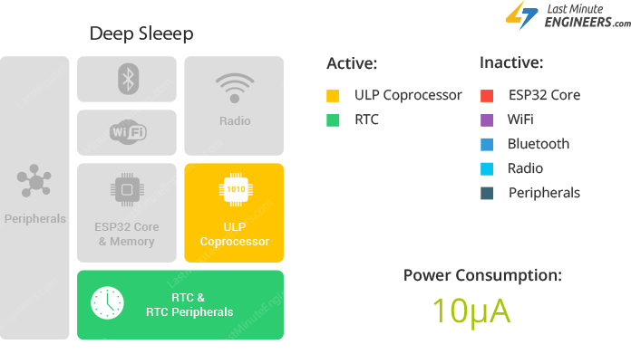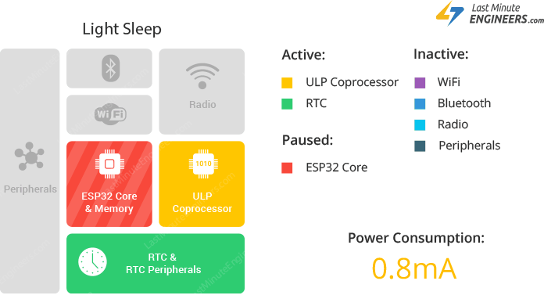

Figure : Comparison of light sleep mode and deep sleep mode of ESP32

(Source: [ESP32 Sleep Modes & Their Power Consumption lastminuteengineers.com](https://lastminuteengineers.com/esp32-sleep-modes-power-consumption/))

### ESP32 standalone

ESP32 can function as a full standalone system or as a slave device to a host MCU, which lessens the burden on the primary application CPU caused by communication stack overhead.

## DHT11 Sensor

The DHT11 sensor is a basic low budget temperature and humidity sensor. It can measure the humidity in the air using a thermistor and a capacitive humidity sensor and it outputs a digital signal on the data pin, there is no analog input pins needed. Although reasonably easy to operate, data collection requires precise timing.

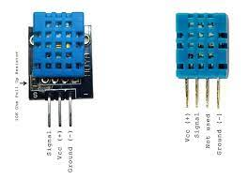

Figure : DHT11 sensor

(Source:https://www.google.com/search?q=dht11+sensor&source=lnms&tbm=isch&sa=X&ved=0ahUKEwiW4_jfnZ76AhVb63MBHTAHDCMQ_AUIBigB&biw=1349&bih=659)

The DHT11 uses a 3-5.5V DC power supply. To get over the unstable status after the sensor receives power, don't send it any instructions for one second. DHT11 can measure 0 to 50 Celsius temperature range and 20% to 90% humidity range. There are and accuracy.

## BME180 Pressure sensor

## LDR sensor

LDR means Light Dependent Resistor. LDR is made from a piece of exposed semiconductor material. This sensor is a light-sensitive device that is often used to indicate the presence or absence of light or to measure the intensity of light.

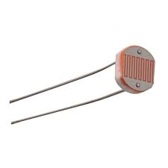

Figure : LDR sensor

(Source: [ldr sensor - Google Search](https://www.google.com/search?q=ldr+sensor&sxsrf=ALiCzsZPyN54sRBWSv1anwy653mGzxdf4g:1663514775817&source=lnms&tbm=isch&sa=X&ved=2ahUKEwi96Km60576AhXiFbcAHVITD2AQ_AUoAXoECAIQAw&biw=683&bih=656&dpr=1))

This resistor can vary from about 100 Ohm in the sun light, to over 10 Mega Ohm in absolute darkness. Alarm clocks, street lights, light intensity meters are some applications of LDR sensor.

# METHODOLOGY

## PCB design and making

First PCB was designed using EasyEDA software. Additionally, it is processed using sensors.

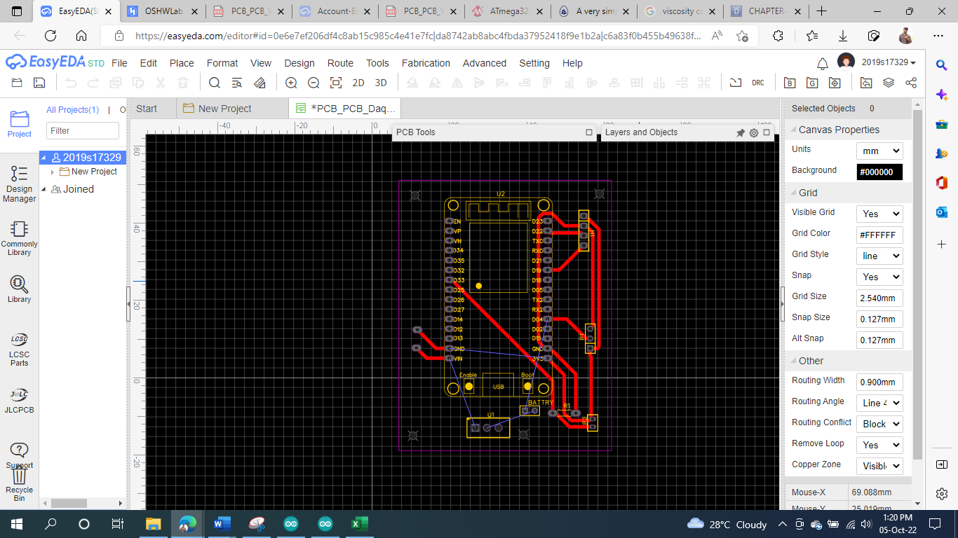

Figure : PCB design using EasyEDA software

Routing the whole path of the PCB and download pdf of circuit. Then PCB was marked according to the relevant process.

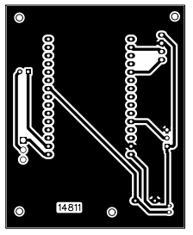

Figure : Structure of the final PCB design

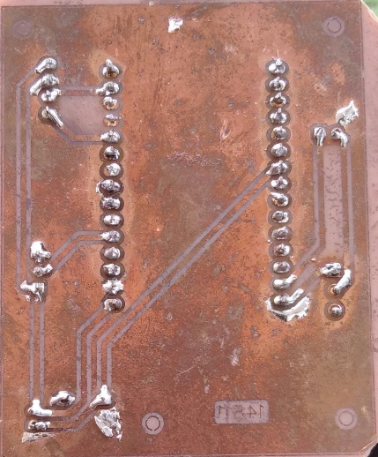

Figure : Real PCB marking

DHT11 sensor, BMP180 sensor and LDR sensor were attached to the PCB. Also attached is an 18650 (3.7 V) battery. The switch was set to control on/off of the battery.

BMP180

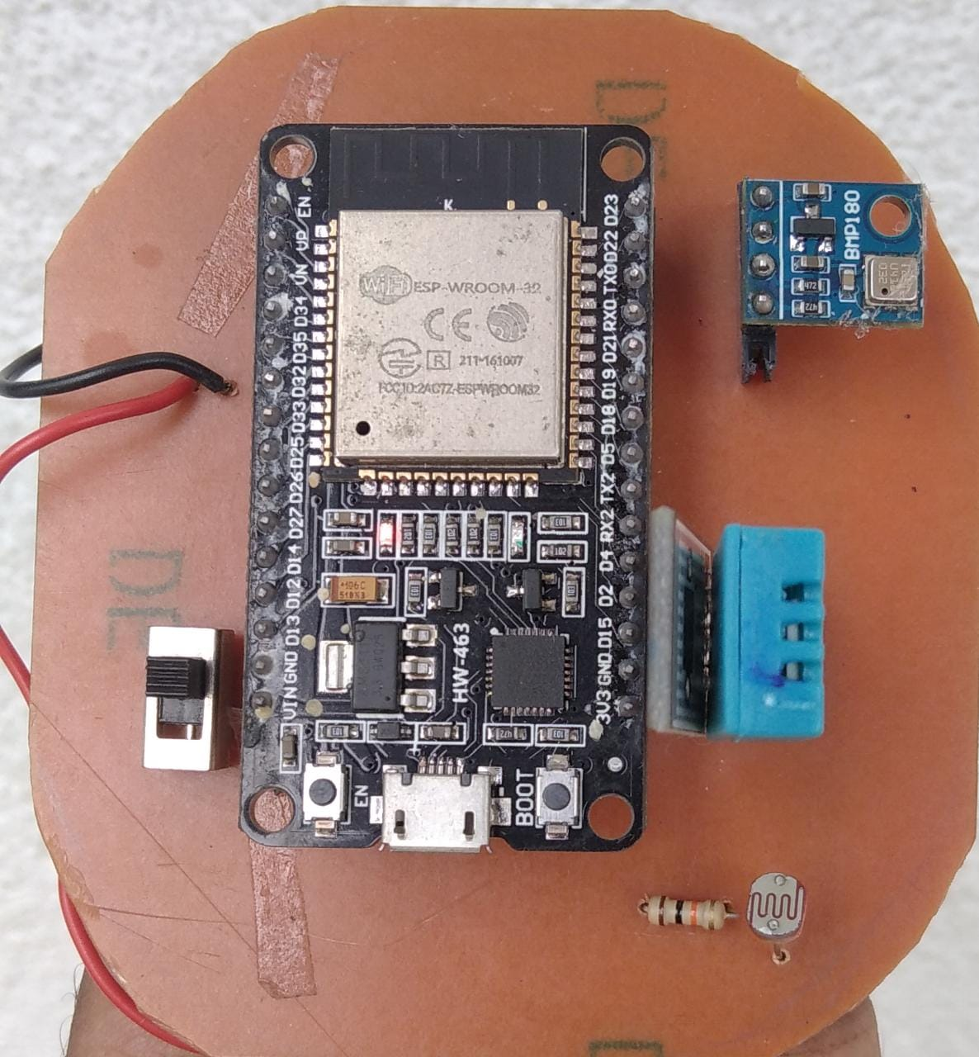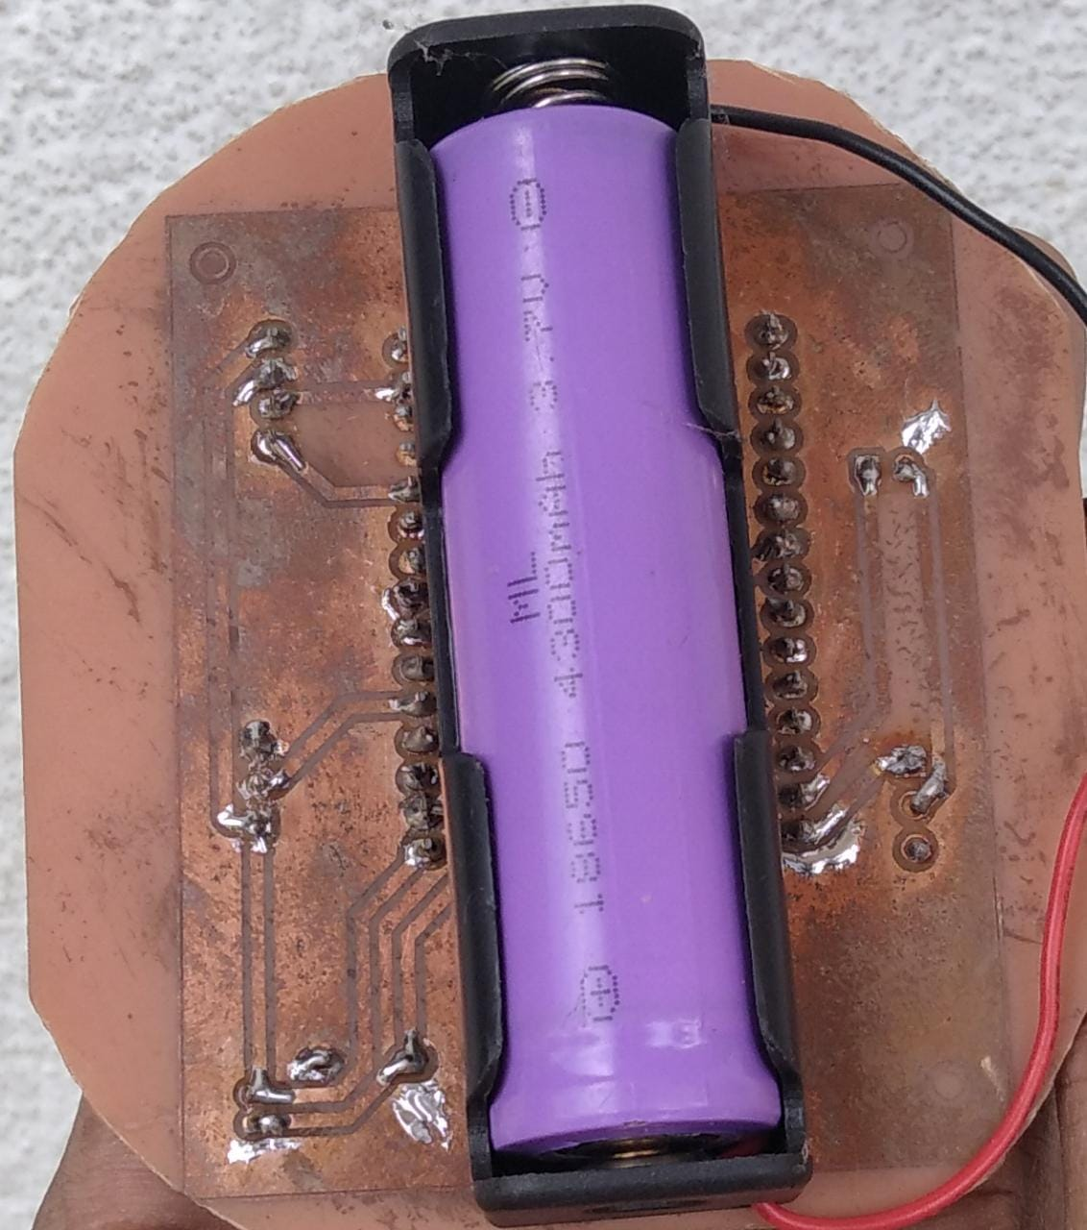

switch

DHT11

LDR

18650

battery

ESP32

Figure 8: Adding the components to the PCB

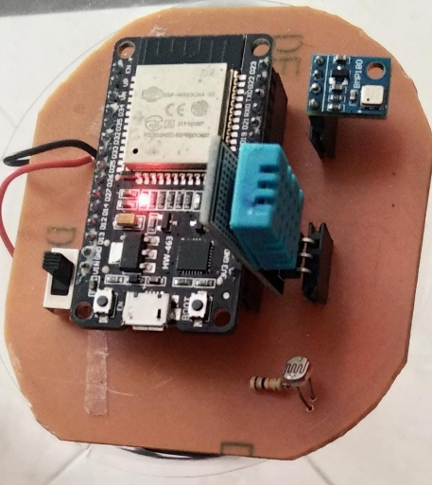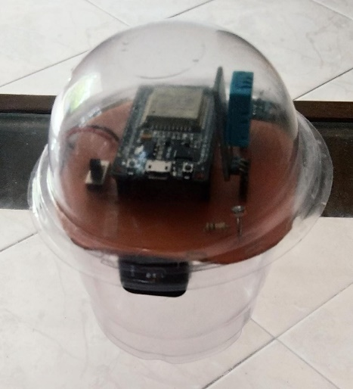 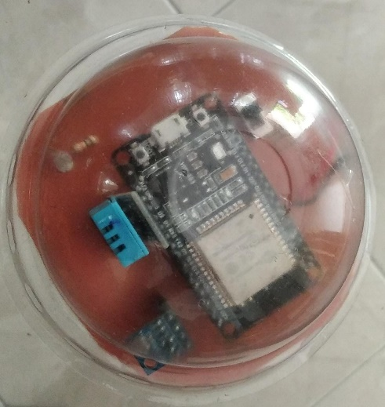

Figure : Final look of the weather station

## Installing the ESP32 in Arduino IDE

In this experiment was used ESP32 microcontroller. The ESP32 can be programmed with the Arduino IDE and its programming language using an add-on for that software. Before installing ESP32 wants to update to the latest version of the Arduino IDE. Then open the Arduino IDE and go to File, Preferences.

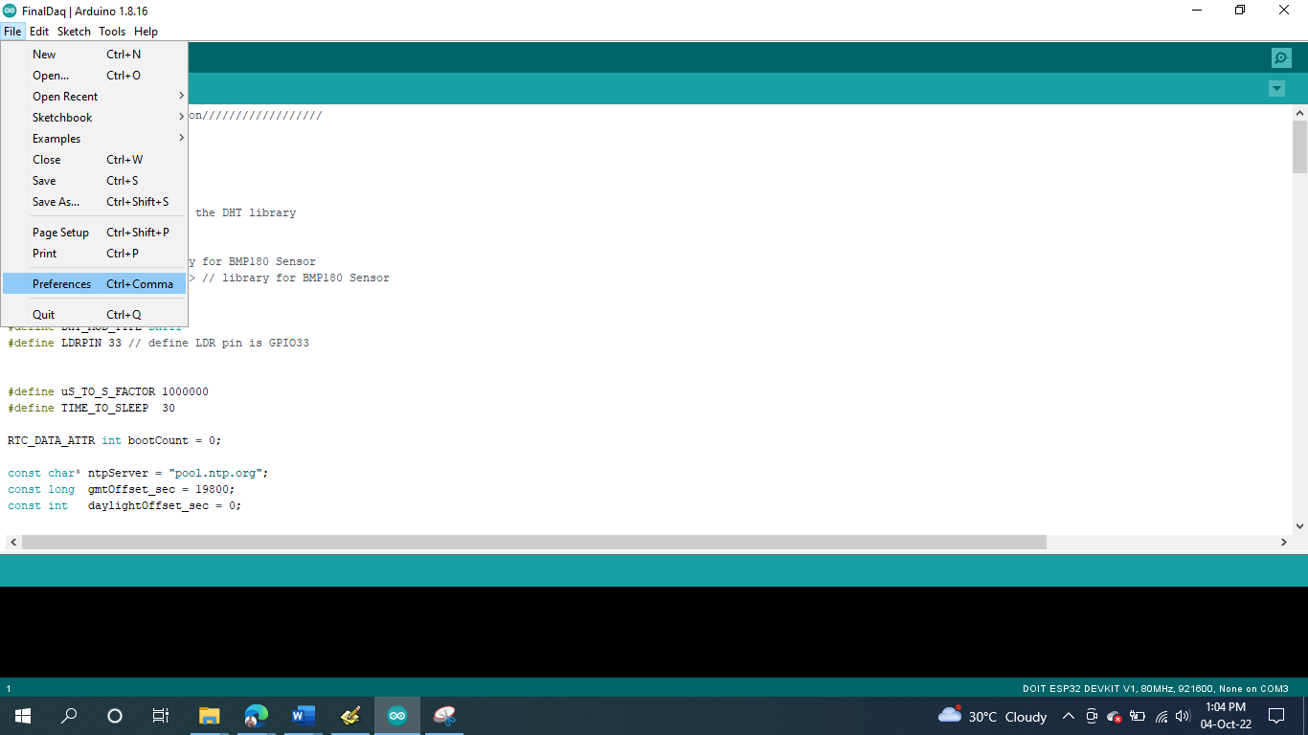

Figure : open the Arduino IDE and go to file preferences

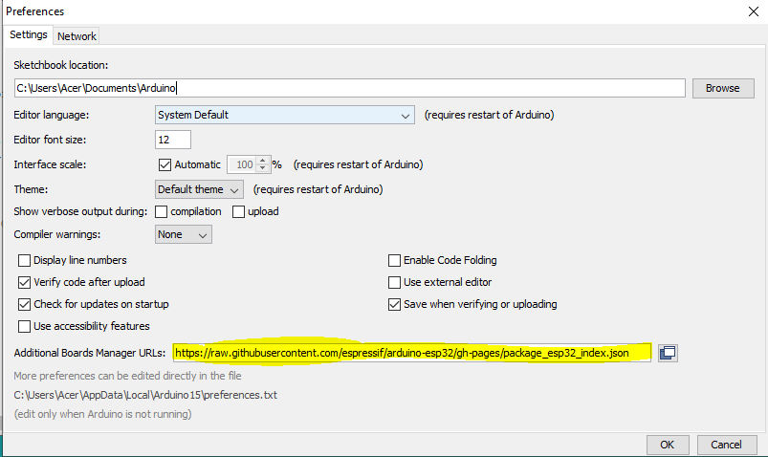

Figure : Enter the additional Board Manager URLs

In Figure 6 highlight part was shown the json URL. Then click the tools in action bar was selected the Boards Manager. And also selected the board as DOIT ESP 32 DEVKIT V1.

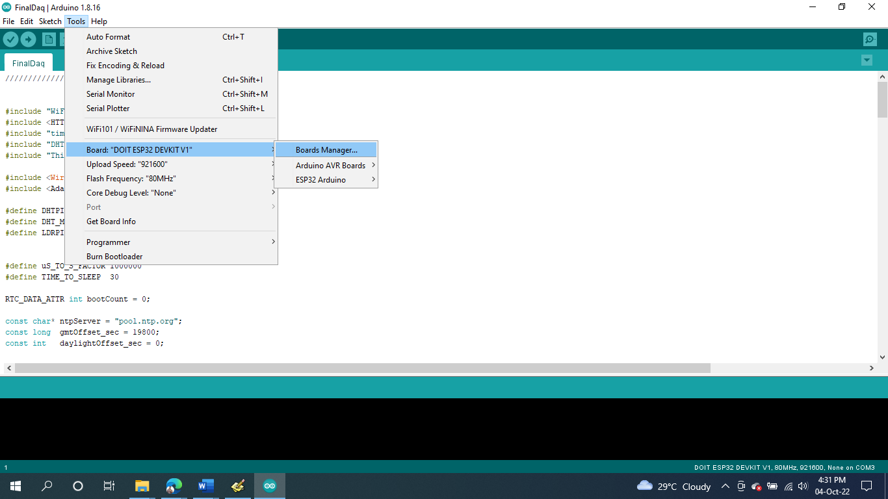

Figure : Selected the Boards Manager

Select the Boards manager and search ESP32 in the search box. Then installed the ESP32 by Espressif Systems.

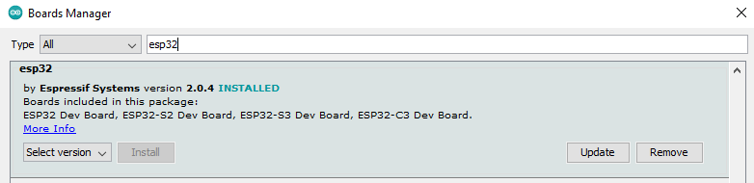

Figure : Installed the ESP32 Systems

## Creating Google Sheet and Data Logger

In here, was used IFTTT platform. IFTTT is the web base service. IFTTT means If This, Then, That service. Its purpose is to connect disparate services and systems. Users can automate web-based processes and increase productivity with the use of this free web application. IFTTT links diverse developers' hardware, software, and applications to produce "applets" that carry out automations.

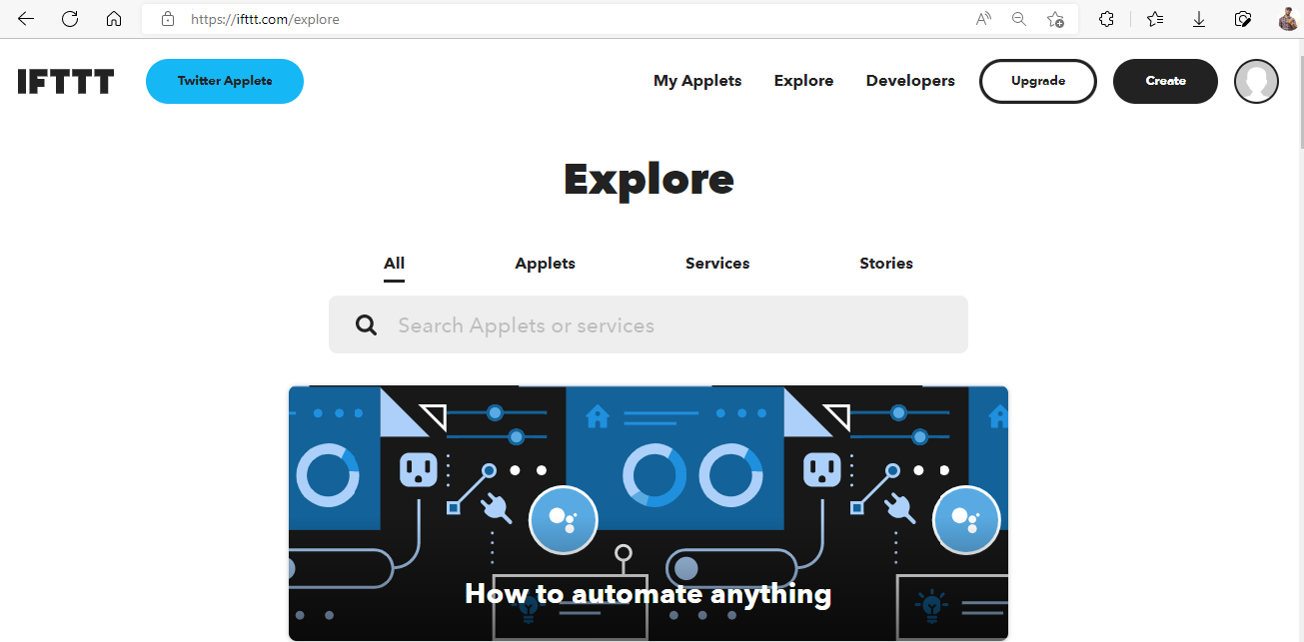

Figure : IFTTT web service interface

Press the create button and proceed. Then the applet can be seen as 'if this then that'. They should be filled one by one.

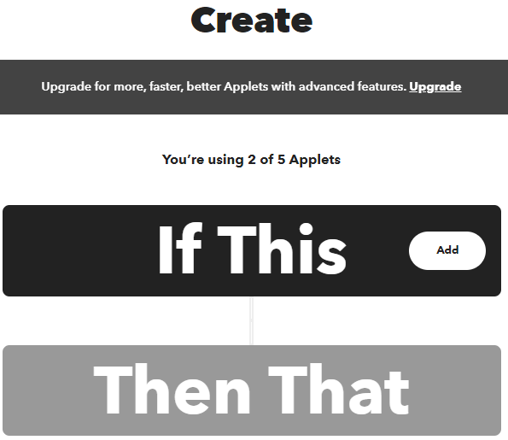

Figure : If This Then That applets

Then click the add button can be seen choose a service. Webhooks was searched the search bar and clicked it.

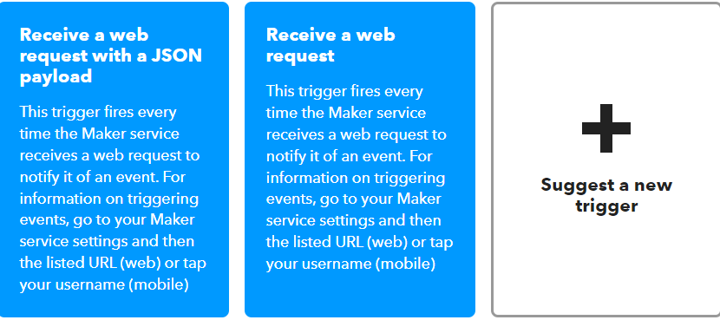 

Figure : Search the Webhooks service and receive a web request

After the entering the Webhooks choose the receive a web request. Event Name was given in next page and create a new trigger.

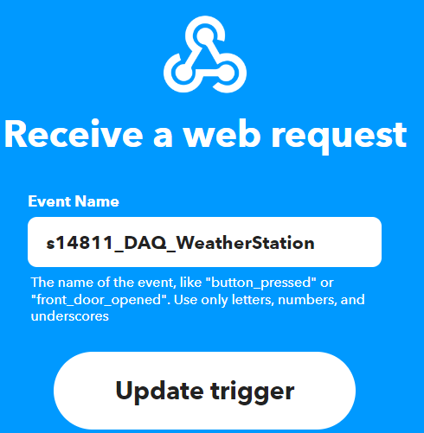

Figure : Create a new trigger in Webhooks

After that choose the google sheet service and select the ‘add row to spreadsheet option’. This action will add a single row to the bottom of the first worksheet of a spreadsheet.

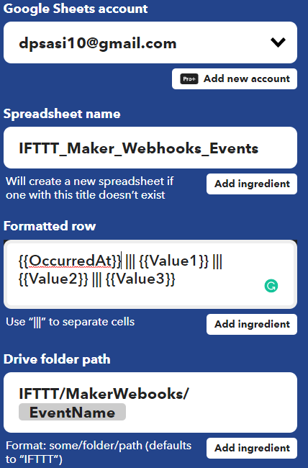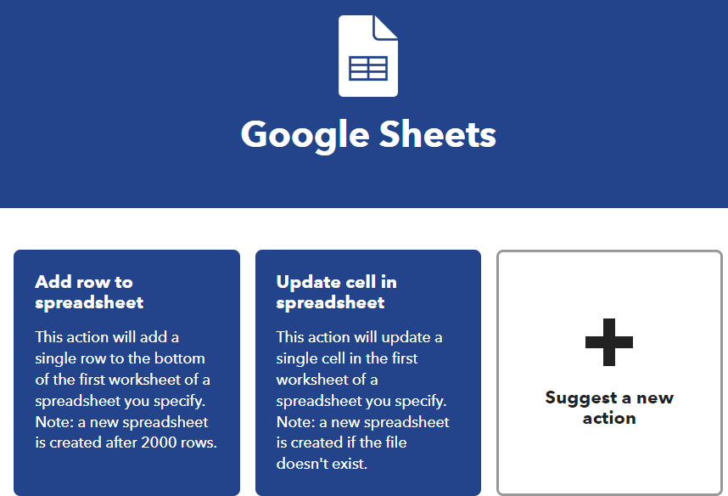

Figure : Choose the Add row to spreadsheet option

More details can be seen after selecting Add row option. Here you can see the details of the Account, spreadsheet name, formatted rows and Drive Folder path, where the google sheet is created. They can also be changed if needed.

When logged into the relevant google drive, a google sheet with the event name has been created.

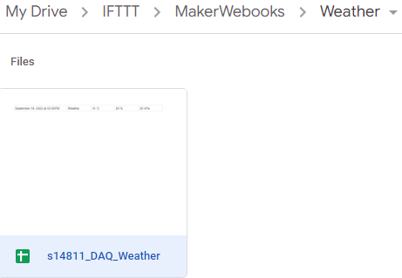

Figure : Google Sheet create in the google drive within event name

A test run can be done to see if the data goes to the Google Sheet.

## Data Visualization using ThingSpeak

Arduino IDE serial monitor was used to data visualization. The best observation can be obtained from the 'Thinkspeak' online, even if it is possible to represent the serial monitor. The web browser was opened and searched “Thingspeak” channels.

First haven’t any ThingSpeak account create account using Gmail. Then create new channel and the "Name" column was then filled with "DAQ Weather Station." Then "Temperature" was entered in "Field 1." Then the other field for "Humidity," "Pressure," and "Light Intensity" was filled in in the same manner. The "Save Channel" button was clicked after the user-required form had been filled out. The new channel was then developed.

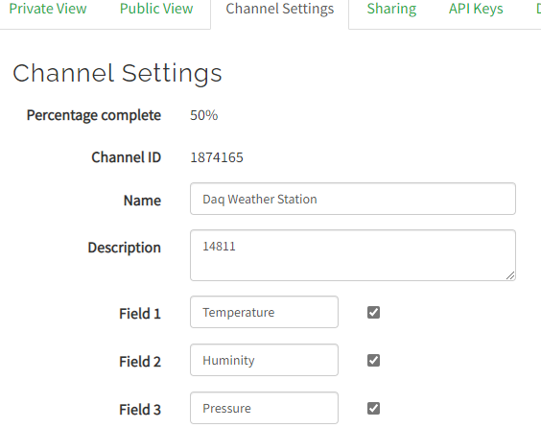

Figure : "ThingSpeak" channel setting

For show channel location we can give Latitude and Longitude in ThingSpeak.

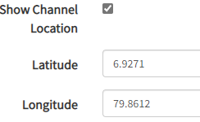

Figure : Given Latitude and Longitude of station location

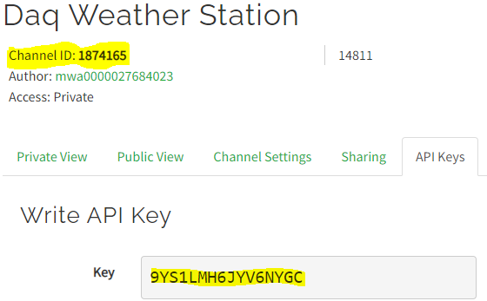

Figure : API Keys and channel ID of ThingSpeak

ThingSpeak website and Arduino IDE can be connected using "API key" and "channel ID". Finally, we can come to some conclusions after studying the dashboards of ThingSpeak.

# RESULTS AND ANALYSIS

## LDR sensor calibration

Lux meter was used for get corresponding resistance value of LDR sensor in different light intensity. Then Excel was used to obtained the graph of lux value and resistor value.

Table : Lux values with ADC values(resistance) for LDR calibration

|  |  |
| --- | --- |
| Lux Value | Resistance Value |
| 0.6 | 630 |
| 128 | 540 |
| 305 | 457 |
| 500 | 380 |
| 670 | 320 |
| 995 | 219 |
| 1380 | 135 |
| 1615 | 91 |
| 2000 | 60 |

Figure : Graph of Lux value vs Resistor value of LDR in different light intensity

According to the above graph when low light intensity resistor value was increase and high light intensity resistor value was become decrease. The graph was given the equation for the calibrate LDR sensor.

## Data logger and analyze

In this experiment was used ESP32 microcontroller. Weather station update every 60 seconds in the google sheet. ESP32 goes into deep sleep mode to avoid power loss between two modes because it records the weather only once every 60 seconds. Power consumption is very important because the weather station receives power from the battery. By saving power, you can easily get a day's worth of data from a fully charged battery.

Wi-Fi was enabled, the weather station was powered on, and data transmission was permitted. Data on temperature, humidity, light intensity and atmospheric pressure has been sent to a Google Sheet.

Table : Enter the data using WIFI to the Google Sheet

|  |  |  |  |  |  |
| --- | --- | --- | --- | --- | --- |
| Date | Time | Temperature(*C) | Humidity (%) | Light Intensity | Pressure (Pa) |
| 9/27/2022 | 10.51.34 | 32.7 | 70 | 585.13 | 100825 |
| 9/27/2022 | 10.52.20 | 32.7 | 70 | 590.3 | 100827 |
| 9/27/2022 | 10.53.07 | 32.7 | 70 | 590.3 | 100829 |
| 9/27/2022 | 10.54.00 | 32.7 | 69 | 590.3 | 100824 |
| 9/27/2022 | 10.54.46 | 32.6 | 69 | 509.58 | 100823 |
| 9/27/2022 | 10.55.19 | 32.7 | 75 | 464.58 | 100819 |
| 9/27/2022 | 10.56.35 | 32.3 | 69 | 581.84 | 100814 |
| 9/27/2022 | 10.58.18 | 32.8 | 68 | 590.3 | 100806 |
| 9/27/2022 | 11.03.05 | 32.7 | 69 | 590.3 | 100811 |
| 9/27/2022 | 11.03.59 | 32.7 | 69 | 590.3 | 100809 |
| 9/27/2022 | 11.04.45 | 32.7 | 69 | 590.3 | 100814 |
| 9/27/2022 | 11.05.30 | 32.7 | 68 | 590.3 | 100806 |
| 9/27/2022 | 11.06.14 | 32.7 | 69 | 590.3 | 100809 |
| 9/27/2022 | 11.07.00 | 32.1 | 69 | 590.3 | 100804 |
| 9/27/2022 | 11.07.58 | 32.2 | 69 | 590.3 | 100811 |
| 9/27/2022 | 11.41.56 | 32.2 | 77 | 590.3 | 100762 |
| 9/27/2022 | 11.42.39 | 32.7 | 71 | 590.3 | 100766 |
| 9/27/2022 | 11.43.26 | 32.7 | 69 | 590.3 | 100767 |
| 9/27/2022 | 11.44.10 | 32.7 | 69 | 590.3 | 100763 |

The data obtained by the weather station was taken to "ThingSpeak" and data visualization was done from it.

ThingSpeak retrieves the latitude and longitude of the location where the data is received.

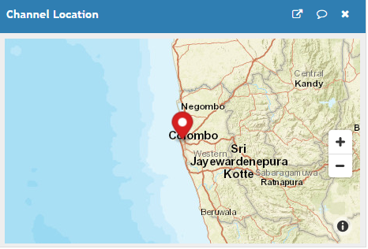

Figure : ThingSpeak get Latitude and longitude of the weather station location

Data were taken when weather station connected to the WIFI. Temperature was displayed in ThingSpeak dashboard as below.

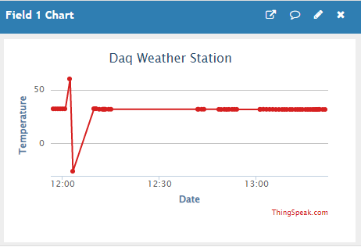

Figure : Temperature graph of ThingSpeak

There are some unusal points. It may be happened because poor WIFI connection. Almost all the time it has not much variation.

Widgets can be added in ThingSpeak and below gauge shown the average temperature in data collecting period. It value is 31.6 Celsius.

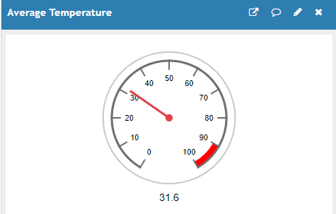

Figure : Average temperature in Data collecting period

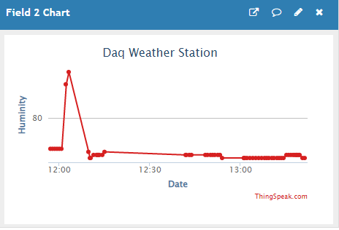

Figure : Humidity variation dashboard in ThingSpeak

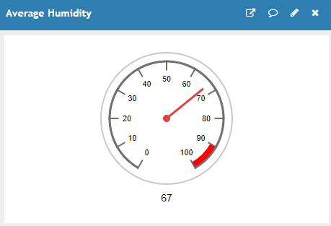

Figure : Average humidity value in data collecting period

The pressure that BMP180 measured is shown below. There are a few oddities. As a result, the average pressure may be calculated incorrectly. The average pressure is 100600 Pa after the odd data is removed from the average. That figure is quite precise.

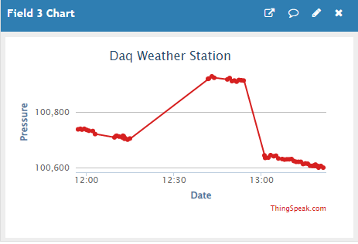

Figure : Pressure variation in ThingSpeak

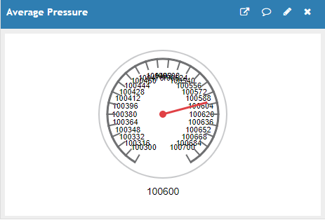

Figure : Average Pressure in data collecting period

# DISCUSSION

* One page is enough.
* Explain the purpose of the practical
* Briefly discuss your results
* if you dint get the correct results, explain why
* How you can improve those experiments.
* Defects in the experimental apparatus.

# CONCLUSION

* Point form conclusions
* Only the important ones.

# REFERENCES

* Harvard referencing method
* You can use reference tool in the word or the website “citethisforme”

Electronic Circuits and Diagram-Electronics Projects and Design. (2017). IC Voltage Regulators-with Circuit Diagram - Design & Theory. [online] Available at: http://www.circuitstoday.com/ic-voltage-regulators [Accessed 22 Mar. 2017].

Electronic Circuits and Diagram-Electronics Projects and Design. (2017). Regulated Power Supply-Block Diagram,Circuit Diagram,Working. [online] Available at: http://www.circuitstoday.com/regulated-power-supply [Accessed 22 Mar. 2017].

**APPENDIX**