**Fast-Secure 5G Technology Network Data**

**(Import / Export)**

**Using Advanced QR-Code Algorithm**



Ben Youssef Anis

ISTIC Borj Cedria

University of Carthage

**Supervisor: Prof. Syrine Sahmim**

**2nd Year Bachelor in Computer System Engineering**

**–**

**Network System Engineering (Year 2021 – 2022)**

**Abstract**

This project investigates the most common problem concerning network field in general, which is the reliability, consistency and most importantly the security of the network configuration security system where there is major lack of basic responsibility when it comes to network corporations staff communications.

The existing system do not integrate the compatibility and the querying components when it comes to inside-communications. We follow a new trend in communication that does combine both factors (Security, Rapidity)

Our approach can affect both network corporations and clients in the same time where it allows them to have a safe accessibility to the network configuration by our NCS program which is now compatible only in 5G Network.

**Acknowledgements**

I would like to thank my supervisor Prof. **Syrine Sahmim.** The weekly consultations brought the project forward and the discussions that she made in every opportunity we’ve had with her were very productive. I also want to thank my colleagues (Rana Bourayou, Jawher Smida) who helped me in many occasions several times with absolutely everything they’ve got. Thank you, a lot, I’m really grateful for your gesture. Last but not least, I want to thank my family for their support and encouragement.

**Contents**

1. **Introduction**
   1. Abbreviation of “NCS”
   2. Purpose
2. **General Overview**
   1. 5G Technology Basic
   2. Architecture
   3. Program Modules
   4. Open-Source Packages
3. **Functionnality** 
   1. Script’s functionality
4. **Conclusion**
5. **Bibliography**
6. **Introduction**
   1. **Abbreviation of “NCS”**

“NCS “is an abbreviation of the project name “Network Configuration System”, it is a python executable program developed by Ben Youssef Anis in order to (Import / Export)

5G Network’s configuration data between engineers in easy, secure and more efficient way…

* 1. **Purpose**

The main purpose of the project is to import/export analysis results files in form of an Advanced QR-Code (that can take up to 10mb theoretically) and be able to share that information’s between network’s employees to figure out which configuration is best suited for each region tested from, that would make it easier for engineers to detect problems and realize solutions faster than usual with less cost (less infrastructure, less hardware equipment, etc.….

1. **General Overview**

**2.1 5G Technology Basic**

5G is the 5th generation mobile network. It is a new global wireless standard after 1G, 2G, 3G, and 4G networks. 5G enables a new kind of network that is designed to connect virtually everyone and everything together including machines, objects, and devices.

5G wireless technology is meant to deliver higher multi-Gbps peak data speeds, [ultra low latency](https://www.qualcomm.com/news/onq/2019/05/13/how-5g-low-latency-improves-your-mobile-experiences), more reliability, massive network capacity, increased availability, and a more uniform user experience to more users. Higher performance and improved efficiency empower new user experiences and connects new industries.

**2.2 Architecture**

In this section we will provide a 5G core architecture overview and describe the 5G core components. We will also show how 5G architecture compares to the current 4G architecture.

The components of the 5G core architecture include:

* User plane Function (UPF)
* Data network (DN), e.g., operator services, Internet access or 3rd party services
* Core Access and Mobility Management Function (AMF)
* Authentication Server Function (AUSF)
* Session Management Function (SMF)
* Network Slice Selection Function (NSSF)
* Network Exposure Function (NEF)
* NF Repository Function (NRF)
* Policy Control function (PCF)
* Unified Data Management (UDM)
* Application Function (AF)

The 5G network architecture diagram below illustrates how these components are associated.

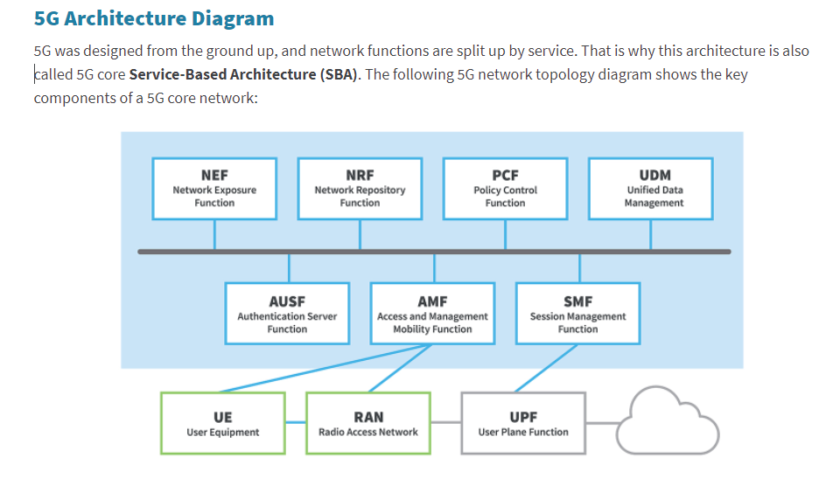

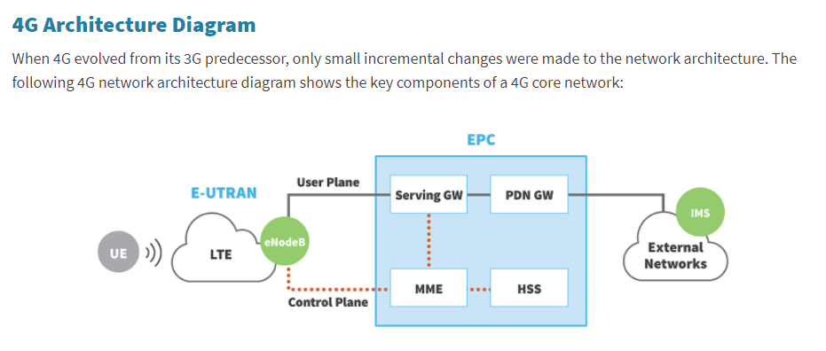

**2.3 Program Modules**

|  |  |
| --- | --- |
| **Module** | Job |
| qrcode. make ()  qrcode. save () | qrcode.make () allow us to create a crypted image based on the data size inputted in definition  qrcode.save () allow us to save that crypted image into the path we want |
| os.exit ()  os.system () | os.exit () allows us to step out of python script while running in real-time.  os.system () allows us to execute any script from outside running python script file |
| variable.isdigit ()  variable.isnumeric() | * this one allows us to verify if the variable characters are digit or not, it accepts only string in entry * this one allows us to check if the variable is integer or not and that apply for negative numbers too |
| Shutil | * this allows us to move/copy files to wherever we want |
| cv2.videocapture()   * this allows us to initiate the camera with stating the physic hardware number of the camera and activate by cv2 commands | |

**2.5 Open-Source Packages**

1. **Functionnality** 
   1. **Script’s functionality**

When you launch FinalProgram.py which is the main of all others facultative scripts because it controls and call for them to activate at the user will, there will be a guide for the user so he can easily understand what he’s doing, its like GUI but actually simpler than that and more efficient, this script will maintain it work until the user request him to terminate his process. Until that time, he’ll have list full of options to choose from.

The main list where the functionality shows up contains 3 options

* Launch NCS Program

NCS = Network Configuration System

* At screen, it will show up like this:

Would you like to:

>> Press 1 if you want to launch NCS Program

* Launch QR-Code Cam Decoder Program (Abbreviation QR-CDP)
* At screen, it will show up like this:

Would you like to:

>> Press 2 if you want to launch QR-Code Cam Decoder Program

* Terminate Program
* At screen, it will show up like this:

Would you like to:

>> Press 2 if you want to terminate program

There are others facultative functionalities matters for the organization of the input and user eyes where he can focus on the printed information.

Finally, there is the System Question at the end of every procedure from these 3 main functionalities where it tells you to restart one of the functionalities selected, main program, save the program result in a text file then automatically cryptate the results into a qrcode image to your desired path.

1. **Conclusion**

This project still under-development where I wish I can still maintain and upgrade it soon enough to be more efficient and applicable in the modern network market. And I think this program actually have potential to evolve a lot if it goes viral and become an open-source for all others developers with more unique skills and ideas.