

外文翻译

学 院 信息科学与工程学院
专 业 计算机科学与技术
届 别 15届计算机
学 号 156002857
姓 名 汪明明
指导教师 严迪群

2018年 11 月 20日
<文献翻译一：原文>

SEGAN: Speech Enhancement Generative Adversarial Network

Abstract
Current speech enhancement techniques operate on the spectral domain and/or exploit some higher-level feature. The majority of them tackle a limited number of noise conditions and rely on first-order statistics. To circumvent these issues, deep networks are being increasingly used, thanks to their ability to learn complex functions from large example sets. In this work, we propose the use of generative adversarial networks for speech enhancement. In contrast to current techniques, we operate at the waveform level, training the model end-to-end, and incorporate 28 speakers and 40 different noise conditions into the same model, such that model parameters are shared across them. We evaluate the proposed model using an independent, unseen test set with two speakers and 20 alternative noise conditions. The enhanced samples confirm the viability of the proposed model, and both objective and subjective evaluations confirm the effectiveness of it. With that, we open the exploration of generative architectures for speech enhancement, which may progressively incorporate further speech-centric design choices to improve their performance.
Index Terms: speech enhancement, deep learning, generative adversarial networks, convolutional neural networks
- Introduction
Speech enhancement tries to improve the intelligibility and quality of speech contaminated by additive noise [1]. Its main applications are related to improving the quality of mobile communications in noisy environments. However, we also find important applications related to hearing aids and cochlear implants, where enhancing the signal before amplification can significantly reduce discomfort and increase intelligibility [2]. Speech enhancement has also been successfully applied as a preprocessing stage in speech recognition and speaker identification systems [3, 4, 5].
Classic speech enhancement methods are spectral subtraction [6], Wiener filtering [7], statistical model-based methods [8], and subspace algorithms [9, 10]. Neural networks have been also applied to speech enhancement since the 80s [11, 12]. Recently, the denoising auto-encoder architecture [13] has been widely adopted. However, recurrent neural networks (RNNs) are also used. For instance, the recurrent denoising autoencoder has shown significant performance exploiting the temporal context information in embedded signals. Most recent approaches apply long short-term memory networks to the denoising task [4, 14]. In [15] and [16], noise features are estimated and included in the input features of deep neural networks. The use of dropout, post-filtering, and perceptually motivated metrics are shown to be effective.
Most of the current systems are based on the short-time Fourier analysis/synthesis framework [1]. They only modify the spectrum magnitude, as it is often claimed that short-time phase is not important for speech enhancement [17]. However, further studies [18] show that significant improvements of speech quality are possible, especially when a clean phase spectrum is known. In 1988, Tamura et al. [11] proposed a deep network that worked directly on the raw audio waveform, but they used feed-forward layers that worked frame-by-frame (60 samples) on a speaker-dependent and isolated-word database.
A recent breakthrough in the deep learning generative modeling field are generative adversarial networks (GANs) [19]. GANs have achieved a good level of success in the computer vision field to generate realistic images and generalize well to pixel-wise, complex (high-dimensional) distributions [20, 21, 22]. As far as we are concerned, GANs have not yet been applied to any speech generation nor enhancement task, so this is the first approach to use the adversarial framework to generate speech signals.
The main advantages of the proposed speech enhancement GAN (SEGAN) are:
• It provides a quick enhancement process. No causality is required and, hence, there is no recursive operation like in RNNs.
• It works end-to-end, with the raw audio. Therefore, no hand-crafted features are extracted and, with that, no explicit assumptions about the raw data are done.
• It learns from different speakers and noise types, and incorporates them together into the same shared parametrization. This makes the system simple and generalizable in those dimensions.

- Generative Adversarial Networks
GANs [19] are generative models that learn to map samples z from some prior distribution Z to samples x from another distribution X , which is the one of the training examples (e.g., images, audio, etc.). The component within the GAN structure that performs the mapping is called the generator (G), and its main task is to learn an effective mapping that can imitate the real data distribution to generate novel samples related to those of the training set. Importantly, G does so not by memorizing input-output pairs, but by mapping the data distribution characteristics to the manifold defined in our prior Z.
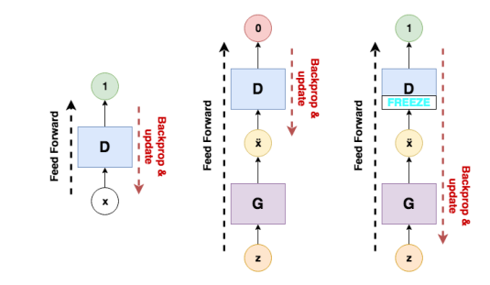
Figure 1: GAN training process. First, D back-props a batch of real examples. Then, D back-props a batch of fake examples that come from G, and classifies them as fake. Finally, D’s parameters are frozen and G back-props to make D misclassify.
The way in which G learns to do the mapping is by means of an adversarial training, where we have another component, called the discriminator (D). D is typically a binary classifier, and its inputs are either real samples, coming from the dataset that G is imitating, or fake samples, made up by G. The adversarial characteristic comes from the fact that D has to classify the samples coming from X as real, whereas the samples coming from G, Xˆ, have to be classified as fake. This leads to G trying to fool D, and the way to do so is that G adapts its parameters such that D classifies G’s output as real. During back-propagation, D gets better at finding realistic features in its input and, in turn, G corrects its parameters to move towards the real data manifold described by the training data (Fig. 1). This adversarial learning process is formulated as a minimax game between G and D, with the objective
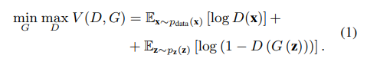
We can also work with a conditioned version of GANs, where we have some extra information in G and D to perform mapping and classification (see [20] and references therein). In that case, we may add some extra input xc, with which we change the objective function to
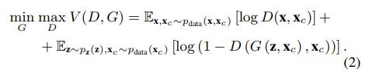
There have been recent improvements in the GAN methodology to stabilize training and increase the quality of the generated samples in G. For instance, the classic approach suffered from vanishing gradients due to the sigmoid cross-entropy loss used for training. To solve this, the least-squares GAN (LSGAN) approach [21] substitutes the cross-entropy loss by the least-squares function with binary coding (1 for real, 0 for fake). With this, the formulation in Eq. 2 changes to
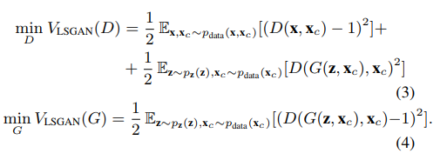
- Speech Enhancement GAN
The enhancement problem is defined so that we have an input noisy signal ˜x and we want to clean it to obtain the enhanced signal ˆx. We propose to do so with a speech enhancement GAN (SEGAN). In our case, the G network performs the enhancement. Its inputs are the noisy speech signal ˜x together with the latent representation z, and its output is the enhanced version ˆx = G(˜x). We design G to be fully convolutional, so that there are no dense layers at all. This enforces the network to focus on temporally-close correlations in the input signal and throughout the whole layering process. Furthermore, it reduces the number of training parameters and hence training time.
The G network is structured similarly to an auto-encoder (Fig. 2). In the encoding stage, the input signal is projected and compressed through a number of strided convolutional layers followed by parametric rectified linear units (PReLUs) [23], getting a convolution result out of every N steps of the filter. We choose strided convolutions as they were shown to be more stable for GAN training than other pooling approaches [22]. Decimation is done until we get a condensed representation, called the thought vector c, which gets concatenated with the latent vector z. The encoding process is reversed in the decoding stage by means of fractional-strided transposed convolutions (sometimes called deconvolutions), followed again by PReLUs.
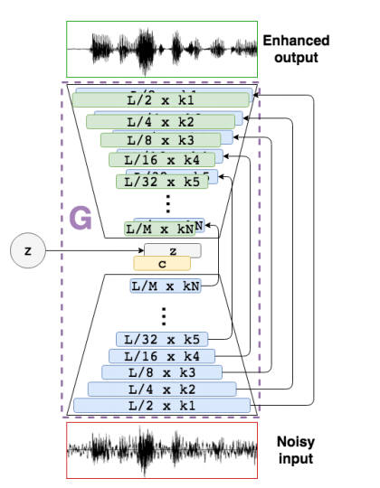
Figure 2: Encoder-decoder architecture for speech enhancement (G network). The arrows between encoder and decoder blocks denote skip connections.
The G network also features skip connections, connecting each encoding layer to its homologous decoding layer, and bypassing the compression performed in the middle of the model (Fig. 2). This is done because the input and output of the model share the same underlying structure, which is that of natural speech. Therefore, many low level details could be lost to reconstruct the speech waveform properly if we force all information to flow through the compression bottleneck. Skip connections directly pass the fine-grained information of the waveform to the decoding stage (e.g., phase, alignment). In addition, they offer a better training behavior, as the gradients can flow deeper through the whole structure [24]. An important feature of G is its end-to-end structure, so that it processes raw speech sampled at 16 kHz, getting rid of any intermediate transformations to extract acoustic features (contrasting to many common pipelines). In this type of model, we have to be careful with typical regression losses like mean absolute error or mean squared error, as noted in the raw speech generative model WaveNet [25]. These losses work under strong assumptions on how our output distribution is shaped and, therefore, impose important modeling limitations (like not allowing multi-modal distributions and biasing the predictions towards an average of all the possible predictions). Our solution to overcome these limitations is to use the generative adversarial setting. This way, D is in charge of transmitting information to G of what is real and what is fake, such that G can slightly correct its output waveform towards the realistic distribution, getting rid of the noisy signals as those are signaled to be fake. In this sense, D can be understood as learning some sort of loss for G’s output to look real.
In preliminary experiments, we found it convenient to add a secondary component to the loss of G in order to minimize the distance between its generations and the clean examples. To measure such distance, we chose the L1 norm, as it has been proven to be effective in the image manipulation domain [20, 26]. This way, we let the adversarial component to add more fine-grained and realistic results. The magnitude of the L1 norm is controlled by a new hyper-parameter λ. Therefore, the G loss, which we choose to be the one of LSGAN (Eq. 4), becomes
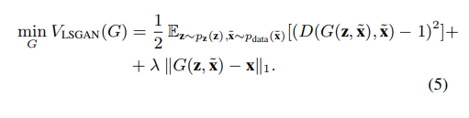
- Experimental Setup
4.1 Data Set
To evaluate the effectiveness of the SEGAN, we resort to the data set by Valentini et al. [27]. We choose it because it is open and available1 , and because the amount and type of data fits our purposes for this work: generalizing on many types of noise for many different speakers. The data set is a selection of 30 speakers from the Voice Bank corpus [28]: 28 are included in the train set and 2 in the test set.
To make the noisy training set, a total of 40 different conditions are considered [27]: 10 types of noise (2 artificial and 8 from the Demand database [29]) with 4 signal-to-noise ratio (SNR) each (15, 10, 5, and 0 dB). There are around 10 different sentences in each condition per training speaker. To make the test set, a total of 20 different conditions are considered [27]: 5 types of noise (all from the Demand database) with 4 SNR each (17.5, 12.5, 7.5, and 2.5 dB). There are around 20 different sentences in each condition per test speaker. Importantly, the test set is totally unseen by (and different from) the training set, using different speakers and conditions.
4.2. SEGAN Setup
The model is trained for 86 epochs with RMSprop [30] and a learning rate of 0.0002, using an effective batch size of 400. We structure the training examples in two pairs (Fig. 3): the real pair, composed of a noisy signal and a clean signal (˜x and x), and the fake pair, composed of a noisy signal and an enhanced signal (˜x and $\hat{x}$). To adequate the data set files to our waveform generation purposes, we down-sample the original utterances from 48 kHz to 16 kHz. During train, we extract chunks of waveforms with a sliding window of approximately one second of speech (16384 samples) every 500 ms (50% overlap). During test, we basically slide the window with no overlap through the whole duration of our test utterance and concatenate the results at the end of the stream. In both train and test, we apply a high-frequecy preemphasis filter of coefficient 0.95 to all input samples (during test, output is correspondingly deemphasized).
Regarding the λ weight of our L1 regularization, after some experimentation, we set it to 100 for the whole training. We initially set it to 1, but we observed that the G loss was two orders of magnitude under the adversarial one, so the L1 had no practical effect on the learning. Once we set it to 100, we saw a minimization behavior in the L1 and an equilibrium behavior in the adversarial one. As the L1 got lower, the quality of the output samples increased, which we hypothesize helped G being more effective in terms of realistic generation.
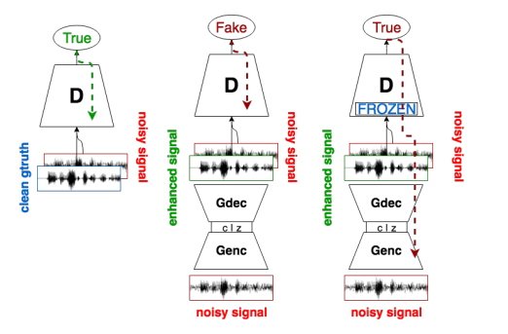
Figure 3: Adversarial training for speech enhancement. Dashed lines represent gradient backprop.
Regarding the architecture, G is composed of 22 one-dimensional strided convolutional layers of filter width 31 and strides of N = 2. The amount of filters per layer increases so that the depth gets larger as the width (duration of signal in time) gets narrower. The resulting dimensions per layer, being it samples × feature maps, is 16384×1, 8192×16, 4096×32, 2048×32, 1024×64, 512×64, 256×128, 128×128, 64×256, 32×256, 16×512, and 8×1024. There, we sample the noise samples z from our prior 8×1024-dimensional normal distribution N (0, 1). As mentioned, the decoder stage of G is a mirroring of the encoder with the same filter widths and the same amount of filters per layer. However, skip connections and the addition of the latent vector make the number of feature maps in every layer to be doubled.
The network D follows the same one-dimensional convolutional structure as G’s encoder stage, and it fits to the conventional topology of a convolutional classification network. The differences are that (1) it gets two input channels of 16384 samples, (2) it uses virtual batch-norm [31] before LeakyReLU nonlinearities with α = 0.3, and (3) in the last activation layer there is a one-dimensional convolution layer with one filter of width one that does not downsample the hidden activations (1×1 convolution). The latter (3) reduces the amount of parameters required for the final classification neuron, which is fully connected to all hidden activations with a linear behavior. This means that we reduce the amount of required parameters in that fully-connected component from 8 × 1024 = 8192 to 8, and the way in which the 1024 channels are merged is learnable in the parameters of the convolution.
All the project is developed with TensorFlow [32], and the code is available at https://github.com/santi-pdp/segan.We refer to this resource for further details of our implementation. A sample of the enhanced speech audios is provided at http://veu.talp.cat/segan.
- Results
5.1 Objective Evaluation
To evaluate the quality of the enhanced speech, we compute the following objective measures (the higher the better). All metrics compare the enhanced signal with the clean reference of the 824 test set files. They have been computed using the implementation included in [1], and available at the publisher website2 .

Table 1: Objective evaluation results comparing the noisy signal and the Wiener- and SEGAN-enhanced signals.
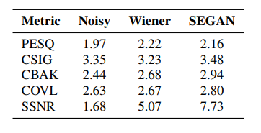
• PESQ: Perceptual evaluation of speech quality, using the wide-band version recommended in ITU-T P.862.2 [33] (from –0.5 to 4.5).
• CSIG: Mean opinion score (MOS) prediction of the signal distortion attending only to the speech signal [34] (from 1 to 5).
• CBAK: MOS prediction of the intrusiveness of background noise [34] (from 1 to 5).
• COVL: MOS prediction of the overall effect [34] (from 1 to 5).
• SSNR: Segmental SNR [35, p. 41] (from 0 to ∞).
Table 1 shows the results of these metrics. To have a comparative reference, it also shows the results of these metrics when applied directly to the noisy signals and to signals filtered using the Wiener method based on a priori SNR estimation [36], as provided in [1]. It can be observed how SEGAN gets slightly worse PESQ. However, in all the other metrics, which better correlate with speech/noise distortion, SEGAN outperforms the Wiener method. It produces less speech distortion (CSIG) and removes noise more effectively (CBAK and SSNR). Therefore, it achieves a better tradeoff between the two factors (COVL).
5.2. Subjective Evaluation
A perceptual test has also been carried out to compare SEGAN with the noisy signal and the Wiener baseline. For that, 20 sentences were selected from the test set. As the database does not indicate the amount and type of noise for each file, the selection was done by listening to some of the provided noisy files, trying to balance different noise types. Most of the files have low SNR, but a few with high SNR were also included.
Table 2: Subjective evaluation results comparing the noisy signal and the Wiener- and SEGAN-enhanced signals.
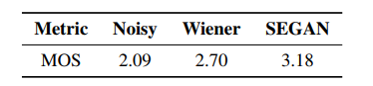
Figure 4: CMOS box plot (the median line in the SEGAN– Wiener comparison is located at 1). Positive values mean that SEGAN is preferred.
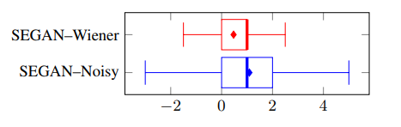
A total of 16 listeners were presented with the 20 sentences in a randomized order. For each sentence, the following three versions were presented, also in random order: noisy signal, Wiener-enhanced signal, and SEGAN-enhanced signal. For each signal, the listener rated the overall quality, using a scale from 1 to 5. In the description of the 5 categories, they were instructed to pay attention to both the signal distortion and the noise intrusiveness (e.g., 5=excellent: very natural speech with no degradation and not noticeable noise). Listeners could listen to each signal as many times as they wanted, and were asked to pay attention to the comparative rate of the three signals.
In Table 2, it can be observed how SEGAN is preferred over both the noisy signal and the Wiener baseline. However, as there is a large variation in the SNR of the noisy signal, the MOS range is very large, and the difference between Wiener and SEGAN is not significant. However, as the listeners compared all the systems at same time, it is possible to compute the comparative MOS (CMOS) by subtracting the MOS of the two systems being compared. Fig. 4 depicts this relative comparison. We can see how the signals generated by SEGAN are preferred. More specifically, SEGAN is preferred over the original (noisy) signal in 67% of the cases, while the noisy signal is preferred in 8% of the cases (no preference in 25% of the cases). With respect to the Wiener system, SEGAN is preferred in 53% of cases and Wiener is preferred in 23% of the cases (no preference in 24% of the cases).
- Conclusions
In this work, an end-to-end speech enhancement method has been implemented within the generative adversarial framework. The model works as an encoder-decoder fully-convolutional structure, which makes it fast to operate for denoising waveform chunks. The results show that, not only the method is viable, but it can also represent an effective alternative to current approaches. Possible future work involves the exploration of better convolutional structures and the inclusion of perceptual weightings in the adversarial training, so that we reduce possible high frequency artifacts that might be introduced by the current model. Further experiments need to be done to compare SEGAN with other competitive approaches.
- Acknowledgements
This work was supported by the project TEC2015-69266-P (MINECO/FEDER, UE).
- References
- P. C. Loizou, Speech Enhancement: Theory and Practice, 2nd ed. Boca Raton, FL, USA: CRC Press, Inc., 2013.
- L.-P. Yang and Q.-J. Fu, “Spectral subtraction-based speech enhancement for cochlear implant patients in background noise,” The Journal of the Acoustical Society of America, vol. 117, no. 3, pp. 1001–1004, 2005.
- D. Yu, L. Deng, J. Droppo, J. Wu, Y. Gong, and A. Acero, “A minimum-mean-square-error noise reduction algorithm on melfrequency cepstra for robust speech recognition,” in Proc. of the IEEE Int. Conf. on Acoustics, Speech and Signal Processing (ICASSP). IEEE, 2008, pp. 4041–4044.
- A. L. Maas, Q. V. Le, T. M. O’Neil, O. Vinyals, P. Nguyen, and A. Y. Ng, “Recurrent neural networks for noise reduction in robust asr.” in Proc. of INTERSPEECH, 2012, pp. 22–25.
- J. Ortega-Garcia and J. Gonzalez-Rodriguez, “Overview of speech enhancement techniques for automatic speaker recognition,” in Spoken Language, 1996. ICSLP 96. Proceedings., Fourth International Conference on, vol. 2, Oct 1996, pp. 929–932 vol.2.
- M. Berouti, R. Schwartz, and J. Makhoul, “Enhancement of speech corrupted by acoustic noise,” in Proc. of the Int. Conf. on Acoustics, Speech, and Signal Processing (ICASS), vol. 4, Apr 1979, pp. 208–211.
- J. Lim and A. Oppenheim, “All-pole modeling of degraded speech,” IEEE Trans. on Acoustics, Speech, and Signal Processing, vol. 26, no. 3, pp. 197–210, Jun 1978.
- Y. Ephraim, “Statistical-model-based speech enhancement systems,” Proceedings of the IEEE, vol. 80, no. 10, pp. 1526–1555, Oct 1992.
- M. Dendrinos, S. Bakamidis, and G. Carayannis, “Speech enhancement from noise: A regenerative approach,” Speech Communication, vol. 10, no. 1, pp. 45–57, 1991.
- Y. Ephraim and H. L. Van Trees, “A signal subspace approach for speech enhancement,” IEEE Trans. on speech and audio processing, vol. 3, no. 4, pp. 251–266, 1995.
- S. Tamura and A. Waibel, “Noise reduction using connectionist models,” in Proc. of the IEEE Int. Conf. on Acoustics, Speech and Signal Processing (ICASSP), 1988, pp. 553–556.
- S. Parveen and P. Green, “Speech enhancement with missing data techniques using recurrent neural networks,” in Proc. of the IEEE Int. Conf. on Acoustics, Speech and Signal Processing (ICASSP), 2004, pp. 733–736.
- X. Lu, Y. Tsao, S. Matsuda, and C. Hori, “Speech enhancement based on deep denoising autoencoder.” in Proc. of INTERSPEECH, 2013, pp. 436–440.
- F. Weninger, H. Erdogan, S. Watanabe, E. Vincent, J. Le Roux, J. R. Hershey, and B. Schuller, “Speech enhancement with LSTM recurrent neural networks and its application to noise-robust ASR,” in Proc. of the Int. Conf. on Latent Variable Analysis and Signal Separation, 2015, pp. 91–99.
- Y. Xu, J. Du, L.-R. Dai, and C.-H. Lee, “A regression approach to speech enhancement based on deep neural networks,” IEEE/ACM Trans. on Audio, Speech and Language Processing, vol. 23, no. 1, pp. 7–19, 2015.
- A. Kumar and D. Florencio, “Speech enhancement in multiplenoise conditions using deep neural networks,” in Proc. of the Int. Speech Communication Association Conf. (INTERSPEECH), 2016, pp. 3738–3742.
- D. Wang and J. Lim, “The unimportance of phase in speech enhancement,” IEEE Trans. on Acoustics, Speech, and Signal Processing, vol. 30, no. 4, pp. 679–681, Aug 1982.
- K. Paliwal, K. Wojcicki, and B. Shannon, “The importance of ´ phase in speech enhancement,” Speech Communication, vol. 53, no. 4, pp. 465 – 494, 2011. [Online]. Available: http://www. sciencedirect.com/science/article/pii/S0167639310002086
- I. Goodfellow, J. Pouget-Abadie, M. Mirza, B. Xu, D. WardeFarley, S. Ozair, A. Courville, and Y. Bengio, “Generative adversarial nets,” in Advances in Neural Information Processing Systems (NIPS), 2014, pp. 2672–2680.
- P. Isola, J.-Y. Zhu, T. Zhou, and A. A. Efros, “Image-toimage translation with conditional adversarial networks,” ArXiv: 1611.07004, 2016.
- X. Mao, Q. Li, H. Xie, R. Y. K. Lau, and Z. Wang, “Least squares generative adversarial networks,” ArXiv: 1611.04076, 2016.
- A. Radford, L. Metz, and S. Chintala, “Unsupervised representation learning with deep convolutional generative adversarial networks,” arXiv preprint arXiv:1511.06434, 2015.
- K. He, X. Zhang, S. Ren, and J. Sun, “Delving deep into rectifiers: Surpassing human-level performance on imagenet classification,” in Proc. of the IEEE Int. Conf. on Computer Vision (ICCV), 2015, pp. 1026–1034.
- ——, “Deep residual learning for image recognition,” in Proc. of the IEEE Conf. on Computer Vision and Pattern Recognition (CVPR), 2016, pp. 770–778.
- A. van den Oord, S. Dieleman, H. Zen, K. Simonyan, O. Vinyals, A. Graves, N. Kalchbrenner, A. Senior, and K. Kavukcuoglu, “Wavenet: A generative model for raw audio,” CoRR abs/1609.03499, 2016.
- D. Pathak, P. Krahenbuhl, J. Donahue, T. Darrell, and A. A. Efros, “Context encoders: Feature learning by inpainting,” in Proc. of the IEEE Conf. on Computer Vision and Pattern Recognition (CVPR), 2016, pp. 2536–2544.
- C. Valentini-Botinhao, X. Wang, S. Takaki, and J. Yamagishi, “Investigating rnn-based speech enhancement methods for noiserobust text-to-speech,” in 9th ISCA Speech Synthesis Workshop, pp. 146–152.
- C. Veaux, J. Yamagishi, and S. King, “The voice bank corpus: Design, collection and data analysis of a large regional accent speech database,” in Int. Conf. Oriental COCOSDA, held jointly with 2013 Conference on Asian Spoken Language Research and Evaluation (O-COCOSDA/CASLRE). IEEE, 2013, pp. 1–4.
- J. Thiemann, N. Ito, and E. Vincent, “The diverse environments multi-channel acoustic noise database: A database of multichannel environmental noise recordings,” The Journal of the Acoustical Society of America, vol. 133, no. 5, pp. 3591–3591, 2013.
- T. Tieleman and G. Hinton, “Lecture 6.5-RMSprop: divide the gradient by a running average of its recent magnitude,” COURSERA: Neural Networks for Machine Learning 4, 2, 2012.
- T. Salimans, I. Goodfellow, W. Zaremba, V. Cheung, A. Radford, and X. Chen, “Improved techniques for training gans,” in Advances in Neural Information Processing Systems (NIPS), 2016, pp. 2226–2234.
- M. Abadi, A. Agarwal, P. Barham, E. Brevdo, Z. Chen, C. Citro, G. S. Corrado, A. Davis, J. Dean, M. Devin et al., “Tensorflow: Large-scale machine learning on heterogeneous distributed systems,” arXiv preprint arXiv:1603.04467, 2016.
- P.862.2: Wideband extension to Recommendation P.862 for the assessment of wideband telephone networks and speech codecs, ITU-T Std. P.862.2, 2007.
- Y. Hu and P. C. Loizou, “Evaluation of objective quality measures for speech enhancement,” IEEE Trans. on Audio, Speech, and Language Processing, vol. 16, no. 1, pp. 229–238, Jan 2008.
- S. R. Quackenbush, T. P. Barnwell, and M. A. Clements, Objective Measures of Speech Quality. Englewood Cliffs, NJ: PrenticeHall, 1988.
- P. Scalart and J. V. Filho, “Speech enhancement based on a priori signal to noise estimation,” in Proc. of the IEEE Int. Conf. on Acoustics, Speech, and Signal Processing (ICASSP), vol. 2, May 1996, pp. 629–632 vol. 2.
<文献翻译一：译文>

SEGAN：语音增强生成对抗网络

摘 要
当前的语音增强技术在频谱域上操作和利用一些更高级别的特征。他们中的大多数解决噪声有条件的限制，并依靠一阶统计。为了避免这些问题，深层网络正在被越来越多地使用，这要归功于它们从大型示例集中学习复杂功能的能力。在这项工作中，我们建议使用生成对抗网络进行语音增强。与现有技术相比，我们在波形水平上操作，端到端的训练模型，并将28个扬声器和40个不同的噪声条件合并到同一模型中，以便在它们之间共享模型参数。我们使用独立的，看不见的测试装置评估所提出的模型，该测试装置具有2个扬声器和20个替代噪声条件增强的样本证实了所提出的模型的可行性，客观和主观评估都证实了它的有效性。有了这个，我们开始探索用于语音增强的生成架构，这可以进一步逐步纳入以语音为中心的设计选择，以改善其性能。
[关键词]：语音增强，深度学习，生成对抗网络，卷积神经网络。
1.介绍
语音增强是指提高被加性噪声污染的语音的清晰度和质量[1]，最主要应用是在嘈杂环境中提高移动通信质量。然而，我们发现助听器和人工耳蜗埋植等应用中，在功率放大前增强信号可以明显降低语音不适度并提高语音清晰度[2]。此外，语音增强也已成功应用于语音识别和说话人识别系统中的预处理阶段[3,4,5]。
经典的语音增强方法有频谱提取[6]、维纳滤波[7]，基于统计模型的方法[8]和子空间算法[9,10]。80年代后，神经网络也开始应用于语音增强[11,12]。最近，降噪自动编码器[13]已被广泛采纳，并且，递归神经网络（RNN）也被采用。例如，递归降噪自动编码器利用了噪音信号的时域上下文信息而获得优越性能。大多数最新的方法将长短记忆存储RNN应用于降噪[4,14]。有的学者将估计的噪声特征包含在深度神经网络的输入特征中。使用丢失，后滤波和感知激励度量标准是有效的。
目前大多数现代系统都是基于短时傅里叶分析框架的[1]。它们仅仅改变频谱幅度，因为通常短时相位对语音增强并不重要[17]。然而，一些深层研究显示语音质量可以明显提高，特别是在干净的相位谱已知时。1988年，Tamura等人[11]提出了一个直接在原始音频波形上工作的深度网络，但是他们使用前馈层，这些前馈层在依赖于说话者和隔离词的数据库上逐帧（60个样本）工作。
在深度学习生成模型方面的最新突破是生成对抗网络（GAN）[19]。GAN在计算机视觉领域生成逼真图像上取得巨大成功，可以生成像素级、复杂分布的图像[20,21,22]。据我们所知，GAN尚未应用于任何语音生成或语音增强方面，因此本文是首次将对抗框架应用于语音信号生成上。
语音增强GAN（SEGAN）的主要优点是：
•提供了一种快速增强处理方法，不需要因果关系，因此，没有像RNN中类似的递归操作。
•直接处理原始音频的端到端的方法，不需要手工提取特征，不需要对原始数据做明显假设；
•从不同的扬声器和噪声类型中学习，并将它们结合在一起形成相同的共享参数，使得系统简单切泛化能力较强。
在下文中，我们概述了GAN（第2节），接下来，我们描述了所提出的模型（第3节）及其实验装置（第4节）。我们最后报告结果（第5节）并讨论一些结论（第6节）。
2.生成性对抗网络
GAN[19]是学习将服从某种分布Z的样本z映射为服从另外一种分布X的样本x的生成模型（例如，图像，音频等）。负责映射称为生成器（G），其主要任务是学习模仿真实的数据分布，以生成与训练集相关的新样本。重要的是，G并不是通过记住输入输出对，而是通过将数据分布特征映射到先前Z中定义的特征来实现的。
G是通过与鉴别器D的对抗训练学习映射的。D是典型的二类分类器，其输入是实际样本和G生成的假样本。G试图愚弄D，通过调整参数使D将G的输出分类为正例（real）；而D需要将G产生的逼真样本辨别为负例，因此称之为“对抗”。通过后向传播，D辨别分类能力越来越强，G对训练数据的拟合程度越来越高，如图1所示。
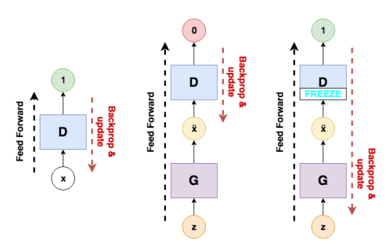
图1：GAN培训流程。首先，D有一批真实的例子。然后，D反向支持一批来自G的假例子，并将它们归类为假的。最后，D的参数被冻结，G使D错误分类.
这种对抗学习过程可以用公式表示为G和D的最小最大，目标函数为
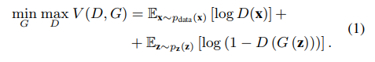
如果我们有G或D映射或分类的一些额外信息，就可以得到带有条件的GAN版本，可以增加一些额外的输入$x_{c}$，并将目标函数调整为
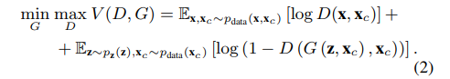
为了稳定训练并提高G生成样本的质量，GAN有一些新的改进，因为经典方法有S形交叉熵损失函数导致的梯度消失问题。我们采用最小平方GAN（LSGAN）方法，将损失函数替换为编码为1（real）和0（fake）的最小平方函数。这样，式（2）可改写为
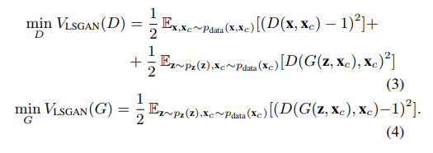
3.语音增强GAN
语音增强问题是有输入含噪音信号x得到增强信号ˆx，本文通过语音增强GAN（SEGAN）实现，其中G网络用于增强。G的输入含噪音信号x和潜在表征z，输出是增强后的信号$\hat{x}$=G(x)。我们将G设计为全部是卷积层而没有全连接层，这强制网络集中在输入信号和整个分层过程中的时间上紧密的相关性。此外，这么做也减少了训练参数从而缩短了训练时间。
G网络和自编码器在结构上类似（如图2所示），在编码阶段，输入信号通过多个含PReLU的步进卷积层投影和压缩，在N个滤波器后得到一个卷积结果。之所以选择步进卷积，是由于它们在GAN训练时比其它汇集方法更稳定。直到得到一个与潜在向量z连接的被称为思维向量c的高度抽象表征。解码阶段就是解卷积过程。
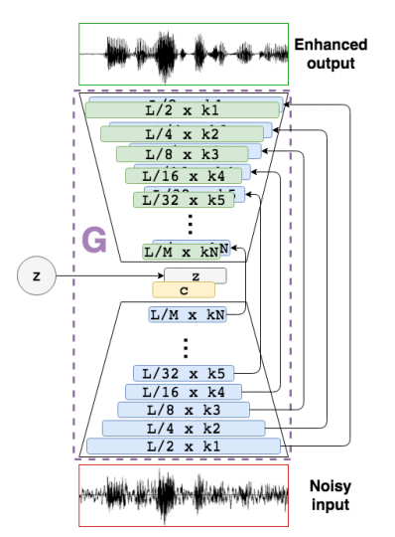
图2：用于语音增强的编码器——解码器架构（G网络）。编码器和解码器块之间的箭头表示跳过连接。
G网络还设有跳过连接，将每个编码层连接到其同源解码层，并绕过在模型中间进行的压缩（如图2）。这是因为该模型的输入和输出共享相同的底层结构，即自然语音的结构。因此，许多低级别的细节可能会丢失，如果我们迫使所有的信息，通过压缩瓶颈流向适当地恢复语音波形。跳过连接直接将波形的细粒度信息传递到解码级（例如，相位，对齐）。此外，它们提供了一个更好的训练行为，因为梯度会贯穿整个结构流向更深[24]。
G网络的一个重要特点是端到端结构，因此它处理以16kHz采样的原始语音，避免了通过中间变换提取声学特征（与许多常见管道形成对比）。在这种模型下，我们必须对平均绝对值误差或均方误差等典型回归损失特别小心，就像原始语音生成模型WaveNet[25]所描述的那样。这些损失在对输出分布做出了较强的假设，加强了重要的建模限制（如不允许多模态分布，并将预测偏向所有可能预测的平均值）。我们突破这些限制的方法是利用生成对抗性设置。通过这种方式，D负责向G发送输入数据中哪些是真的哪些是假的，使得G可以将其输出波形朝着真实的分布微调，从而消除噪声信号。
在初步实验中，我们发现G的损失中增加一个二次项（最小化生成样本和干净样本之间的距离）更有效。为了测量这样的距离，我们选择了L1范数，因为它已在图像处理领域中被证明是有效的。通过这种方式，我们让G添加更细粒度和现实结果。L1范数的大小由新的参数λ控制。因此，G的新损失函数为
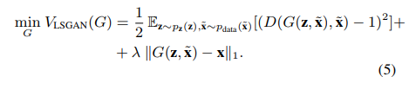
4.实验装置
4.1.数据集设置
为了评估SEGAN的有效性，我们采用了Valentini等人的数据集[27]。之所以选择该数据集，是由于它开放容易获取，总量和类型符合本文要求：许多不同类型的噪声和许多不同的发言者。该数据集是来自Voice Bank语料库[28]中选择30个发言者：28个用来训练，2个用来测试。
为了制作嘈杂的训练集，总共考虑了40种不同的条件[27]：10种类型的噪声（2种人工噪声和8种来自需求数据库[29]），每种噪声具有4种信噪比（SNR）（15，10,5和0dB）。每个训练说话者的每种情况都有大约10个不同的句子。为了制作测试集，总共考虑了20种不同的条件[27]：5种类型的噪声（均来自需求数据库），每种噪声有4个SNR（17.5,12.5,7.5和2.5dB）。每个测试发言者的每个条件中有大约20个不同的句子。重要的是，使用不同的扬声器和条件，测试集完全不受训练集的影响（并且与之不同）。
4.2.SEGAN设置
该模型通过RMSprop[30]迭代训练86次，学习率为0.0002，有效批量的大小为400。我们将训练样本分为两对（如图3）：由噪声信号和干净信号（$\tilde{x}$和x）组成的真是对，以及由噪声信号和增强信号（$\tilde{x}$和$\hat{x}$）组成的伪对。为了使数据集文件适合我们的波形生成目的，我们将采样率由48kHz降为16kHz。在训练期间，我们用每500ms（50%重叠）的大约一秒语音（16384个样本）的滑动窗口提取波形块。在测试期间，我们基本上是通过我们的测试发言的整个过程中没有重叠滑动窗口，在流的末端连接结果。在训练和测试中，我们对所有输入样本应用系数0.95的高频预加重滤波器（在测试期间，输出相应地不在强调）。
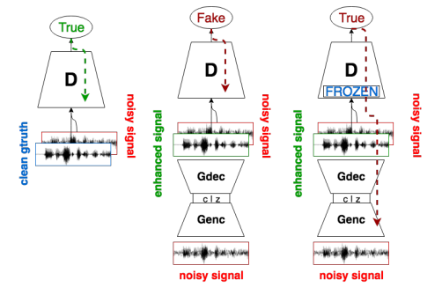
图3 语音增强对抗训练
虚线代表梯度backprop
关于L1正则化的λ权重，经过一些实验，我们将整数训练设置为100。我们最初设定为1，但我们观察到在对抗性下G损失是两个数量级，因此L1对学习没有实际影响。一旦我们将其设置为100，我们就会看到L1中的最小化行为和对抗行为中的均衡行为。随着L1的降低，输出样本的质量增加，我们假设这有助于G在实际生成方面更有效。
关于该体系结构，G由22个滤波器组成，宽度为31，步长N=2。每层滤波器的数量增加，使得随着宽度（信号的持续时间）变窄，深度变大。每层的结果尺寸，即样本×特征图，为16384*1，8192*16，4096*32，2048*32,1024*64,512*64,256*128,64*256,32*256,16*512,和8*1024。因此，噪声z为8*1024的标准正态分布。如上所述，G的解码阶段是编码阶段的镜像，滤波器宽度和个数与编码阶段保持镜像关系。但是，跳过连接和加入特征向量使每层特征图数量加倍。
网络D同样有1维卷积结构构成，是个卷积分类网络，有两个16384样本输入通道，使用$α=0.3$的LeakyReLU非线性激活函数，最后一层为1x1的卷积。最后一层将隐藏层线性连接，并降低了最后分类神经元所需的参数个数，将全连接所需的8*1024=8192个参数降为8,1024个通道合并后学习卷积参数。
网络D遵循与G的编码器级相同的一维卷积结构，并且它适合于卷积分类网络的传统拓扑。不同之处在于（1）它获得16384个样本的两个输入通道，（2）它在LeakyReLU非线性之前使用虚拟批量范数[31]，其中$α=0.3$，并且（3）在最后一个激活层中有一个 - 具有一个宽度为1的滤波器的维度卷积层，其不下采样隐藏的激活（1×1卷积）。后者（3）减少了最终分类神经元所需的参数量，该神经元与具有线性行为的所有隐藏激活完全连接。这意味着我们将完全连接组件中所需参数的数量从8×1024 = 8192减少到8，并且可以在卷积参数中学习1024个通道的合并方式。
所有项目都是用TensorFlow [32]，代码可在https://github.com/santi-pdp/segan获得。我们将参考此资源以获取有关我们实施的更多详细信息。有关增强型语音音频的示例，请访问http://veu.talp.cat/segan。
5.结果
5.1.客观评价
为了评估增强语音的质量，我们计算以下客观测量值（越高越好）。所有指标都将增强信号与824测试集文件的干净参考进行比较。它们是使用[1]中使用的算法，可以在发布者网站上获得
•PESQ：使用ITU-T P.862.2建议的宽带版本[33]（从-0.5到4.5）对语音质量进行感知评估。
•CSIG：仅针对语音信号[34]（从1到5）的信号失真的平均意见得分（MOS）预测。
•CBAK：MOS预测背景噪声的侵入性[34]（从1到5）。
•COVL：总体效应的MOS预测[34]（从1到5）。
•SSNR：分段SNR [35，p。 41]（从0到∞）。
表1 比较噪声信号和Wiener和SEGAN增强信号的客观评估结果
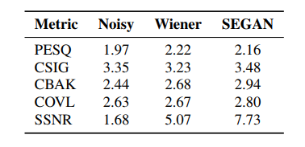
表1显示了这些指标的结果。为了得到比较参考，它还显示了直接应用于噪声信号时这些指标的结果，以及使用基于先验SNR估计的Wiener方法滤波的信号[36]，如[1]中所提供的。可以观察到SEGAN如何使PESQ略微恶化。然而，在与语音/噪声失真更好地相关的所有其他度量中，SEGAN优于Wiener方法。它产生较少的语音失真（CSIG）并更有效地消除噪声（CBAK和SSNR）。因此，它在两个因素（COVL）之间实现了更好的权衡。
5.2.主观评价
还进行了感知测试以将SEGAN与噪声信号和Wiener基线进行比较。为此，从测试集中选择了20个句子。由于数据库没有指出每个文件的噪声量和类型，因此通过收听一些提供的噪声文件来完成选择，尝试平衡不同的噪声类型。大多数文件具有低SNR，但也包括一些具有高SNR的文件。
共有16名听众以随机顺序提交了20个句子。对于每个句子，还以随机顺序呈现以下三个版本：噪声信号，Wiener增强信号和SEGAN增强信号。对于每个信号，听者使用1到5的等级评定整体质量。在5个类别的描述中，他们被指示注意信号失真和噪声侵入（例如，5 =优秀：非常自然语音，没有退化，没有明显的噪音）。听众可以根据需要多次收听每个信号，并被要求注意三个信号的比较速率。
表2 比较噪声信号和Wiener和SEGAN增强信号的主观评估结果。
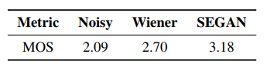
在表2中，可以观察到SEGAN如何优于噪声信号和Wiener信号。然而，由于噪声信号的SNR存在较大变化，因此MOS范围非常大，并且Wiener和SEGAN之间的差异不显着。然而，当听众同时比较所有系统时，可以通过减去被比较的两个系统的MOS来计算比较MOS（CMOS）。图4描绘了这种相对比较。我们可以看到SEGAN生成的信号是如何首选的。更具体地，在67％的情况下，SEGAN优于原始（有噪声）信号，而在8％的情况下优选有噪声信号（在25％的情况下没有偏好）。对于Wiener系统，SEGAN在53％的情况下是首选，Wiener在23％的情况下是首选（在24％的情况下没有偏好）。
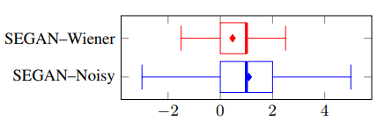
图4：CMOS框图（SEGAN-Wiener比较中的中间线位于1）。
正值意味着SEGAN是优选的。
6.结论
在这项工作中，在生成对抗框架内实现了端到端语音增强方法。该模型作为编码器—解码器全卷积结构工作，使得它可以快速操作以对波形块进行降噪。结果表明，该方法不仅可行，而且还可以代表当前方法的有效替代方法。未来可能的工作涉及探索更好的卷积结构以及在对抗训练中包含感知权重，以便我们减少可能由当前模型引入的高频伪像。需要进一步的实验来比较SEGAN与其他竞争方法。

7.致谢

这项工作得到了TEC2015-69266-P（MINECO / FEDER，UE）项目的支持。
8．参考文献
- P. C. Loizou, Speech Enhancement: Theory and Practice, 2nd ed. Boca Raton, FL, USA: CRC Press, Inc., 2013.
- L.-P. Yang and Q.-J. Fu, “Spectral subtraction-based speech enhancement for cochlear implant patients in background noise,” The Journal of the Acoustical Society of America, vol. 117, no. 3, pp. 1001–1004, 2005.
- D. Yu, L. Deng, J. Droppo, J. Wu, Y. Gong, and A. Acero, “A minimum-mean-square-error noise reduction algorithm on melfrequency cepstra for robust speech recognition,” in Proc. of the IEEE Int. Conf. on Acoustics, Speech and Signal Processing (ICASSP). IEEE, 2008, pp. 4041–4044.
- A. L. Maas, Q. V. Le, T. M. O’Neil, O. Vinyals, P. Nguyen, and A. Y. Ng, “Recurrent neural networks for noise reduction in robust asr.” in Proc. of INTERSPEECH, 2012, pp. 22–25.
- J. Ortega-Garcia and J. Gonzalez-Rodriguez, “Overview of speech enhancement techniques for automatic speaker recognition,” in Spoken Language, 1996. ICSLP 96. Proceedings., Fourth International Conference on, vol. 2, Oct 1996, pp. 929–932 vol.2.
- M. Berouti, R. Schwartz, and J. Makhoul, “Enhancement of speech corrupted by acoustic noise,” in Proc. of the Int. Conf. on Acoustics, Speech, and Signal Processing (ICASS), vol. 4, Apr 1979, pp. 208–211.
- J. Lim and A. Oppenheim, “All-pole modeling of degraded speech,” IEEE Trans. on Acoustics, Speech, and Signal Processing, vol. 26, no. 3, pp. 197–210, Jun 1978.
- Y. Ephraim, “Statistical-model-based speech enhancement systems,” Proceedings of the IEEE, vol. 80, no. 10, pp. 1526–1555, Oct 1992.
- M. Dendrinos, S. Bakamidis, and G. Carayannis, “Speech enhancement from noise: A regenerative approach,” Speech Communication, vol. 10, no. 1, pp. 45–57, 1991.
- Y. Ephraim and H. L. Van Trees, “A signal subspace approach for speech enhancement,” IEEE Trans. on speech and audio processing, vol. 3, no. 4, pp. 251–266, 1995.
- S. Tamura and A. Waibel, “Noise reduction using connectionist models,” in Proc. of the IEEE Int. Conf. on Acoustics, Speech and Signal Processing (ICASSP), 1988, pp. 553–556.
- S. Parveen and P. Green, “Speech enhancement with missing data techniques using recurrent neural networks,” in Proc. of the IEEE Int. Conf. on Acoustics, Speech and Signal Processing (ICASSP), 2004, pp. 733–736.
- X. Lu, Y. Tsao, S. Matsuda, and C. Hori, “Speech enhancement based on deep denoising autoencoder.” in Proc. of INTERSPEECH, 2013, pp. 436–440.
- F. Weninger, H. Erdogan, S. Watanabe, E. Vincent, J. Le Roux, J. R. Hershey, and B. Schuller, “Speech enhancement with LSTM recurrent neural networks and its application to noise-robust ASR,” in Proc. of the Int. Conf. on Latent Variable Analysis and Signal Separation, 2015, pp. 91–99.
- Y. Xu, J. Du, L.-R. Dai, and C.-H. Lee, “A regression approach to speech enhancement based on deep neural networks,” IEEE/ACM Trans. on Audio, Speech and Language Processing, vol. 23, no. 1, pp. 7–19, 2015.
- A. Kumar and D. Florencio, “Speech enhancement in multiplenoise conditions using deep neural networks,” in Proc. of the Int. Speech Communication Association Conf. (INTERSPEECH), 2016, pp. 3738–3742.
- D. Wang and J. Lim, “The unimportance of phase in speech enhancement,” IEEE Trans. on Acoustics, Speech, and Signal Processing, vol. 30, no. 4, pp. 679–681, Aug 1982.
- K. Paliwal, K. Wojcicki, and B. Shannon, “The importance of ´ phase in speech enhancement,” Speech Communication, vol. 53, no. 4, pp. 465 – 494, 2011. [Online]. Available: http://www. sciencedirect.com/science/article/pii/S0167639310002086
- I. Goodfellow, J. Pouget-Abadie, M. Mirza, B. Xu, D. WardeFarley, S. Ozair, A. Courville, and Y. Bengio, “Generative adversarial nets,” in Advances in Neural Information Processing Systems (NIPS), 2014, pp. 2672–2680.
- P. Isola, J.-Y. Zhu, T. Zhou, and A. A. Efros, “Image-toimage translation with conditional adversarial networks,” ArXiv: 1611.07004, 2016.
- X. Mao, Q. Li, H. Xie, R. Y. K. Lau, and Z. Wang, “Least squares generative adversarial networks,” ArXiv: 1611.04076, 2016.
- A. Radford, L. Metz, and S. Chintala, “Unsupervised representation learning with deep convolutional generative adversarial networks,” arXiv preprint arXiv:1511.06434, 2015.
- K. He, X. Zhang, S. Ren, and J. Sun, “Delving deep into rectifiers: Surpassing human-level performance on imagenet classification,” in Proc. of the IEEE Int. Conf. on Computer Vision (ICCV), 2015, pp. 1026–1034.
- ——, “Deep residual learning for image recognition,” in Proc. of the IEEE Conf. on Computer Vision and Pattern Recognition (CVPR), 2016, pp. 770–778.
- A. van den Oord, S. Dieleman, H. Zen, K. Simonyan, O. Vinyals, A. Graves, N. Kalchbrenner, A. Senior, and K. Kavukcuoglu, “Wavenet: A generative model for raw audio,” CoRR abs/1609.03499, 2016.
- D. Pathak, P. Krahenbuhl, J. Donahue, T. Darrell, and A. A. Efros, “Context encoders: Feature learning by inpainting,” in Proc. of the IEEE Conf. on Computer Vision and Pattern Recognition (CVPR), 2016, pp. 2536–2544.
- C. Valentini-Botinhao, X. Wang, S. Takaki, and J. Yamagishi, “Investigating rnn-based speech enhancement methods for noiserobust text-to-speech,” in 9th ISCA Speech Synthesis Workshop, pp. 146–152.
- C. Veaux, J. Yamagishi, and S. King, “The voice bank corpus: Design, collection and data analysis of a large regional accent speech database,” in Int. Conf. Oriental COCOSDA, held jointly with 2013 Conference on Asian Spoken Language Research and Evaluation (O-COCOSDA/CASLRE). IEEE, 2013, pp. 1–4.
- J. Thiemann, N. Ito, and E. Vincent, “The diverse environments multi-channel acoustic noise database: A database of multichannel environmental noise recordings,” The Journal of the Acoustical Society of America, vol. 133, no. 5, pp. 3591–3591, 2013.
- T. Tieleman and G. Hinton, “Lecture 6.5-RMSprop: divide the gradient by a running average of its recent magnitude,” COURSERA: Neural Networks for Machine Learning 4, 2, 2012.
- T. Salimans, I. Goodfellow, W. Zaremba, V. Cheung, A. Radford, and X. Chen, “Improved techniques for training gans,” in Advances in Neural Information Processing Systems (NIPS), 2016, pp. 2226–2234.
- M. Abadi, A. Agarwal, P. Barham, E. Brevdo, Z. Chen, C. Citro, G. S. Corrado, A. Davis, J. Dean, M. Devin et al., “Tensorflow: Large-scale machine learning on heterogeneous distributed systems,” arXiv preprint arXiv:1603.04467, 2016.
- P.862.2: Wideband extension to Recommendation P.862 for the assessment of wideband telephone networks and speech codecs, ITU-T Std. P.862.2, 2007.
- Y. Hu and P. C. Loizou, “Evaluation of objective quality measures for speech enhancement,” IEEE Trans. on Audio, Speech, and Language Processing, vol. 16, no. 1, pp. 229–238, Jan 2008.
- S. R. Quackenbush, T. P. Barnwell, and M. A. Clements, Objective Measures of Speech Quality. Englewood Cliffs, NJ: PrenticeHall, 1988.
- P. Scalart and J. V. Filho, “Speech enhancement based on a priori signal to noise estimation,” in Proc. of the IEEE Int. Conf. on Acoustics, Speech, and Signal Processing (ICASSP), vol. 2, May 1996, pp. 629–632 vol. 2.
翻译二：原文>
Generative Adversarial Nets
Abstract
We propose a new framework for estimating generative models via an adversarial process, in which we simultaneously train two models: a generative model G that captures the data distribution, and a discriminative model D that estimates the probability that a sample came from the training data rather than G. The training procedure for G is to maximize the probability of D making a mistake. This framework corresponds to a minimax two-player game. In the space of arbitrary functions G and D, a unique solution exists, with G recovering the training data distribution and D equal to 1/2 everywhere. In the case where G and D are defined by multilayer perceptrons, the entire system can be trained with backpropagation. There is no need for any Markov chains or unrolled approximate inference networks during either training or generation of samples. Experiments demonstrate the potential of the framework through qualitative and quantitative evaluation of the generated samples.
1 Introduction
The promise of deep learning is to discover rich, hierarchical models [2] that represent probability distributions over the kinds of data encountered in artificial intelligence applications, such as natural images, audio waveforms containing speech, and symbols in natural language corpora. So far, the most striking successes in deep learning have involved discriminative models, usually those that map a high-dimensional, rich sensory input to a class label [14, 22]. These striking successes have primarily been based on the backpropagation and dropout algorithms, using piecewise linear units [19, 9, 10] which have a particularly well-behaved gradient . Deep generative models have had less of an impact, due to the difficulty of approximating many intractable probabilistic computations that arise in maximum likelihood estimation and related strategies, and due to difficulty of leveraging the benefits of piecewise linear units in the generative context. We propose a new generative model estimation procedure that sidesteps these difficulties.

In the proposed adversarial nets framework, the generative model is pitted against an adversary: a discriminative model that learns to determine whether a sample is from the model distribution or the data distribution. The generative model can be thought of as analogous to a team of counterfeiters, trying to produce fake currency and use it without detection, while the discriminative model is analogous to the police, trying to detect the counterfeit currency. Competition in this game drives both teams to improve their methods until the counterfeits are indistiguishable from the genuine articles.

This framework can yield specific training algorithms for many kinds of model and optimization algorithm. In this article, we explore the special case when the generative model generates samples by passing random noise through a multilayer perceptron, and the discriminative model is also a multilayer perceptron. We refer to this special case as adversarial nets. In this case, we can train both models using only the highly successful backpropagation and dropout algorithms [17] and sample from the generative model using only forward propagation. No approximate inference or Markov chains are necessary.
2 Related work
An alternative to directed graphical models with latent variables are undirected graphical models with latent variables, such as restricted Boltzmann machines (RBMs) [27, 16], deep Boltzmann machines (DBMs) [26] and their numerous variants. The interactions within such models are represented as the product of unnormalized potential functions, normalized by a global summation/integration over all states of the random variables. This quantity (the partition function) and its gradient are intractable for all but the most trivial instances, although they can be estimated by Markov chain Monte Carlo (MCMC) methods. Mixing poses a significant problem for learning algorithms that rely on MCMC [3, 5].

Deep belief networks (DBNs) [16] are hybrid models containing a single undirected layer and several directed layers. While a fast approximate layer-wise training criterion exists, DBNs incur the computational difficulties associated with both undirected and directed models.

Alternative criteria that do not approximate or bound the log-likelihood have also been proposed, such as score matching [18] and noise-contrastive estimation (NCE) [13]. Both of these require the learned probability density to be analytically specified up to a normalization constant. Note that in many interesting generative models with several layers of latent variables (such as DBNs and DBMs), it is not even possible to derive a tractable unnormalized probability density. Some models such as denoising auto-encoders [30] and contractive autoencoders have learning rules very similar to score matching applied to RBMs. In NCE, as in this work, a discriminative training criterion is employed to fit a generative model. However, rather than fitting a separate discriminative model, the generative model itself is used to discriminate generated data from samples a fixed noise distribution. Because NCE uses a fixed noise distribution, learning slows dramatically after the model has learned even an approximately correct distribution over a small subset of the observed variables.

Finally, some techniques do not involve defining a probability distribution explicitly, but rather train a generative machine to draw samples from the desired distribution. This approach has the advantage that such machines can be designed to be trained by back-propagation. Prominent recent work in this area includes the generative stochastic network (GSN) framework [5], which extends generalized denoising auto-encoders [4]: both can be seen as defining a parameterized Markov chain, i.e., one learns the parameters of a machine that performs one step of a generative Markov chain. Compared to GSNs, the adversarial nets framework does not require a Markov chain for sampling. Because adversarial nets do not require feedback loops during generation, they are better able to leverage piecewise linear units [19, 9, 10], which improve the performance of backpropagation but have problems with unbounded activation when used ina feedback loop. More recent examples of training a generative machine by back-propagating into it include recent work on auto-encoding variational Bayes [20] and stochastic backpropagation [24].
3 Adversarial nets
The adversarial modeling framework is most straightforward to apply when the models are both multilayer perceptrons. To learn the generator’s distribution $P_{g}$ over data x, we define a prior on input noise variables$p_{z}\left(z\right)$, then represent a mapping to data space as $G\left(z;θ_{g}\right)$, where G is a differentiable function represented by a multilayer perceptron with parameters $θ_{g}$. We also define a second multilayer perceptron $D\left(x;θ_{d}\right)$ that outputs a single scalar. $D\left(x\right)$ represents the probability that x came from the data rather than pg. We train D to maximize the probability of assigning the correct label to both training examples and samples from G. We simultaneously train G to minimize $\log\left(1-D\left(G\left(z\right)\right)\right)$:
In other words, D and G play the following two-player minimax game with value function V (G, D):
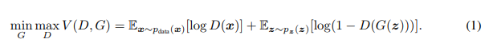
In the next section, we present a theoretical analysis of adversarial nets, essentially showing that the training criterion allows one to recover the data generating distribution as G and D are given enough capacity, i.e., in the non-parametric limit. See Figure 1 for a less formal, more pedagogical explanation of the approach. In practice, we must implement the game using an iterative, numerical approach. Optimizing D to completion in the inner loop of training is computationally prohibitive, and on finite datasets would result in overfitting. Instead, we alternate between k steps of optimizing D and one step of optimizing G. This results in D being maintained near its optimal solution, so long as G changes slowly enough. This strategy is analogous to the way that SML/PCD [31, 29] training maintains samples from a Markov chain from one learning step to the next in order to avoid burning in a Markov chain as part of the inner loop of learning. The procedure is formally presented in Algorithm 1.

In practice, equation 1 may not provide sufficient gradient for G to learn well. Early in learning, when G is poor, D can reject samples with high confidence because they are clearly different from the training data. In this case, $\log\left(1-D\left(G\left(z\right)\right)\right)$ saturates. Rather than training G to minimize $\log\left(1-D\left(G\left(z\right)\right)\right)$ we can train G to maximize $\log{D\left(G\left(z\right)\right)}$. This objective function results in the same fixed point of the dynamics of G and D but provides much stronger gradients early in learning.
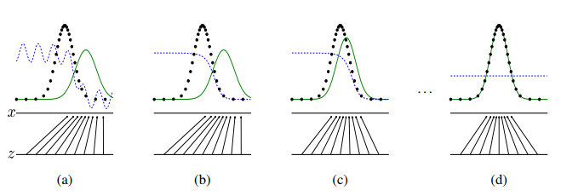
Figure 1: Generative adversarial nets are trained by simultaneously updating the discriminative distribution (D, blue, dashed line) so that it discriminates between samples from the data generating distribution (black, dotted line) px from those of the generative distribution $p_{g}\left(G\right)$(green, solid line). The lower horizontal line is the domain from which z is sampled, in this case uniformly. The horizontal line above is part of the domain of x. The upward arrows show how the mapping x = G(z) imposes the non-uniform distribution pg on transformed samples. G contracts in regions of high density and expands in regions of low density of pg. (a) Consider an adversarial pair near convergence: $p_{g}$ is similar to $p_{data}$and D is a partially accurate classifier. (b) In the inner loop of the algorithm D is trained to discriminate samples from data, converging to $D^{*}\left(x\right)=P_{data}\left(x\right)/\left(P_{data}\left(x\right)+P_{g}\left(x\right)\right)$. (c) After an update to G, gradient of D has guided G(z) to flow to regions that are more likely to be classified as data. (d) After several steps of training, if G and D have enough capacity, they will reach a point at which both cannot improve because $p_{g}$ = $p_{data}$. The discriminator is unable to differentiate between the two distributions, i.e. D(x)=1/2.
4 Theoretical Results
The generator G implicitly defines a probability distribution $P_{g}$as the distribution of the samples G(z) obtained when z∼Pz. Therefore, we would like Algorithm 1 to converge to a good estimator of $P_{data}$, if given enough capacity and training time. The results of this section are done in a nonparametric setting, e.g. we represent a model with infinite capacity by studying convergence in the space of probability density functions.

We will show in section 4.1 that this minimax game has a global optimum for $P_{g}=P_{data}$We will then show in section 4.2 that Algorithm 1 optimizes Eq 1, thus obtaining the desired result.
Algorithm 1 Minibatch stochastic gradient descent training of generative adversarial nets. The number of steps to apply to the discriminator, k, is a hyperparameter. We used k = 1, the least expensive option, in our experiments
for number of training iterations do
for k steps do
• Sample minibatch of m noise samples $\{z^{\left(1\right)},…,z^{(m)}\}$ from noise prior $P_{g}(z)$.
• Sample minibatch of m examples $\{x^{\left(1\right)},…,x^{(m)}\}$ from data generating distribution $P_{data}\left(x\right)$.
• Update the discriminator by ascending its stochastic gradient:
$$∇θ_{d}\frac{1}{m}\sum_{i=1}^{m}{\left[logD\left(x^{\left(i\right)}\right)+log⁡(1-D(G(z^{(i)}))\right]}$$
end for
• Sample minibatch of m noise samples $\{z^{\left(1\right)},…,z^{(m)}\}$ from noise prior $P_{g}\left(z\right)$.
• Update the generator by descending its stochastic gradient:
$$∇θ_{g}\frac{1}{m}\sum_{i=1}^{m}{log⁡(1-D(G(z^{(i)}))}$$
end for
The gradient-based updates can use any standard gradient-based learning rule. We used momentum in our experiments.
4.1 Global Optimality of $P_{g}=P_{data}$
We first consider the optimal discriminator D for any given generator G.
Proposition 1. For G fixed, the optimal discriminator D is
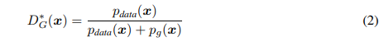
Proof. The training criterion for the discriminator D, given any generator G, is to maximize the quantity V (G, D)
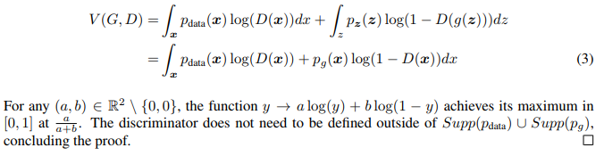
Note that the training objective for D can be interpreted as maximizing the log-likelihood for estimating the conditional probability $P\left(Y=y | x\right)$, where Y indicates whether x comes from $P_{data}$ (with y = 1) or from pg (with y = 0). The minimax game in Eq. 1 can now be reformulated as:
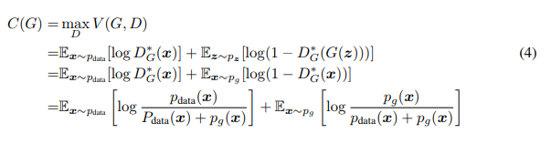
Theorem 1. The global minimum of the virtual training criterion C(G) is achieved if and only if $P_{g}=P_{data}$. At that point, C(G) achieves the value − log 4.
Proof. For $P_{g}=P_{data}$,$D_{G}^{*}\left(x\right)=1/2$, (consider Eq. 2). Hence, by inspecting Eq. 4 at $D_{G}^{*}\left(x\right)=1/2$, we find $C\left(G\right)=\log{1/2}+\log{1/2}=-log4$. To see that this is the best possible value of C(G), reached only for $P_{g}=P_{data}$, observe that
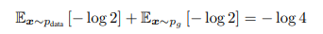
and that by subtracting this expression from$C\left(G\right)=V\left(D_{G}^{*},G\right)$, we obtain:
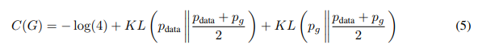
where KL is the Kullback–Leibler divergence. We recognize in the previous expression the Jensen– Shannon divergence between the model’s distribution and the data generating process:
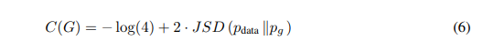
Since the Jensen–Shannon divergence between two distributions is always non-negative and zero only when they are equal, we have shown that $C^{*}=-log\left(4\right)$ is the global minimum of C(G) and that the only solution is $P_{g}=P_{data}$, i.e., the generative model perfectly replicating the data generating process.
4.2 Convergence of Algorithm 1
Proposition 2. If G and D have enough capacity, and at each step of Algorithm 1, the discriminator is allowed to reach its optimum given G, and $P_{g}$ is updated so as to improve the criterion
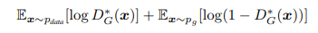
then $P_{g}$ converges to $P_{data}$
Proof. Consider $V\left(G,D\right)=U\left(P_{g},D\right)$ as a function of pg as done in the above criterion. Note that $U\left(P_{g},D\right)$ is convex in pg. The subderivatives of a supremum of convex functions include the derivative of the function at the point where the maximum is attained. In other words, if $f\left(x\right)=\sup_{α∈A}f_{α}\left(x\right)$ and $f_{α}\left(x\right)$ is convex in x for every $α$, then $∂f_{β}\left(x\right)∈∂f$ if $β=arg\sup_{α∈A}f_{α}\left(x\right)$. This is equivalent to computing a gradient descent update for pg at the optimal D given the corresponding G. $\sup_{D}U\left(P_{g},D\right)$ is convex in $P_{g}$ with a unique global optima as proven in Thm 1, therefore with sufficiently small updates of $P_{g}$, $P_{g}$ converges to $P_{x}$, concluding the proof.

In practice, adversarial nets represent a limited family of $P_{g}$ distributions via the function $G\left(z,θg\right)$, and we optimize $θg$ rather than $P_{g}$ itself. Using a multilayer perceptron to define G introduces multiple critical points in parameter space. However, the excellent performance of multilayer perceptrons in practice suggests that they are a reasonable model to use despite their lack of theoretical guarantees.
5 Experiments
We trained adversarial nets an a range of datasets including MNIST[23], the Toronto Face Database (TFD) [28], and CIFAR-10 [21]. The generator nets used a mixture of rectifier linear activations [19, 9] and sigmoid activations, while the discriminator net used maxout [10] activations. Dropout [17] was applied in training the discriminator net. While our theoretical framework permits the use of dropout and other noise at intermediate layers of the generator, we used noise as the input to only the bottommost layer of the generator network.

We estimate probability of the test set data under $P_{g}$ by fitting a Gaussian Parzen window to the samples generated with G and reporting the log-likelihood under this distribution. The $σ$ parameter of the Gaussians was obtained by cross validation on the validation set. This procedure was introduced in Breuleux et al. [8] and used for various generative models for which the exact likelihood is not tractable [25, 3, 5]. Results are reported in Table 1. This method of estimating the likelihood has somewhat high variance and does not perform well in high dimensional spaces but it is the best method available to our knowledge. Advances in generative models that can sample but not estimate likelihood directly motivate further research into how to evaluate such models.
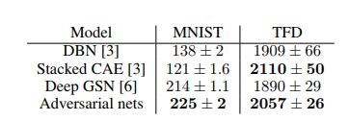
Table 1: Parzen window-based log-likelihood estimates. The reported numbers on MNIST are the mean loglikelihood of samples on test set, with the standard error of the mean computed across examples. On TFD, we computed the standard error across folds of the dataset, with a different $σ$ chosen using the validation set of each fold. On TFD, $σ$ was cross validated on each fold and mean log-likelihood on each fold were computed. For MNIST we compare against other models of the real-valued (rather than binary) version of dataset.
In Figures 2 and 3 we show samples drawn from the generator net after training. While we make no claim that these samples are better than samples generated by existing methods, we believe that these samples are at least competitive with the better generative models in the literature and highlight the potential of the adversarial framework.
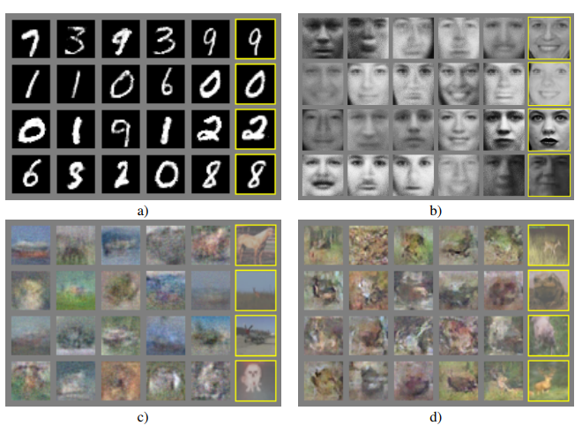
Figure 2: Visualization of samples from the model. Rightmost column shows the nearest training example of the neighboring sample, in order to demonstrate that the model has not memorized the training set. Samples are fair random draws, not cherry-picked. Unlike most other visualizations of deep generative models, these images show actual samples from the model distributions, not conditional means given samples of hidden units. Moreover, these samples are uncorrelated because the sampling process does not depend on Markov chain mixing. a) MNIST b) TFD c) CIFAR-10 (fully connected model) d) CIFAR-10 (convolutional discriminator and “deconvolutional” generator)
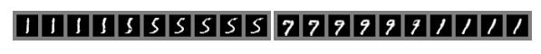
Figure 3: Digits obtained by linearly interpolating between coordinates in z space of the full model
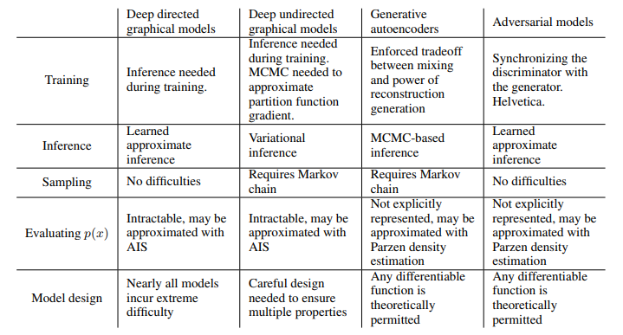
Table 2: Challenges in generative modeling: a summary of the difficulties encountered by different approaches to deep generative modeling for each of the major operations involving a model.
6 Advantages and disadvantages
This new framework comes with advantages and disadvantages relative to previous modeling frameworks. The disadvantages are primarily that there is no explicit representation of Pg(x), and that D must be synchronized well with G during training (in particular, G must not be trained too much without updating D, in order to avoid “the Helvetica scenario” in which G collapses too many values of z to the same value of x to have enough diversity to model $p_{data}$), much as the negative chains of a Boltzmann machine must be kept up to date between learning steps. The advantages are that Markov chains are never needed, only backprop is used to obtain gradients, no inference is needed during learning, and a wide variety of functions can be incorporated into the model. Table 2 summarizes the comparison of generative adversarial nets with other generative modeling approaches.

The aforementioned advantages are primarily computational. Adversarial models may also gain some statistical advantage from the generator network not being updated directly with data examples, but only with gradients flowing through the discriminator. This means that components of the input are not copied directly into the generator’s parameters. Another advantage of adversarial networks is that they can represent very sharp, even degenerate distributions, while methods based on Markov chains require that the distribution be somewhat blurry in order for the chains to be able to mix between modes.
7 Conclusions and future work
This framework admits many straightforward extensions:
- A conditional generative model p(x | c) can be obtained by adding c as input to both G and D.
- Learned approximate inference can be performed by training an auxiliary network to predict z given x. This is similar to the inference net trained by the wake-sleep algorithm [15] but with the advantage that the inference net may be trained for a fixed generator net after the generator net has finished training.
- . One can approximately model all conditionals$p\left(x_{S} | x_{S/}\right)$ where S is a subset of the indices of x by training a family of conditional models that share parameters. Essentially, one can use adversarial nets to implement a stochastic extension of the deterministic MP-DBM [11].
- Semi-supervised learning: features from the discriminator or inference net could improve performance of classifiers when limited labeled data is available.
- Efficiency improvements: training could be accelerated greatly by divising better methods for coordinating G and D or determining better distributions to sample z from during training.

This paper has demonstrated the viability of the adversarial modeling framework, suggesting that these research directions could prove useful.
Acknowledgments
We would like to acknowledge Patrice Marcotte, Olivier Delalleau, Kyunghyun Cho, Guillaume Alain and Jason Yosinski for helpful discussions. Yann Dauphin shared his Parzen window evaluation code with us. We would like to thank the developers of Pylearn2 [12] and Theano [7, 1], particularly Fred´ eric Bastien who rushed a Theano feature specifically to benefit this project. Ar- naud Bergeron provided much-needed support with LATEX typesetting. We would also like to thank CIFAR, and Canada Research Chairs for funding, and Compute Canada, and Calcul Quebec for ´ providing computational resources. Ian Goodfellow is supported by the 2013 Google Fellowship in Deep Learning. Finally, we would like to thank Les Trois Brasseurs for stimulating our creativity.
References
- Bastien, F., Lamblin, P., Pascanu, R., Bergstra, J., Goodfellow, I. J., Bergeron, A., Bouchard, N., and Bengio, Y. (2012). Theano: new features and speed improvements. Deep Learning and Unsupervised Feature Learning NIPS 2012 Workshop.
- Bengio, Y. (2009). Learning deep architectures for AI. Now Publishers.
- Bengio, Y., Mesnil, G., Dauphin, Y., and Rifai, S. (2013a). Better mixing via deep representations. In ICML’13.
- Bengio, Y., Yao, L., Alain, G., and Vincent, P. (2013b). Generalized denoising auto-encoders as generative models. In NIPS26. Nips Foundation.
- Bengio, Y., Thibodeau-Laufer, E., and Yosinski, J. (2014a). Deep generative stochastic networks trainable by backprop. In ICML’14.
- Bengio, Y., Thibodeau-Laufer, E., Alain, G., and Yosinski, J. (2014b). Deep generative stochastic networks trainable by backprop. In Proceedings of the 30th International Conference on Machine Learning (ICML’14).
- Bergstra, J., Breuleux, O., Bastien, F., Lamblin, P., Pascanu, R., Desjardins, G., Turian, J., Warde-Farley, D., and Bengio, Y. (2010). Theano: a CPU and GPU math expression compiler. In Proceedings of the Python for Scientific Computing Conference (SciPy). Oral Presentation.
- Breuleux, O., Bengio, Y., and Vincent, P. (2011). Quickly generating representative samples from an RBM-derived process. Neural Computation, 23(8), 2053–2073.
- Glorot, X., Bordes, A., and Bengio, Y. (2011). Deep sparse rectifier neural networks. In AISTATS’2011.
- Goodfellow, I. J., Warde-Farley, D., Mirza, M., Courville, A., and Bengio, Y. (2013a). Maxout networks. In ICML’2013.
- Goodfellow, I. J., Mirza, M., Courville, A., and Bengio, Y. (2013b). Multi-prediction deep Boltzmann machines. In NIPS’2013.
- Goodfellow, I. J., Warde-Farley, D., Lamblin, P., Dumoulin, V., Mirza, M., Pascanu, R., Bergstra, J., Bastien, F., and Bengio, Y. (2013c). Pylearn2: a machine learning research library. arXiv preprint arXiv:1308.4214.
- Gutmann, M. and Hyvarinen, A. (2010). Noise-contrastive estimation: A new estimation principle for unnormalized statistical models. In AISTATS’2010.
- Hinton, G., Deng, L., Dahl, G. E., Mohamed, A., Jaitly, N., Senior, A., Vanhoucke, V., Nguyen, P., Sainath, T., and Kingsbury, B. (2012a). Deep neural networks for acoustic modeling in speech recognition. IEEE Signal Processing Magazine, 29(6), 82–97.
- Hinton, G. E., Dayan, P., Frey, B. J., and Neal, R. M. (1995). The wake-sleep algorithm for unsupervised neural networks. Science, 268, 1558–1161.
- Hinton, G. E., Osindero, S., and Teh, Y. (2006). A fast learning algorithm for deep belief nets. Neural Computation, 18, 1527–1554.
- Hinton, G. E., Srivastava, N., Krizhevsky, A., Sutskever, I., and Salakhutdinov, R. (2012b). Improving neural networks by preventing co-adaptation of feature detectors. Technical report, arXiv:1207.0580.
- Hyvarinen, A. (2005). Estimation of non-normalized statistical models using score matching. ¨ J. Machine Learning Res., 6.
- Jarrett, K., Kavukcuoglu, K., Ranzato, M., and LeCun, Y. (2009). What is the best multi-stage architecture for object recognition? In Proc. International Conference on Computer Vision (ICCV’09), pages 2146–2153. IEEE.
- Kingma, D. P. and Welling, M. (2014). Auto-encoding variational bayes. In Proceedings of the International Conference on Learning Representations (ICLR).
- Krizhevsky, A. and Hinton, G. (2009). Learning multiple layers of features from tiny images. Technical report, University of Toronto.
- Krizhevsky, A., Sutskever, I., and Hinton, G. (2012). ImageNet classification with deep convolutional neural networks. In NIPS’2012.
- LeCun, Y., Bottou, L., Bengio, Y., and Haffner, P. (1998). Gradient-based learning applied to document recognition. Proceedings of the IEEE, 86(11), 2278–2324.
- Rezende, D. J., Mohamed, S., and Wierstra, D. (2014). Stochastic backpropagation and approximate inference in deep generative models. Technical report, arXiv:1401.4082.
- Rifai, S., Bengio, Y., Dauphin, Y., and Vincent, P. (2012). A generative process for sampling contractive auto-encoders. In ICML’12.
- Salakhutdinov, R. and Hinton, G. E. (2009). Deep Boltzmann machines. In AISTATS’2009, pages 448– 455.
- Smolensky, P. (1986). Information processing in dynamical systems: Foundations of harmony theory. In D. E. Rumelhart and J. L. McClelland, editors, Parallel Distributed Processing, volume 1, chapter 6, pages 194–281. MIT Press, Cambridge.
- Susskind, J., Anderson, A., and Hinton, G. E. (2010). The Toronto face dataset. Technical Report UTML TR 2010-001, U. Toronto.
- Tieleman, T. (2008). Training restricted Boltzmann machines using approximations to the likelihood gradient. In W. W. Cohen, A. McCallum, and S. T. Roweis, editors, ICML 2008, pages 1064–1071. ACM.
- Vincent, P., Larochelle, H., Bengio, Y., and Manzagol, P.-A. (2008). Extracting and composing robust features with denoising autoencoders. In ICML 2008.
- Younes, L. (1999). On the convergence of Markovian stochastic algorithms with rapidly decreasing ergodicity rates. Stochastics and Stochastic Reports, 65(3), 177–228.
<文献翻译二：译文>

生成对抗网络
摘 要
我们提出了一个通过对抗过程来估计生成模型的新框架，在新框架中我们同时训练两个模型：一个用来捕获数据分布的生成模型G，和一个用来估计样本来自训练数据而不是G的概率的判别模型D,G的训练过程是最大化D产生错误的概率。这个框架相当于一个极小化极大的双方博弈。在任意函数G和D的空间中存在唯一的解，其中G恢复训练数据分布，并且D处处都等于1/2。在G和D由多层感知器定义的情况下，整个系统可以用反向传播进行训练。在训练或生成样本期间不需要任何马尔科夫链或展开的近似推理网络。实验通过对生成的样品进行定性和定量评估来展示这个框架的潜力。
1.引言
深度学习的任务是寻找丰富的层次模型[2]，能够在人工智能领域里用来表达各种数据的概率分布，例如自然图像，包含语音的音频波形和自然语言语料库中的符号等。到目前为止，在深度学习领域，目前为止最成功的模型之一就是判别式模型，通常它们将高维丰富的感知器输入映射到类标签上[14,22]。这些显著的成功主要是基于反向传播和丢失算法来实现的，特别是具有特别良好梯度的分段线性单元[19,9,10]。由于在最大似然估计和相关策略中出现的许多难以解决的概率计算的困难，以及很难利用在生成上下文中时使用分段线性单元的好处，深度生成模型的影响很小。我们提出一个新的生成模型估计程序，来分步处理这些难题。
在提到的对抗网络框架中，生成模型对抗着一个对手：一个学习去判别一个样本是来自模型分布还是数据分布的判别模型。生成模型可以被认为是一个伪造团队，试图产生假币并在不被发现的情况下使用它，而判别模型类似于警察，试图检测假币。在这个游戏中的竞争驱使两个团队改进他们的方法，直到真假难分为止。
这个框架可以针对多种模型和优化算法提供特定的训练算法。在本文中，我们探讨了生成模型通过将随机噪声传输到多层感知机来生成样本的特例，同时判别模型也是通过多层感知机实现的。我们称这个特例为对抗网络。在这种情况下，我们可以仅使用非常成熟的反向传播和丢弃算法[17]训练两个模型，生成模型在生成样本时只使用前向传播算法。并且不需要近似推理和马尔可夫链作为前提。
2.相关工作
具有潜在变量的有向图模型可以由具有潜在变量的无向图模型替代，例如受限制波尔兹曼机(RBMs)[27,16]，深度波尔兹曼机(DBMs)[26]和它们很多的变种。这些模型之间的相互影响可以被表达为非标准化的势函数的乘积，再通过随机变量的所有状态的全局整合来标准化。这个数量（配分函数）和它的梯度的估算是很棘手的，尽管他们能够依靠马尔可夫链和蒙特卡罗(MCMC)算法来估计，同时依靠MCMC的学习算法的混合也会引发一个严重的问题[3,5]。
深度信念网络(DBNs)[16]是包含单个无向层和若干有向层的混合模型。当使用一个快速近似的逐层训练法则时，DBNs会引发无向模型和有向模型相关的计算
不受对数似然函数估计或约束的替代准则已经被提出来了，例如分数匹配[18]和噪音压缩评估(NCE)[13]。这些都需要先验概率密度来分析指定一个规范化的常量。应该注意的是许多有趣的带有一些隐层变量的生成模型（如DBNs和DBMs），它们甚至不需要一些难以处理的非标准化的概率密度先验知识。一些模型（自动编码降噪机[30]和压缩编码）的学习准则与分数匹配在RBMs上的应用非常相似。在NCE中，与本研究一样，使用一个判别训练准则来拟合一个生成模型。然而，生成模型常常被用来判别从一个固定噪音分布中抽样生成的数据，而不是拟合一个独立的判别模型。由于NCE使用一个固定的噪音分布，仅仅是从观测变量的一个小子集中学习到一个大致正确的分布后，模型的学习便急剧减慢。
最后，一些技术并没有用来明确定义概率分布，而是用来训练一个生成器来从期望的分布中拟合出样本。这个方法优势在于这些生成器能够被设计使用反向传播算法训练。这个领域最近比较突出的工作包含生成随机网络（GSN）框架[5]，它扩展了广义的降噪自动编码器[4]:两者都可以看作是定义了一个参数化的马尔可夫链，即一个通过执行生成马尔科夫链的一个步骤来学习生成器参数的算法。同GSNs相比，对抗网络框架不需要使用马尔可夫链来采样。由于对抗网络在生成阶段不需要循环反馈信息，它们能够更好的利用分段线性单元[19,9,10]，这可以提高反向传播的效率，但当使用循环反馈时却存在不受控激活的问题。大部分利用反向传播算法[24]来训练生成器的例子包括变分贝叶斯[20]自动编码和随机反向传播。
3.对抗网络
当模型都是多层感知器时，对抗模型框架是最直接应用的。为了学习生成器关于数据x上的分布Pg,我们定义输入噪声的先验变量Pz(z)，然后使用G(z，θg)来代表数据空间的映射，这里G是一个由含有参数θg的多层感知机表示的可微函数。我们再定义了一个多层感知机D(x，θd)用来输出一个单独的标量。D(x)代表x来自于真实数据分布而不是Pg的概率。我们训练D来最大化分配正确标签给来自于训练样例和由G生成的样例的概率。我们同时训练G
来最小化log(1-D(G(z)))：
换句话说，D和G的训练是关于值函数V(G,D)的极小化极大化的二人博弈问题：
在下一节中，我们提出了对抗网络的理论分析，基本上表明基于训练准则可以恢复数据生成分布，因为G和D被给予足够的容量，即在非参数极限。如图1展示了该方法的一个非正式却更加直观的解释。实际上，我们必须使用迭代数值方法来实现这个过程。在训练的内部循环中优化D到完成的计算是禁止的，并且有限的数据集将导致过拟合。相反，我们在优化D的k个步骤和优化G的一个步骤之间交替。只要G变化足够慢，就可以保证D保持在其最佳解附近。这种策略是类似于SML / PCD [31，29]训练样本保持从马尔可夫链从一个学习步骤到下一个，以避免在一个Markov链燃烧作为学习的内回路的一部分的方式。该过程如算法1所示。
实际上，方程1可能无法为G提供足够的梯度来学习。训练初期，当G的生成效果很差时，D会以高置信度来拒绝生成样本，因为它们与训练数据明显不同。在这种情况下，log(1-D(G(z)))饱和。因此我们选择最大化logD(G(z))而不是最小化log(1-D(G(z)))来训练G，该目标函数使G和D的动力学稳定点相同，并且在训练初期，该目标函数可以提供更强大的梯度。
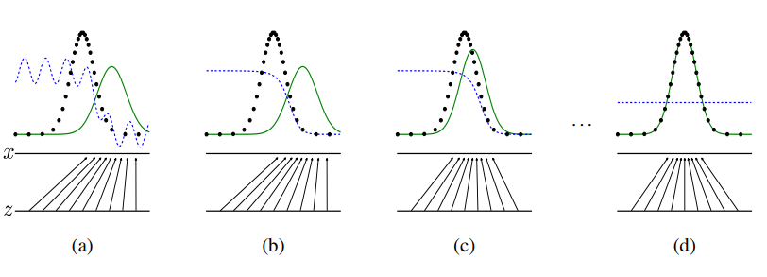
图1 训练对抗生成网络时，同时更新判别分布（D，蓝色虚线）使D能区分数据生成分布Px（黑色虚线）中的样本和生成分布$P_{g}$（G，绿色实线）中的样本。下面的水平线为均匀采样z的区域，上面的水平线为x的部分区域。朝上的箭头显示映射$x=G\left(z\right)$如何将非均匀分布$P_{g}$作用在转换后的样本上。G在$P_{g}$高密度区域收缩，且在$P_{g}$的低密度区域扩散。(a)考虑一个接近收敛的对抗的模型对：$P_{g}$与$P_{data}$相似，且D是个部分准确的分类器。(b)算法的内循环中，训练D来判别数据中的样本，收敛到：$D^{*}\left(x\right)=P_{data}\left(x\right)/\left(P_{data}\left(x\right)+P_{g}\left(x\right)\right)$。(c)在G的一次更新后，D的梯度引导$G\left(z\right)$流向更可能分类为数据的区域。(d)训练若干步后，如果G和D性能足够，它们接近某个稳定点并都无法继续提高性能，因为此时$P_{g}=P_{data}$。判别器将无法区分训练数据分布和生成数据分布，即D(x)=1/2。
4.理论结果
当z∼Pz时，获得样本G(z)，生成器G隐式的定义概率分布$P_{g}$为G(z)获得的样本的分布。因此，如果模型容量和训练时间足够大时，我们希望算法1收敛为$P_{data}$的良好估计量。本节的结果是在非参数设置下完成的，例如，我们通过研究概率密度函数空间中的收敛来表示具有无限容量的模型。
我们将在4.1节中显示，这个极小极大问题的全局最优解为$P_{g}=P_{data}$。我们将在4.2节中展示使用算法1来优化等式1，从而获得期望的结果。
算法1.生成对抗网络的minibatch随机梯度下降训练。判别器的训练步数，k是一个超参数。在我们的试验中使用k=1，使消耗最小。
for number of training iterations do
for k steps do
- 在噪声先验分布为$P_{g}(z)$的m个噪声样本$\{z^{\left(1\right)},…,z^{(m)}\}$中采一个minibatch。
- 在数据分布为$P_{data}\left(x\right)$的m个训练样本$\{x^{\left(1\right)},…,x^{(m)}\}$中采一个minibatch。
- 通过随机梯度上升来更新判别器：
$∇θ_{d}\frac{1}{m}\sum_{i=1}^{m}{\left[logD\left(x^{\left(i\right)}\right)+log⁡(1-D(G(z^{(i)}))\right]}$.
end for
- 在噪声先验分布为$P_{g}\left(z\right)$的m个噪声样本$\{z^{\left(1\right)},…,z^{(m)}\}$中采一个minibatch。
- 通过随机梯度下降来更新判别器：
$∇θ_{g}\frac{1}{m}\sum_{i=1}^{m}{log⁡(1-D(G(z^{(i)}))}$.
end for
基于梯度的更新可以使用任何标准的基于梯度的学习准则。我们在实验中使用了动量准则。
4.1.全局最优：$P_{g}=P_{data}$
首先任意给定生成器G，考虑最优判别器D。
命题1.固定G，最优判别器D为：
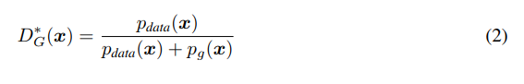
证明：给定任意生成器G，判别器D的训练标准为最大化目标函数V(G,D)数量
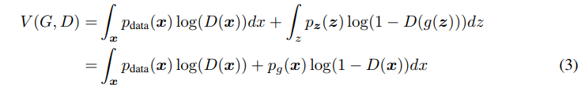
对于任意的$\left(a,b\right)∈R^{2}\backslash \{0,0\}$，函数$y→alog\left(y\right)+blog\left(1-y\right)$在$\left[0,1\right]$中的$a/\left(a+b\right)$处达到最大值，无需在$Supp\left(P_{data}\right)∪Supp\left(P_{g}\right)$外定义判别器，证毕。
注意到，判别器D的训练目标可以看作为条件概率$P\left(Y=y | x\right)$的最大似然估计，当y=1时，x来自于$P_{data}$；当y=0时，x来自$P_{g}$。公式1中的极小化极大化问题可以变形为：
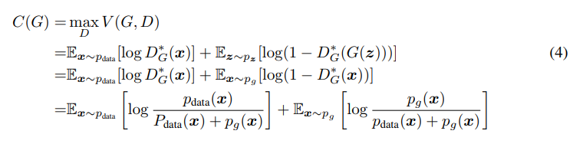
定理1：当且仅当$P_{g}=P_{data}$时，C(G)达到全局最小。此时，C(G)的值为-log4。
证明：$P_{g}=P_{data}$时，$D_{G}^{*}\left(x\right)=1/2$（公式2）。再根据公式4可得，当$D_{G}^{*}\left(x\right)=1/2$时，$C\left(G\right)=\log{1/2}+\log{1/2}=-log4$。为了看仅当$P_{g}=P_{data}$时C(G)是否是最优的，观测：
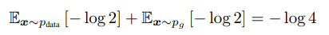
然后从$C\left(G\right)=V\left(D_{G}^{*},G\right)$减去上式，可得：
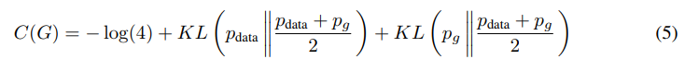
其中KL为Kullback-Leibler散度。我们在之前的表达式中识别出了模型分布和数据生成过程之间的Jensen-Shannon散度：
由于两个分布之间的Jensen-Shannon散度总是非负的，并且当两个分布相等时，值为0。因此$C^{*}=-log\left(4\right)$为C(G)的全局极小值，并且唯一解为$P_{g}=P_{data}$，即生成模型能够完美的复制数据的生成过程。
4.2.算法1的收敛性
命题2：如果G和D有足够的性能，对于算法1中的每一步，给定G时，判别器能够达到其最优，并且通过更新$P_{g}$来提高这个判别准则，则$P_{g}$收敛于$P_{data}$。
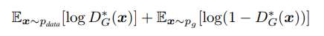
证明：如上述准则，考虑$V\left(G,D\right)=U\left(P_{g},D\right)$为关于$P_{g}$的函数。注意到$U\left(P_{g},D\right)$为$P_{g}$的凸函数。该凸函数上确界的一次导数包括达到最大值处的该函数的导数。换句话说，如果$f\left(x\right)=\sup_{α∈A}f_{α}\left(x\right)$且对于每一个$α$，$f_{α}\left(x\right)$是关于$x$的凸函数，那么如果$β=arg\sup_{α∈A}f_{α}\left(x\right)$，则$∂f_{β}\left(x\right)∈∂f$。这等价于给定对应的G和最优的D，计算$P_{g}$的梯度更新。如定理1所证明，$\sup_{D}U\left(P_{g},D\right)$是关于$P_{g}$的凸函数且有唯一的全局最优解，因此，当$P_{g}$的更新足够小时，$P_{g}$收敛到$P_{x}$，证毕。
实际上，对抗网络通过函数$G\left(z,θg\right)$表示一个有限的$P_{g}$分布族，我们优化$θg$而不是$P_{g}$本身。使用多层感知器来定义G引入参数空间中的多个关键点。然而，多层感知器在实践中的优异表现表明，尽管缺乏理论保证，它们仍是一个合理的可用模型。
5.实验
我们在一系列包括MNIST[23]、多伦多面孔数据库(TFD)[28]和CIFAR-10[21]的数据集上来训练对抗网络。生成器网络使用的激活函数包括修正线性激活(ReLU)[19,9]和sigmoid激活，而判别器网络使用maxout[10]激活。Dropout[17]被用于训练判别器网络。虽然我们的理论框架可以在生成器的中间层使用dropout和其他噪声，但是这里仅在生成器网络的最底层使用噪声输入。
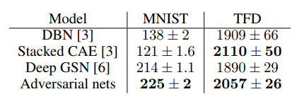
表1 基于Parzen窗口的对数似然估计。MNIST上报告的数字是测试集上的平均对数似然以及在样本上平均计算的标准误差。在TFD上，我们计算数据集的不同折之间的标准误差，在每个折的验证集上选择不同的$σ$。在TFD上，在每一个折上对$σ$进行交叉验证并计算平均对数似然函数。对于MNIST，我们与真实值（而不是二进制）版本的数据集的其他模型进行比较。
我们通过对G生成的样本应用高斯Parzen窗口并计算此分布下的对数似然，来估计测试集数据的概率。高斯的$σ$参数通过对验证集的交叉验证获得。Breuleux等人引入该过程且用于不同的精确[8]似然难以处理的生成模型[25,3,5]上。结果显示在表1中。该方法估计似然的方差较大且在高维空间中表现不好，但据我们所知却是目前最有效的办法。生成模型的优点是可采样而不直接估计似然，从而促进了对如何评估该模型的进一步研究。
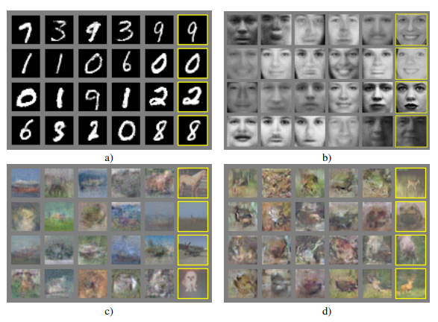
图2 来自模型的样本可视化。最右边的列示出了相邻样本的最近训练示例，以便证明该模型没有记住训练集。样本是完全随机抽取，而并非精心挑选的。与其他大多数深度生成模型的可视化不同，这些图像显示来自模型分布的实际样本，不是隐藏单元给定样本。此外，这些样本是不相关的，因为，采样过程并不依赖马尔科夫链混合。a)MNIST；b)TFD；c)CIFAR-10（全连接模型）；d)CIFAR-10（卷积判别器和“解卷积”生成器）
图3 通过在完整模型的z空间的坐标之间进行线性内插获得的数字
训练后的生成样本如下图2、图3所示。虽然未声明该方法生成的样本优于其它方法生成的样本，但我们相信这些样本至少和文献中更好的生成模型相比依然具有竞争力，也突出了对抗框架的潜力。
6.优点和缺点
这个新框架相比以前的建模框架有其优缺点。缺点主要是Pg(x)的隐式表示，而且在训练期间，D和G必须很好地同步（特别地，不更新D时G不必过度训练，为避免“Helvetica情景”。否则，x值相同时G丢失过多z值以至于模型$p_{data}$多样性不足，正如玻尔兹曼机的负向链在学习步骤间的必须持续不断地更新。其优点是无需马尔科夫链，仅用反向传播来获得梯度，学习间无需推理，且模型中可融入多种函数。表2总结了生成对抗网络与其他生成建模方法的比较。
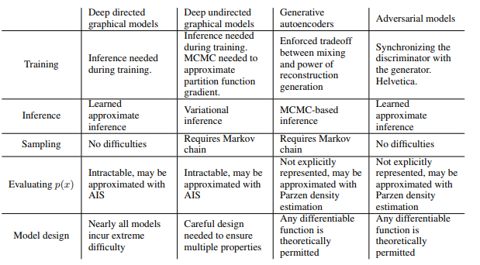
表2 生成建模中的挑战：对涉及模型的每个主要操作的深度生成建模的不同方法遇到的困难的总结。
上述优势主要在计算上。对抗的模型也可能用数据实例，仅用流过判别器的梯度，从间接更新的生成模型中获得一些统计优势。这意味输入部分未直接复制进生成器的参数。对抗的网络的另一优点是可表示很尖，甚至退化的分布，而基于马尔科夫链的方法为混合模式而要求模糊的分布。
7.结论和未来研究方向
该框架允许许多直接的扩展：
- 条件生成模型$p\left(x | c\right)$可以通过将c作为G和D的输入来获得。
- 给定x，可以通过训练一个辅助网络来学习近似推理以预测z。这和wake-sleep算法训练出的推理网络类似，但是它具有一个优势，就是在生成器网络训练完成后，这个推理网络可以针对固定的生成器网络进行训练。
- 能够用来近似模拟所有的条件概率$p\left(x_{S} | x_{S/}\right)$，其中S是通过训练共享参数的条件模型簇的关于x索引的一个子集。本质上，可以使用生成对抗网络来随机拓展确定的MP-DBM。
- 半监督学习：当标签数据有限时，判别网络或推理网络的特征会提高分类器效果。
- 效率改善：为协调G和D设计更好的方法或训练期间确定更好的分布来采样z，能够极大的加速训练。
本文已经展示了对抗建模框架的可行性，表明这些研究方向是有用的。
致谢
我们要感谢Patrice Marcotte，Olivier Delalleau，Kyunghyun Cho，Guillaume Alain和Jason Yosinski的有益讨论。 Yann Dauphin与我们分享了他的Parzen窗口评估代码。 我们要感谢Pylearn2 [12]和Theano [7,1]的开发人员，尤其是弗雷德·埃里克·巴斯蒂安，他们特意推出了Theano功能，以使该项目受益。 Ar-'naud Bergeron通过LATEX排版提供了急需的支持。 我们还要感谢CIFAR和加拿大研究主席的资助，以及Compute Canada和Calcul Quebec的“提供计算资源”。 Ian Goodfellow得到2013年谷歌深度学习奖学金的支持。 最后，我们要感谢Les Trois Brasseurs激发我们的创造力。
参考文献
- Bastien, F., Lamblin, P., Pascanu, R., Bergstra, J., Goodfellow, I. J., Bergeron, A., Bouchard, N., and Bengio, Y. (2012). Theano: new features and speed improvements. Deep Learning and Unsupervised Feature Learning NIPS 2012 Workshop.
- Bengio, Y. (2009). Learning deep architectures for AI. Now Publishers.
- Bengio, Y., Mesnil, G., Dauphin, Y., and Rifai, S. (2013a). Better mixing via deep representations. In ICML’13.
- Bengio, Y., Yao, L., Alain, G., and Vincent, P. (2013b). Generalized denoising auto-encoders as generative models. In NIPS26. Nips Foundation.
- Bengio, Y., Thibodeau-Laufer, E., and Yosinski, J. (2014a). Deep generative stochastic networks trainable by backprop. In ICML’14.
- Bengio, Y., Thibodeau-Laufer, E., Alain, G., and Yosinski, J. (2014b). Deep generative stochastic networks trainable by backprop. In Proceedings of the 30th International Conference on Machine Learning (ICML’14).
- Bergstra, J., Breuleux, O., Bastien, F., Lamblin, P., Pascanu, R., Desjardins, G., Turian, J., Warde-Farley, D., and Bengio, Y. (2010). Theano: a CPU and GPU math expression compiler. In Proceedings of the Python for Scientific Computing Conference (SciPy). Oral Presentation.
- Breuleux, O., Bengio, Y., and Vincent, P. (2011). Quickly generating representative samples from an RBM-derived process. Neural Computation, 23(8), 2053–2073.
- Glorot, X., Bordes, A., and Bengio, Y. (2011). Deep sparse rectifier neural networks. In AISTATS’2011.
- Goodfellow, I. J., Warde-Farley, D., Mirza, M., Courville, A., and Bengio, Y. (2013a). Maxout networks. In ICML’2013.
- Goodfellow, I. J., Mirza, M., Courville, A., and Bengio, Y. (2013b). Multi-prediction deep Boltzmann machines. In NIPS’2013.
- Goodfellow, I. J., Warde-Farley, D., Lamblin, P., Dumoulin, V., Mirza, M., Pascanu, R., Bergstra, J., Bastien, F., and Bengio, Y. (2013c). Pylearn2: a machine learning research library. arXiv preprint arXiv:1308.4214.
- Gutmann, M. and Hyvarinen, A. (2010). Noise-contrastive estimation: A new estimation principle for unnormalized statistical models. In AISTATS’2010.
- Hinton, G., Deng, L., Dahl, G. E., Mohamed, A., Jaitly, N., Senior, A., Vanhoucke, V., Nguyen, P., Sainath, T., and Kingsbury, B. (2012a). Deep neural networks for acoustic modeling in speech recognition. IEEE Signal Processing Magazine, 29(6), 82–97.
- Hinton, G. E., Dayan, P., Frey, B. J., and Neal, R. M. (1995). The wake-sleep algorithm for unsupervised neural networks. Science, 268, 1558–1161.
- Hinton, G. E., Osindero, S., and Teh, Y. (2006). A fast learning algorithm for deep belief nets. Neural Computation, 18, 1527–1554.
- Hinton, G. E., Srivastava, N., Krizhevsky, A., Sutskever, I., and Salakhutdinov, R. (2012b). Improving neural networks by preventing co-adaptation of feature detectors. Technical report, arXiv:1207.0580.
- Hyvarinen, A. (2005). Estimation of non-normalized statistical models using score matching. ¨ J. Machine Learning Res., 6.
- Jarrett, K., Kavukcuoglu, K., Ranzato, M., and LeCun, Y. (2009). What is the best multi-stage architecture for object recognition? In Proc. International Conference on Computer Vision (ICCV’09), pages 2146–2153. IEEE.
- Kingma, D. P. and Welling, M. (2014). Auto-encoding variational bayes. In Proceedings of the International Conference on Learning Representations (ICLR).
- Krizhevsky, A. and Hinton, G. (2009). Learning multiple layers of features from tiny images. Technical report, University of Toronto.
- Krizhevsky, A., Sutskever, I., and Hinton, G. (2012). ImageNet classification with deep convolutional neural networks. In NIPS’2012.
- LeCun, Y., Bottou, L., Bengio, Y., and Haffner, P. (1998). Gradient-based learning applied to document recognition. Proceedings of the IEEE, 86(11), 2278–2324.
- Rezende, D. J., Mohamed, S., and Wierstra, D. (2014). Stochastic backpropagation and approximate inference in deep generative models. Technical report, arXiv:1401.4082.
- Rifai, S., Bengio, Y., Dauphin, Y., and Vincent, P. (2012). A generative process for sampling contractive auto-encoders. In ICML’12.
- Salakhutdinov, R. and Hinton, G. E. (2009). Deep Boltzmann machines. In AISTATS’2009, pages 448– 455.
- Smolensky, P. (1986). Information processing in dynamical systems: Foundations of harmony theory. In D. E. Rumelhart and J. L. McClelland, editors, Parallel Distributed Processing, volume 1, chapter 6, pages 194–281. MIT Press, Cambridge.
- Susskind, J., Anderson, A., and Hinton, G. E. (2010). The Toronto face dataset. Technical Report UTML TR 2010-001, U. Toronto.
- Tieleman, T. (2008). Training restricted Boltzmann machines using approximations to the likelihood gradient. In W. W. Cohen, A. McCallum, and S. T. Roweis, editors, ICML 2008, pages 1064–1071. ACM.
- Vincent, P., Larochelle, H., Bengio, Y., and Manzagol, P.-A. (2008). Extracting and composing robust features with denoising autoencoders. In ICML 2008.
- Younes, L. (1999). On the convergence of Markovian stochastic algorithms with rapidly decreasing ergodicity rates. Stochastics and Stochastic Reports, 65(3), 177–228.

Santiago P, Antonio B, Joan S. SEGAN: Speech Enhancement Generative Adversarial Network[C]// INTERSPEECH. 2017:3642-3646
Goodfellow I, Pouget-Abadie J, Mirza M, Xu B, WardeFarley D, Ozair S, Courville A, Bengio Y. Generative Adversarial nets. In: Proceedings of the 2014 Conference on Advances in Neural Information Processing Systems 27. Montreal, Canada: Curran Associates, Inc.,2014.2672-2680

