[**Lab 3: Multiple View Controllers**](https://bbhosted.cuny.edu/webapps/assignment/uploadAssignment?content_id=_80353513_1&course_id=_2286381_1&group_id=&mode=view)

Ivan Chukharev

*Source code:*

**FirstView.swift**

//

// FirstView.swift

// Lab3

//

// Created by Ivan Chukharev on 10/27/23.

//

import SwiftUI

struct CustomButtonStyle: ButtonStyle {

func makeBody(configuration: Self.Configuration) -> some View {

configuration.label

.padding()

.background(Color.white)

.foregroundColor(Color.black)

.cornerRadius(15)

.scaleEffect(configuration.isPressed ? 0.9 : 1.0)

}

}

struct FirstView: View {

@State private var name: String = ""

@State private var greeting: String = "Hello, Guest"

var body: some View {

NavigationView {

ZStack {

Color.blue

VStack {

Text("First Screen")

.font(Font.custom("YourCustomFont", size: 40))

.padding()

TextField("Enter your name", text: $name)

.textFieldStyle(RoundedBorderTextFieldStyle())

.padding()

Button("Update Greeting") {

if !name.isEmpty {

greeting = "Hello, \(name)"

} else {

greeting = "Hello, Guest"

}

}

.buttonStyle(CustomButtonStyle())

.padding()

NavigationLink("Go to SecondView", destination: SecondView(greeting: $greeting).navigationBarBackButtonHidden(true))

.buttonStyle(CustomButtonStyle())

.padding()

NavigationLink("Go to ThirdView", destination: ThirdView().navigationBarBackButtonHidden(true))

.buttonStyle(CustomButtonStyle())

.padding()

}

}

}

}

}

*Screenshots:*

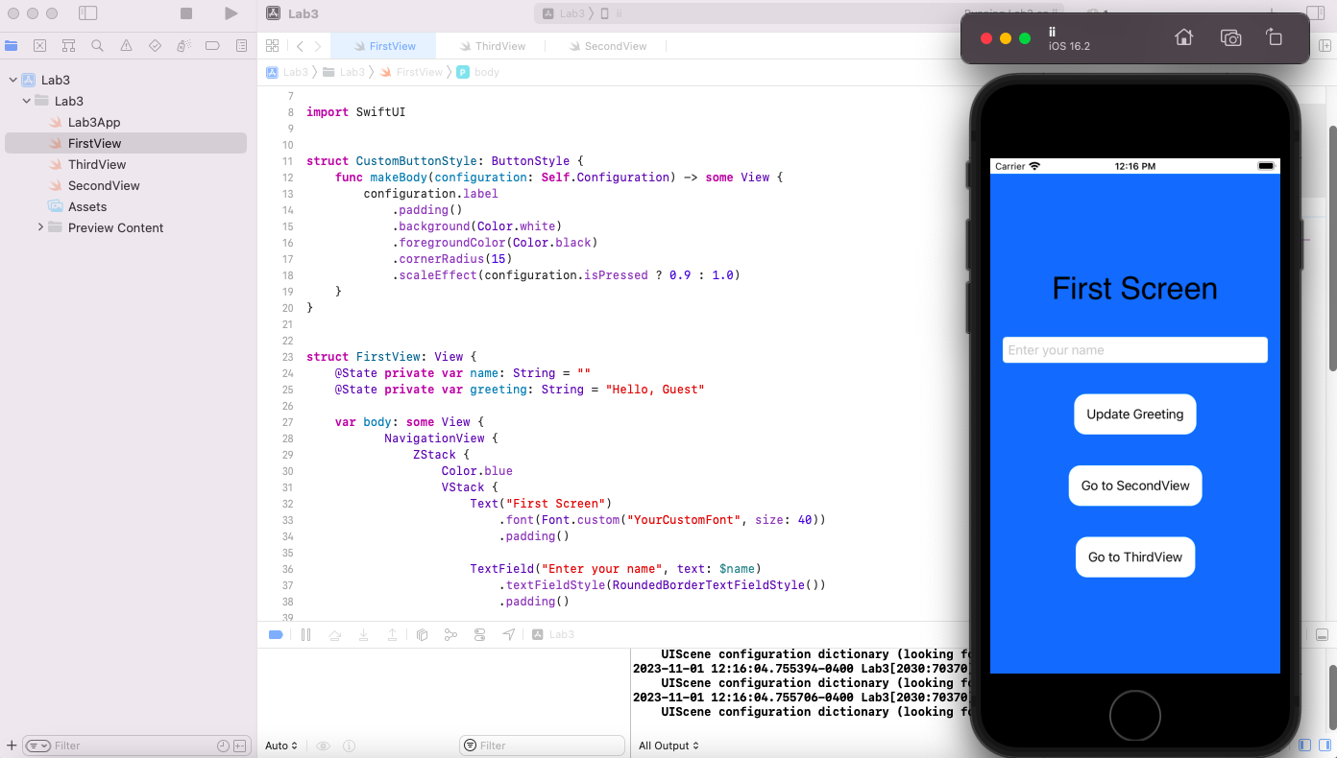

**SecondView.swift**

//

// FirstView.swift

// Lab3

//

// Created by Ivan Chukharev on 10/27/23.

//

import SwiftUI

struct CustomButtonStyle: ButtonStyle {

func makeBody(configuration: Self.Configuration) -> some View {

configuration.label

.padding()

.background(Color.white)

.foregroundColor(Color.black)

.cornerRadius(15)

.scaleEffect(configuration.isPressed ? 0.9 : 1.0)

}

}

struct FirstView: View {

@State private var name: String = ""

@State private var greeting: String = "Hello, Guest"

var body: some View {

NavigationView {

ZStack {

Color.blue

VStack {

Text("First Screen")

.font(Font.custom("YourCustomFont", size: 40))

.padding()

TextField("Enter your name", text: $name)

.textFieldStyle(RoundedBorderTextFieldStyle())

.padding()

Button("Update Greeting") {

if !name.isEmpty {

greeting = "Hello, \(name)"

} else {

greeting = "Hello, Guest"

}

}

.buttonStyle(CustomButtonStyle())

.padding()

NavigationLink("Go to SecondView", destination: SecondView(greeting: $greeting).navigationBarBackButtonHidden(true))

.buttonStyle(CustomButtonStyle())

.padding()

NavigationLink("Go to ThirdView", destination: ThirdView().navigationBarBackButtonHidden(true))

.buttonStyle(CustomButtonStyle())

.padding()

}

}

}

}

}

*Screenshots:*

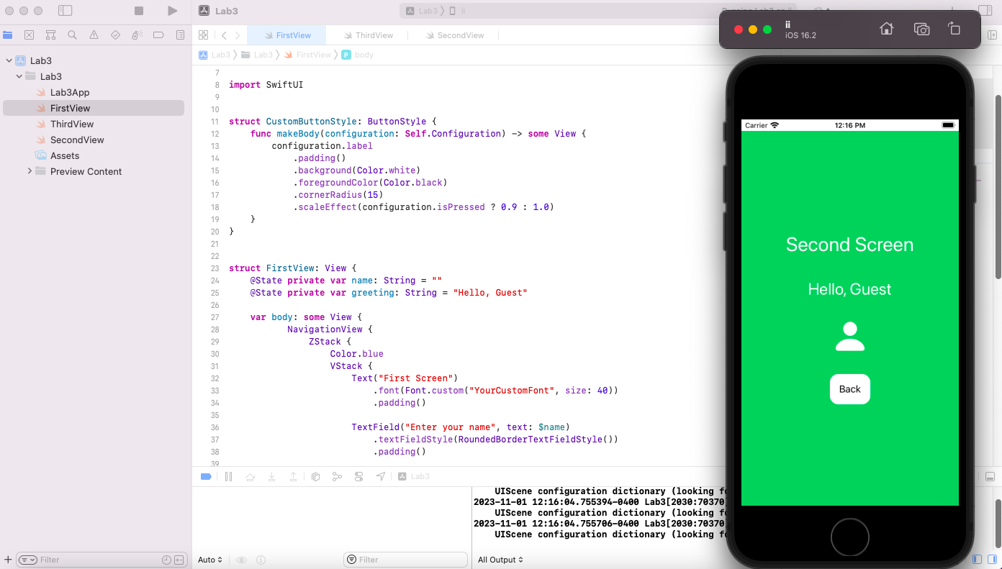

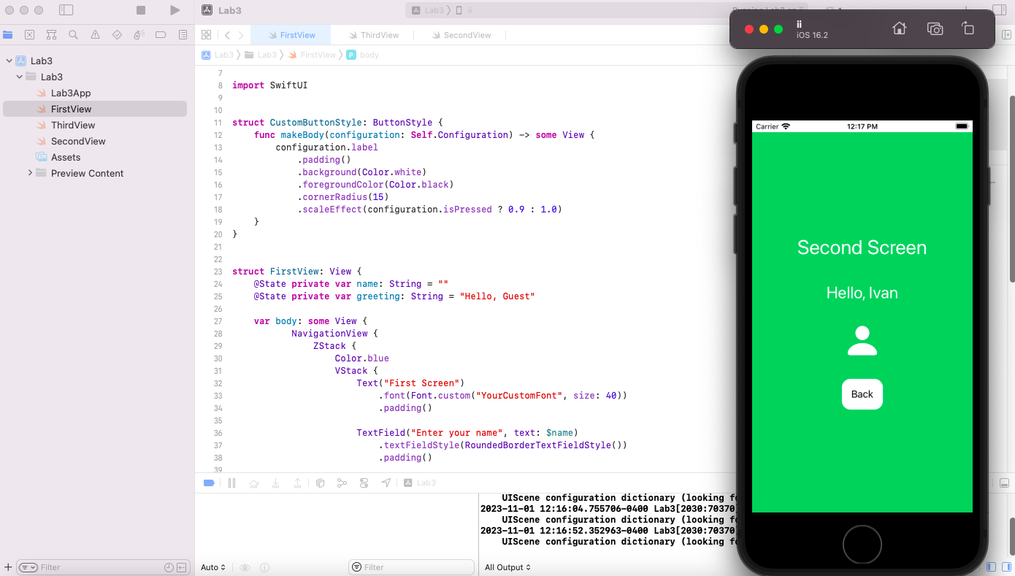

**ThirdView.swift**

//

// ThirdView.swift

// Lab3

//

// Created by Ivan Chukharev on 10/27/23.

//

import SwiftUI

struct ThirdView: View {

@State private var message: String = "Tap the button for a surprise!"

@State private var isShowingMessage: Bool = false

var body: some View {

ZStack {

Color.purple

VStack {

Text("Third Screen")

.font(.largeTitle)

.padding()

.foregroundColor(.white)

Text(message)

.font(.title)

.padding()

.foregroundColor(.white)

Button("Reveal Message") {

isShowingMessage.toggle()

if isShowingMessage {

message = getRandomMessage()

} else {

message = "Tap the button for a surprise!"

}

}

.buttonStyle(CustomButtonStyle())

.padding()

NavigationLink( destination: FirstView().navigationBarBackButtonHidden(true),

label: {Text("Back")})

.buttonStyle(CustomButtonStyle())

.padding()

}

}

}

func getRandomMessage() -> String {

let messages = ["You're awesome!", "Keep going!", "Success is near!", "Stay positive!"]

return messages.randomElement() ?? "Surprise!"

}

}

*Screenshots:*

