### [Lab 4: Classroom Assignment](https://bbhosted.cuny.edu/webapps/assignment/uploadAssignment?content_id=_81492253_1&course_id=_2286381_1&group_id=&mode=view)

Ivan Chukharev

*Source code:*

**ContentView.swift**

//

// ContentView.swift

// ObservableObject

//

// Created by Ivan Chukharev on 11/13/23.

//

import SwiftUI

class UserData: ObservableObject {

@Published var username: String = "Guest"

@Published var age: Int = 20

var canVote: Bool {

age >= 18

}

func increaseAge(){

age += 1

}

func decreaseAge(){

age -= 1

}

}

struct ContentView: View {

@ObservedObject var userData = UserData()

var body: some View {

NavigationView {

ZStack {

Color.yellow

VStack {

Text("Welcome, \(userData.username)")

.font(.headline)

Text("Age: \(userData.age)")

.font(.headline)

Text("Can vote: \(userData.canVote ? "Yes" : "No")")

.font(.headline)

HStack{

Button("Increase Age") {

userData.increaseAge()

}.padding(10)

Button("Decrease Age") {

userData.decreaseAge()

}.padding(10)

}.padding(15)

if(userData.age >= 18){

NavigationLink("Apply to Vote", destination: SecondView(age: $userData.age).navigationBarBackButtonHidden(true)).frame(width: 200, height: 50)

.background(Color.blue)

.foregroundColor(.white)

}

else {

NavigationLink("Apply to Vote", destination: SecondView(age: $userData.age).navigationBarBackButtonHidden(true)).frame(width: 200, height: 50)

.background(Color.blue)

.foregroundColor(.white)

.hidden()

}

}

.padding()}

}

}

}

*Screenshots:*

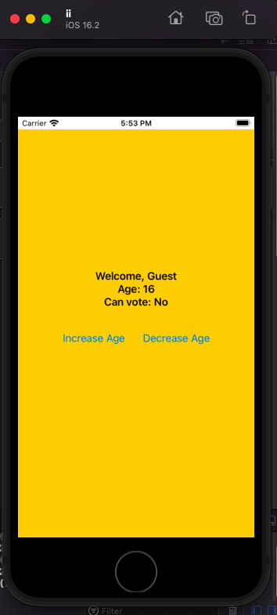

**SecondView.swift**

//

// SecondView.swift

// ObservableObject

//

// Created by Ivan Chukharev on 11/13/23.

//

import SwiftUI

struct SecondView: View {

@State private var name: String = ""

@Binding var age: Int

var body: some View {

NavigationView {

ZStack {

Color.green

VStack {

Text("Vote Form")

.font(.largeTitle)

.padding()

.foregroundColor(.white)

Image(systemName: "person.fill")

.resizable()

.frame(width: 50, height: 50)

.foregroundColor(.white)

.padding()

TextField("Enter your name", text: $name)

.textFieldStyle(RoundedBorderTextFieldStyle())

.padding()

Text("Age: \(age)")

.font(.title)

.padding()

.foregroundColor(.white)

Button("Submit") {

}

NavigationLink( destination: ContentView().navigationBarBackButtonHidden(true),

label: {Text("Back")}).frame(width: 200, height: 50)

.background(Color.blue)

.foregroundColor(.white)

.padding()

}

}

}

}

}

*Screenshots:*

