MAC 172

50 points

**Question 1: (20 points)**

Create and test an HTML document that has a form with the following controls:

1. A text box to collect the user’s name. Assume that user’s name has a max length of 10 characters.
2. A text box to collect the user’s password. Assume that user’s name has a max length of 10 characters.
3. Four checkboxes, one each for the following items:
   * Four 100-watt light bulbs for $2.39
   * Eight 100-watt light bulbs for $4.29
   * Four 100-watt, long-life light bulbs for $3.95
   * Eight 100-watt, long-life light bulbs for $7.49
4. A collection of three radio buttons that are labeled as follows:
   * Visa
   * Master Card
   * Discover

**Question 2: (30 points)**

In this assignment, you need to create a small website designed to provide online courses in computer science.   The website needs to contain several pages as follow:

1. Home Page: That provide general information about the website.
2. About me page: This page should contain information such as your education, experience, skills (Technical), certifications, and Work Experience / Projects.
3. Register page: This page is designed to allow your website visitors to register in your website. Therefore, it should contain a form with some controls to collect the user information such as:
   * First and last names.
   * Password.
   * Emails.
   * This page also should contain two buttons to submit and reset.
4. Login Page: This page is designed to allow users to login to your website.

**Requirements**:

1. All pages must have navigation menu where user can go to any page within the website.
2. I left the logn page to you.So, try to be creative.

Note: All images have been provided that you need in the attached folder.

**Home Page**

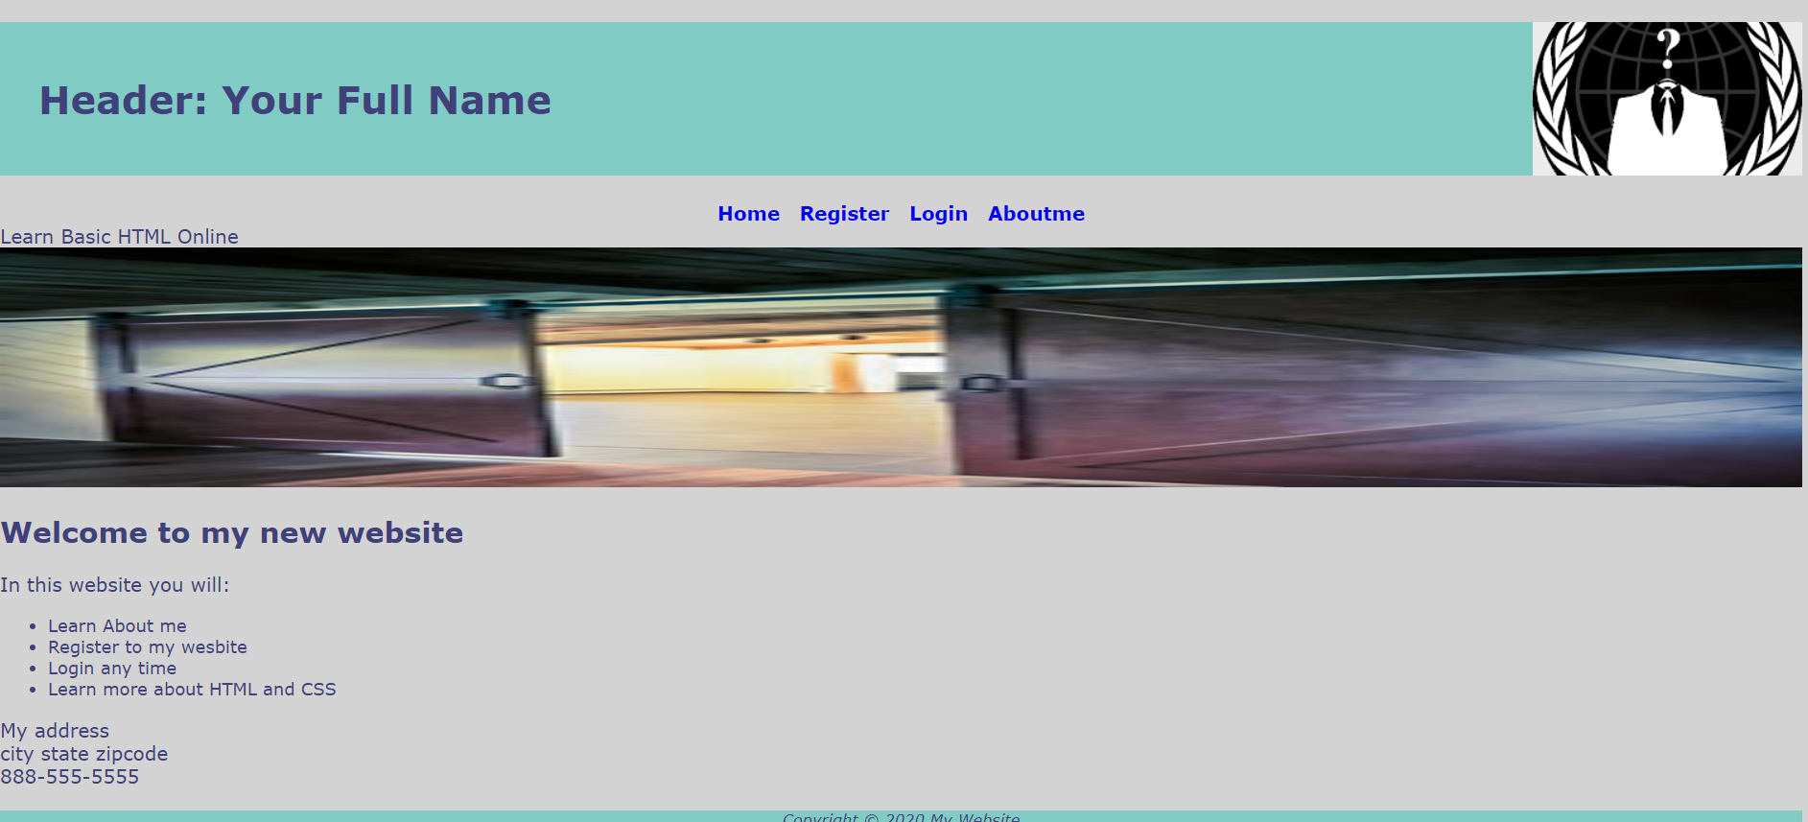

**About me Page**

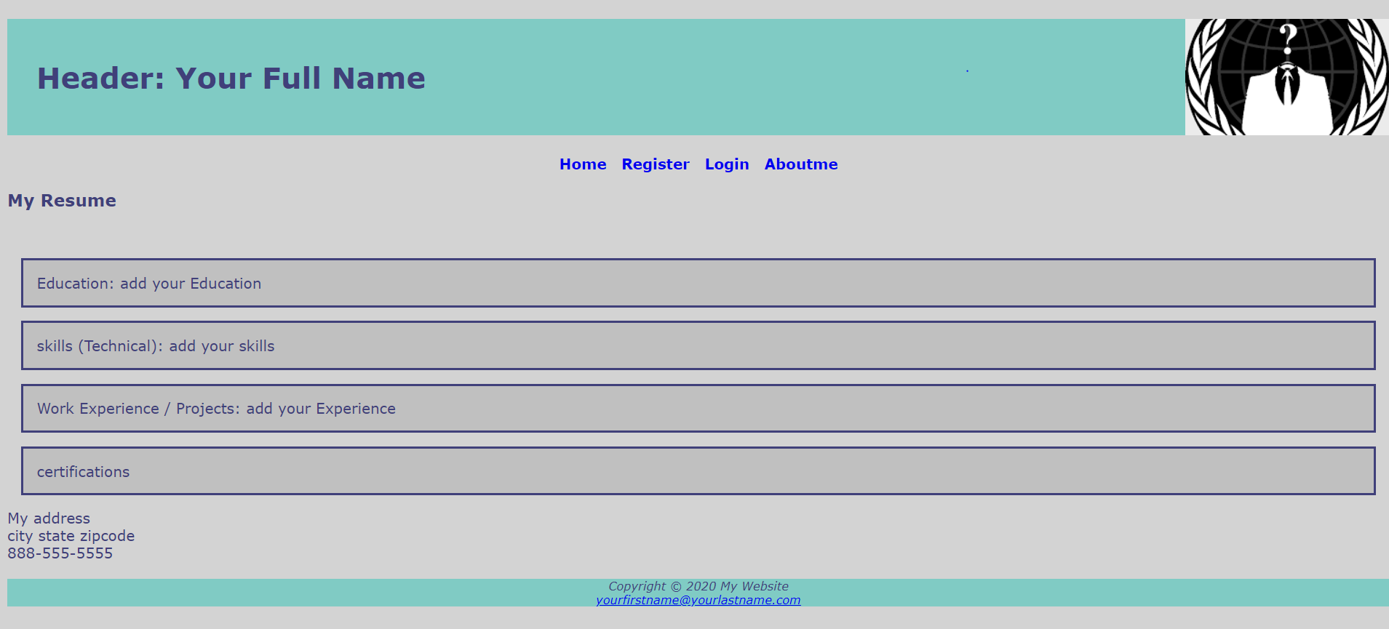

**Register Page**

