Samsung declared to release the A42 5G handset of its galaxy series in 2nd september, 2020. This handset is released in Thiland then. Preiously released A41 is a predecessor of this phone. Price of this has been decided as 399 euro in amazon prime. In UK, every unit is being sold in 469 euro in ebay.

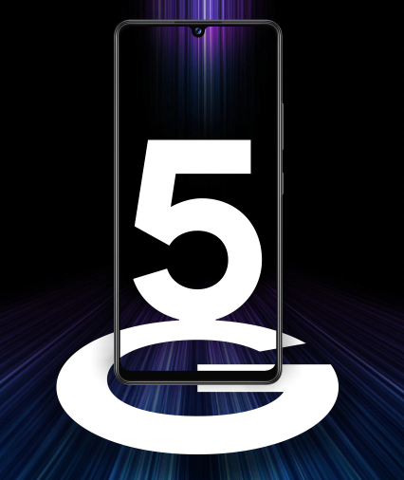

Samsung Galaxy A42 5G

Screen size of this phone is 6.47”x2.99” with an area of 105 sq cm. Nature of this screen is super amoled. According to the official website of samsung, display supports a resolution of 1080p. When you wish to record a video, 30 frame in every second is captured. So size of the video is bigger but quality will be great.

Multi camera supporting technology is attached here with 4 back and one front camera. Main back camera is of 48 megapixel and has a focal length of 1.8m. An ultra wide camera of 8 megapixel can capture views with 123 degree angles. You can take photos of very tini substances with another 5 megapixel macro camera. Front camera has an resolution of 20 megapixel with high performance of capturing selfie ignoring the background.

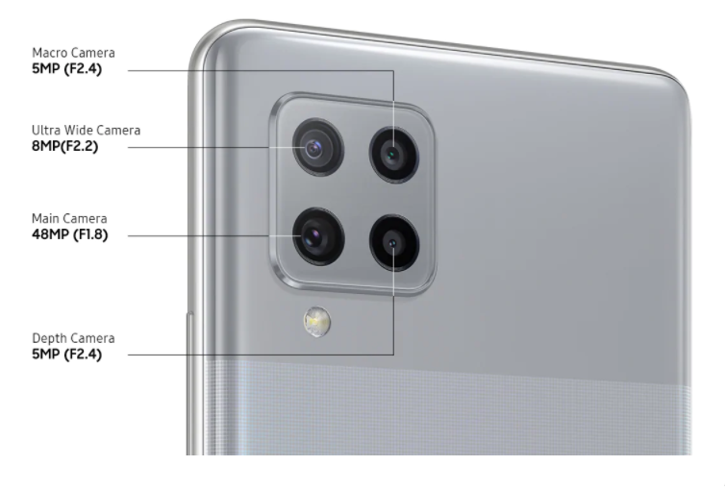

Back camera

A 5000 mili ampire battery has benn integrated here for considering the user side. This battery is charged with a 15 watt fast charging. Type of charging port is USB-c 2.0. So you need not think more while trying to connect a charger to this port. In the context of today’s world, here used lithium polymar battery is much typical. It is also non removable.

While deciding to buy a new handset, customers first think of performance. Performance of an electric gadget depends upon its RAM-ROM-processor-chipset. Samsung tries to provide better serice with these parts from the ery beginning. Qualcomm SM7225 Snapdragon 750 chipset is used here with octacore processor of 2.2 GHz. Length of this chipset is only 8 nanometer. In the previous phones, samsung has used other processor which is less efficient then snapdragon. Operationg system is integrated with Android 10.0.

Samsung used 128 Gigabyte ROM as internal storage and a variety of RAM od 4, 6 and 8 Gigabyte. You can add an extra 1 Terabyte micro SD card but not with two SIM simultaneously. You have to use two SIM card or one SIM card with SD card. These slots support 5G network. Infact you can use 4G, 3G even 2G in these slots.

Performance of this handset is more visible to gamers. A feature named ‘Game Booster’ is applied here which can runs the graphics more smoothly and live. On the other hand, it analyzes the pattern of a gamer to minimize power usage, increase the battery time, decrease the internal temperature. The analysis is applied later when a gamer plays games.

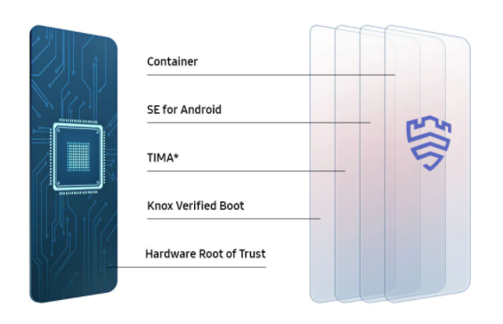

‘Samsung Knox’ security system

From that moment when you unbox and run the phone for the first time, a multi-layered security system called ‘Samsung Knox’ is activated. The posibility of malware attack lessen as well as users information is protected as a result.

Unlike most of the smartphones of samsung, this handset has an feature to delete the junk files, clear the cache and memory. Night mode can be activated at night so that user can have a great experience all the time. External security is applied here with fingerrint sensor and face unlocking system.

Main external difference from other device is that it has the fingerprint sensor integrated with screen. In the other phone, this part is connected in the back or right side of phone but here built in with display.

Though samsung has remarked and highlighted many pros and advancement from predecessors, there are some cons too. Some users have addressed this handset as ‘very odd’. Quality of display, non-waterproof and non-dustproof functions, non-dedicated SIM slots and only wired charging system have made the users very dissaponted.

According to the users, resolution of this phone is very similar to 720p though samsung has told 1080p. Another problem is that dust makes makes the chipset and other ICs slow gradually since it is not dustproof. Size of this phone can’t satisfy the gamers also.

Links:

1. <https://www.samsung.com/uk/smartphones/galaxy-a/galaxy-a42-5g-light-gray-128gb-sm-a426bzadeua/>
2. <https://www.gsmarena.com/reviewcomm-2210.php>