Samsung’s new generation phone, Samsung Galaxy s10, has been release worldwide on 8th march, 2019. This phone comes out to market with 4 different version including a global one. Other versions are available in USA, Canada and China.

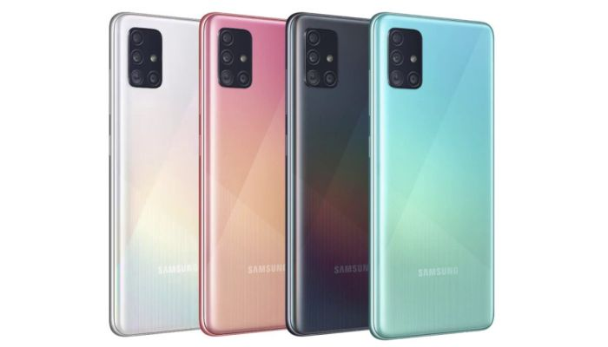

Samsung Galaxy s10

Body of s10 consists of a 149.9mm height, 70.4mm width and 7.8mm depth frame of aluminium. Front and back side is coated with gorilla glass to make it more protected from scratch.

Amoled, diagonally 6.1 inches wide dynamic display is mounted on the homescreen. High resoluted display is featured with 1440x3040 pixel and has a pixel density of 550 per inch. A gorilla glass is placed on the display which makes it scratch and dust proof. [110]

Very powerful Exynos 9820 chipset is integrated in Global version of Samsung Galaxy s10 where other version has Qualcom SM8150 snapdragon chipset. All version has android 9 (pie) as operating system. Users can upgrade it to android 11. [146]

Users get a very large domain of internal memory of 512GB to store their necessary information. If necessary, this can be extended by inserting an extra SD card. But two SIM and one SD card can’t be used simulatneously as this phone perfomes a shared slot system.

One 12 megapixel wide, another 12 megapixel telephoto lensed camera with one 123 degree wide 16 megapixel camera forms the back camera environment. Samsung has integrated a LED flash system while taking images in dark. Selfie camera is featured with 10 megapixel resolution. [232]

Fingerprint and natural language commands are use to unlock the phone. FM radio is integrated in only USA and Canada version.

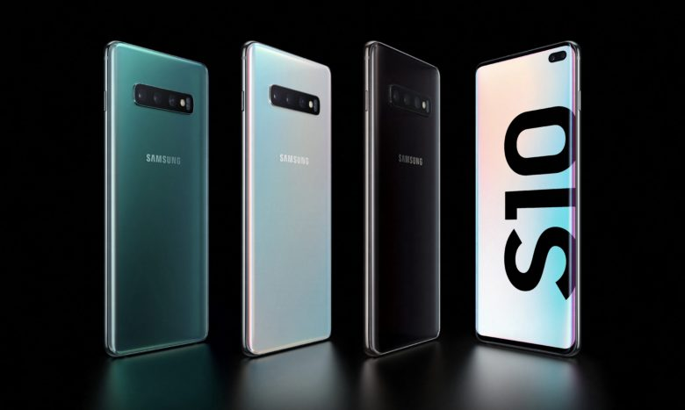

Samsung Galaxy s10 : Camera

Sammsung has used a non-removeable, 3400mA Lithium ion battery to supply energy. This battery is charged with a 15W fast charging charger.