After releasing the iPhone-11 pro max, fans and tech lovers have been waiting eagerly for the next phone of Apples’s iPhone series. With a bunch of new features, iPhone-12 pro gets a grand release on 13th october, 2020. Though pandemic situation makes the world stand still, it can’t stop the craziness of fans and followers.

The iPhone-12 pro max supports not only its predecessors’ networking protocol but also a new 5G networking technology has been integrated here so that user can be connected to their relatives more easily and efficiently.

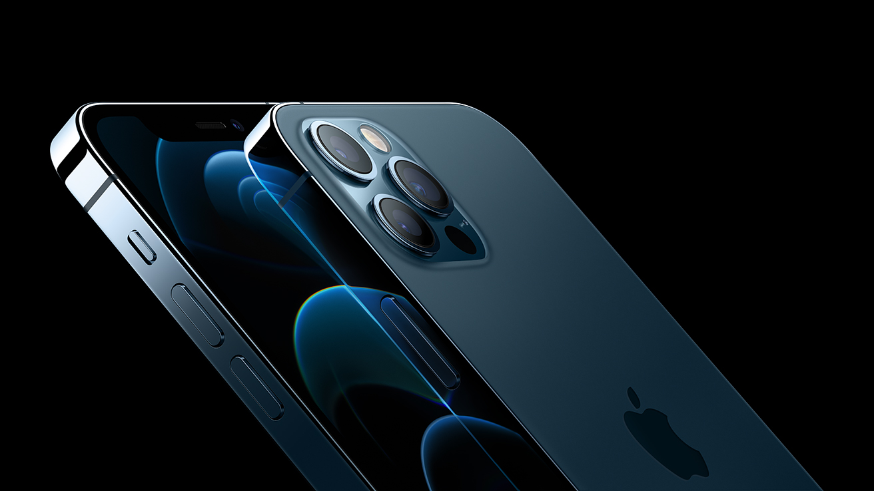

iPhone-12 pro

5.78 inch height, 2.81 inch width and 0.29 inch depth has formed the external layout of this phone. Gorilla glass is used at front and back to protect from unexpected stranges. Total layout is covered with a stainless steel frame.

Homescreen is formed with a super etina OLED, diagonally 6.1 inches wide display of 90.2sq cm. Resolution of this display is 1170x2532 pixel with a density of 460 ppi. Total display is scratch resistance. SO you can use it without being so careful.

A very small, only 5nm, Apple 14 bionic chipset and hexa core 3.1 GHz, firestorm processor performs all the computational task of iPhone-12 pro. Latest vesion of iOS is used as default operating system here.

Apple has bring a big change in the memory system. 6GB RAM is used here with maximum 512GB storage. So you need not add any extra SD card.

Three back camera, each of 12 pixel, allow the user to capture the moments in celluloid. One camera has telephoto lens, anothen can take view from 120 degree

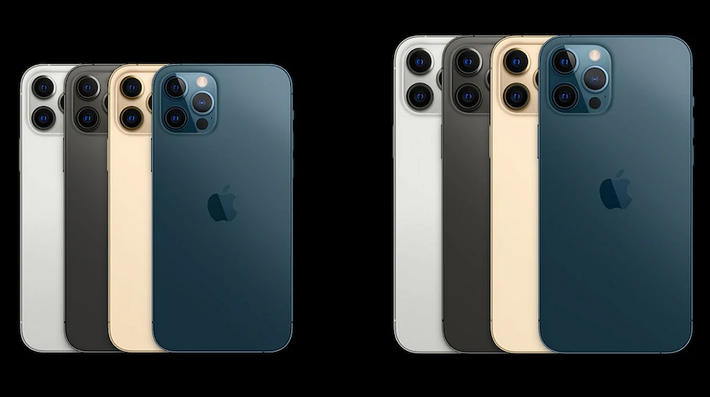

iPhone-12 pro : Camera

angle. Selfie came has same resolution as the back cameha has. In addition, it has biometric feature.