Grand release ceremony of Apple’s iPhone-6s have took place on 25th september, 2015. A new generation iPhone has been introduced to the worldwide with newest features and super fast hardwares. It’s available in market with four colors- Rose gold, Gold, Silver and Space gray.

Layout of the iPhone-6s is- height 5.44 inch, width 2.64 inch and depth is 0.28 inch. Homescreen is protected with gorilla glass and aluminium frame has coated other sides. The SIM slots support nano SIM.

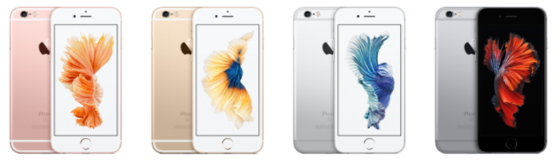

iPhone-6s : Different colors

The diplay of iPhone-6s is diagonally 4.7 inch wide and has a 3D touch feature with retina HD type. 750x1334 pixel resolution and 326ppi has made the images on this display clearer. [108]

Different types of networking mode is integrated in this phone so that user can communicate in 4G, 3G and even in 2G.

Apple A9 chipset is mounted here as the heart of all hardware with a dual core 1.84 GHz twister processor. By default iOS 9 is installed here but user can change this to iOS 14.2.

4 different ammount of memory, 16GB, 32GB, 64GB and 128GB, with 2GB RAM store all necessary data for user. This storage can’t be extended as there is no extra slot for SD card.

A 12 megapixel camera having 1.8m focul length is mounted on the back of iPhone-6s. Dual tone flash helps to capture images more clearly, specially when its about to dark around. On the other hand selfie camera is of 5megapixel and featured with face detection facility.

Fingerprint sesnor is mounted on the home screen button. Natural language and face recognition also acts as unlocking system.

Non-removeable, 1715mA battery supplies energy to the phone. With a full charged battery, you can keep this phone stand by for 240hours, listen music upto 50hours.