The iPhone-7 is totally new and advanced products from its predecessors, iPhone-6 and iPhone-6s, in this iPhone series. With a big surprize and challenge, Apple announced to released iPhone-7 on septemer 7, 2016. This handset is available in market from september 16 with six different versions including ‘Global version (A1778)’, ‘US version (A1660)’, ‘Chinese version (A1780)’.

Four different network protocol system is applied in iPhone-7- [GSM, CDMA, HSPA, EVDO and LTE](https://www.gsmarena.com/apple_iphone_7-8064.php). So anyone can operate this phone in bothn 4G, 3G and even 2G.

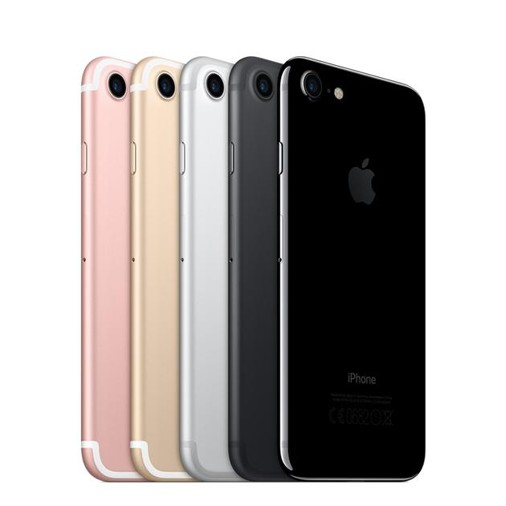

iPhone-7

Size of this handset is 138.3x67.1x7.1 milimeters with a mass of 138gm. Front side is covered with gorilla glass and rest are coated with aluminium plate and aluminium frame. An LCD display has been mounted on iPhone-7 with a length of 4.7 inches and its area is 60.9 sq cm. The resolution at which this display is operated is 750x1334 pixels.

As default operation system, iOS-10.0.1 is installed here which can be upgraded to iOS-14.2 later. This OS is performed on the *Apple A10 Fusion (16 nm)* chipset and *Quad-core 2.34 GHz* processor.

There are a 2GB RAM and 32/128/256 GB storage installed in the phone. You can’t use an extra SD card because there is no sard slot. The SIM slot supports a nano SIM which can be of 2G, 3G or 4G.

A new featured based camera system is attached here with two camera. One is the main back camera of 12 megapixel and 1.8m focal length with auto flash. With this camera, user can capture video in 720p, 1080p and 4K reolution. Selfie camera has 7 megapixel and 2.2 focal length with face detection feature. It can record incidents in 1080p.

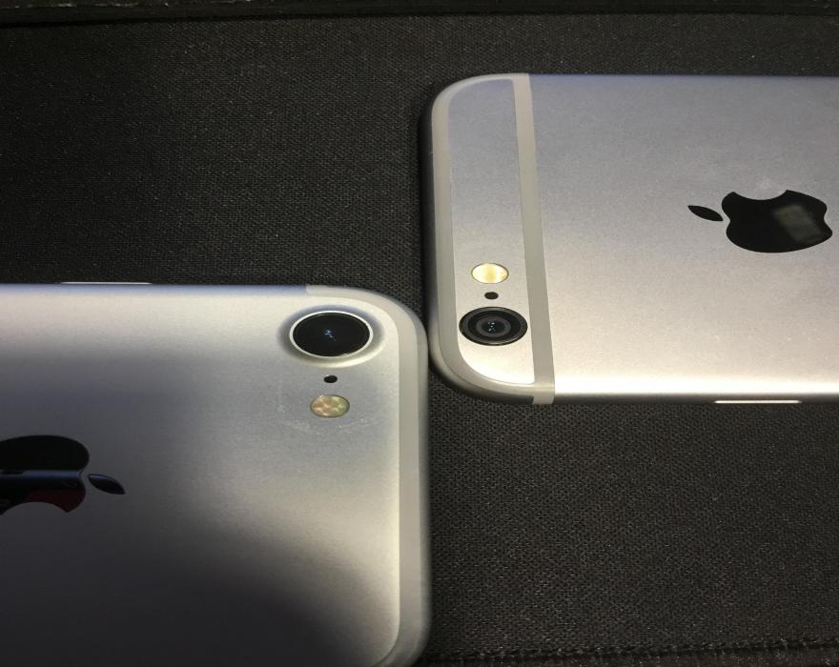

iPhone-7 : Camera

A front mounted fingerprint sensor works as security and lock system as well as face detection system. A non-removeable 1960 mA battery supplies power for whole internal activity using which you can talk more than 14 hours (approximate).

You can buy this phone from amazon with 178.98 USD.