After declaring the release of iPhone-7, Apple decided to launch the next version, or successor of its, iPhone-7 Plus. Both these two phones are launched in the same date, 16 sepetember, 2016. Though launched together, there are some differences between them on features and other security techniques.

The iPhone-7 Plus supports five type of networking protocol including GSM, CDMA, HSPA, EVDO, LTE- which is totally similar to its predecessor. This phone also can be operated in 2G, 3G, 4G and 5G alike iPhone-7.

In market, iPhone-7 Plus is available in 6 different color- Rose Gold, Gold, Silver, Black, Jet Black and Red. Height, weight and depth of this handset is approximately 158.2mm, 77.9mm and 7.3mm respectively. Manufacturers have prepared it as very lightweight having only 188gm of weight.

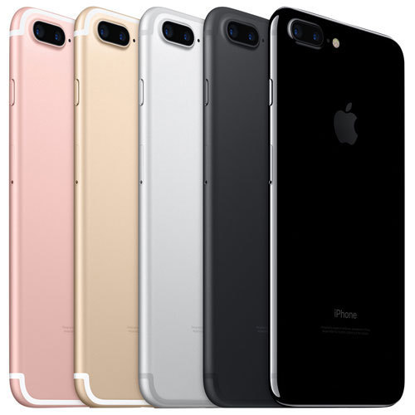

iPhone-7 Plus

A retina HD, LCD display has been mounted on the front side which is diagonally 5.5 inch. The display resolution is 1080x1920 pixel with 440 pixel per inch. A fingerprint-resistant oleophobic layer has coated this display.

A small change has been brought in iPhone-7 Plus. It has a 3GB RAM and 32/128/256GB memory storage where iPhone-7’s RAM is 2GB. In both these two, there is no slot for extra SD card.

Two camera at back and one selfie camera are attached here to capture the surrondings. Two both back camera has 12 megapixel power and one can operate as telephoto lens.

A fingerprint sensor has been applied on the home button. Face unlocking system also works as another security feature. You can also unlock this handset with natural language commands.

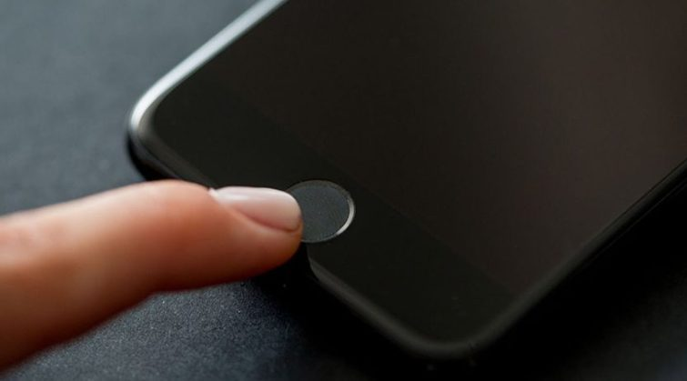

iPhone-7 Plus : Fingerprint sensor

The iPhone-7 Plus costs $260.37 in Amazon, but if you wish to buy it from eBay, you have to pay $350.