Apple launched iphone 8 on 22 september, 2017 while they declared to realease on 12. It is an amazing and beautiful handset from tech-giant apple with iphone operating system as OS. It is available in market with three different color - space gray, siver and gold in UK.

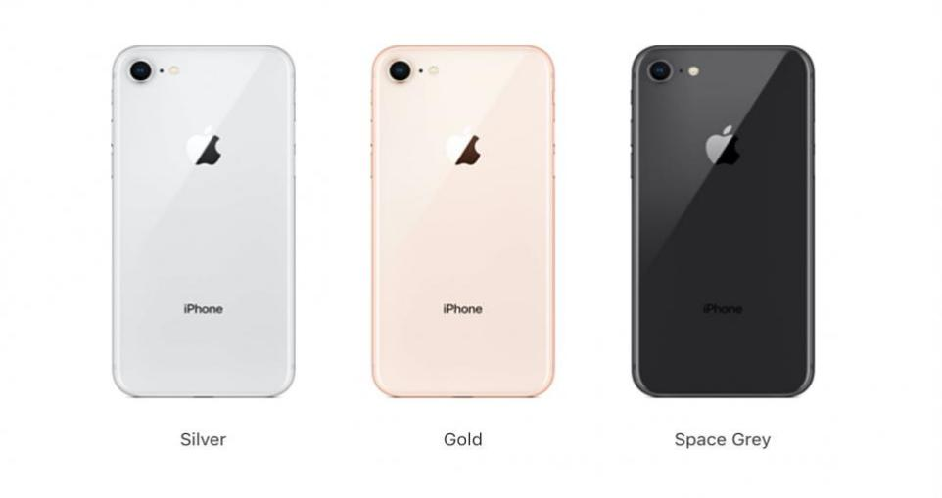

iPhone-8 in Different color

The iPhone-8 supports three types of networks. They are GSM (Global System for Mobile networks), HSPA (High Speed Packet Access) and LTE (Long Term Evolution). User can operate this handset in both 2G, 3G and 4G networks.

Total dimension of this charming handset is 138.4\*67.3\*7.3 milimeter where the screen size is 4.7 inches and has an area of 60.9 sq cm. Total phone is coated with gorilla glass (front and back) and has an aluminium frame at the side. Horizontaly, the display has 750 pixel per inch and vertically the number of pixel in every inch is 1334.

Performance of iPhone-8 is so faster than many other handset. Apple A11 Bionic, which length is 10 nanometer only, is used here as chipset and hexa-core (2x Monsoon + 4x Mistral) as processor. The built in operation system is iOS 11 which can be upgrader to iOS 14.2.

The sim slot supports nano SIM but there is no slot for external SD cards. You can use 2G, 3G and 4G SIM here as iPhone-8 can be operated in multiple network mode. Internal storage of this phone is 64GB and 256 GB and main memory (RAM) has an size of 2GB.

For capturing happiest moments, two cameras are integrated here. One at the back having 12 megapixel resolution with 1.8m focal length, second is the front camera of 7 megapixel. While capturing video, 4K resolution video is recorded with 24/30/60 frame per second and 1080p resolution video can be taken in 30/60/120/240 fps.

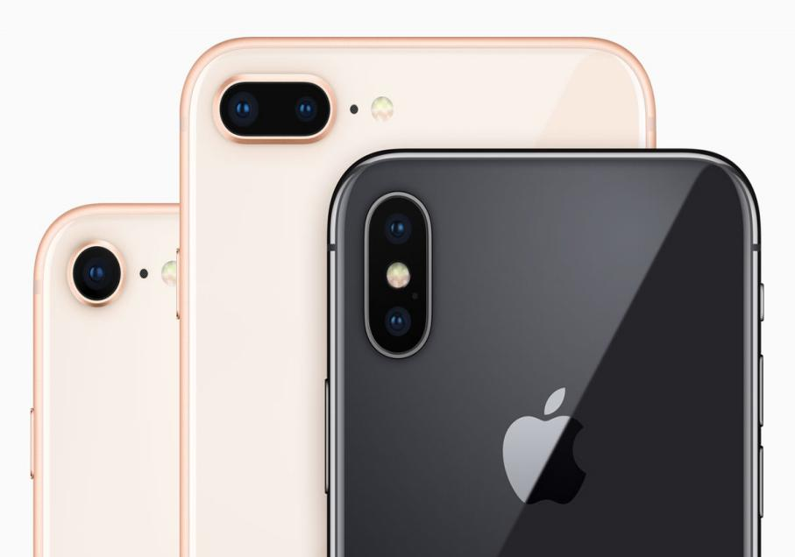

iPhone-8 : Camera