Apples’s iPhone-8 and iPhone-8 Plus is the new generation iPhone which has many new features, both in software and hardware, than previous phones. Successor of iPhone-8, iPhone-8 Plus’ grand release helds on september 22, 2017. Note that iPhone-8 also is launched at the same time. It is released in two version, A1864 and A1897 where the first one is released in US, New Zeland, China and second one in UK, Canada, Singapore.

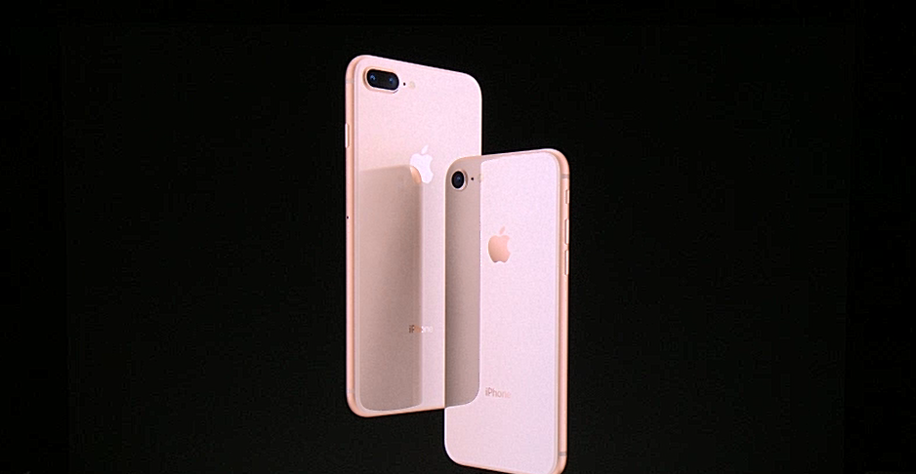

iPhone-8 and iPhone-8 Plus

iPhone-8 Plus has the same network confiuaration as its predecessor. There is a huge change in the dimension and display features. It’s dimension is 158.4x78.1x7.5 milimeter with 202 gm wight and screen size is 5.5 inches. It has more resolution than iPhone-8, 1080x1920 pixels. Display is protected by a Ion-strengthened glass.

Hardware and software feature of this phone is exactly same as iPhone-8 just with a difference in RAM. The iPhone-8 has a RAM of 2 GB where iPhone-8 Plus’ RAM size is 3GB.

There are two cameras attached at the back of which every is of 12 megipixel resolution and captures videos in not only 4K mode but also 1080p resolution. One of these two camera has tepephoto lens which can bring an object to two time closer. It’s selfie camera is similar to iPhone-8’s.

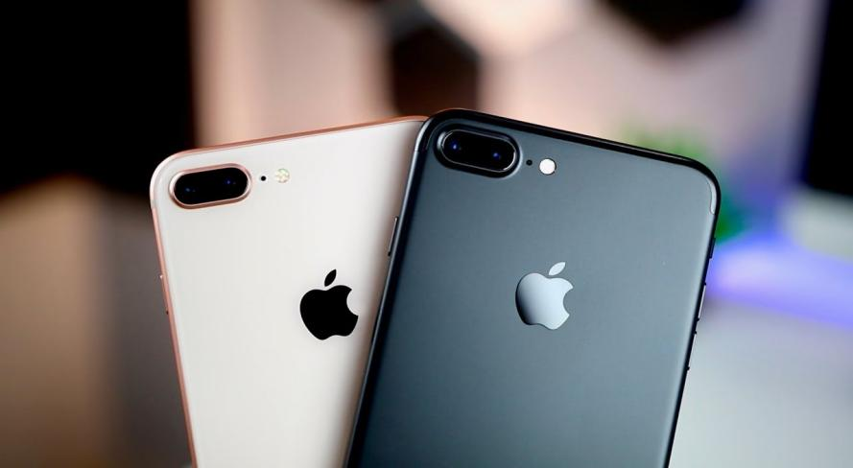

iPhone-8 Plus camera

There is also a difference in price. In amazom, iPhone-8 Plus’ price is 499 USD and iPhone-8 has a cost of 264 USD. If anyone want to buy iPhone with 64 GB memory, then he needs $249 and $318 for iPhone-8 and iPhone-8 Plus respectively.

The iPhone-8 Plus has mainted the sequence of features, sensors, security system which has been integrated in its previous version. It has front-mounted fingerprint sensor, 2691 mA battery, 15W fast charging (charged in 30 min).