Apple released iPhone-XR in the global market on 26th October, 2018 just after the iPhone-XS. This is available in market in six different color and five different version.

Five different network protocol- CDMA, HSPA, LTE, EVDO and GSM is supported is this phone, So, user can communicate in different generation network such as 2G, 3G and 4G. Two dedicated slot for nano SIM works simultaneously to provide continuous connectivity.

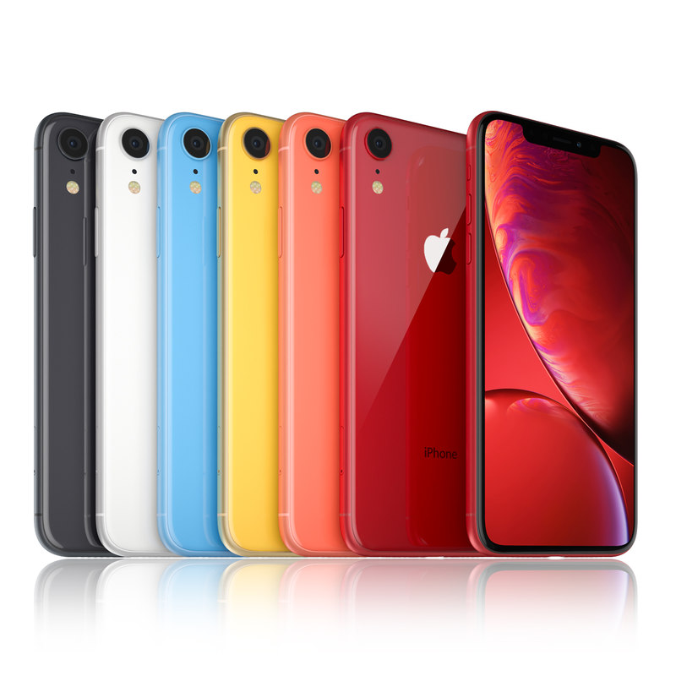

iPhone-XR

Dimention of this phone is 150.9x75.7x8.3 milimeter and weight is 194gm. So it’s lighter than its predecessor iPhone-XS and iPhone-XS max. Front and backside has been protected with gorilla glass and a 7000 series aluminium frame forms the external layout of iPhone-XR. This makes the phone water and dust resistance and facilitates the internal harware to run more smoothly over a long time.

A LCD display of liquid retina IPS is mounted on front portion which is diagonally 6.1 inch long. The display of 90.3 sq cm has been featured with resolution of 828x1792 pixel and 326 ppi density.

Apple has been using the bionic series chipset to maximise the operational speed. This tendency has been kept here also with a hexa core 2.5 GHz processor. The default operating sytem is iOS 12 which is upgradeable to iOS 14.1. 3GB RAM and 256GB internal storage is manufactured. You can’t use any extra SD card.

Two camera, one in back and one at front, consists the camera features of this iPhone-XR. 12 megapixel, 26mm wide back camera has an focul length of 1.8 m with dual tone flash system. Selfie camera is featured with 7megapixel resolution and biometric sesnsor.

There is no fingerprint sensor but face ID feature and voice recognition works as locking system. Battery is of 2942 mA and gets charged by a 15W fast charger.