The iPhone-XR max gets worldwide released on 21st september, 2018 with a great experctation from the users. It is available in the market in five various version including a global version.

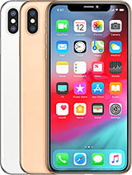

iPhone-XR max

Maintining the trends which was used in preious phones of Apple, 5 different networking protocol has been integrated so that user can be connected in various network such as 4G, 3G and even 2G. [60]

A frame of 157.5mm length, 77.4mm width and 7.7mm depth forms the outline of this phone. Weight of iPhone-XR max in 208gm which is lighter than its predecessors. Gorilla glass and stainless steel plate have coated the full phone.

Diagonally 6.5 inch long display of 102.9 sq cm area has been mounted on the front side. This super retina OLED type display gives the user enjoying the beauty of technology more smoothly. Again, wide color gamut technology has become the display more attractive and lively like original object.

Apple has kept the previously used 12 version of its bionic chipset and hexa-core 2.5GHz processor with iOS 12 built-in it. Operating system can be upgraded to 14.1 version.

4GB of RAM stores the temporary data in iPhone-XR max where the permanent storage size starts from 64GB to 512GB. There is no slot for external memory card. So user can’t extend the memory size.

Two back mounted camera of 12 megapixel gives the user facility to take the memorable moment. One back camera has telephoto lens which can bring an object to 2 times closer.

Selfie camera has been featured with 7megapixel resolution, biometric sesnor and gyri-EIS.

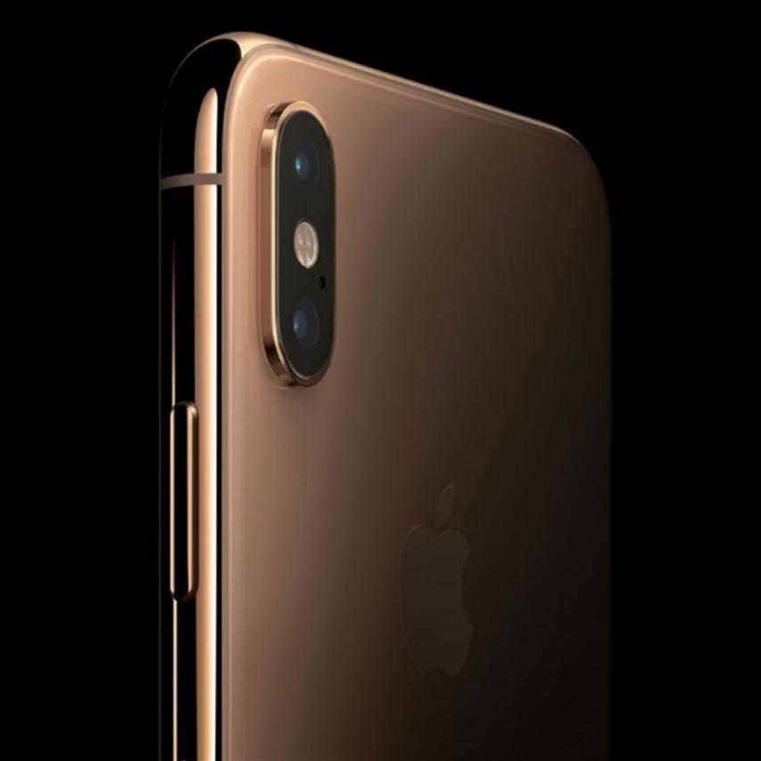

iPhone-XR max : camera

Battery consists of Litium-ion and has a capability of 3174mA electicity flow. This battery is powered with a 15W fast charging charger.