CEO of Apple, Tim Cook announced a new handset which is twelveth generation flagship of iPhone, succeding iPhone-X, iPhone XS. This phone have come to market for sale in 21st september, 2018. This phone arises with a ton of advanced feature than its previous iPhone-X.

The iPhone-XS comes with a dimention of 143.6x70.9x7.7 milimeter. It’s very light with a weightage of 172gm only. Front and back side is coated with gorilla glass and other side has a stainless steel cover.

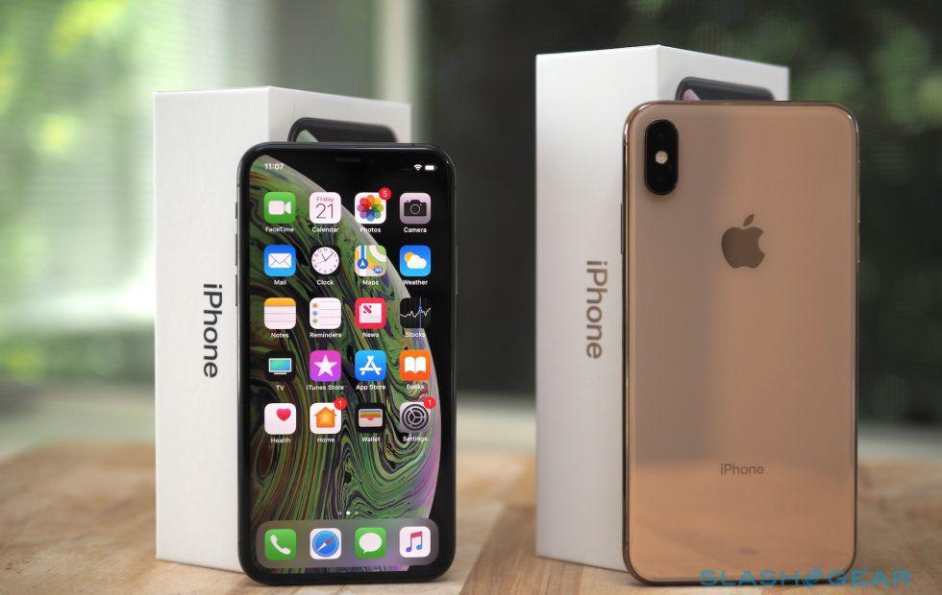

iPhone-XS

Multiple network is supported in iPhone-XS including CDMA, GSM, HSPA and LTE. Apple’ve released it in four version, Global (A2097), A1920 (USA), A2100 (China), A2098 (Japan).

A diagonally 5.8 inch long super retina OLED dislay is placed on the front side. 84.4 sq cm display has a resolution of 1125 x 2436 pixels in 458 pixel per inch density. It is scratch resistance and featured with wide color gamut so that imaged and ides captured here can be seen more lively.

Apple 12 bionic chipset of 7 nanometer is used as chipset with hexa core 2.5 GHz processor in Iphone-XS on which iOS 12 is installed as default operating system. If wish, user can upgrade OS to iOS 14.1.

4GB RAM and 64/256/512 GB internal storage has made this phone so charming and dream handset to many people. There is no extra slot for SD card in phones of Apple- same sequence has been preserved here. There is some limitation also when you use dual SIM here.

Two back camera of 12 megapixel, one with telephoto lens and optical zoom feature, has brings the world more closer to its user. Front camera’s resolution is 7 megapixel and integrated with biometric sensors

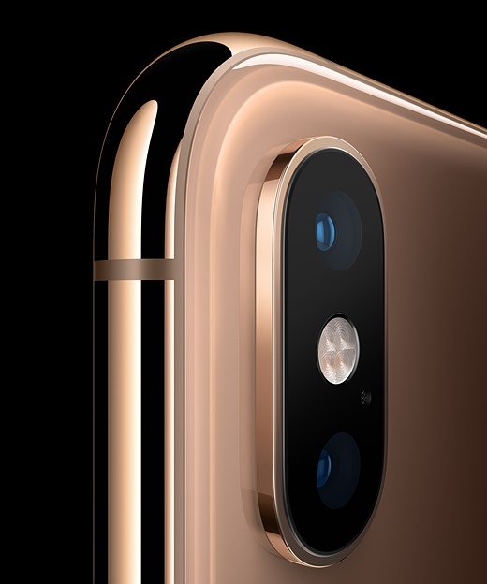

iPhone-XS : Back camera

Face detection and voice recognition is used as secutity. A 2658 mA battery supplies power which is chared with a 15W charger.