Apple’ve released iPhone-XS max in 21st september, 2018 with its predeccesor iPhone-XS. These two phones are almost same, but some differences in features and hardwares.

Four versoin of iPhone-XS max have come out in market during release. All versions support five network protocol including HSPA, CDMA, GSM, LTE and EVDO so that user can operate it in multiple network mode such as 2G, 3G and 4G. Two nano SIM can be inserted in two slot but there is no extra slot for SD card.

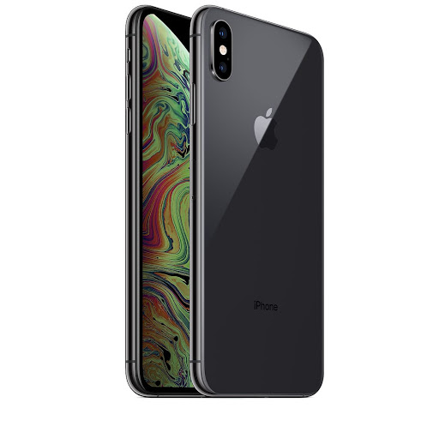

iPhone-XS max

Total size of iPhone-XS max is 157.5x77.4x7.7 milimeter. Gorilla glass gives protection of internal parts in the front and back side. Other portion is coated with stainless steel plate. Total weight of this phone is 208gm. In market, this handset is available with three different color.

The authority has manufactured the home screen with a super retina OLED type display which is diagonally 6.5 inch long and has an area of 102.9 sq cm. The display has a higher resolution of 1242x2688 pixel and 458 ppi density.

Very powerful Apple A12 Bionic chipset and a hexa core processor of 2.5Ghz is has structired the hardware center which runs very smoothly without any hindrances. As operation system, iOS 12 is used but upgradeable to iOS 14.1.

4GB RAM and 64/256/512GB storage is internally built in. You can use no extra SD card here. [214]

Two back camera and one front camera have been mounted on two sides. Both the back camera has focul length of 1.8m and 2.4m where the second one is featured with telephoto lens. The slefie camera is of 7 megapixel and supports face ID feature.