Sadhana

2403A51256

**AI ASSISTED CODING – TEST – 1**

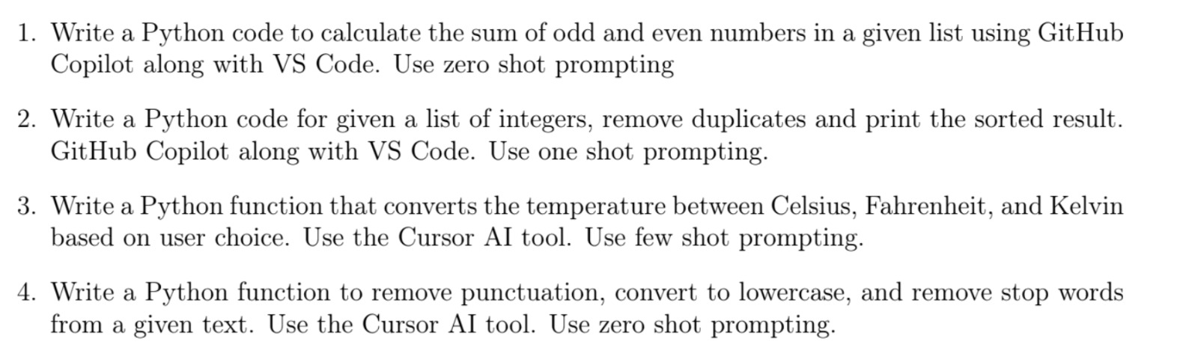

**Question 1**

Prompt –

Calculate the sum of odd and even numbers in a given list. [1, 2, 3, 4, 5, 6, 7, 8, 9, 10].

Code –

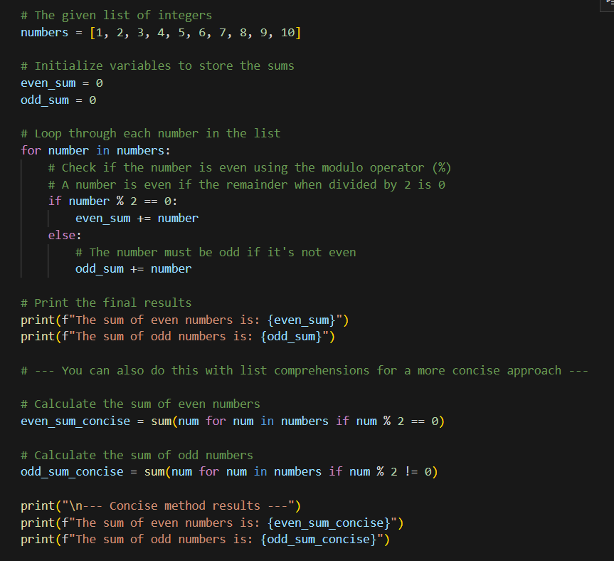

Output –

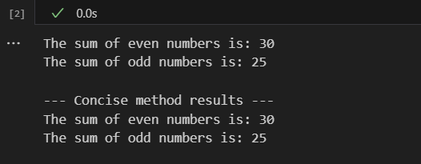

**Question 2**

Prompt –

numbers = [2, 4, 5, 6, 7, 5, 6, 5, 9, 2, 3, 1]

unique_sorted = sorted(set(numbers))

print(unique_sorted)

This is a python code to remove duplicates and print the sorted list for the given list of integers [2,4,5,6,7,5,6,5,9,2,3,1].

Now write a python code for a given list of integers [1,5,4,5,6,7,8,3,4,5,1,2] remove duplicates and print the sorted list.

Code –

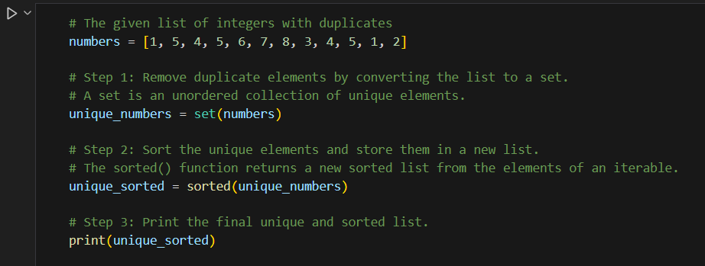

Output –

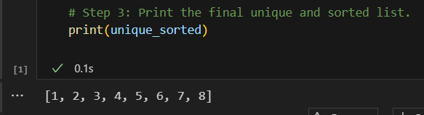

**Question 3**

Prompt –

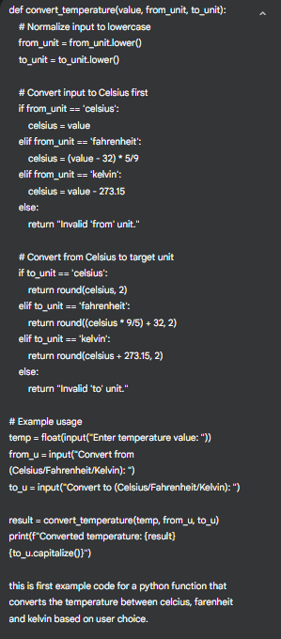 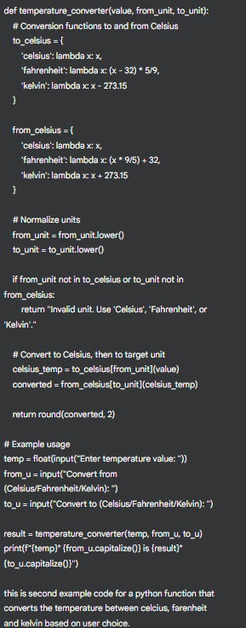

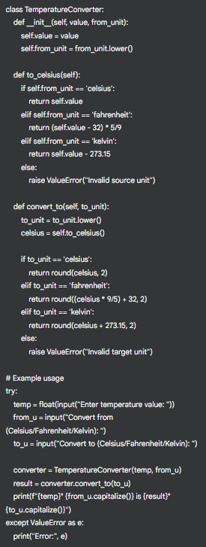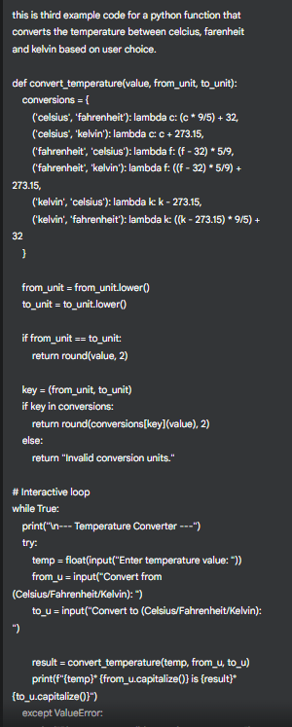

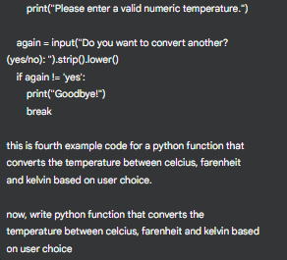

Code–

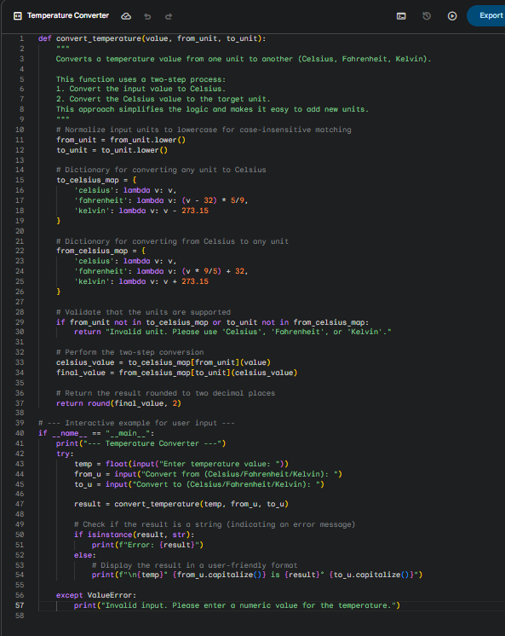

Output –



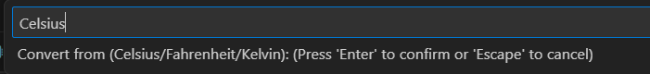



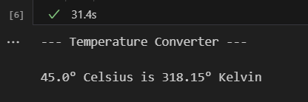

**QUESTION 4**

Prompt -

write a python function to remove puntuation, convert to lowercase, and remove stop words from a given text

Code –

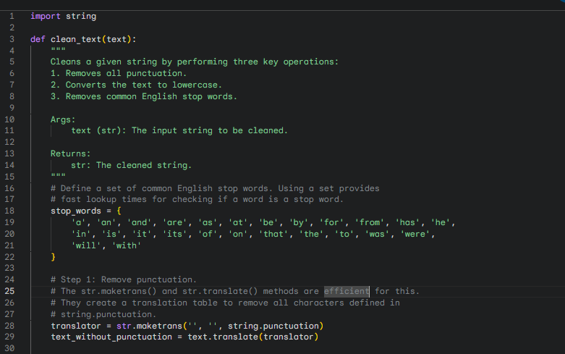

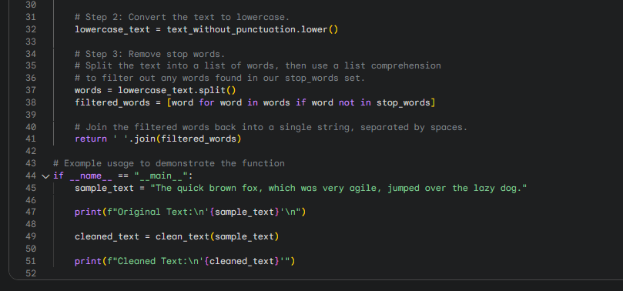

Output –

