Sadhana

2403A51256

**AI ASSISTED CODING – ASSIGNMENT – 2.3**

Task Description#1  
● Use Google Gemini in Colab to write a function that reads a CSV file and calculates mean, min, max.

prompt –

write a function that reads a CSV file and calculates mean, min, max

Code –

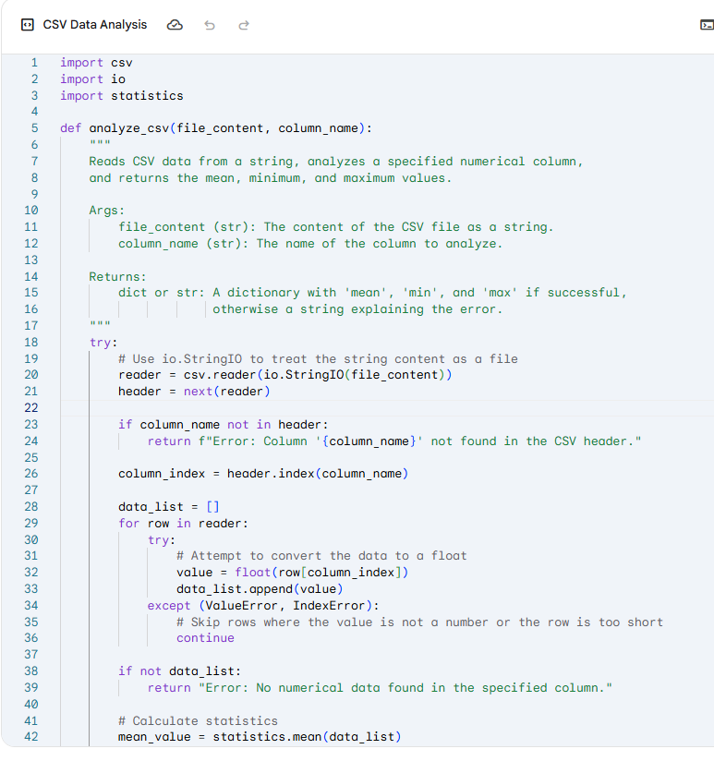

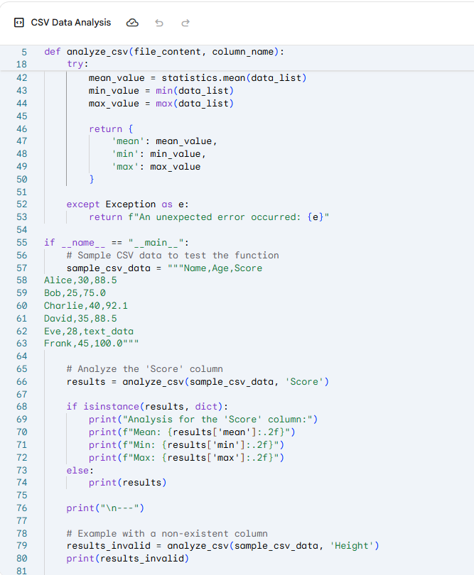

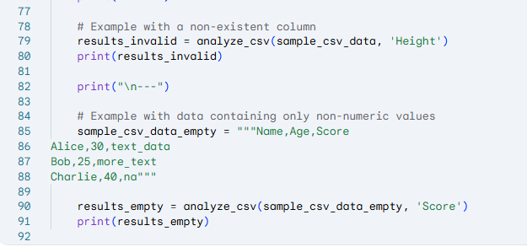

Output –

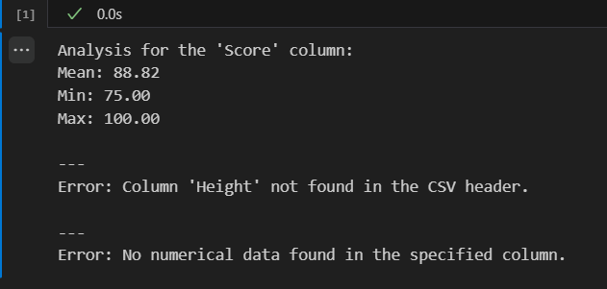

Task Description#2  
● Compare Gemini and Copilot outputs for a palindrome check function.

prompt –

generate a palindrome check function.

Code by gemini –

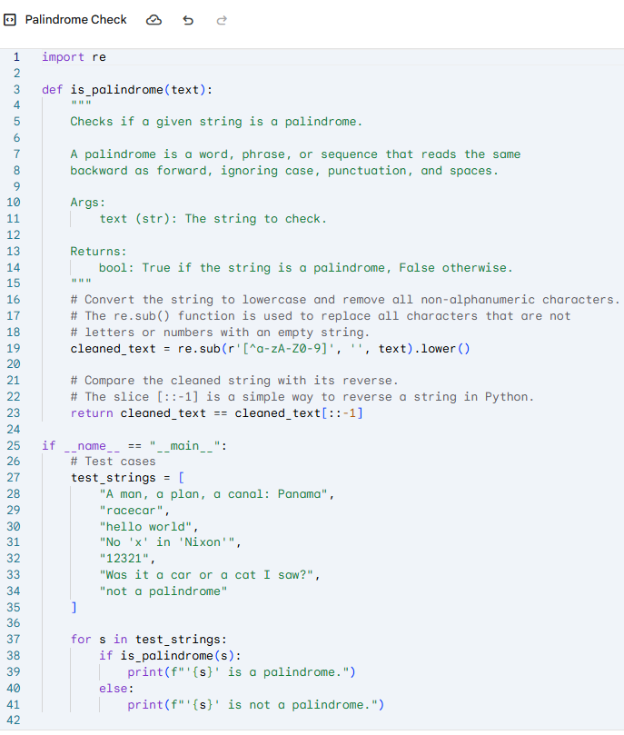

Output –

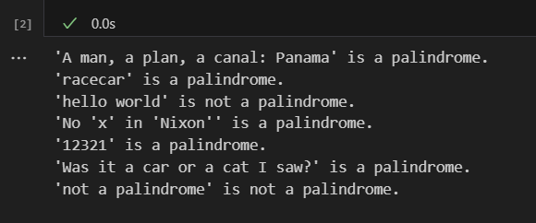

Code by copilot–

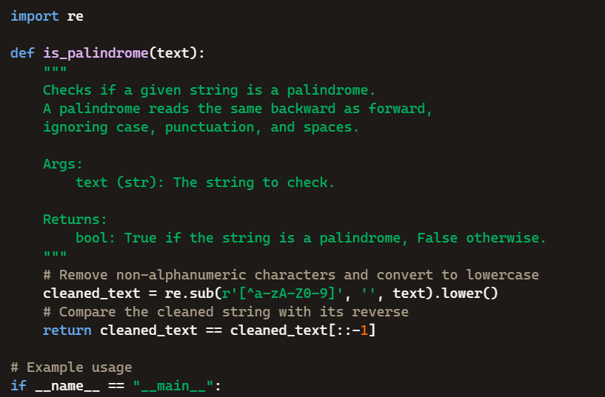

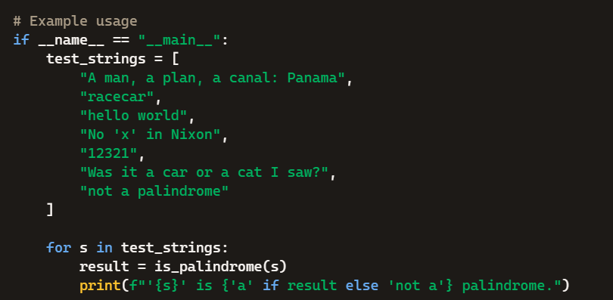

Output –

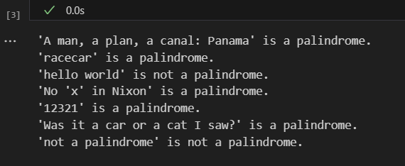

Code given by copilot is simpler than compared to gemini but both the outcomes are exactly the same

Task Description#3  
● Ask Gemini to explain a Python function (to calculate area of various shapes) line by line.

prompt –

explain a Python function (to calculate area of various shapes) line by line.

Code by gemini–

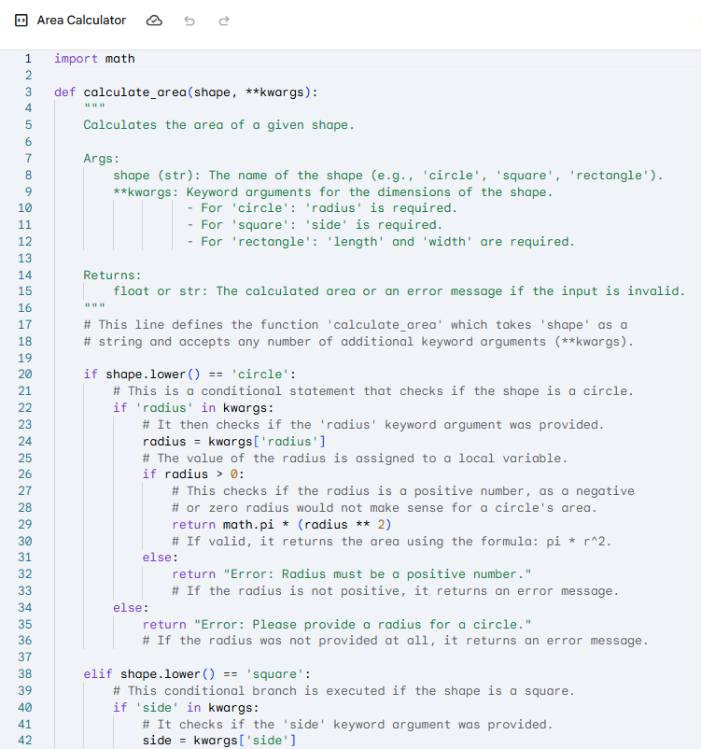

Output –

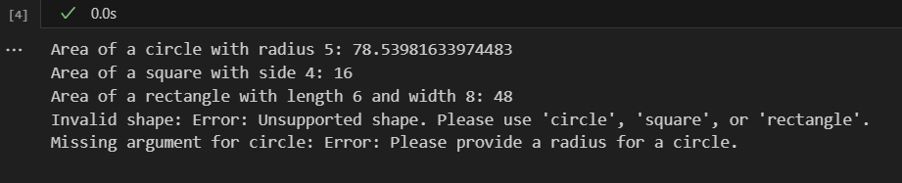

Code by copilot –

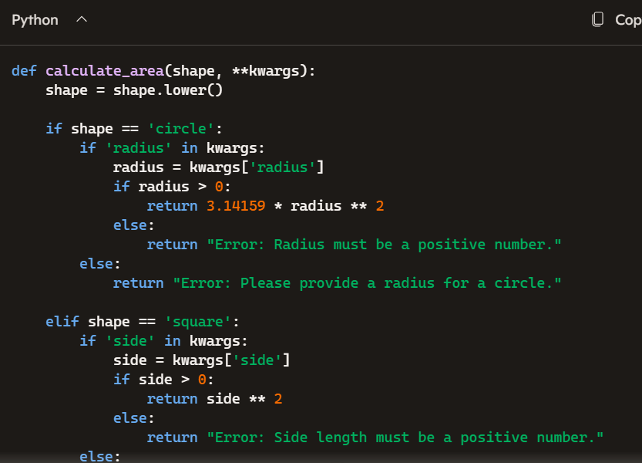

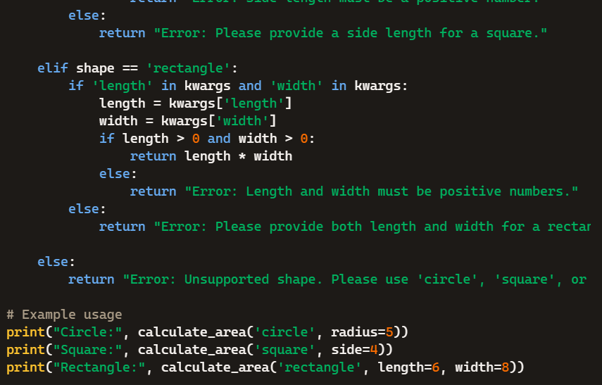

Output –

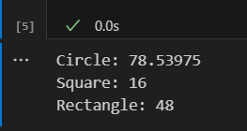

Copilot is again shorter and easy to understand compared to gemini and again the output is simpler in copilot

Task Description#4  
● Install and configure Cursor AI. Use it to generate a Python function (e.g., sum of squares).

prompt –

generate a Python function

Code –

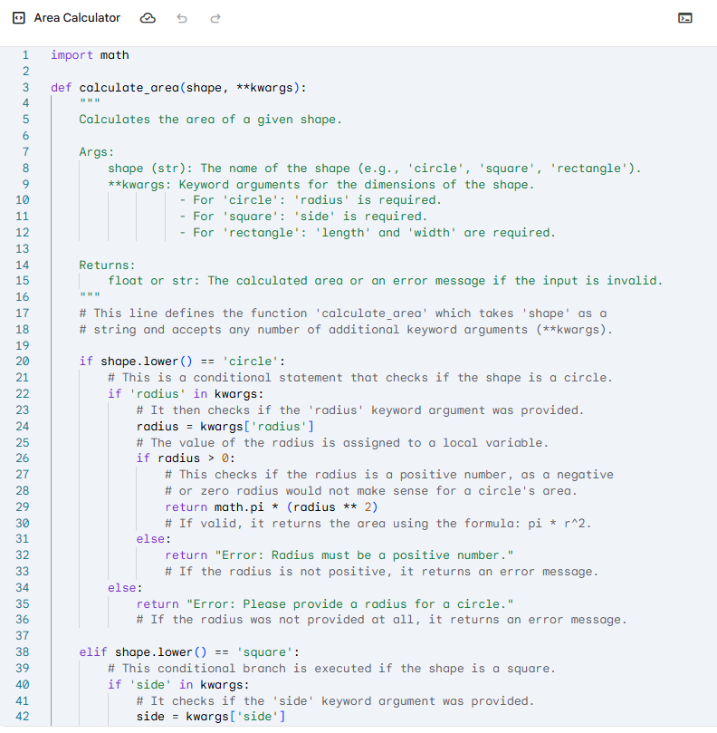

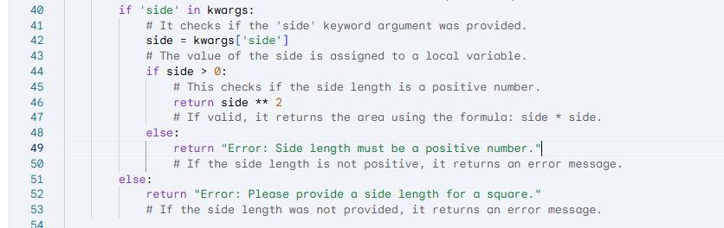

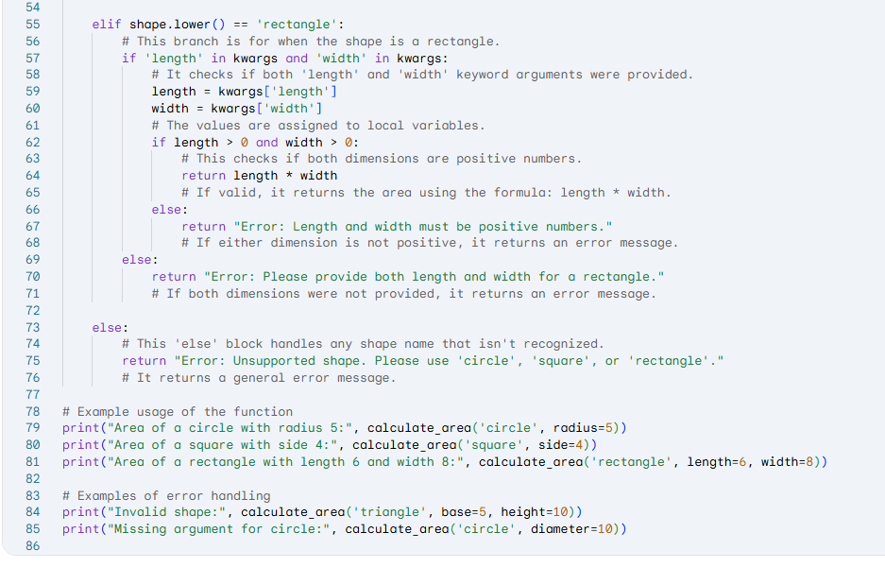

Output –

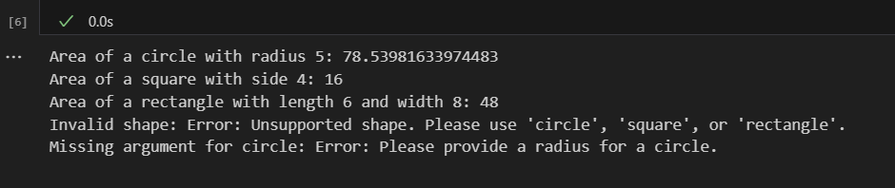

Task Description#5  
● Student need to write code to calculate sum of add number and even numbers in the list.

prompt –

write code to calculate sum of add number and even numbers in the list.

Code –

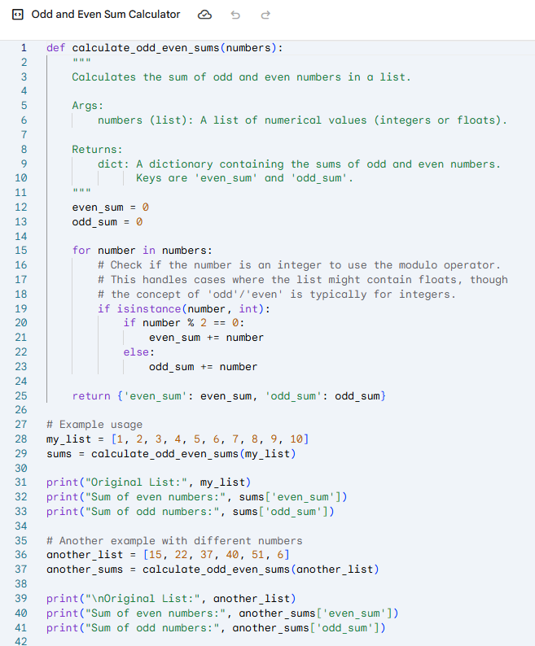

Output –

