Shiva sadhana

2403A51256

**AI ASSISTED CODING – ASSIGNMENT 4.5**

**Lab 4**: Advanced Prompt Engineering: Zero-shot, one-shot, and few-shot techniques.

Suppose that you work for a company that receives hundreds of customer emails daily.  
Management wants to automatically classify emails into categories like "Billing",  
"Technical Support", "Feedback", and "Others" before assigning them to appropriate  
departments. Instead of training a new model, your task is to use prompt engineering  
techniques with an existing LLM to handle the classification.

**1. Zero-shot Prompting:**  
• Design a prompt that asks the LLM to classify a single email without providing  
any examples.

Prompt –

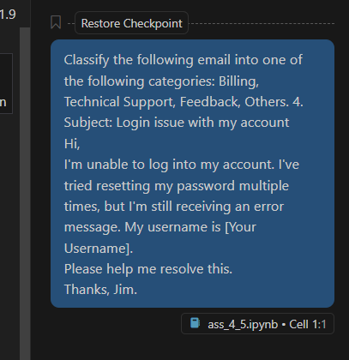

Output –

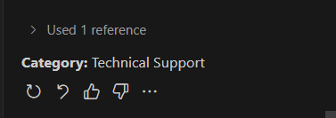

**2. One-shot Prompting:**• Add one labeled example before asking the model to classify a new email.

Prompt –

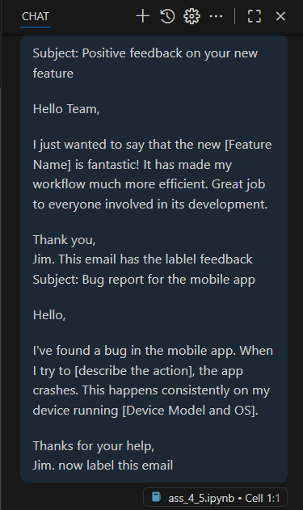

Output –

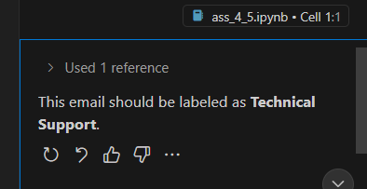

**3. Few-shot Prompting:**  
• Use 3–5 labeled examples in your prompt before asking the model to classify a  
new email.

Prompt –

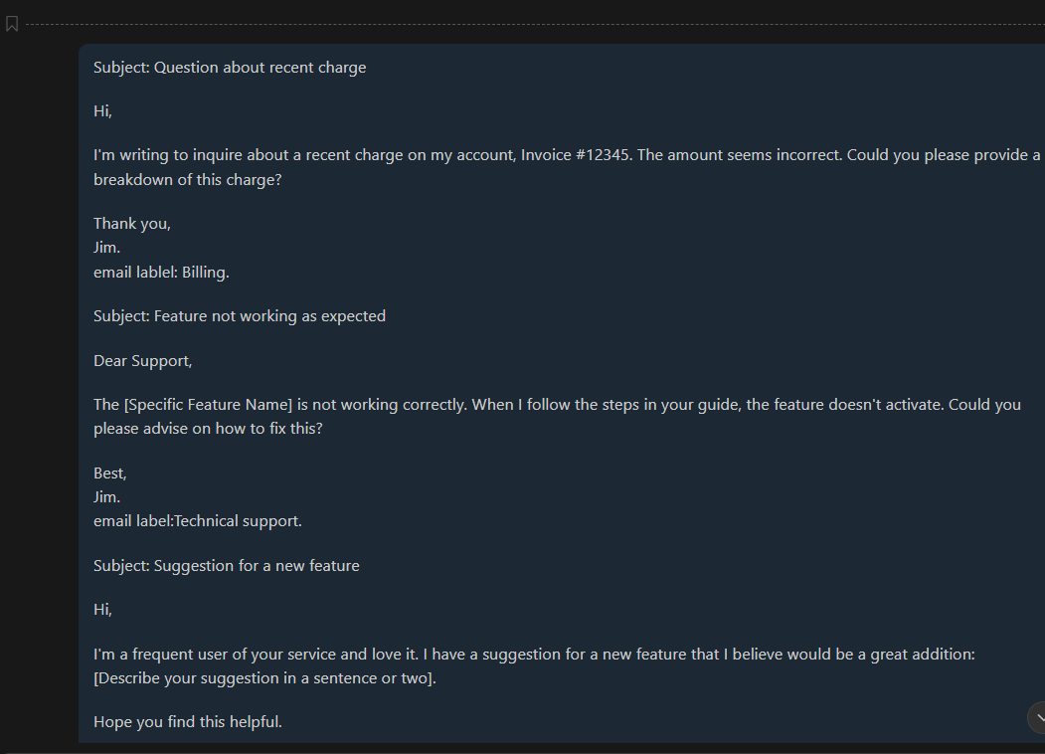

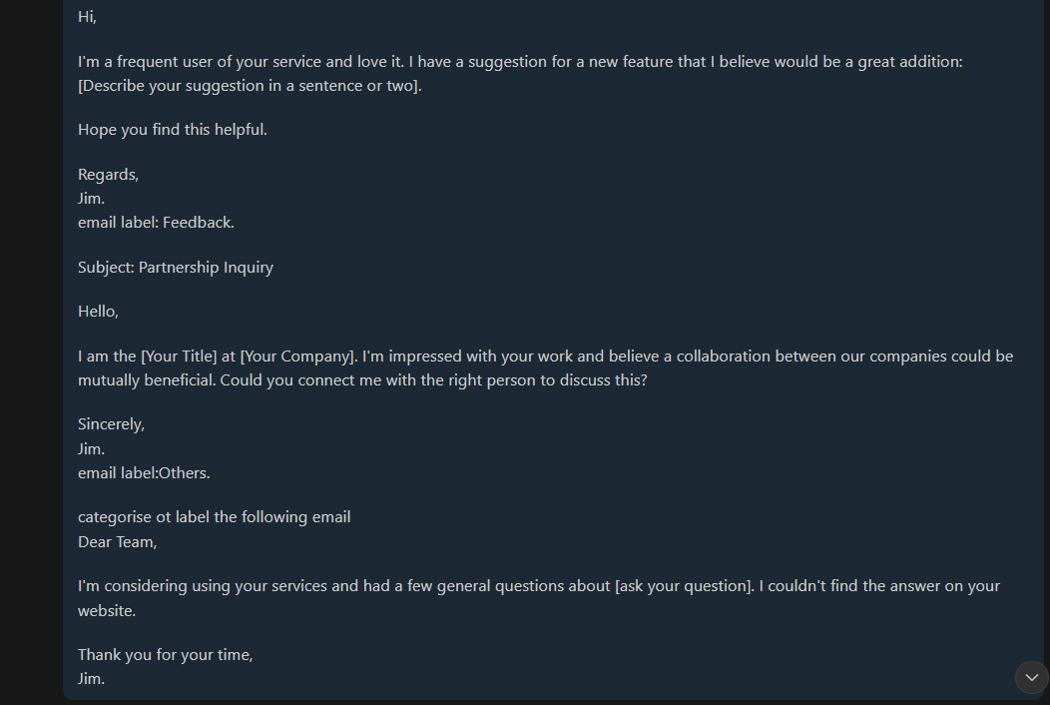

Output –

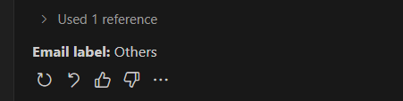

**Evaluation:**

**Zero shot prompting:** mostly accurate but due to the lack of examples it is not the most reliable.

**One shot prompting:** accurate enough and works best when classifying emails which have the same label as the example.

**Few-shot prompting:** most accurate and reliable.

**Comparison table showing classification accuracy for each technique**:

|  |  |  |  |
| --- | --- | --- | --- |
| **Prompt type** | zero-shot prompting | One-shot prompting | Few-shot prompting |
| **Classification accuracy** | Works well but not the most accurate | Accurate enough but could be more better at classification | Most accurate |

The most effective method was **few-shot prompting**.