Sadhana

2403A51256

**AI ASSISTED CODING – ASSIGNMENT 5.4**

**Task Description #1:**

• Prompt GitHub Copilot to generate a Python script that collects user data (e.g., name, age,  
email). Then, ask Copilot to add comments on how to anonymize or protect this data.

Github copilot prompt and output –

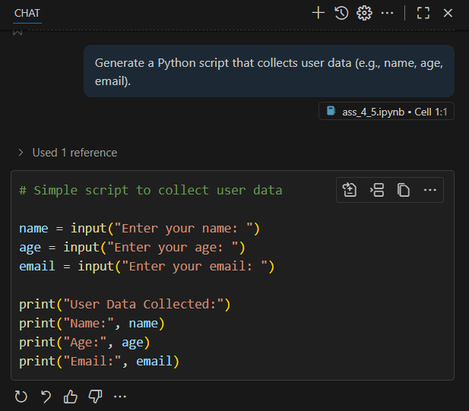

Copilot prompt and output –

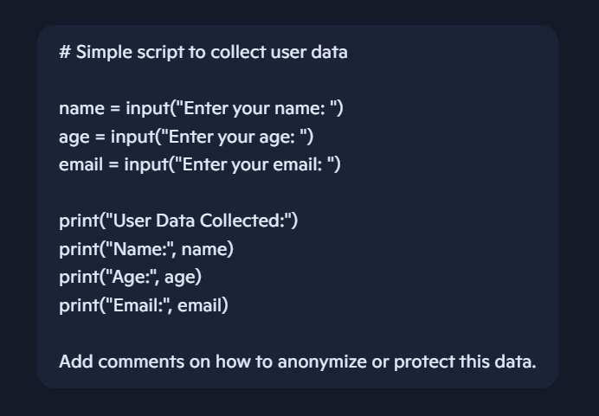 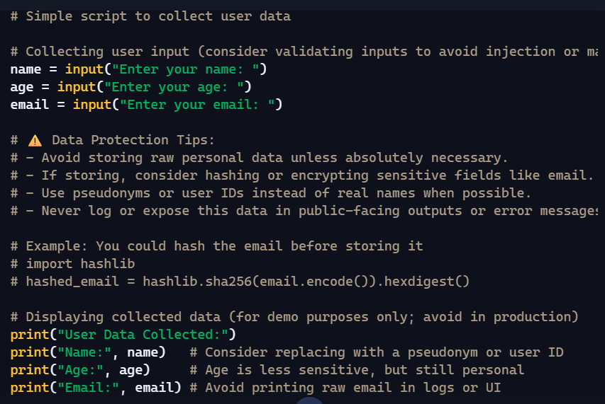

**Task Description #2:**  
• Ask Copilot to generate a Python function for sentiment analysis. Then prompt Copilot to  
identify and handle potential biases in the data.

Github copilot prompt and output –

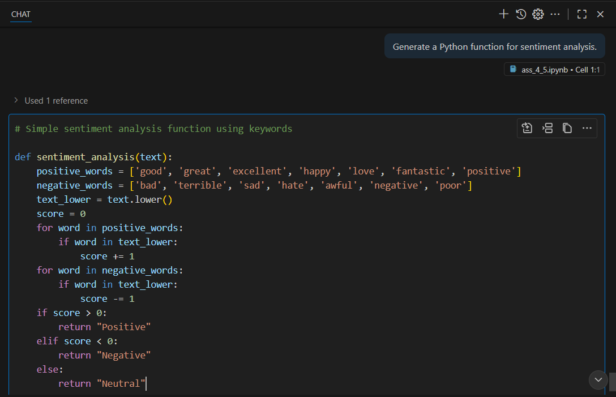

Copilot prompt and output –

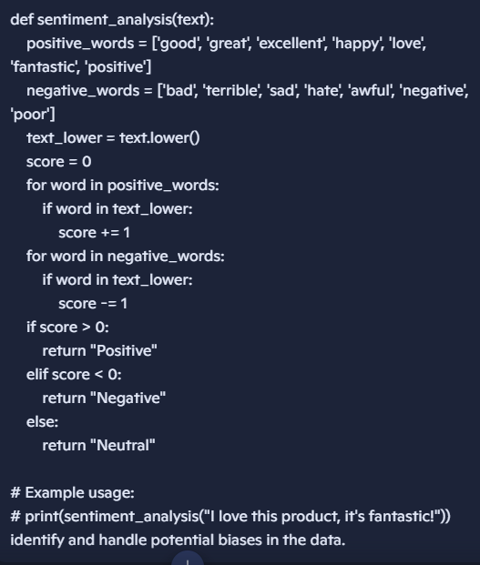 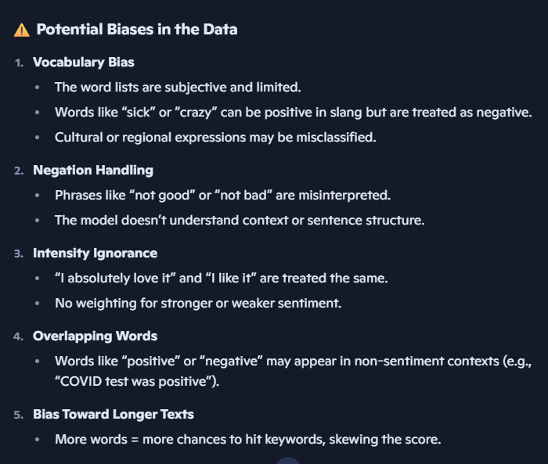

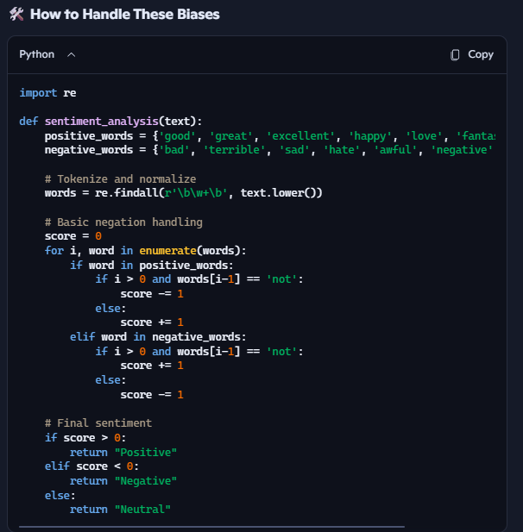

**Task Description #3:**  
• Use Copilot to write a Python program that recommends products based on user history. Ask it to follow ethical guidelines like transparency and fairness.

copilot prompt and output –



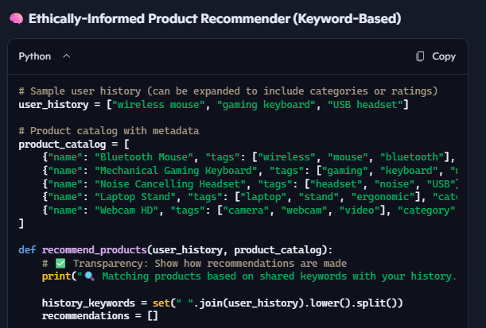

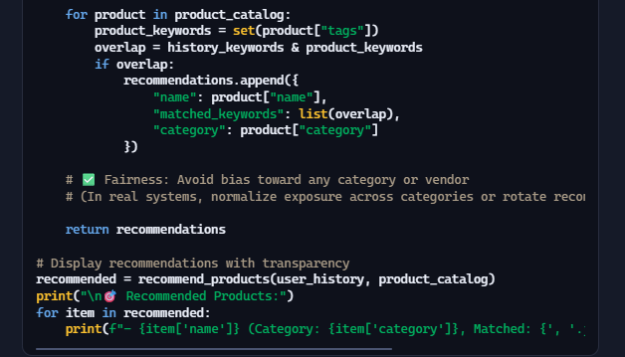

**Task Description #4:**  
• Prompt Copilot to generate logging functionality in a Python web application. Then, ask it to ensure the logs do not record sensitive information.

copilot prompt and output –

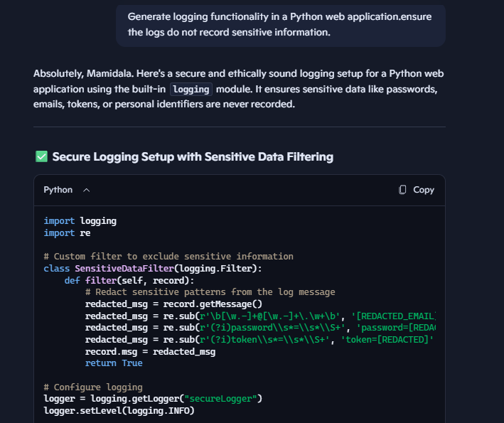

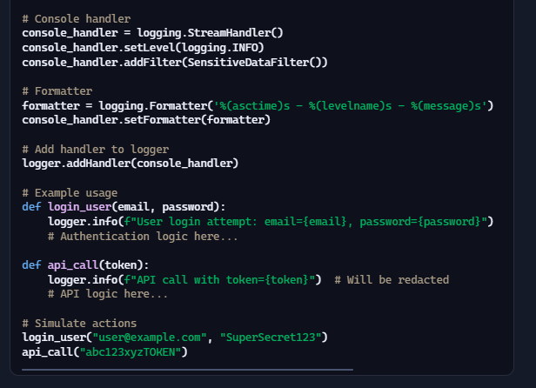

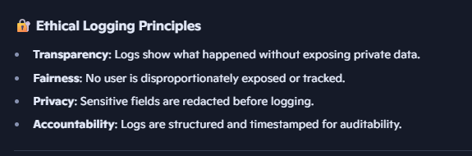

**Task Description #5:**

• Ask Copilot to generate a machine learning model. Then, prompt it to add documentation on how to use the model responsibly (e.g., explainability, accuracy limits).

copilot prompt and output –

