Sadhana

2403A51256

Batch – 11

**AI ASSISTED CODING – ASSIGNMENT – 6.1**

**Task 1 :**

(Classes – Employee Management)

Use AI to create an Employee class with attributes (name, id, salary) and a method to calculate yearly salary.

Prompt –

create an Employee class with attributes (name, id, salary) and a method to calculate yearly salary.

Code –

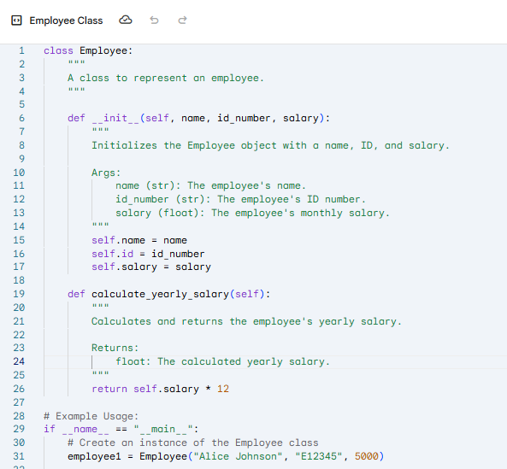

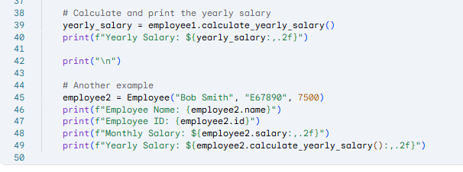

Output –

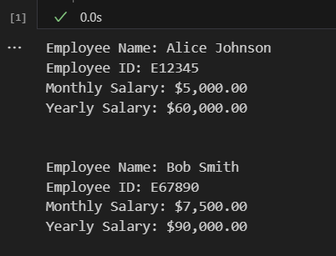

Asking ai to Add a method to give a bonus and recalculate salary.

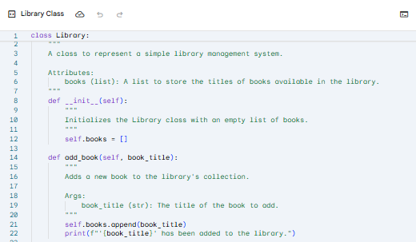

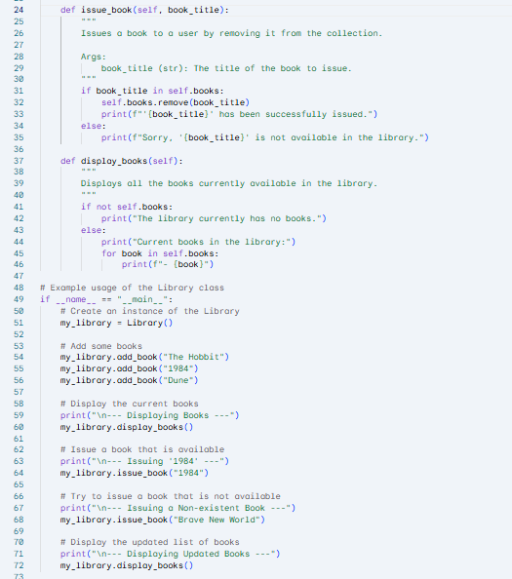

**Task 2 :**

(Loops – Automorphic Numbers in a Range)

Prompt AI to generate a function that displays all Automorphic numbers between 1 and 1000 using a for loop.

Prompt –

Asking ai generate a function that displays all Automorphic numbers between 1 and 1000 using a for loop.

Code –

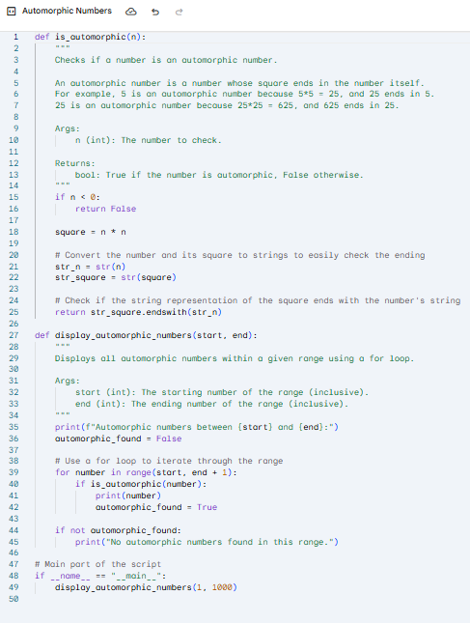

Output –

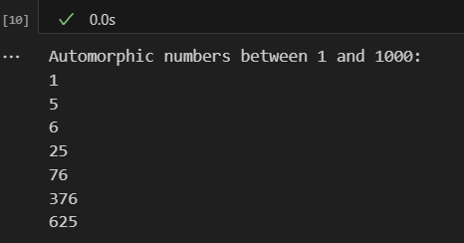

regenerateing using a while loop and compare both implementations.

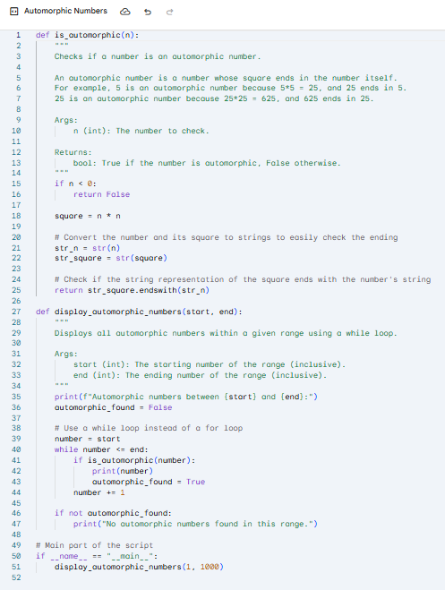

Both give same output and work almost the same.

**Task 3**:

(Conditional Statements – Online Shopping Feedback Classification)

Ask AI to write nested if-elif-else conditions to classify online shopping feedback as Positive, Neutral, or Negative based on a numerical rating (1–5).

Prompt –

write nested if-elif-else conditions to classify online shopping feedback as Positive, Neutral, or Negative based on a numerical rating (1–5).

Code –

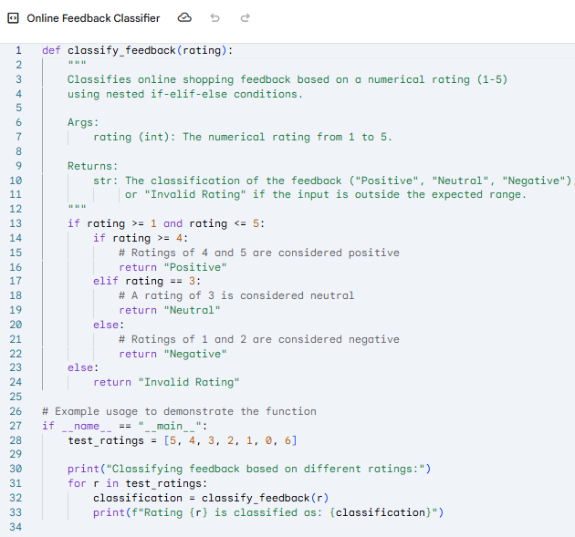

Output –

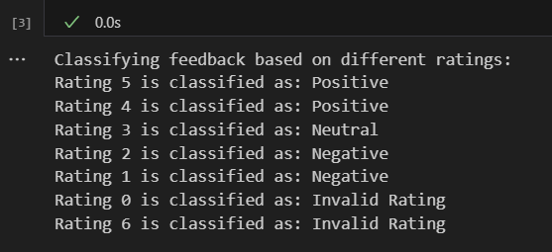

Asking ai to rewrite the code using dictionary-based or match-case structure.

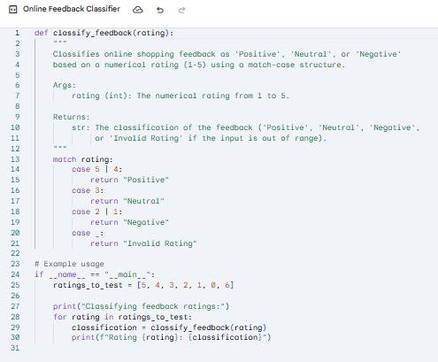

**Task 4**:

(Loops – Prime Numbers in a Range)

Generate a function using AI that displays all prime numbers within a user-specified range (e.g., 1 to 500).

Prompt –

Generate a function using AI that displays all prime numbers within a user-specified range (e.g., 1 to 500).

Code –

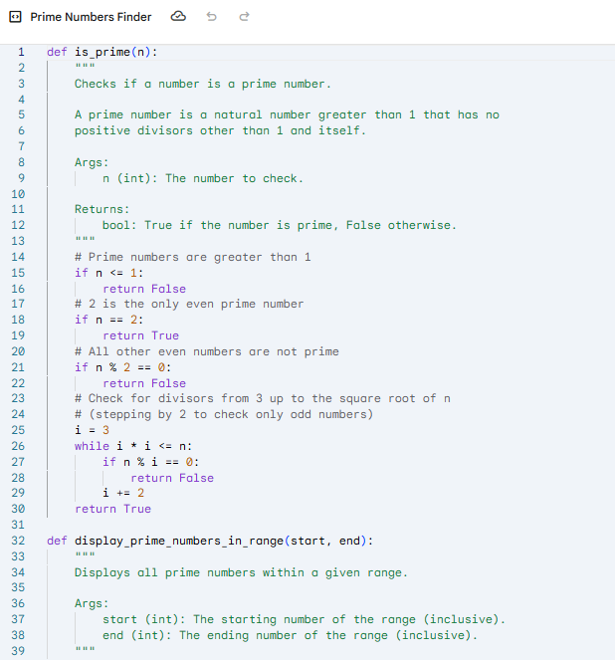

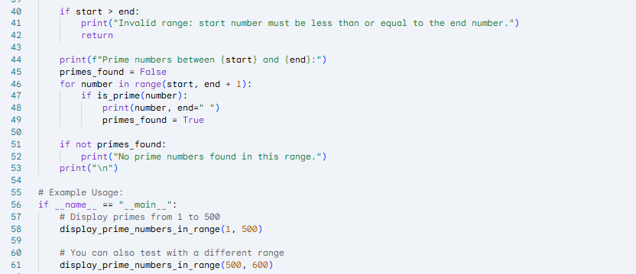

Output –

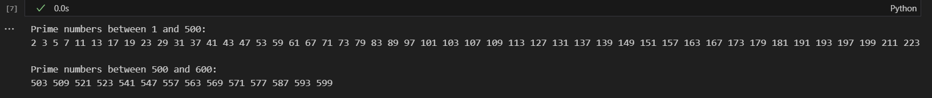

Asking ai to regenerate an optimized version (e.g., using the square root method). 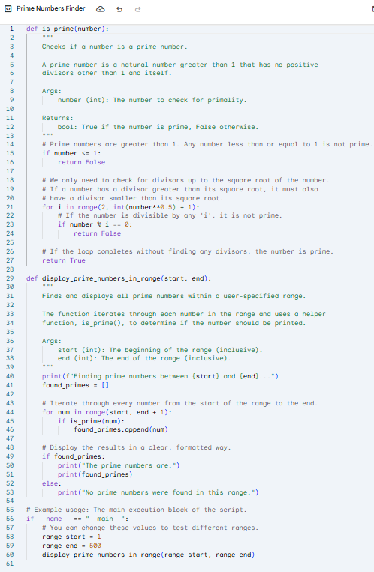

**Task 5:**

(Classes – Library System)

Use AI to build a Library class with methods to add_book(), issue_book(), and display_books().

Prompt –

build a Library class with methods to add_book(), issue_book(), and display_books().

Code –

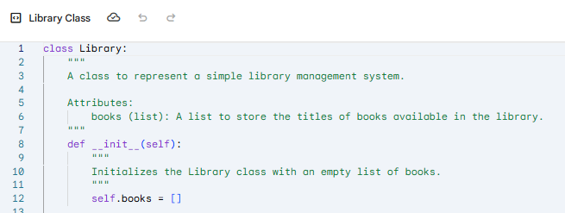

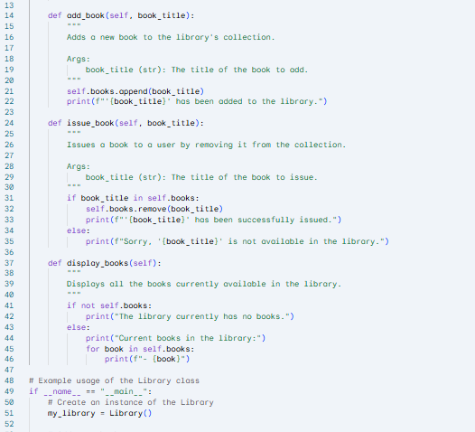

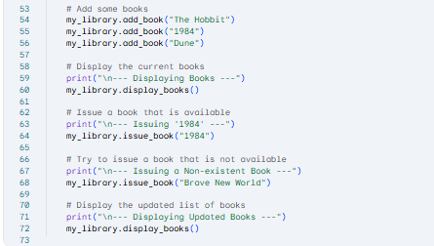

Output –

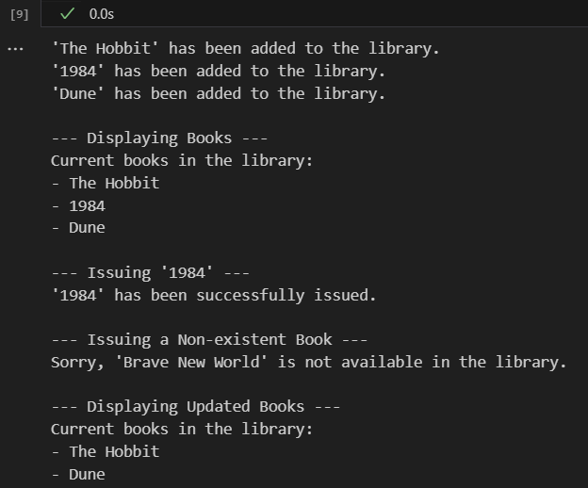

Asing ai to add comments and documentation.

