Sadhana

2403A51256

**AI ASSISTED CODING – ASSIGNMENT 7.1**

**Task Description #1** (Syntax Errors – Missing Parentheses in Print Statement)  
Provide a Python snippet with a missing parenthesis in a print statement (e.g., print "Hello"). Use AI to detect and fix the syntax error.

Prompt –

Missing parentheses in print statement

def greet():

print "Hello, AI Debugging Lab!"

greet()

detect and fix the syntax error.

Code –

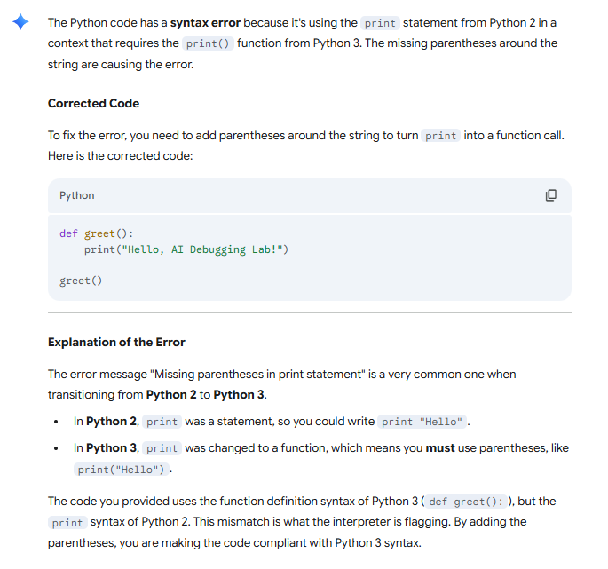

Output –

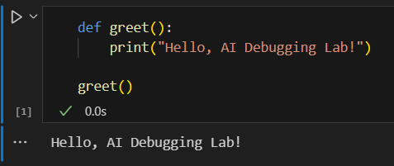

**Task Description #2** (Logic Error – Incorrect Condition in an If Statement)  
Supply a function where an if-condition mistakenly uses = instead of ==. Let AI identify and fix the issue.

Prompt –

Using assignment (=) instead of comparison (==)

def check_number(n):

if n = 10:

return "Ten"

else:

return "Not Ten"

fix the code.

Code –

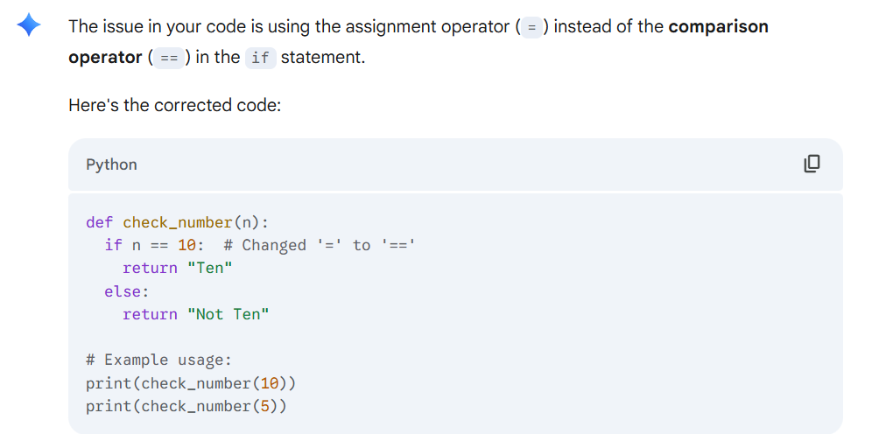

Output –

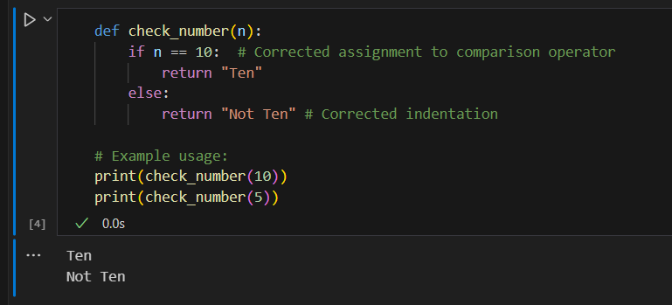

**Task Description #3** (Runtime Error – File Not Found)  
Provide code that attempts to open a non-existent file and crashes. Use AI to apply safe error handling

Prompt –

Program crashes if file is missing

def read_file(filename):

with open(filename, 'r') as f:

return f.read()

print(read_file("nonexistent.txt"))

apply safe error handling

Code –

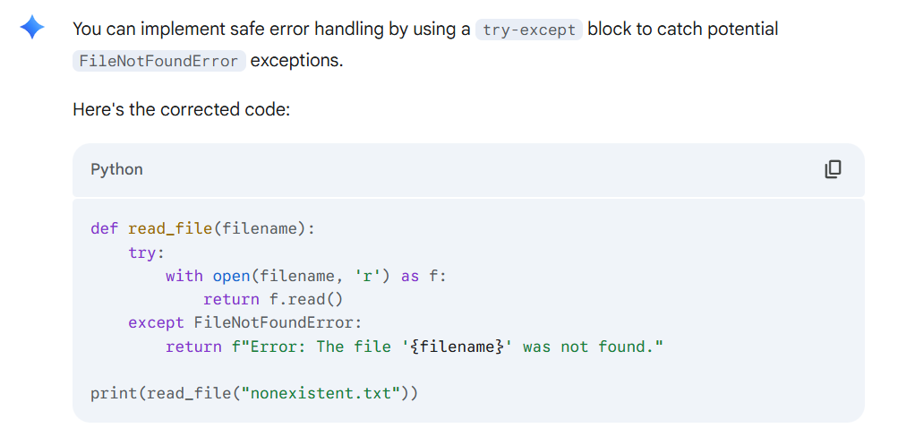

Output –

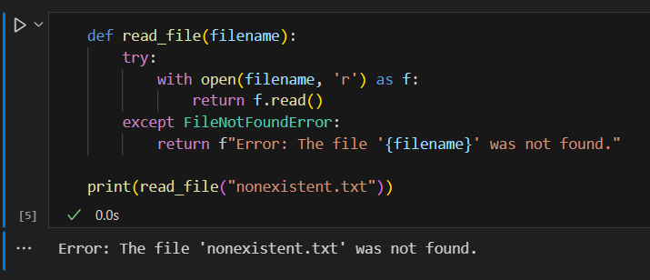

**Task Description #4** (AttributeError – Calling a Non-Existent Method)  
Give a class where a non-existent method is called (e.g., obj.undefined_method()). Use AI to debug and fix.

Prompt –

class Car:

def start(self):

return "Car started"

my_car = Car()

print(my_car.drive()) # drive() is not defined

debug and fix.

Code –

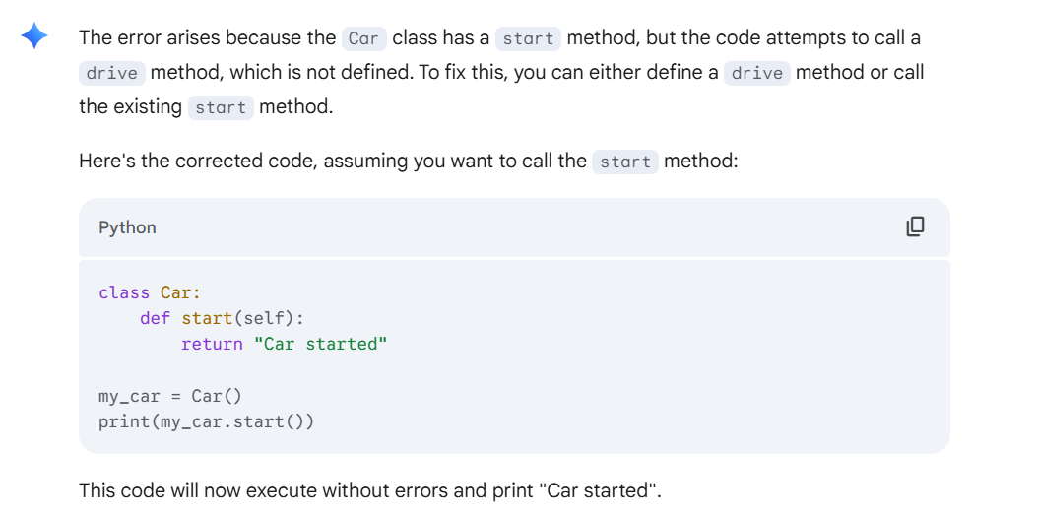

Output –

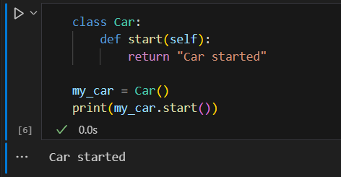

**Task Description #5** (TypeError – Mixing Strings and Integers in Addition)  
Provide code that adds an integer and string ("5" + 2) causing a TypeError. Use AI to resolve the bug.

Prompt –

def add_five(value):

return value + 5

print(add_five("10"))

resolve the bug.

Code –

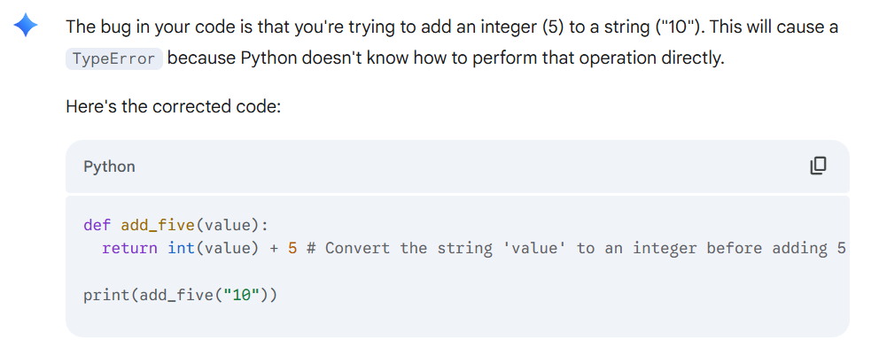

Output –

