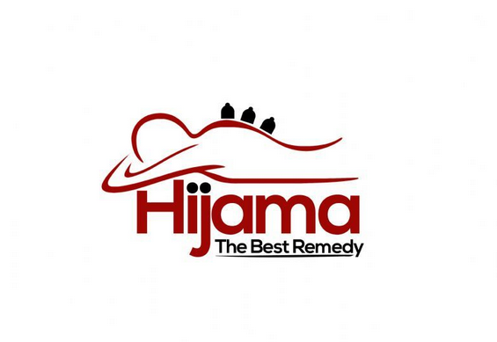

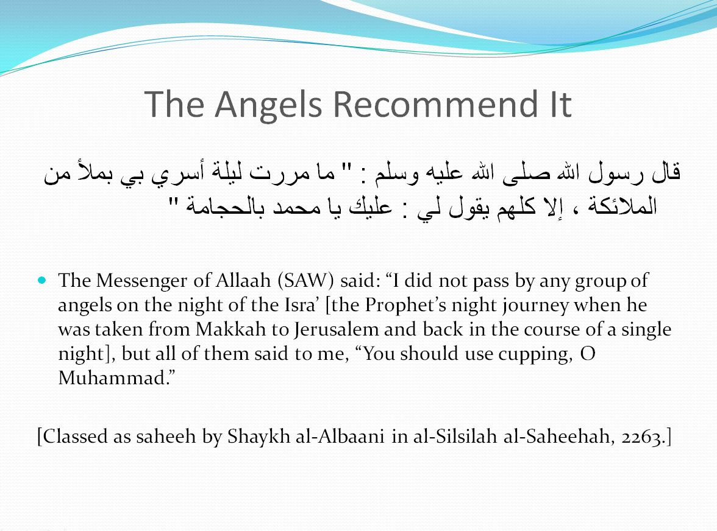

# http://images.all-free-download.com/images/graphiclarge/large_trees_and_grassland_elements_psd_layered_176000.jpg

# H I j a m a I n t r o d u c t I o n

### What is Hijama Therapy?

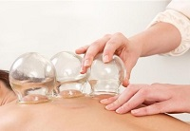Hijama in Arabic is derived from the root ‘hajm’ which means ‘sucking’. Hijama (in English, known as ‘cupping’) is an ancient medical treatment and practiced by forming suctions on the surface of the skin over very small cuts allowing the removal of inflamed, harmful, toxic or stagnant blood. It is called cupping as the process involves applying small cups to various points on the body by removing the air inside the cups to form a vacuum. This vacuum then gently draws the blood out from the areas that have been pricked or scratched.

### How and When Is Hijama Therapy Performed?

In other alternative medicines Hijama is also known as cupping or bloodletting, but the difference between these and Hijama is that with Hijama only the surface of the skin is scratched and then glass cups are placed on the specific spot and a vacuum is made to gently draw the blood out. Kissoon commented, “We sent some samples of blood that were taken during Hijama treatment to a non-Muslim laboratory and the doctors there commented that the blood was highly toxic and unsuitable for a human being.”  
According to the Sunnah of the Prophet (peace and blessings be upon him) there are certain places on the body that should have this treatment even if the individual is well, as a preventive medicine. There are also recommended times to perform Hijama and other times when Hijama should not be performed unless there is necessity. According to the Sunnah it is recommended to have Hijama performed on the 17, 19, and 21 of the Islamic calendar, but if it is necessary it is permissible to do it. Also, according to the Sunnah, Hijama should be done at the back of the neck, and between the two shoulder blades as this connects the brain to the rest of the body and it brings oxygen into the brain and helps the body to repair itself. This is also the place where toxins accumulate. Moreover, it strengthens the lymphatic system. Some Syrian groups do Hijama on the two shoulder blades as opposed to the back of the neck, however, traditional Chinese medicine, as well as other ancient medicine, refer to the back of the neck.

### ARE THERE ANY SIDE EFFECTS TO THE TREATMENT?

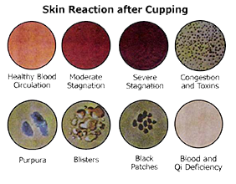

Usually not. As energy is redirected in the body, internal chemicals and hormones are stimulated and healing begins to take place. Occasionally the original symptoms worsen for a few days, or other general changes in appetite, sleep, bowel or urination patterns, or emotional state may be triggered. These should not cause concern, as they are simply indications that the acupuncture is starting to work. It is quite common with the first one or two treatments to have a sensation of deep relaxation or even mild disorientation immediately following the treatment. These pass within a short time, and never require anything more than a bit of rest to overcome.

### Can we perform Hijama while Fasting?

With regards to hijama treatments throughout Ramadhan (month of fasting) :

Abdullah ibn Abbas RA reported that the Messenger PBUH was cupped while he was fasting. [Saheeh al-Bukhaaree (5694)].  
Anas ibn Maalik RA was asked: “Did you dislike cupping for the fasting person?” He said, “No except for the reason of one becoming weak.” [Saheeh al-Bukhaaree (1940)].

This is not affected by the hadeeth, “The cupper and the one being cupped have broken their fast.” [Saheeh see Irwaa al-Ghaleel (931)].

This is because the hadeeth is abrogated as Sheikh al-Albaani and ibn Hazm (may Allah have mercy upon them) showed by the following hadeeth: Abu Sa’eed al-Khudhree T said, “The Messenger PBUH validated cupping for the fasting person.” [Saheeh see Irwaa al-Ghaleel (4/74)].

It appears that cupping (hijama) is allowed but disliked as Anas ibn Maalik RA mentioned because the fasting person becomes weak if they perform cupping (hijama) and Allah knows best. It is not recommended to have hijama treatment whilst fasting as it can make one feel even more weeker, tired & lathergic, especially in the UK, as we’l fasting for aprox (19hours). One may feel the need to break their fast in order to intake nutrients/ energy back to their body to help mobilise blood flow

### HOW MANY TREATMENTS WILL I NEED?

The number of treatments needed differs from person to person. For complex or long-standing conditions, one or two treatments a week for several months may be recommended. For acute problems, usually fewer visits are required, and for health .

### Hijama – How it works and what are the Benefits

In simple terms – think of Hijama therapy as an oil change for your body – it detoxifies the body and rids it of the old, heavy, dirty blood where it has gathered and is impacting the efficiency and productivity of the body. This therapy works with the body’s condition and balances it. One may be feeling sluggish, or suffering from pain; either way Hijama is an effective treatment. As the bad blood is discarded, your body to maintain itself produces fresh blood to replace this and thus your service is complete! The effect is the body feels fresh, revitalized and at optimum health.

Other benefits of Hijama which have been reported are that it:

* stimulates and strengthens the immune system;
* enhances blood circulation;
* stimulates tissues and internal organs;
* improves physical and mental health conditions;
* enhances general health of body;
* relieves chronic pain, migraines and ailments;
* reduces stress and depression by releasing chemicals in the brain;
* allows tissues to release toxins by eliminating them through the surface of the skin;
* brings blood and warmth to an affected organ and therefore promotes healing;
* reduces unwanted side effects of drugs, removes their residue and reduces the risk of drug toxicity; and
* strengthens the power of digestion and absorption of nourishment and the power of secretion…
* and from my own experience… a great night’s sleep!

### The Procedure

There are the following three types of cupping.

1. **Dry cupping:** This is the process of using a vacuum on different areas of the body in order to gather the blood in that area without incisions (small, light scratches using a sterile surgical blade or).

**2 Dry massage cupping:** This is similar to dry cupping but olive oil is applied to the skin (before applying the cups) in order to allow easy movement of the cups. In ailments due to the blood being unable to reach certain parts of the body. Dry cupping and dry massaging cupping allow the blood to reach these places.

Although dry and massage cupping are very beneficial, they are not from the Sunnah. However, they fall under the general hadeeth: The Messenger said,

“For every disease there is a cure so if the medicine comes upon the disease it cures it by the will of Allah, the Most High.” [Saheeh Muslim (2204)].

1. **Wet cupping (hijama):** This is the process of using a vacuum at different points on the body but with small incisions in order to remove ‘harmful’ blood which lies just beneath the surface of the skin. (It is only administered by a cupping therapist).
2. Cups are placed on different points on the body that correspond to different ailments and vacuum is applied.
3. Harmful superficial blood is pulled near the skin.
4. Cups are removed and small incisions are made in the area where blood was pulled near the skin.
5. Cups are reattached and vacuum is reapplied allowing the harmful blood to seep out.
6. Cups are removed and blood cleaned.
7. If done correctly, the marks from the treatment take a few hours to a couple of days to completely heal.

### Sunnah Days

The Holy Prophet (Peace and Blessings of Allah upon Him) recommended getting Hijama Every 17th, 19th and 21st of Islamic Calendar (if not on a Wednesday). These days are known as Sunnah days are provide the best benefits.

### Forbidden Days

It is forbidden to get Hijama on Wednesdays. Therefore the clinic is closed on Wednesdays.

