Project coffee website
Presented by Saad Ali & Danyal
Introduction
The Coffee Website is a modern and responsive web project developed using HTML, CSS, and JavaScript. The purpose of this website is to provide users with an attractive online coffee shop experience where they can explore menu items, read customer testimonials, view the gallery, and contact the coffee shop easily.
The website is designed with a clean user interface, responsive layout, smooth navigation, and interactive elements such as image hover effects and testimonial sliders. The project demonstrates front-end web development concepts including responsive design, CSS styling, flexbox layout, media queries, and JavaScript functionality.
This project helps improve user experience by making the website visually appealing, mobile-friendly, and easy to navigate.
2. Website Features
Navigation Bar
- Responsive navigation menu
- Smooth section navigation
- Mobile hamburger menu support

Hero Section
- Attractive coffee-themed landing section
- Call-to-action buttons
- Hero image and introductory text
About Section
- Information about the coffee shop
- Social media icons
- Responsive image and text layout
Menu Section
- Displays coffee and food categories
- Menu item images with descriptions
- Responsive grid layout
Testimonials Section
- Customer reviews slider using Swiper.js
- Navigation buttons and pagination
- Interactive testimonial cards
Gallery Section
- Coffee shop image gallery
- Hover zoom image effect
- Responsive gallery layout
Contact Section
- Contact information display
- User contact form
- Required field validation

Footer Section
- Copyright information
- Social media links
- Privacy and refund policy links

Responsive Design
- Mobile-friendly interface
- Tablet and desktop compatibility
- Media queries for different screen sizes

Interactive Features
- Hover animations
- Smooth transitions
- Mobile navigation effects
- Image zoom effects
Coffee Website Test Cases
- Best Case
- Average Case
- Worst Case
1. Navbar Test Cases
Case Type | Test Case | Expected Result | Status
Best Case | Click all navbar links | All sections open smoothly | PASS
Average Case | Rapidly click different links | Navigation still works correctly | PASS
Worst Case | Invalid section ID removed | Link does not navigate correctly | FAIL

2. Mobile Menu Test Cases
Case Type | Test Case | Expected Result | Status
Best Case | Open menu on mobile | Sidebar opens smoothly | PASS
Average Case | Open and close repeatedly | Menu still works | PASS
Worst Case | JavaScript file missing | Menu button does not work | FAIL

3. Hero Section Test Cases
Case Type | Test Case | Expected Result | Status
Best Case | Website loads normally | Hero text and image display correctly | PASS
Average Case | Slow internet speed | Hero content loads after delay | PASS
Worst Case | Hero image deleted | Broken image icon appears | FAIL

4. About Section Test Cases
Case Type | Test Case | Expected Result | Status
Best Case | About section loads | Image and text aligned properly | PASS
Average Case | Long paragraph added | Layout still remains readable | PASS
Worst Case | Missing image path | About image not displayed | FAIL

5. Social Media Icons Test Cases
Case Type | Test Case | Expected Result | Status
Best Case | Hover over icons | Hover color changes | PASS
Average Case | Multiple hover actions | Icons still animate correctly | PASS
Worst Case | Font Awesome CDN removed | Icons do not appear | FAIL

6. Menu Section Test Cases

Case Type | Test Case | Expected Result | Status
Best Case | Load menu section | All menu items display correctly | PASS
Average Case | Resize browser window | Items rearrange properly | PASS
Worst Case | Large image size used | Layout breaks or overflows | FAIL

7. Testimonials Slider Test Cases
Case Type | Test Case | Expected Result | Status
Best Case | Click next/prev button | Testimonials slide correctly | PASS
Average Case | Fast multiple clicks | Slider still functions | PASS
Worst Case | Swiper JS missing | Slider stops working | FAIL

8. Gallery Section Test Cases
Case Type | Test Case | Expected Result | Status
Best Case | Hover over gallery image | Zoom effect works | PASS
Average Case | Open on tablet/mobile | Images align properly | PASS
Worst Case | Invalid image path | Gallery image missing | FAIL

9. Contact Form Test Cases
Case Type | Test Case | Expected Result | Status
Best Case | Fill valid data and submit | Form submits successfully | PASS
Average Case | Leave one field empty | Required warning appears | PASS
Worst Case | Enter invalid email | Browser validation error shown | FAIL

10. Footer Test Cases
Case Type | Test Case | Expected Result | Status
Best Case | Footer loads | All links and icons visible | PASS
Average Case | Resize small screen | Footer stacks correctly | PASS
Worst Case | Missing CSS styles | Footer layout breaks | FAIL

11. Responsive Design Test Cases
Case Type | Test Case | Expected Result | Status
Best Case | Open on desktop | Perfect full layout | PASS
Average Case | Open on tablet | Sections adjust properly | PASS
Worst Case | Very small screen | Some elements overlap | FAIL

12. Performance Test Cases
Case Type | Test Case | Expected Result | Status
Best Case | Fast internet connection | Website loads quickly | PASS
Average Case | Medium internet speed | Minor loading delay | PASS
Worst Case | Large unoptimized images | Website becomes slow | FAIL

13. Accessibility Test Cases
Case Type | Test Case | Expected Result | Status
Best Case | Images contain alt text | Screen readers work properly | PASS
Average Case | Keyboard navigation used | Most elements accessible | PASS
Worst Case | Missing alt attributes | Accessibility issues occur | FAIL

14. CSS Error Test Cases
Case Type | Test Case | Expected Result | Status
Best Case | Correct class names used | Styles apply correctly | PASS
Average Case | Minor typo in CSS | Small styling issue appears | PASS
Worst Case | Wrong selector name (.subtilte) | Subtitle style missing | FAIL

Diagrams

- Use Case Diagram
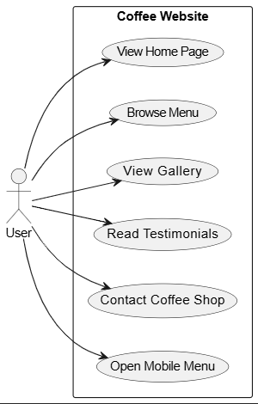
- Activity Diagram
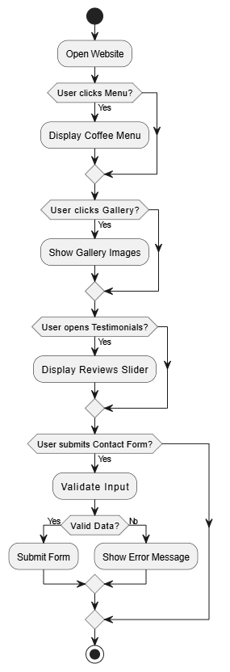
- Class Diagram
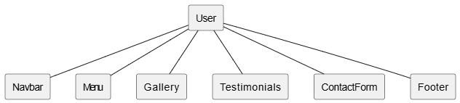
- Sequence Diagram
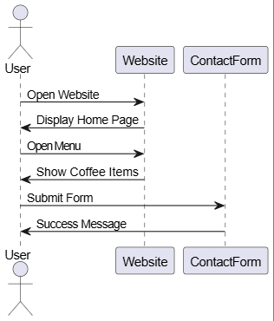
- Communication Diagram
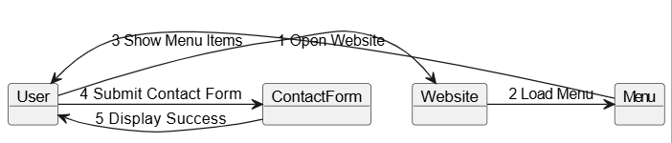

- Petri Net Diagram
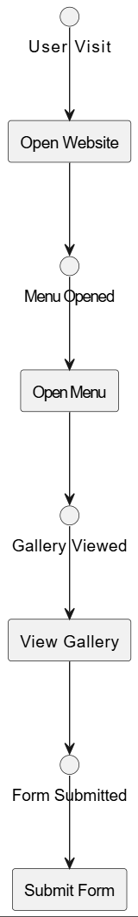
- Component Diagram

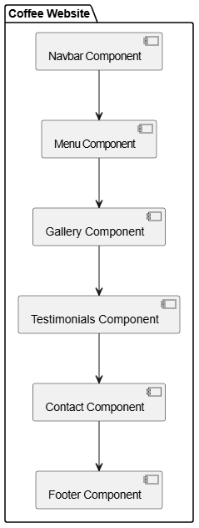
- Deployment Diagram

