Top Gpu For Mining

Admin guide

### Model

#### In the Admin Drop down menu select models

#### Click اضف

#### Fill the below form then click اضف

#### After that you should see all models as picture below

#### Also you can delete or modify model name or description.

Top of Form

Bottom of Form

### Brand

1. Same Model steps.

### GPU

1.after adding (**brand** and **Model**) you can add gpu by select the Model type and Brand type and fill the form 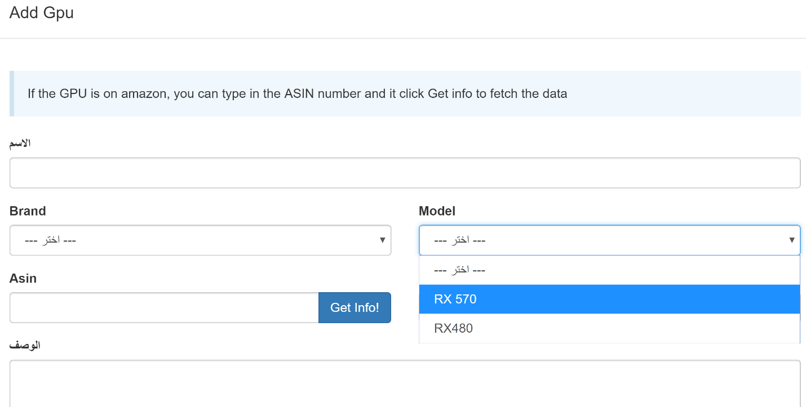

2. you can fill the gpu info manually and click add .

3. or if you find gpu in **Amazon** and you want to add it to **Top Gpu Mining** you can do it easily by taking **Asin** number from amazon and enter the number in Asin text-box and click (Get Info!) to fetch the data 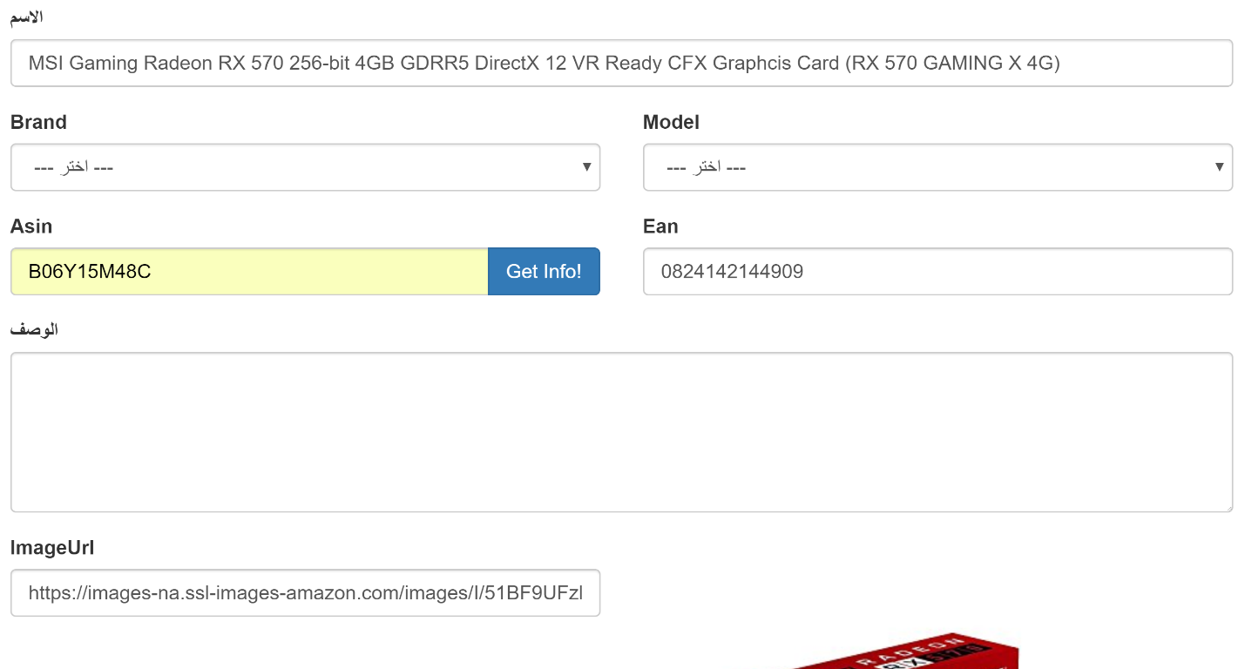

* you can also change the data and click add.

### Algorthim

1. The algorithms list is filled automatically by the system and updated periodically (for more information check system jobs header)
2. Also, you can add algorithms manually same **Model** steps.

### Hashrate

1. After adding **algorithms** and **model** you must add the hashrate**(Mh/s)** .
2. You can take the hashrate from <http://whattomine.com/>
3. Example to extract the hashrate for **model 480** and **algorithm Ethash**:
   1. In the first to rows in <http://whattomine.com/> you can find all models types , insert 1 in front 480 model :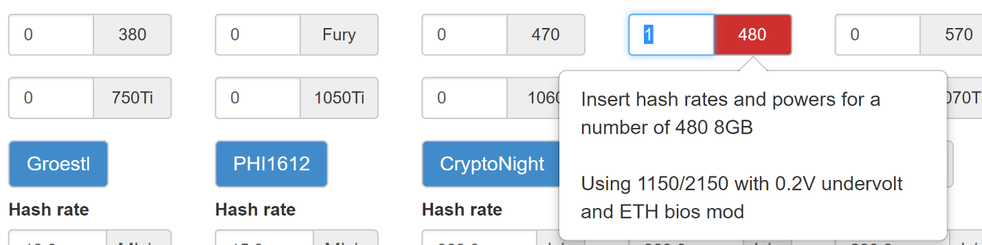
   2. After that you can find the hashrate value under the Ethash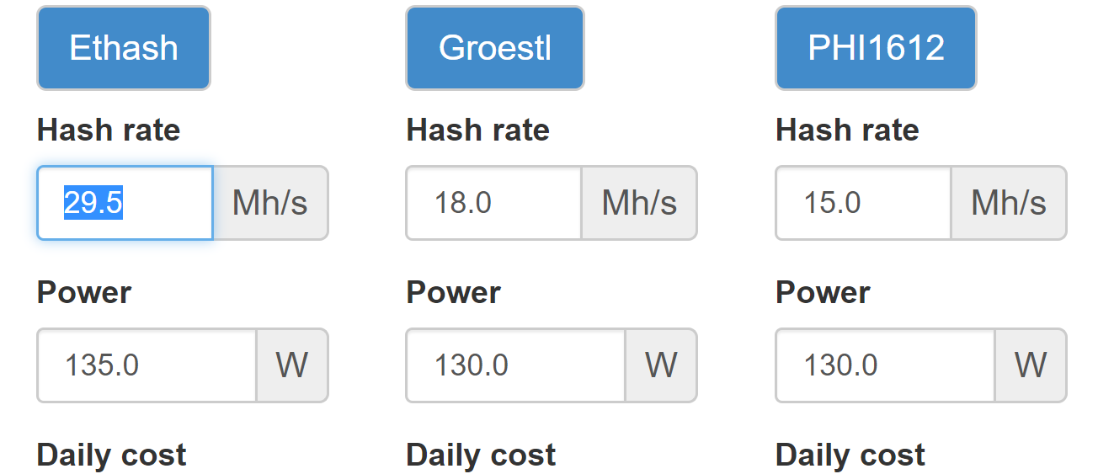
   3. In admin page Add the hashrate and select same model and algorithm 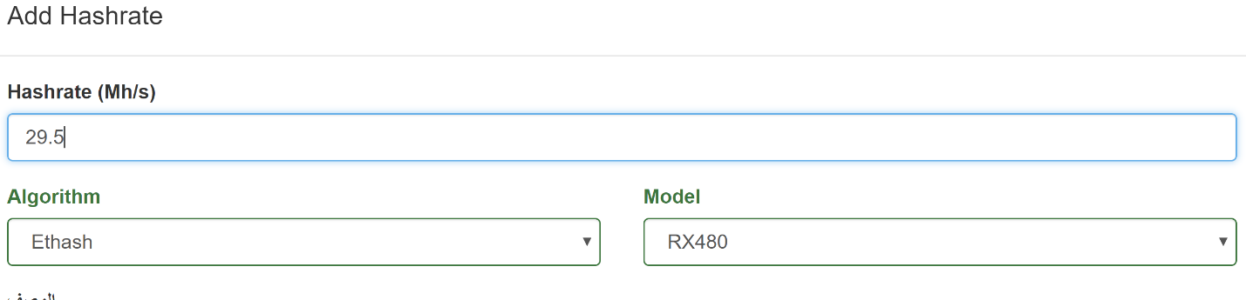

### Price Source

1. If you have price source you can add It in this window and select from DDL the source(AmazonUs,AmazonUK,New Egg ….).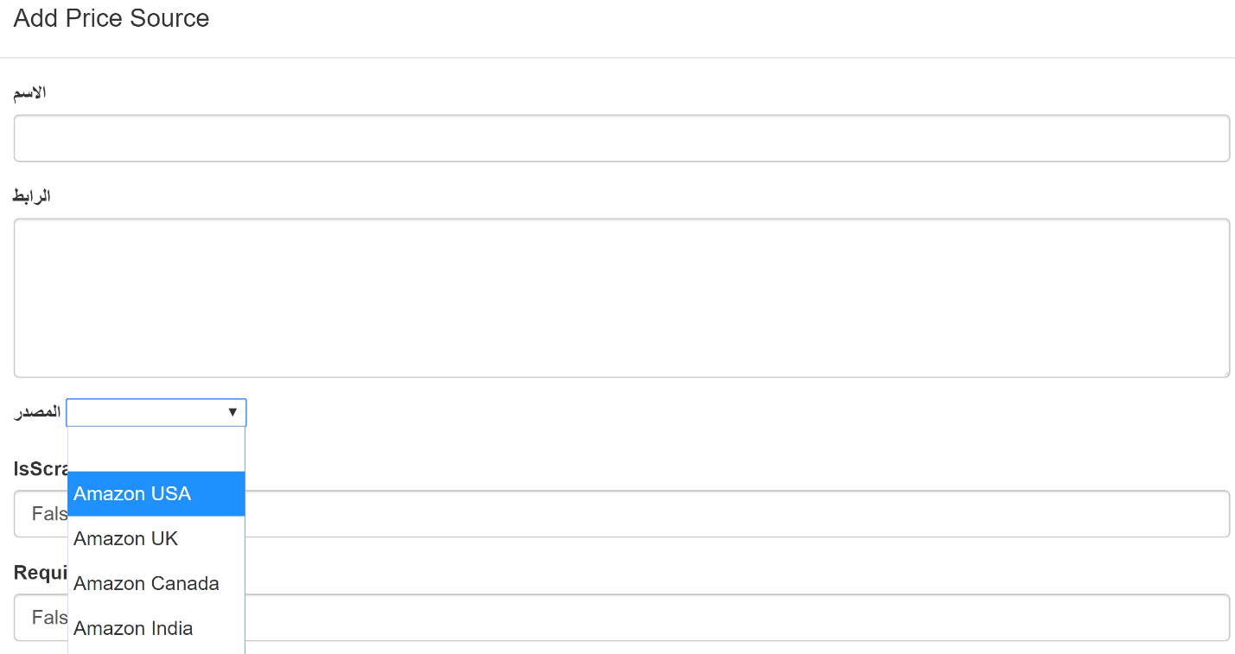
2. Add internal name and url for this price source and click add.

### Gpu price source

* After adding the price source select the Gpu from the list and chose the price source 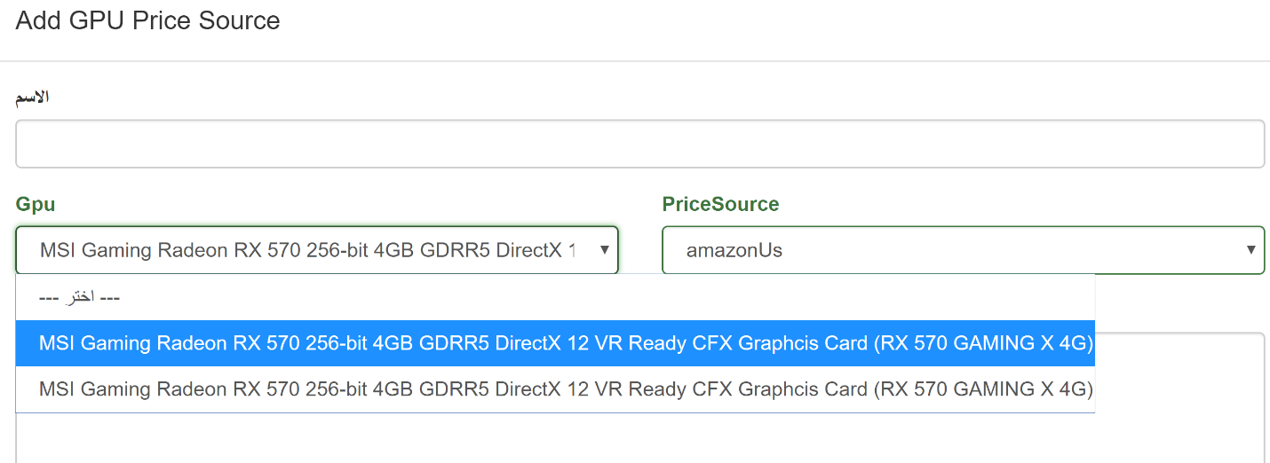
* Add internal name for this gpu price source
* Click add.

### System Jobs

* TBD