**Name: Saad Bin Haroon:**

**Intern ID:TN/IN02/PY/026:**

**DATE: 30 AUGUST 2025:**

**Internship domain: python development:**

TASK1:

**Install Python & print version.**

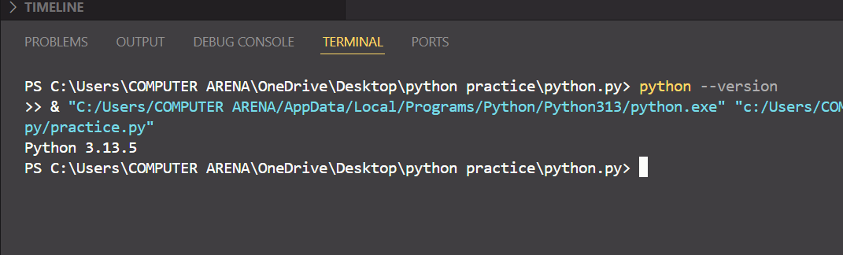

I ave instll the python latest version and just here is the output of it:

**2. Run hello script printing your name.?**

**Code:**

**print("Hello, my name is Saad Bin Haroon!")**

**Output:**

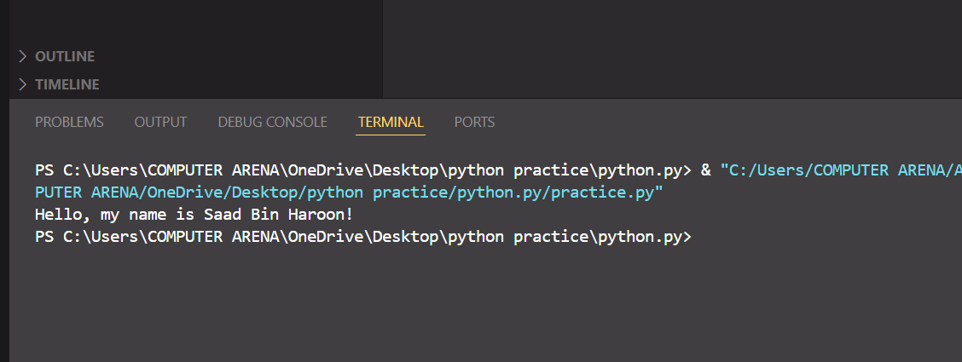

TASK2:

**1. Fix badly-indented code.**

**2. Add comments explaining each step.**

**Code:**

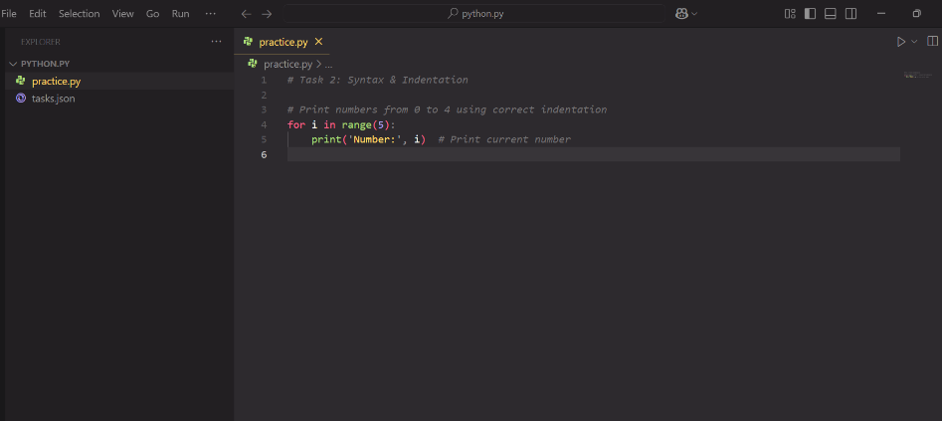

**Task 3:**

1. **Collect user profile & print typed summary.**

**Code:**

**name = input('Enter your name: ')**

**age = *int*(input('Enter your age: '))**

**print(*f*'User: {name}, Age: {age}')**

**Output:**

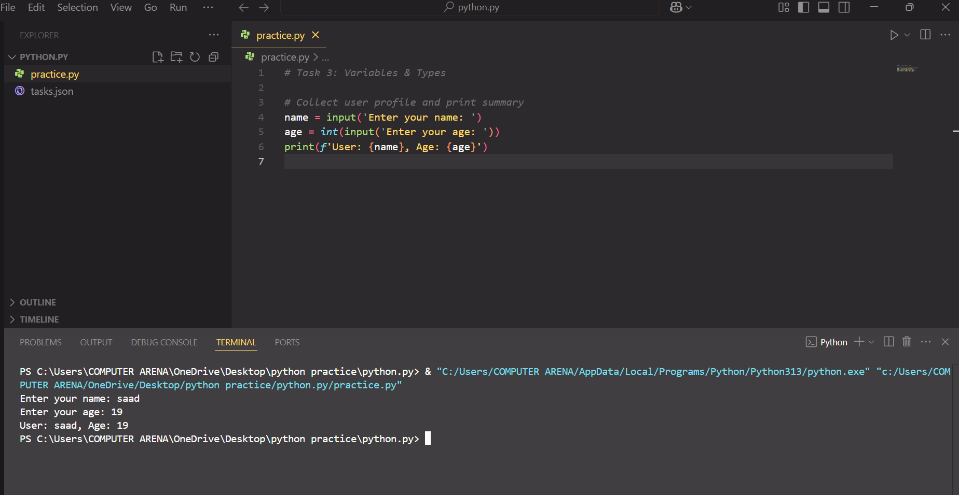

1. **Swap two variables without temp var.**

**Code:**

***# Swap two variables without using a third variable***

**a = 5**

**b = 10**

***# Swapping***

**a, b = b, a**

**print('a:', a, 'b:', b)**

**Output:**

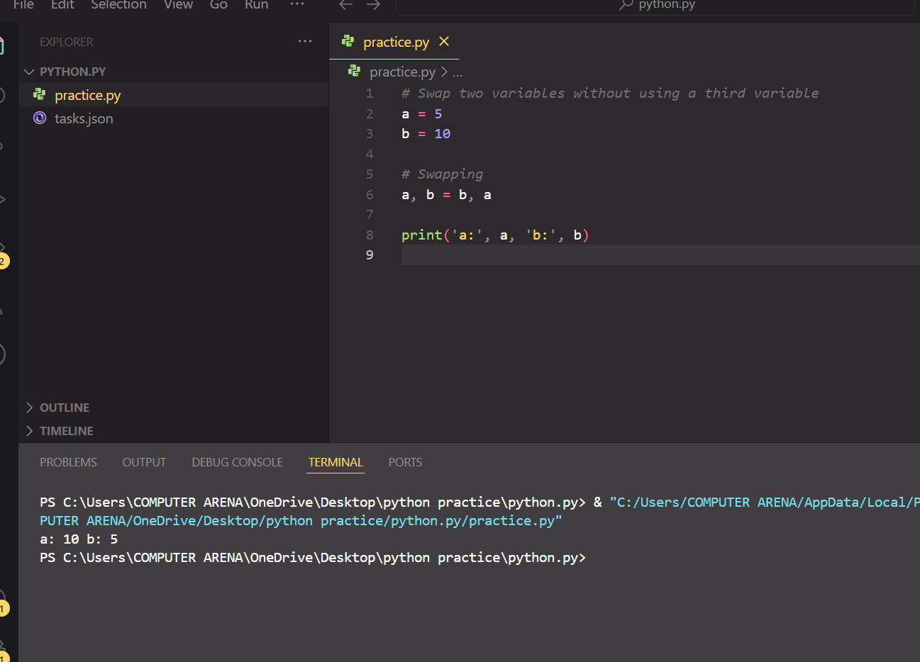

**Task 4:**

**Read three numbers; output avg.**

**Code:**

***Average of 3 numbers***

**a = *float*(input('Enter first number: '))**

**b = *float*(input('Enter second number: '))**

**c = *float*(input('Enter third number: '))**

**avg = (a + b + c) / 3**

**print('Average:', avg)**

**Output:**

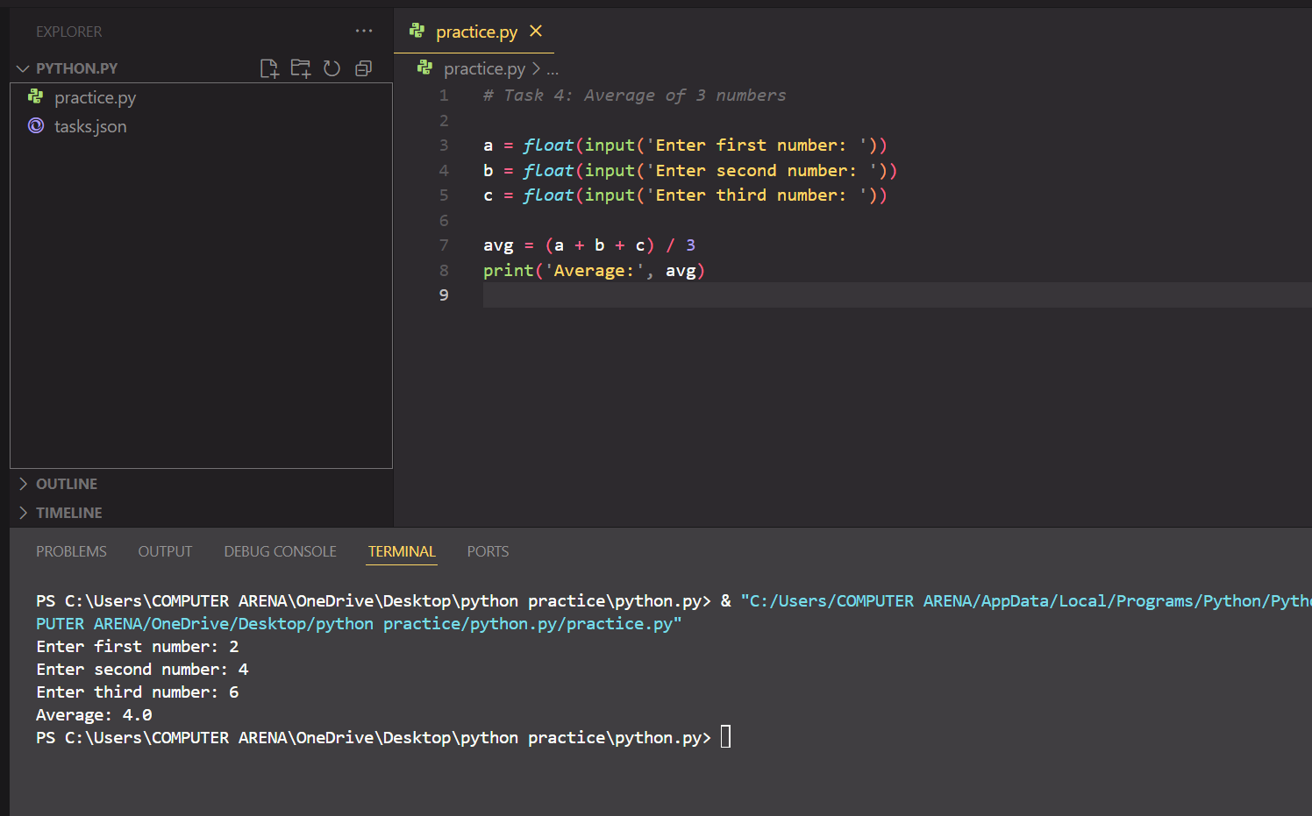

1. **Convert minutes to hours + minutes.**

**Code:**

***# Convert minutes to hours and minutes***

**minutes = *int*(input('Enter minutes: '))**

**hours = minutes // 60**

**mins = minutes % 60**

**print(*f*'{hours} hour(s) and {mins} minute(s)')**

**Output:**

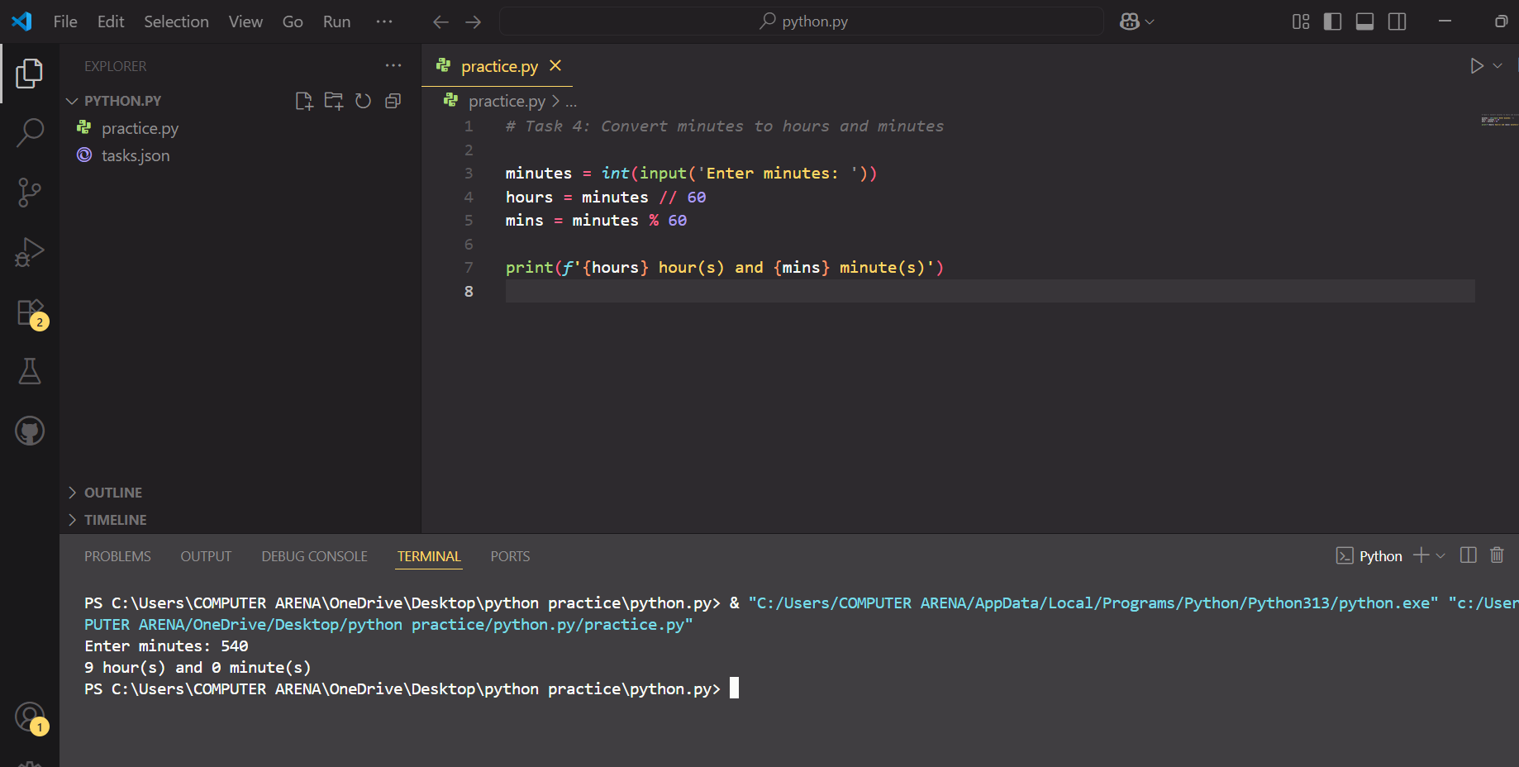

**Task 5:**

**. BMI calc from user input.**

**Code:**

# BMI Calculator

weight = float(input('Enter weight in kg: '))

height = float(input('Enter height in meters: '))

bmi = weight / (height ** 2)

print('BMI:', round(bmi, 2))

**Output:**

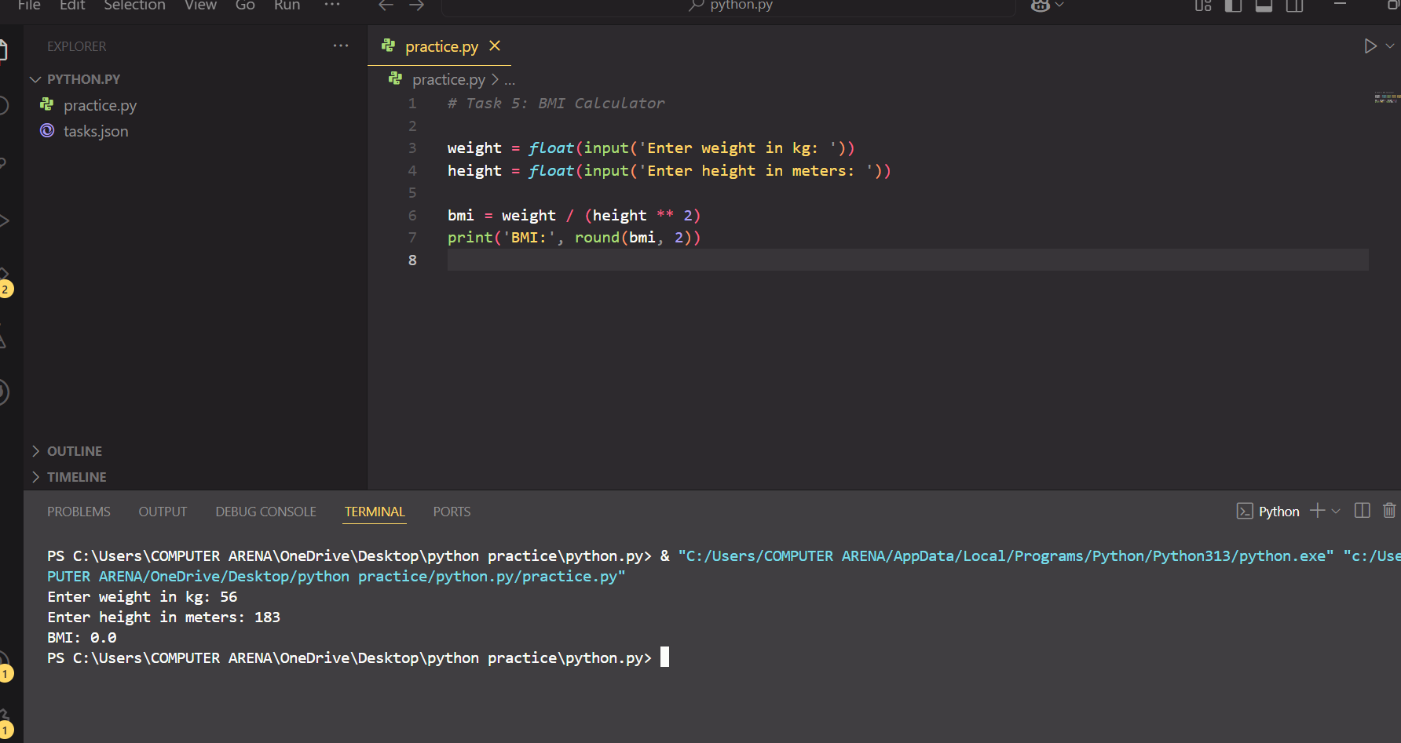

**2. Simple interest calc.**

**Code:**

# Simple Interest Calculator

p = float(input('Principal amount: '))

r = float(input('Rate of interest: '))

t = float(input('Time in years: '))

si = (p * r * t) / 100

print('Simple Interest:', si)

**Output:**

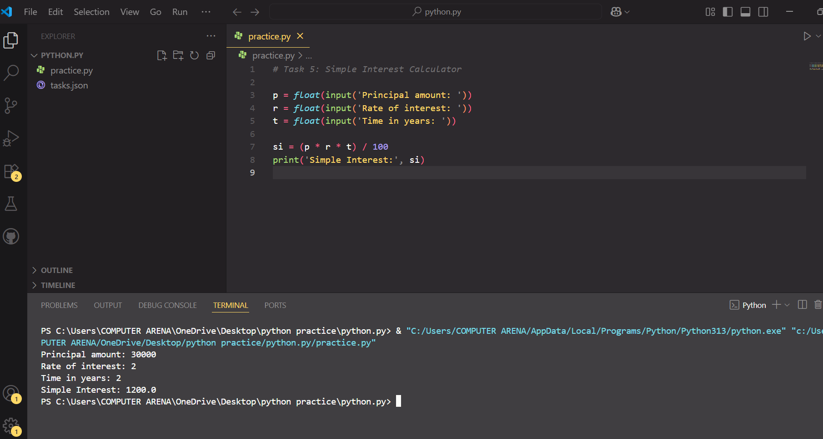

**Task 6:**

**. Username builder from full name.**

**Code:**

*# Username Builder from Full Name*

full_name = input('Enter full name: ')

username = ''.join(full_name.lower().split())

print('Username:', username)

**Output:**

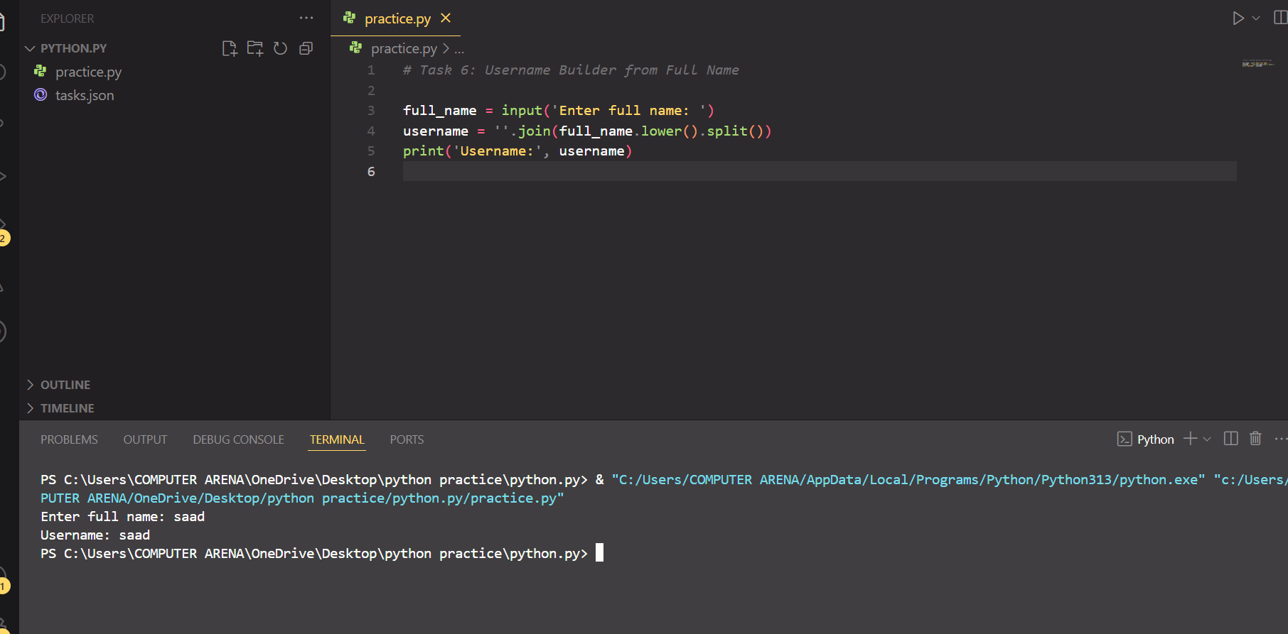

**2. Vowel/consonant counter.**

**Code:**

# vowel and Consonant Counter

vowels = 'aeiouAEIOU'

v = c = 0

for char in full_name:

if char.isalpha():

if char in vowels:

v += 1

else:

c += 1

**Output**

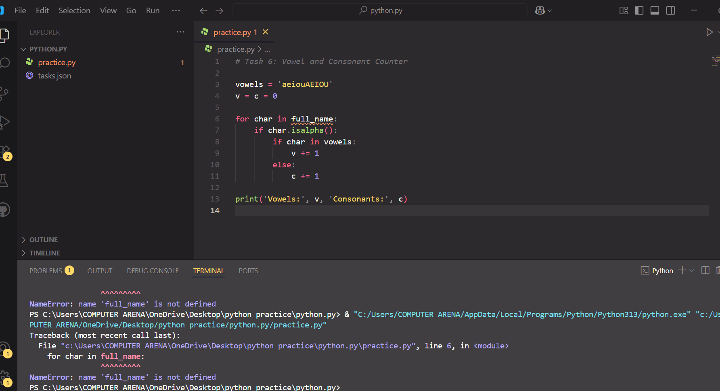

**Sorry, I couldn’t correct the code of vowel and conconent due to an unexpected error. I’m working on fixing it**

**Task 7:**

**. Grade calculator.**

**Code:**

*# Grade Calculator*

marks = *int*(input('Enter marks: '))

if marks >= 90:

    grade = 'A+'

elif marks >= 80:

    grade = 'A'

elif marks >= 70:

    grade = 'B'

else:

    grade = 'C or below'

print('Grade:', grade)

**Output:**

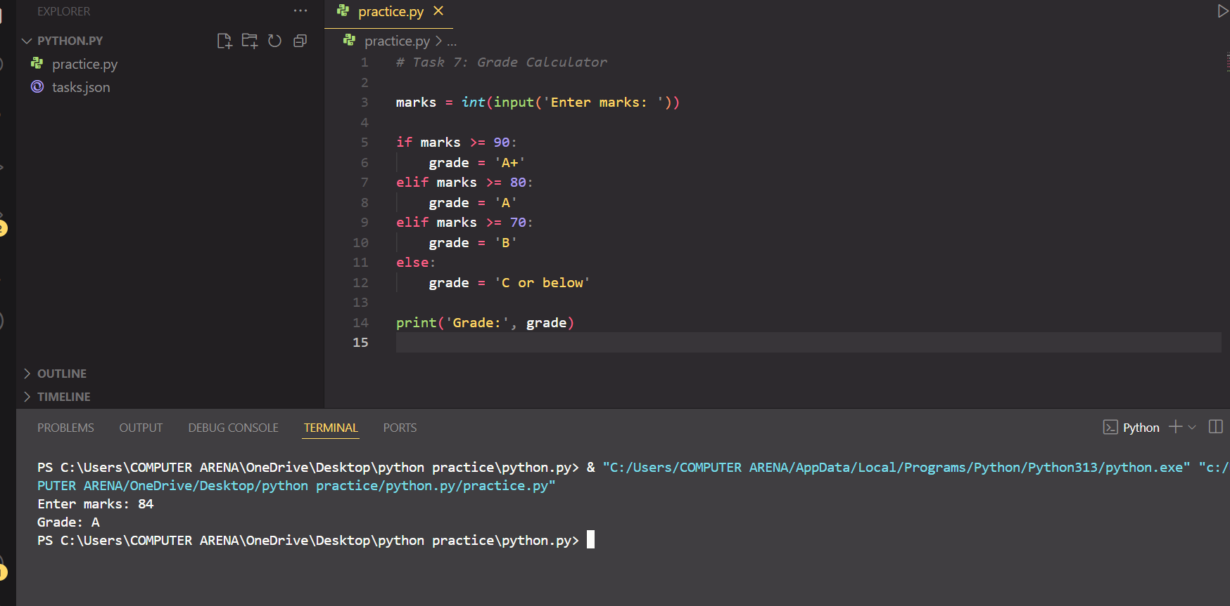

**2. Password strength classifier.**

**Code:**

*# Password Strength Classifier*

pwd = input('Enter password: ')

if len(pwd) >= 8 and any(c.isdigit() for c in pwd) and any(c.isupper() for c in pwd):

    print('Strong Password')

else:

    print('Weak Password')

**Output:**

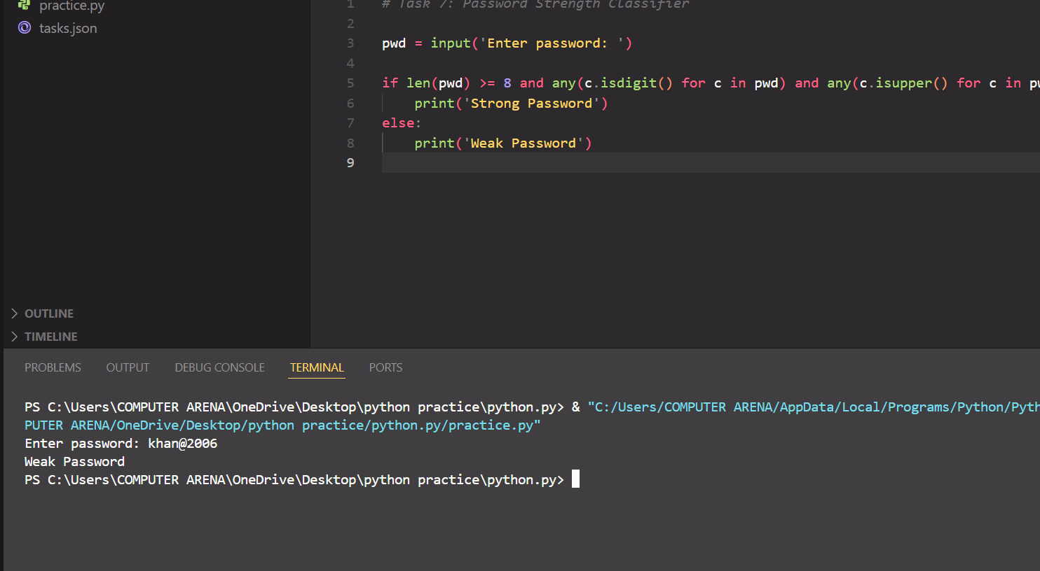

**Task 8:**

**. Multiplication table.**

**Code:**

*Multiplication Table*

num = *int*(input('Enter a number: '))

for i in range(1, 11):

    print(*f*'{num} x {i} = {num * i}')

**Output:**

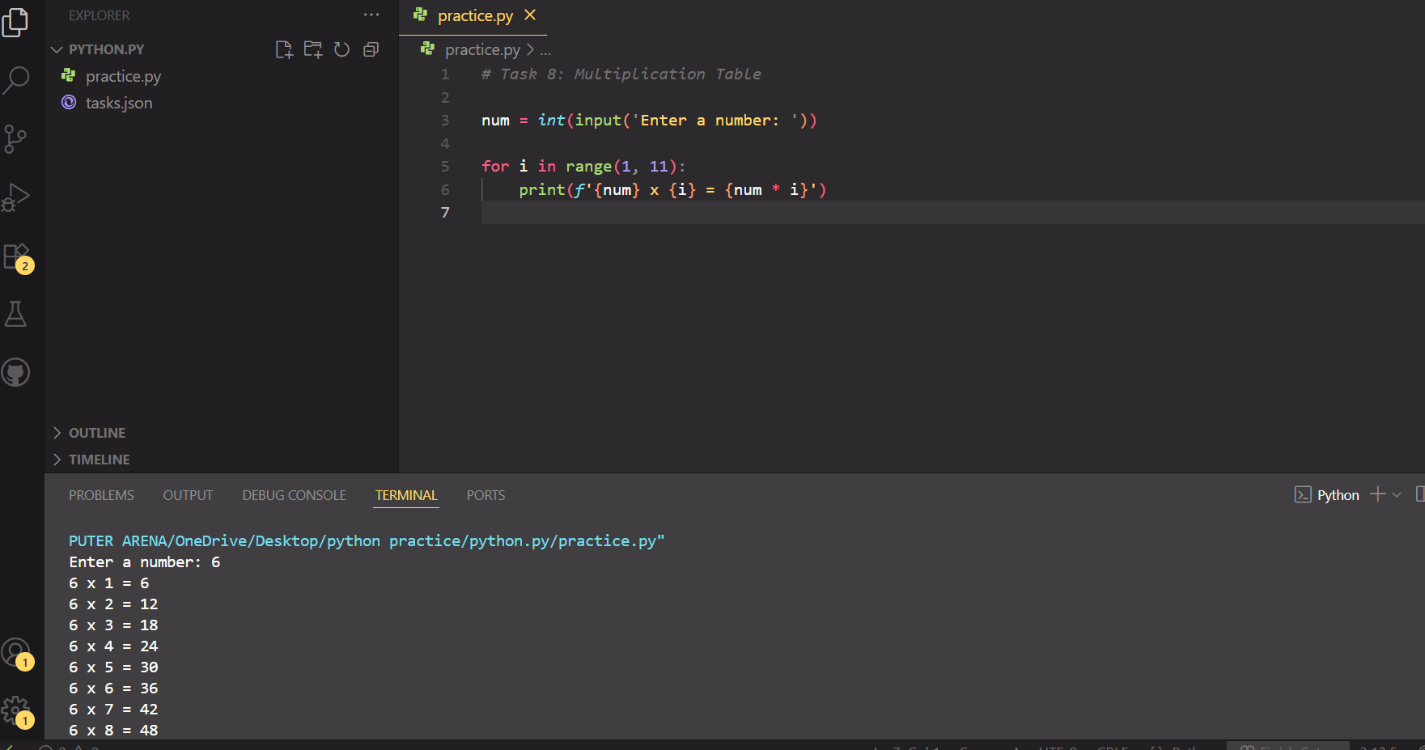

**2. Sum numbers divisible by 3.**

**Code:**

*Sum numbers divisible by 3 (1 to 100)*

total = 0

for i in range(1, 101):

    if i % 3 == 0:

        total += i

print('Sum of numbers divisible by 3:', total)

**Output:**

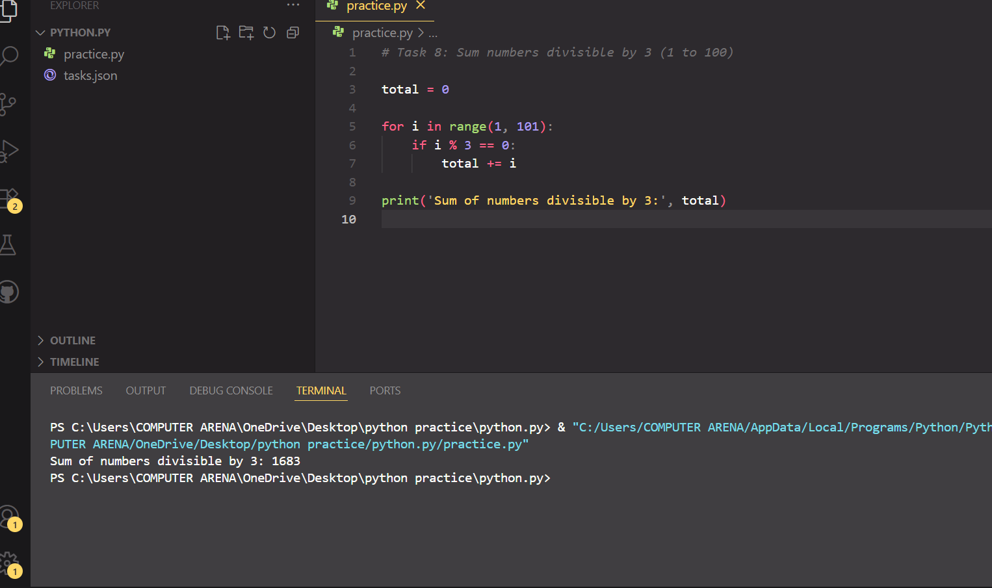

**Task 10:**

**CLI Unit Converter: length, weight, temperature menus + loops & conditionals.**

**Code:**

CLI Unit Converter

# This program converts units of length, weight, and temperature using a menu system.

while True:

# Display the menu options

print('\n1. Length (km to miles)')

print('2. Weight (kg to pounds)')

print('3. Temperature (C to F)')

print('4. Exit')

# Get user's choice

choice = input('Choose an option: ')

# Length conversion: kilometers to miles

if choice == '1':

km = float(input('Enter kilometers: '))

miles = km * 0.621371 # Conversion formula

print('Miles:', round(miles, 2))

# Weight conversion: kilograms to pounds

elif choice == '2':

kg = float(input('Enter kilograms: '))

pounds = kg * 2.20462 # Conversion formula

print('Pounds:', round(pounds, 2))

# Temperature conversion: Celsius to Fahrenheit

elif choice == '3':

c = float(input('Enter Celsius: '))

fahrenheit = (c * 9 / 5) + 32 # Conversion formula

print('Fahrenheit:', round(fahrenheit, 2))

# Exit the program

elif choice == '4':

print("Exiting program. Goodbye!")

break

# Handle invalid menu choices

else:

print('Invalid choice! Please enter a number from 1 to 4.')

**output:**

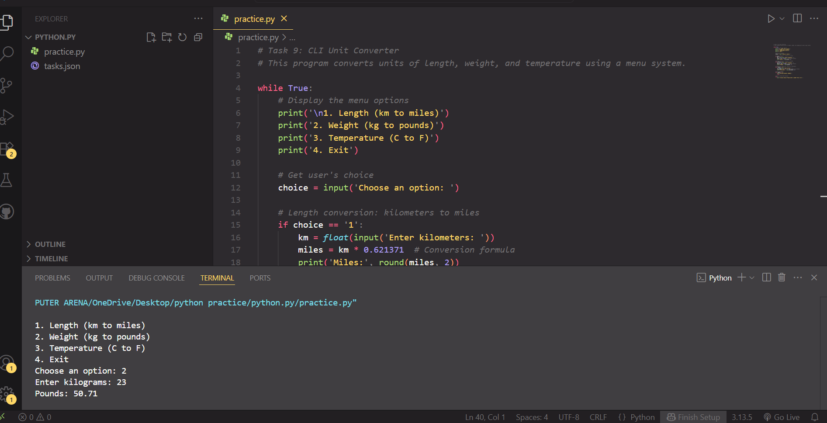

**Learning from the task:**

, I learned the basic structure and syntax of Python, including the importance of proper indentation. I understood how to use the print() function to display messages and how to create and work with variables of different data types like integers, floats, and strings. I also learned how to use loops (for and while) to repeat actions, and how conditional statements (if, elif, else) help in making decisions within a program. Through these tasks, I practiced taking user input using input() and converting it to the required type when needed. Additionally, I realized the value of adding comments for clarity and the process of debugging to fix errors in the code. Overall, these exercises helped me develop logical thinking and a better understanding of how Python works.