**Report for internship task 1:**

**Name: Saad bin haroon**

**Internship iD: TN/IN02/PY/026:**

**GitHub link:** [**https://github.com/Saad-Bin-Haroon/internship-task-1**](https://github.com/Saad-Bin-Haroon/internship-task-1)

Task Objective:

The objective of this task is for how to upload files on git hub and make a new repository:

**What I Did (Step by Step):**

1. I created a new GitHub repository and named it internship-task-1.
2. I completed the Python tasks given in the slides (such as print statements, loops, variables, etc.).
3. I uploaded all my Python script files to the GitHub repository.
4. I wrote this report explaining the work done and included code snippets and screenshots.
5. I saved the report as a PDF and uploaded it to the same repository.

**Code Snippets:**

print("Hello, my name is Saad Bin Haroon!")

*# Swap two variables without using a third variable*

a = 5

b = 10

*# Swapping*

a, b = b, a

print('a:', a, 'b:', b)

*Average of 3 numbers*

a = *float*(input('Enter first number: '))

b = *float*(input('Enter second number: '))

c = *float*(input('Enter third number: '))

avg = (a + b + c) / 3

print('Average:', avg)

**screenshots:**

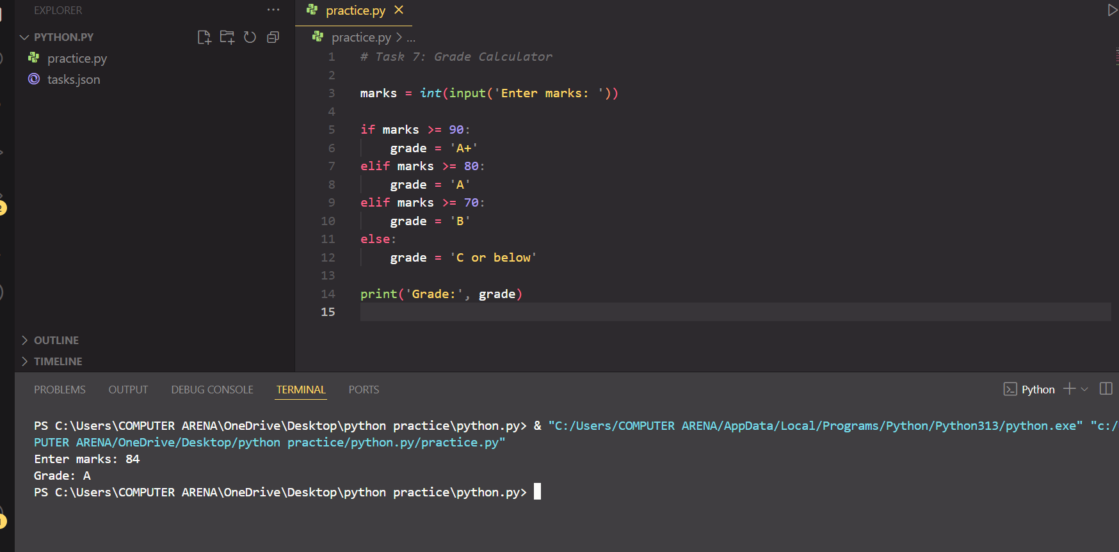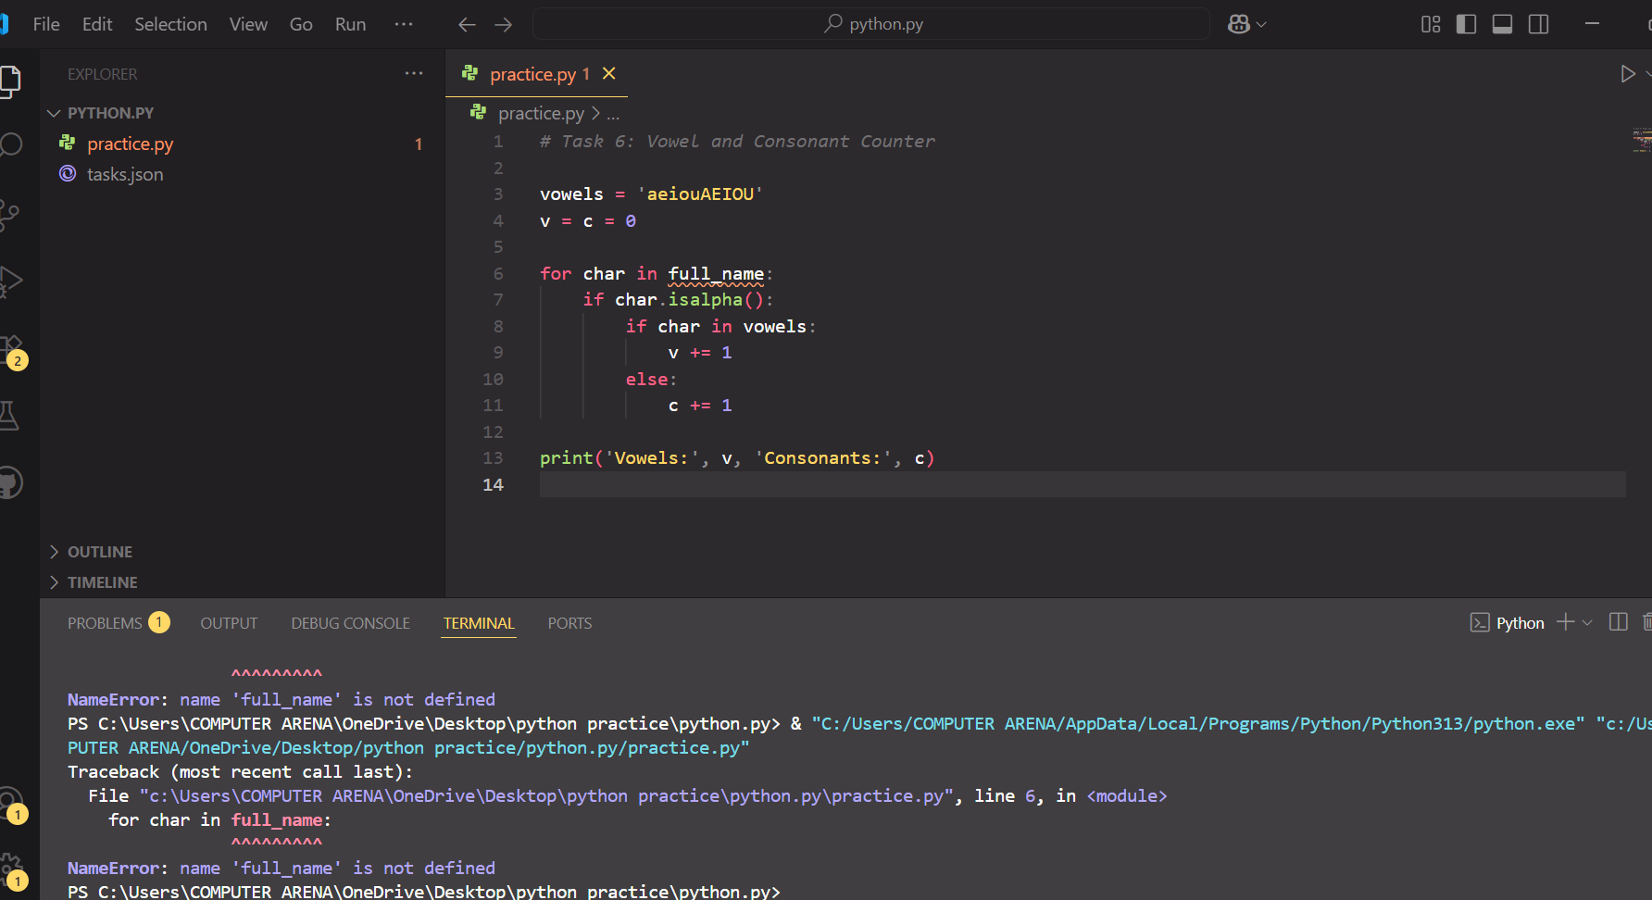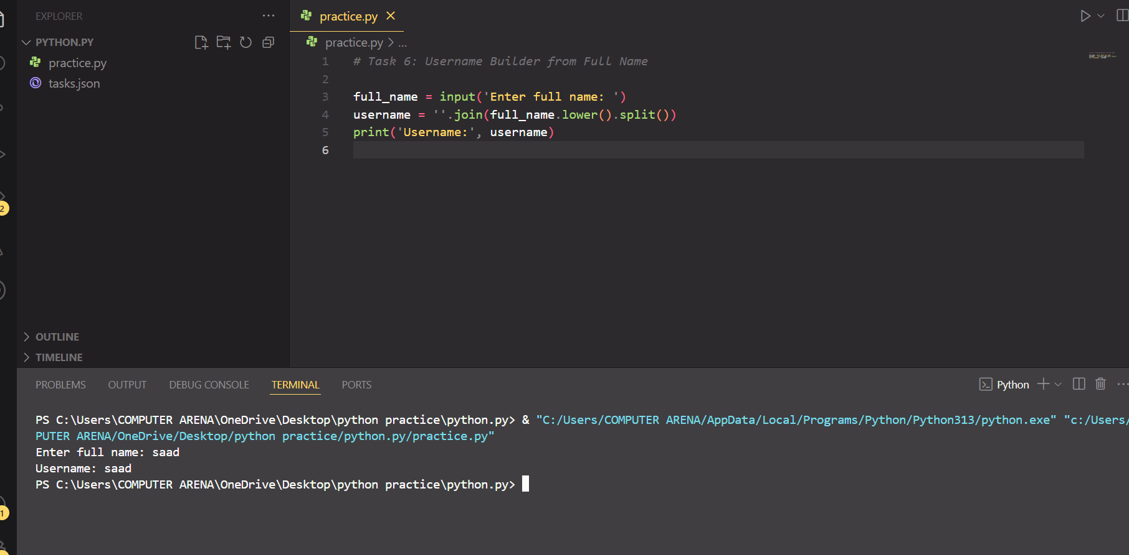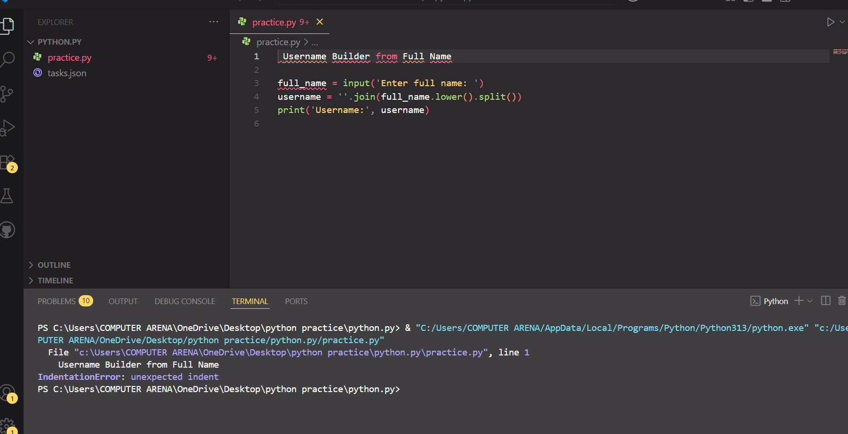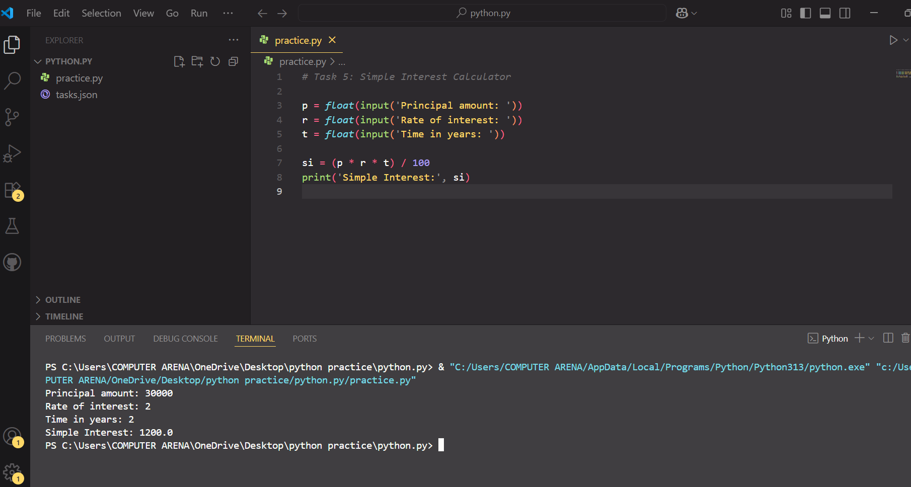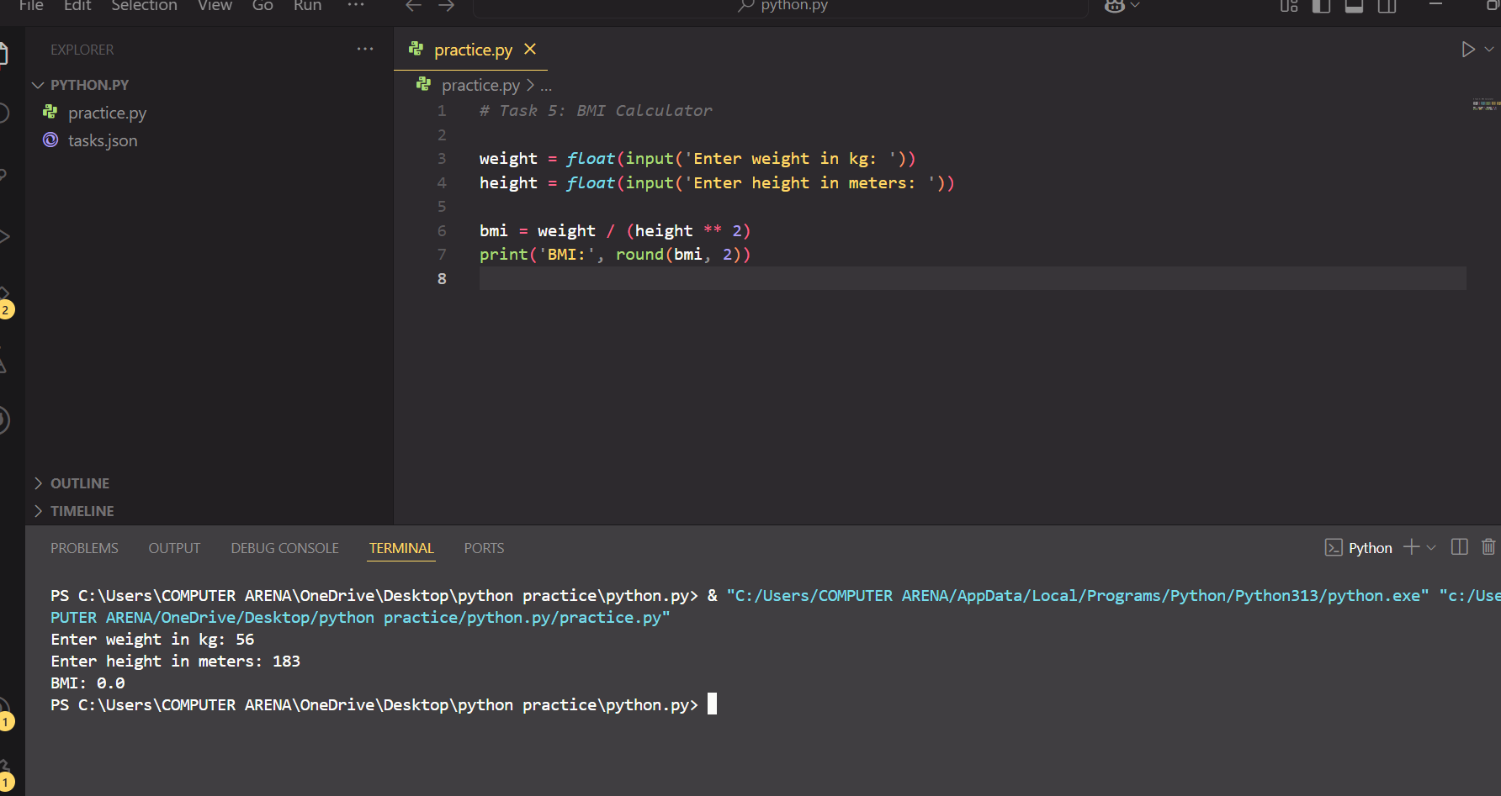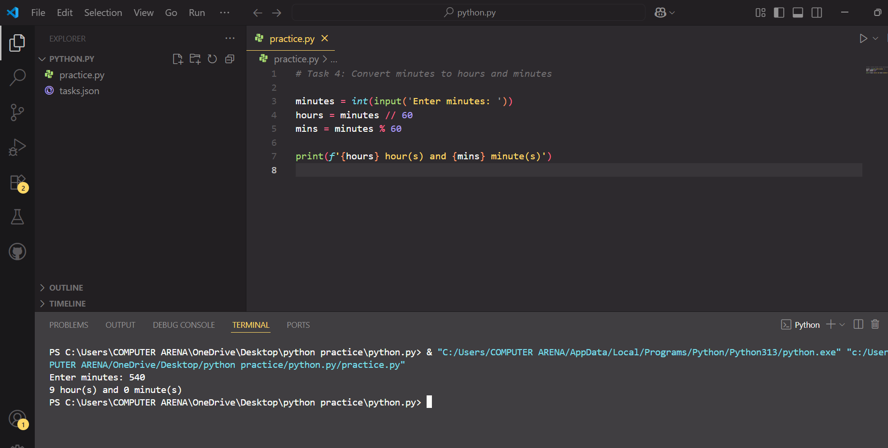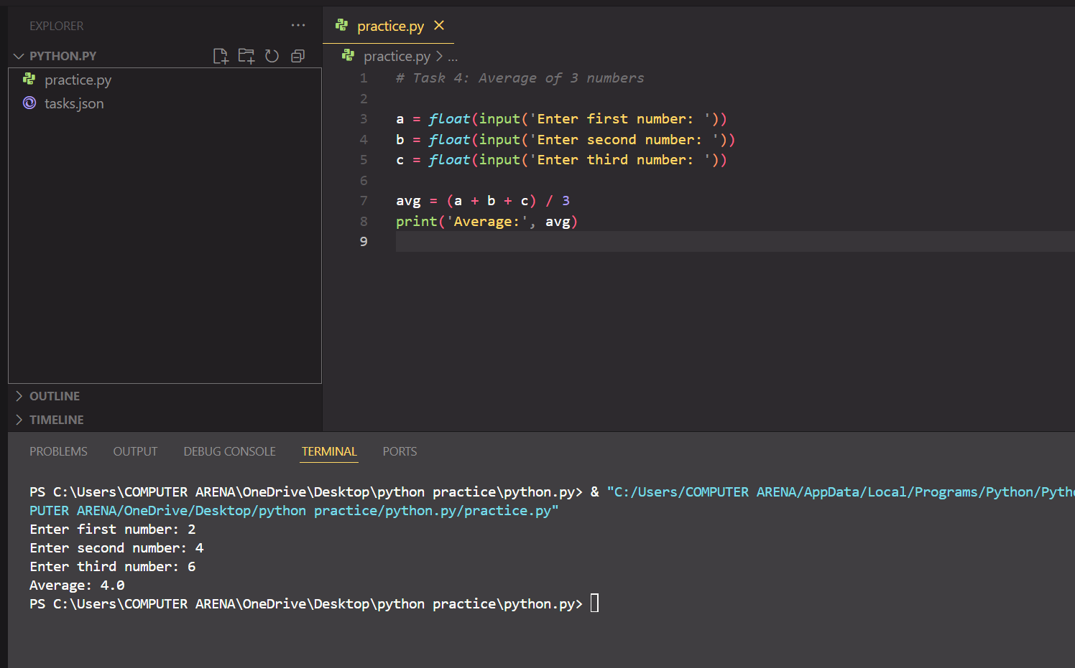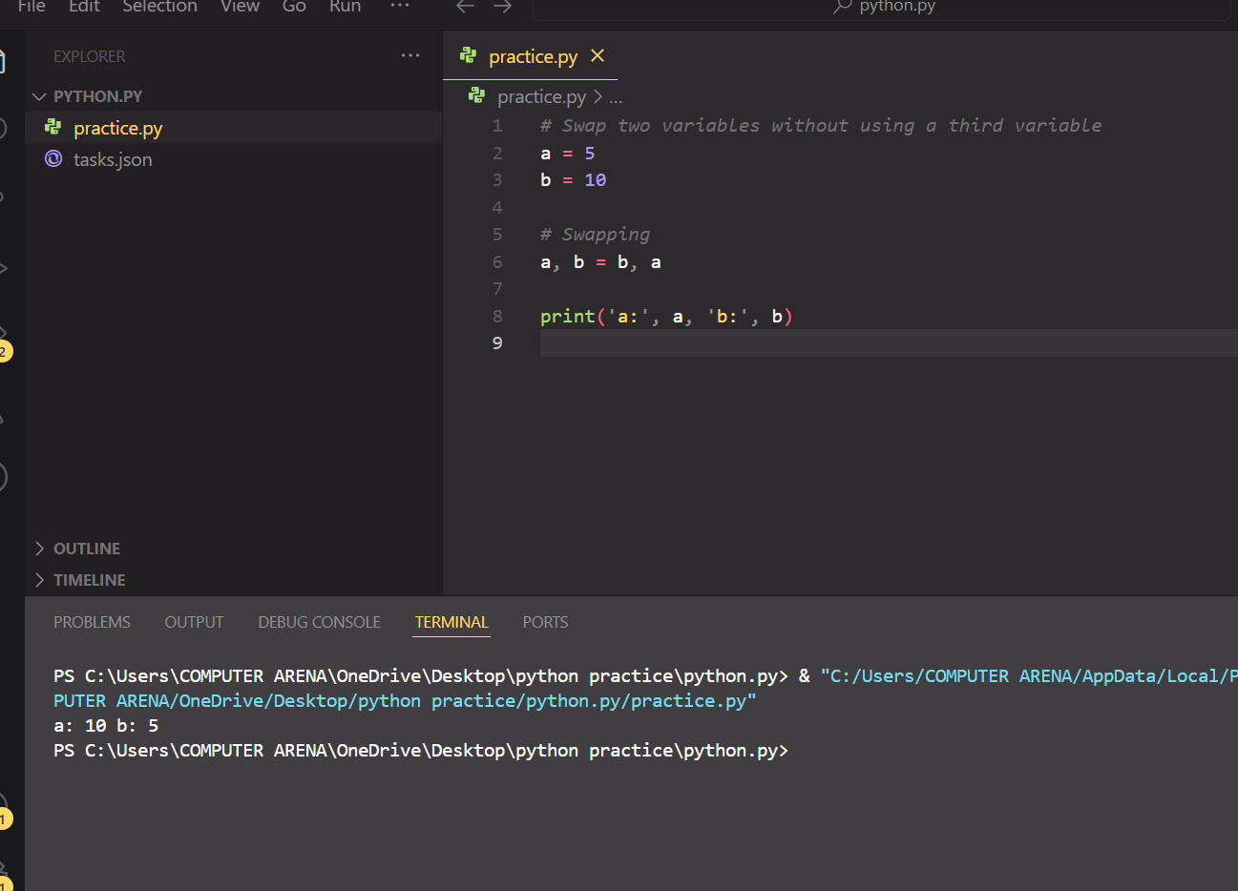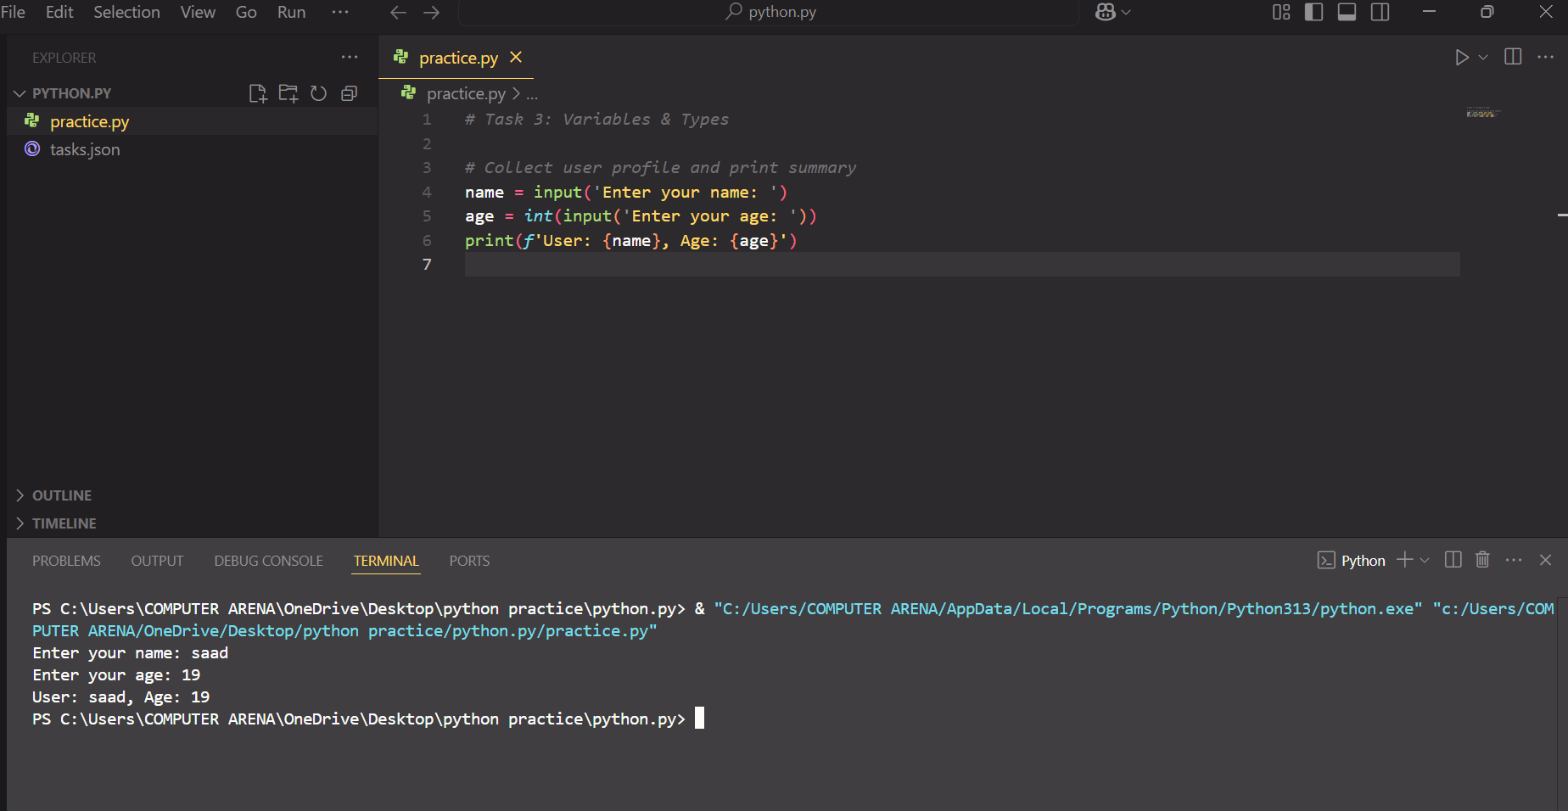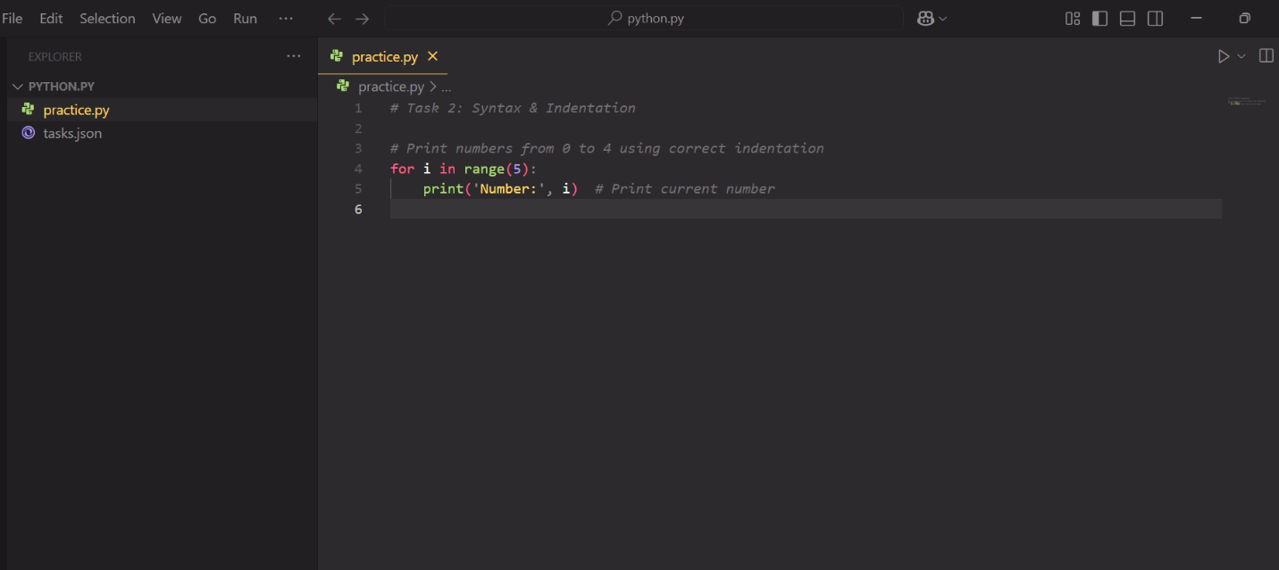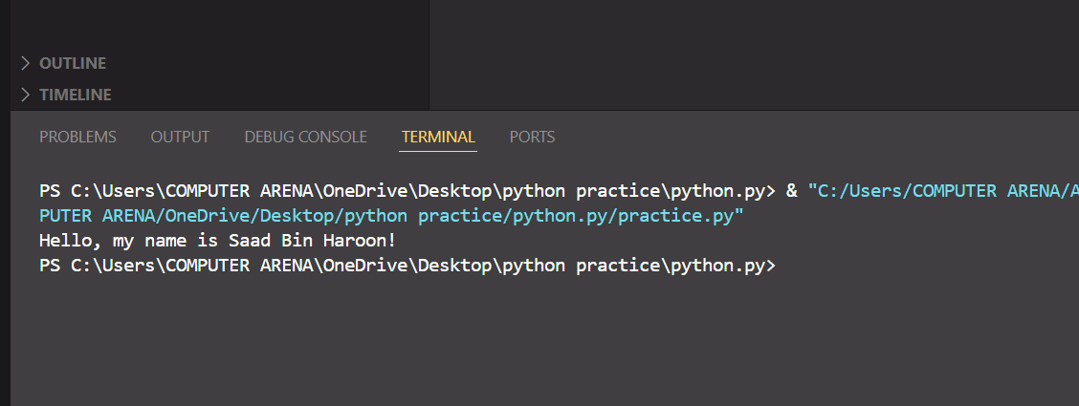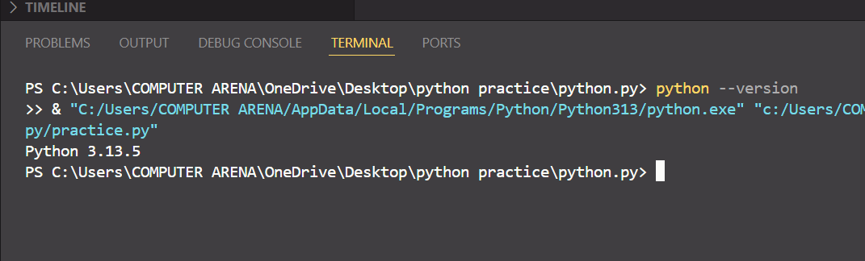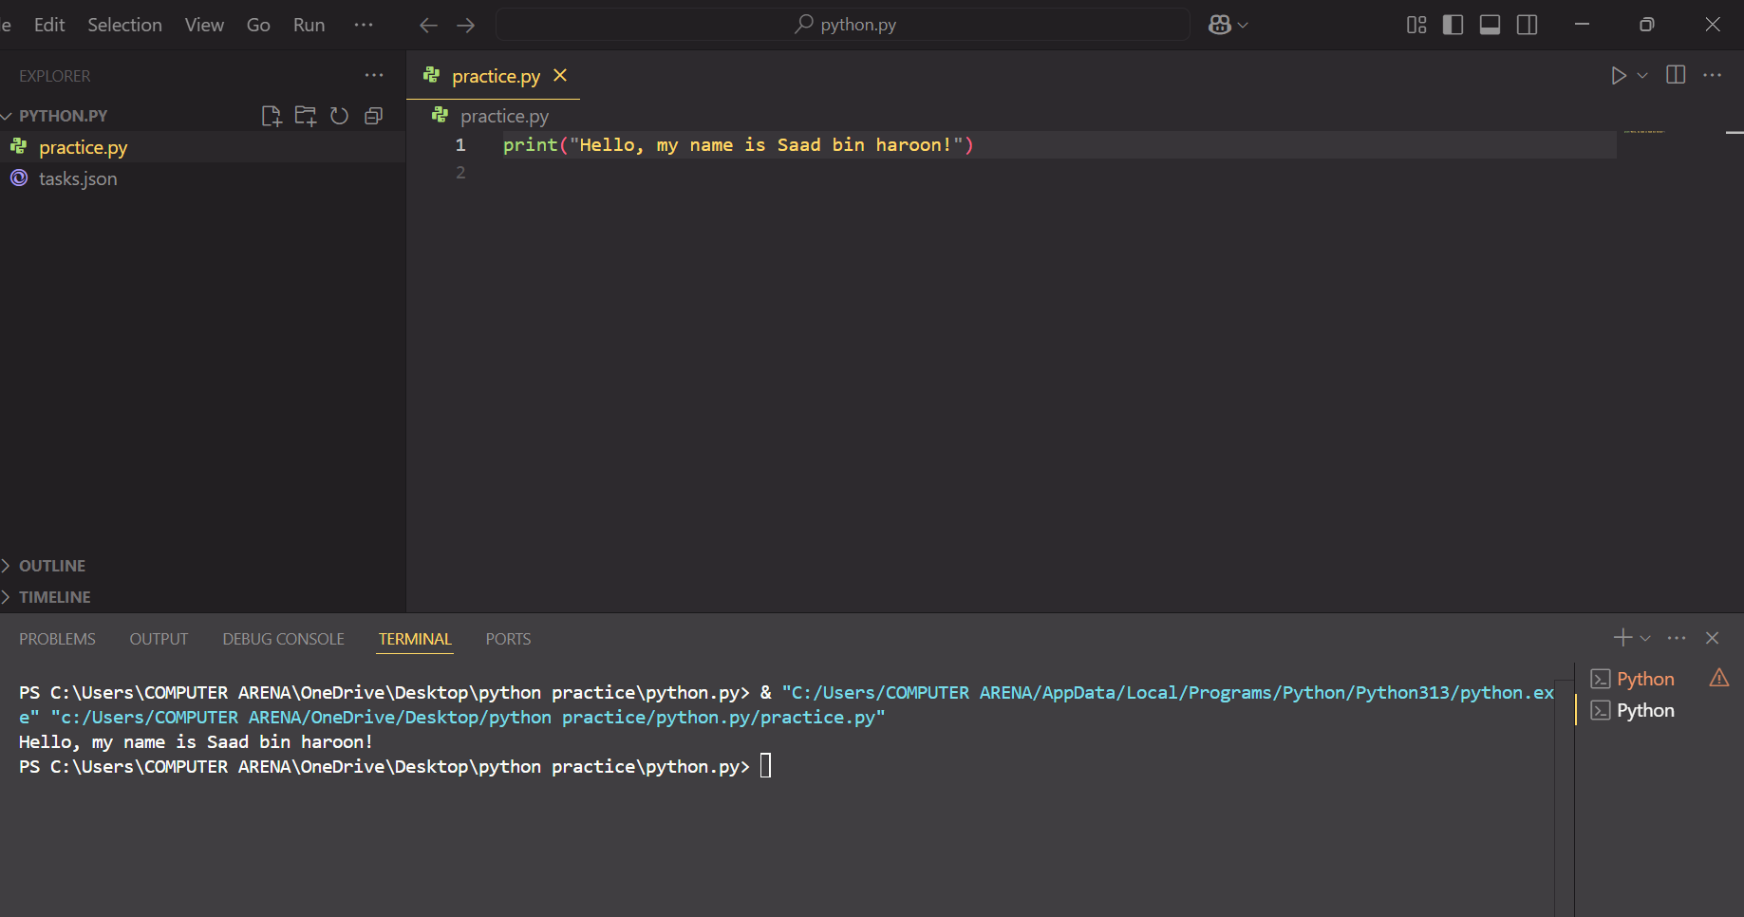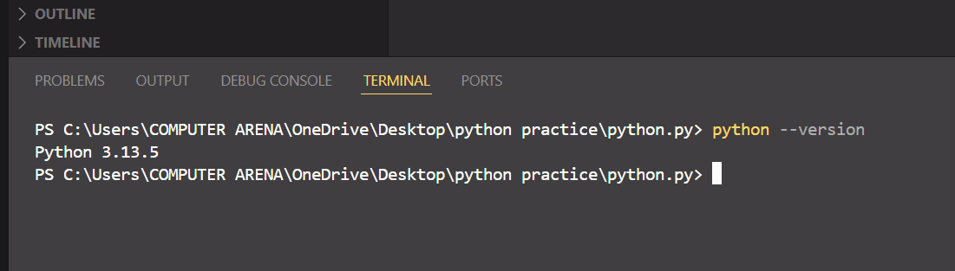

**Learning:**

* I learned how to create and use a GitHub repository.
* I practiced basic Python concepts such as print statements, loops, variables, and indentation.
* I learned how to upload files to GitHub and manage commits.
* I understood how to document my work and create a proper project report.

**Challenges:**

* It was my first time using GitHub, so I was a bit confused at the beginning.
* I faced some indentation errors while writing Python code.
* It took me time to understand how to structure the report correctly.
* Uploading screenshots and converting the report to PDF was a bit tricky at first.

**✅ End of Report:**