# Project Report:

Bahria University

Islamabad h11 campus

# Department of Software Engineering

**Group Members:**

M. Saad (01-131222-023)

Saad Ilyas (01-131222-041)

Talha bin Tahir (01-131222-047)

**Class:** BSE-1

**Subject:** Sir M. Raja Suleman and Sir M. Waleed Khan

# REPORT

**Introduction:**

We have developed a console-based twitter named as “Social Light”; where we strive to provide a seamless and secure user experience. To ensure the integrity of our system, we have implemented a variety of validity checks. Furthermore, our app checks for spaces in the username to ensure that it is formatted correctly. We have implemented a password length check to ensure that the passwords are of sufficient length, and will notify users if their passwords do not meet the required criteria.

Moreover, it gives different options to the user like for writing multiple tweets, to view tweets from the users they are following, to follow other users or to sign out of the Social Light. And for each different option available, the program creates a separate file.

**Tools Used:**

* Visual studio

**Features:**

The main features of our application are:

• Validity Checks

• A single user cannot signup twice.

• App checks for spaces in username.

• It keeps a check on password Length.

• If the password length is not enough. It warns the user about it.

• It asks from user for multiple options.

• User can enter multiple tweets.

• User can follow another user.

• User can view tweets.

• User can continue this process infinitely.

• All the data stores in different files safely.

• User cannot follow himself.

• User can also sign out of it.

**Concept:**

The concepts used in this project are:

• Loops

• Conditional statements

• Functions

• File handling

**Flowchart:**

START

Display welcome message

Prompt user for choice of signing up or logging in

Signup

Username

Password

login

Check username in the file

Username and Password

If username exists

If username doesn’t exist

Open user.txt

This username Exists

Signup successful. Login again.

B

A

Go back to promote username

Read file line by line

B

Check if entered username and password is equal to any stored data

A

If it is not present

Display error message

If data present

Login successful

[1] to enter tweets.

[2] to follow others.

[3] to view tweets.

[4] to sign out.

If choice==4

If choice==1

Sign out

Enter your Tweets

Thanks For using

If No

If Yes

Want to add more

(Y/N)

D

C

E

E

If username doesn’t exist

If username exist

If NO

D

END

Username doesn’t exsist

Write in file

Username exist

If yes

Check username from file

If choice==2

Do you want to follow someone (Y/N)

Enter the name of user you want to follow

If choice==3

E

E

Un followed user tweets

Followed user tweets

read from file

View Tweets

C

**Report:**

This project is a copy of Twitter that performs some functionality like that of actual Twitter. The name of our console-based application is Social Light. We named it Social Light because on it anyone can share his opinion without any Hurdle and hesitation and somehow this application is social in which different users follow each other and view tweets of each other.

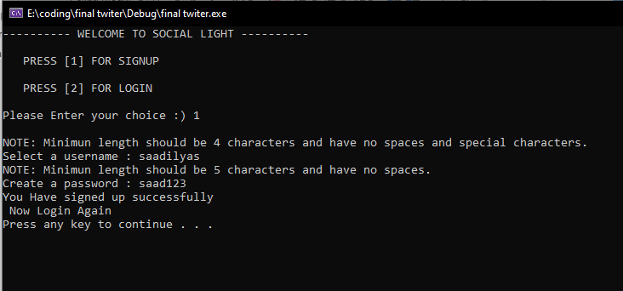

This is the first view application is that it welcomes the user in application and give option of signup and login. If the user doesn’t have account, user will sign up by pressing 1 and then input of username and password will be done and message of success will be shown. After this user has to login again. username already exist user has to sign up again and some features are given. After logging in user get option of Entering tweet , follow others, view tweets and sign out.

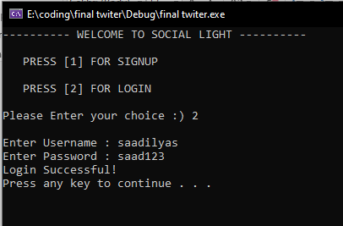

And when user will login by providing correct username and password, the message of login successful will be shown. It will take the current user to main menu where user has option to enter tweets, follow others, view tweets and sign out.

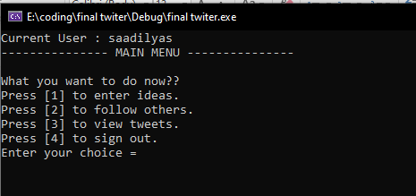

If user press 1 to Enter ideas , A box of IDEA EXPRESS will be open and it will allow user to write ideas and tweets, by pressing yes user can write tweet every time and by pressing n it will come back to main menu page for other option. 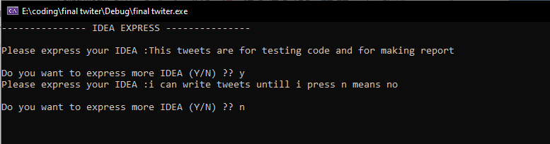

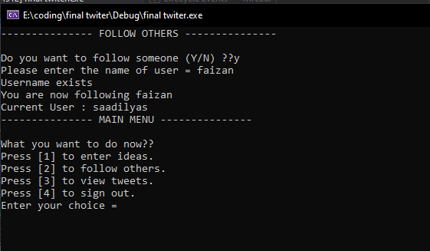

When user press 2 to follow the users the screen clears and a new screen appears which ask user to follow someone and after pressing y user has to give name of user he wants to follow and if user press n it will again come to main menu.

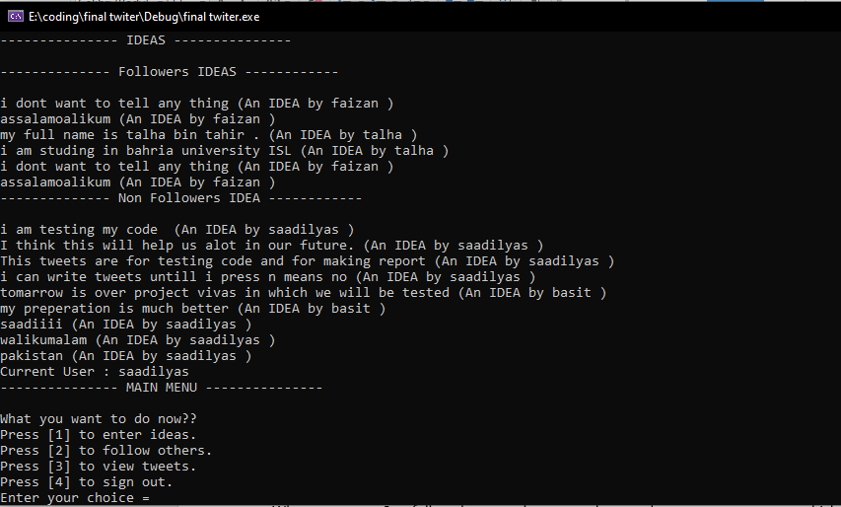

To view tweets user has to press 3, and after pressing 3 the screen of ideas and followers ideas will be open in which user will see the tweets and ideas of followers first and then ideas of non-followers.

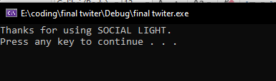

At last, to exit this program and console

User will press 4 and screen will open with the message of **Thankyou.**

…………………………………………………………………………………………………………………………