Draw the Path: Portfolio Sitemap + Toolkit
Week 1 · General AI Fluency · Saad Imran

Proof statement (from "What Are You Proving?")
I build RAG systems that answer strictly from your own documents and refuse to invent anything — when the evidence isn't there, they say so instead of hallucinating. I proved it with DecisAI, a bid-response assistant that reads 500-page tenders and drafts a response only when the evidence backs it up. I'm proving this to a founder or operations lead at a document-heavy company, so they'll email me to set up a call.

Toolkit (all free accounts created)
Claude ✓ · ChatGPT ✓ · Gemini ✓ · Perplexity ✓ — main build partner: Claude.

AI workspace (Claude Project)
Project "Portfolio Build — Grounded RAG (DecisAI)" created with genuine custom instructions in the Instructions field: my proof statement pasted in, plus a request to act as a tutor that explains its reasoning. It follows the build for all 10 weeks. (Screenshot attached separately.)

Sitemap v1 (initial sketch)
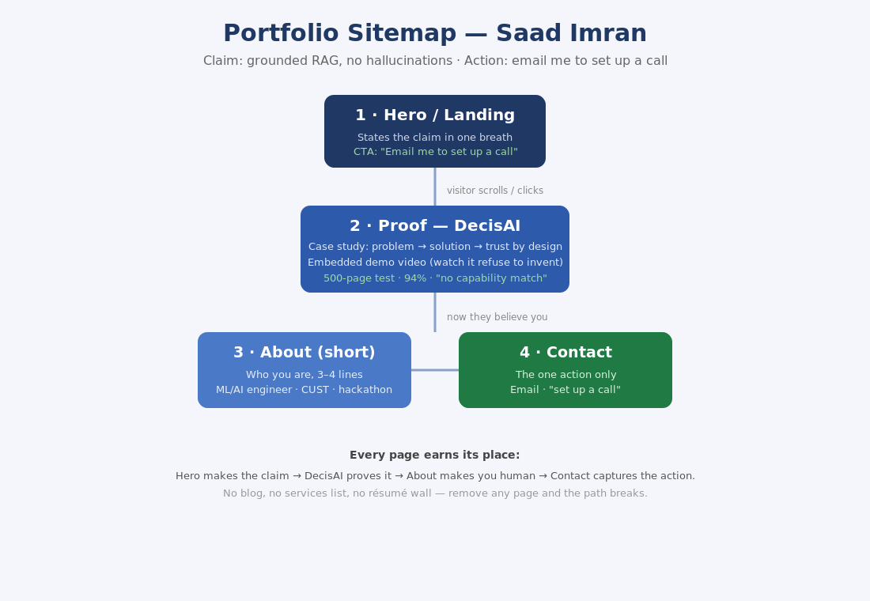

Pressure-test — prompt I ran
Pressure-test this sitemap against my one claim (grounded RAG, no hallucinations) and my one action (email me to set up a call). Which pages earn their place, which are wasted, and what's missing? Be specific and critical, not encouraging. End with the single most important change you'd make.

Pressure-test — key findings
- Hero: right structure, wrong framing — it leads with the mechanism ("no hallucinations") instead of the buyer's real fear (the assistant confidently telling a client something false).
- Proof (DecisAI): the only page that fully earns its place, but it leads with the wrong number — accuracy (94%) is a commodity; the real differentiator is the refusal ("no evidence, no draft").
- About: doesn't earn a standalone page — it adds a step between proof and action; fold it into two lines under the hero.
- Contact: wasted as a page if it just shows an email; only earns its place as a friction-reducer (pre-filled mailto / one-click calendar link).
- Missing (load-bearing): a "how it stays grounded" explanation, a data-privacy answer ("where do my documents go?"), and a direct handler for "will it embarrass me in front of a client?"

The one change I'm making
Stop leading with accuracy; lead with the refusal. The hero and the demo's first ten seconds become the moment DecisAI declines to answer — "no evidence, no draft." That behavior, not the 94% stat, is the only thing on the site a competitor can't copy, and it's what earns the email. I also fold About into the hero, upgrade Contact to a low-friction call link, and add a grounding + data-privacy beat to the proof page.

Sitemap v2 (revised after the pressure-test)
