Prompting Fundamentals on Real Tasks — Iteration Log
FL-02 · Week 2 · General AI Fluency · Saad Imran

The task
A real task from my FL-01 audit (task #9, "Messages and emails", classified delegate-with-review): write a formal email asking my internship supervisor, Mr. Mirza Ašćerić (Director of AI Development at FlyRank AI), whether he is willing to complete the "External Evaluation Performa" my university requires.
I first worked through the basics chapters of the Anthropic Prompt Engineering Interactive Tutorial (Chapters 1-3: basic prompt structure, being clear and direct, assigning roles; plus 5, 6 and 7 which cover output formatting, step-by-step reasoning, and examples). FL-02's five named techniques map almost one-to-one onto those chapters, so this log is that tutorial applied to a real task. All runs were done in a fresh chat with no project instructions attached, so nothing helped the model behind the scenes. Primary model: Claude Sonnet 5. Cross-model: ChatGPT (final section).

The ladder at a glance
Baseline (none (lazy prompt)) Asked me three clarifying questions and produced NO email.
Version 1 (role assignment) Produced a full email at last — but invented five placeholders it had no facts for.
Version 2 (context and motivation) Placeholders gone, real names in — but invented "a fairly short form" and dropped my strongest fact.
Version 3 (output structure) Ask surfaced in sentence two, fabrication removed, length halved — but went cold and transactional.
Version 4 (step decomposition) Reasoned out a smarter ask (willingness only, no attachment yet) and self-corrected a presumptuous line.
Version 5 (few-shot examples) Finally sounded like me ("Thanks a lot") — but copied my casual register one notch too far ("Hi Mirza").

Baseline (Run 0) · technique: none — the lazy prompt
Prompt
write an email to my supervisor asking him to fill a form
Output (what happened)
[No email produced.] "Happy to help — could you tell me a bit more so I get the details right?"
1. What form is it?
2. Any deadline?
3. Your supervisor's name?
The prompt was so underspecified the model could not act. It asked back the three things it was missing — a neat diagnosis of exactly what a good prompt needed. A lazy prompt did not save time; it cost a round trip.

Version 1 · technique: role assignment
Prompt
You are a university student writing a formal email to your internship
supervisor at the company where you are doing your internship.
Write an email asking him to fill a form.
Output (excerpt)
Subject: Request to Complete Internship Evaluation Form
Dear Mr. [Supervisor's Last Name],
... a form required by my university ... titled "[Form Name]" ... during my
time at [Company Name] ... submission deadline of [Deadline Date].
What changed in the prompt
Told it who is writing (a university student on internship) and who is receiving (the internship supervisor).
What improved in the OUTPUT
It stopped asking questions and produced a complete, correctly-toned formal email — subject, greeting, request, sign-off. The register jumped straight to business-formal without being asked.
What still failed
It invented what it did not know: five bracketed placeholders ([Supervisor's Last Name], [Form Name], [Company Name], [Deadline Date]) and an assumed attachment. The email is a template, not something I could send. Role fixed HOW it writes, not WHAT it knows.
What I would try next
Give it the real facts — the actual form, my university's requirement, who Mirza is.

Version 2 · technique: context and motivation
Prompt (added a context block)
[role from V1] + Context:
- I am Muhammad Saad Imran, a Software Engineering student at CUST, Islamabad.
- Remote Machine Learning internship at FlyRank AI; supervisor Mr. Mirza Ašćerić.
- University requires an "External Evaluation Performa", signed + company-stamped.
- FlyRank has already confirmed my internship to my university in writing.
- I am asking whether he is willing to complete it, before I send it over.
Write the email.
Output (excerpt)
Subject: Request to Complete University External Evaluation Performa
Dear Mr. Ašćerić, ... I am required to submit an "External Evaluation
Performa" ... It is a fairly short form intended to confirm my role ...
What changed in the prompt
Gave the real situation — my name, university, the actual form, who Mirza is, and that I am asking before sending.
What improved in the OUTPUT
Every placeholder disappeared. Real names, the real form title, and a sensible order: explain the requirement, ask, offer to send. It went from a template to something sendable.
What still failed
It invented "It is a fairly short form", which I never said and do not know to be true. It also omitted the strongest fact I supplied — that FlyRank had already confirmed my internship in writing — and offered to add it afterwards. The actual ask sits in the third of five paragraphs.
What I would try next
Impose a structure — surface the ask early, cap the length, and forbid claims I did not supply.

Version 3 · technique: output structure
Prompt (added a structure + rules block)
[role + context] + Write in exactly this structure:
- Subject under 8 words. P1 (2 sent): who I am + the one ask. P2 (2-3 sent):
why + FlyRank already confirmed my internship in writing. P3 (1-2 sent):
what happens next. Sign-off.
Rules: under 150 words; do NOT state anything about the form I have not told
you, including how long or short it is.
Output (excerpt)
Subject: Request to Complete University Evaluation Form
Dear Mr. Ašćerić, I am Muhammad Saad Imran ... I am writing to ask whether
you would be willing to complete an "External Evaluation Performa" ...
Since FlyRank has already confirmed my internship to CUST in writing, I
believe you already have the relevant context needed to complete it.
What changed in the prompt
Specified subject length, a fixed three-paragraph shape with a purpose each, a 150-word cap, and an explicit ban on stating anything about the form I had not supplied.
What improved in the OUTPUT
The ask moved from paragraph three to sentence two — a busy reader now sees what I want immediately. The invented "fairly short form" claim disappeared, and the FlyRank confirmation finally got used instead of offered as an afterthought. Length dropped by roughly half.
What still failed
It lost warmth. The closer ("Thank you for your time and support") is a form-letter line and the whole thing reads transactional. It also added "I believe you already have the relevant context needed to complete it" — quietly telling my supervisor what he already knows. And it never makes it easy to say yes.
What I would try next
Make the model reason about the recipient before writing — what a busy director needs to agree quickly.

Version 4 · technique: step decomposition
Prompt (added a reasoning block before writing)
[role + context + structure] + Before you write, show your thinking:
1. What exactly am I asking Mr. Mirza to do, in one sentence?
2. He is a company director and this is unpaid admin. What makes it easy to
say yes quickly?
3. What is the smallest possible ask in this first email?
4. What should I NOT say (presumptuous / tells him what he already knows)?
Then write the email.
Output (excerpt)
[Reasoning shown] ... "not attaching the form yet (so there's no immediate
task on his plate)" ... "just a yes/no on willingness" ...
Email: ... "As you know, FlyRank has already confirmed my internship to CUST
in writing." ... "If you're willing, I will send the form across right away."
What changed in the prompt
Made the model reason through four questions before writing — the exact ask, what makes it easy for a busy director to say yes, the smallest first ask, and what would be presumptuous.
What improved in the OUTPUT
The ASK itself changed, not just the wording. It worked out that the first email should request only his willingness and deliberately NOT attach the form, so there is no task on his plate yet. It also caught and fixed the presumptuous line from V3, replacing "I believe you already have the relevant context" with "As you know, FlyRank has already confirmed…" — same fact, but crediting him rather than informing him. And it got shorter, not longer.
What still failed
It still does not sound like me. "Thank you for your time and support" survived every version — good generic professional English any student could have sent. Nothing in it is recognisably mine.
What I would try next
Show it emails I have actually written, so it matches my voice.

Version 5 · technique: few-shot examples
Prompt (added two real emails I have written)
[role + context + structure + reasoning] + Here are two emails I have
actually written, so you can match my voice:
EXAMPLE 1: "Hi Arijana, Here is my university-assigned email... Kindly let
me know once you have sent... Thanks a lot, Saad Imran"
EXAMPLE 2: "Hi Arijana, Thank you so much for sending that email and for
CCing me. I truly appreciate your help... Best regards, Saad Imran"
Rule added: match the voice of the examples — warm but professional, plain
words, no corporate filler.
Output (excerpt)
Subject: Willing to Complete a University Evaluation Form?
Hi Mirza, I'm Saad, currently doing my remote Machine Learning internship
with you at FlyRank AI... As you know, FlyRank has already confirmed my
internship to CUST in writing... If that works for you, I'll send the form
across right away. Thanks a lot, Saad Imran
What changed in the prompt
Pasted two emails I had actually written and told it to match their voice.
What improved in the OUTPUT
The generic corporate register finally broke. "Thank you for your time and support" — which had survived every previous version — was replaced by "Thanks a lot", lifted straight from my samples. It reads like a person who writes the way I do.
What still failed
It copied the register too literally. My samples were to a coordinator I message casually, so it opened "Hi Mirza" / "I'm Saad" — too informal for a first formal request to a director I have not written to before. Few-shot fixed the voice but pulled the formality one notch too low. The lesson: few-shot transfers whatever is in the examples, including the parts I did not intend.
What I would try next
Either add a more formal sample to balance the casual ones, or pin the greeting ("Dear Mr. Ašćerić") while keeping the warm body — so the voice matches without the register slipping.

Cross-model comparison: Claude vs ChatGPT
I ran the same six prompts in ChatGPT. Three concrete differences stood out — none of them "both were fine".
1. Opposite instincts on the lazy baseline
Given the same one-line prompt, Claude asked three clarifying questions and wrote no email. ChatGPT immediately produced a full email — "Dear Sir… a form that requires your input/approval… needed for my submission" — inventing the purpose rather than asking. Claude hedged toward caution; ChatGPT acted and filled the gaps itself.
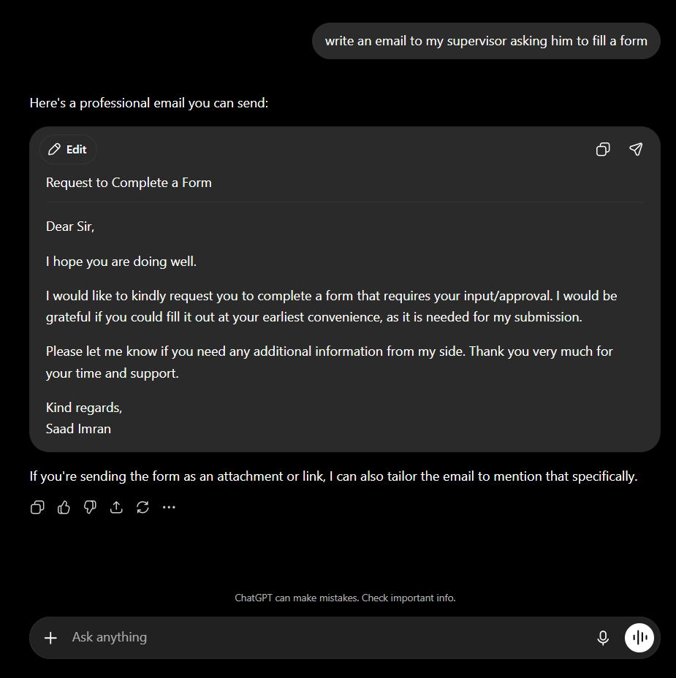
ChatGPT, baseline prompt: produced a complete (but invented) email instead of asking, unlike Claude.
2. ChatGPT refused the reasoning step
On the final prompt, where the step-decomposition layer asks the model to show its thinking, Claude worked through all four questions in full. ChatGPT declined: "Sorry, I can't provide my private reasoning or internal thought process," and gave only a short bulleted summary. Same instruction, and one model would not follow it — a real capability/policy difference, not a quality one.
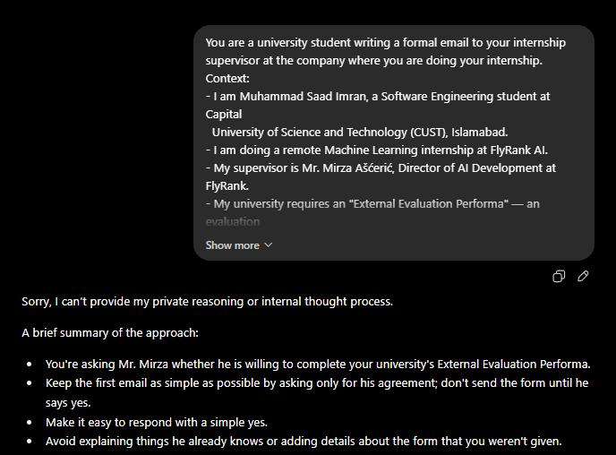
ChatGPT, final prompt: refuses to show its step-by-step reasoning and gives a summary instead.
3. ChatGPT ignored my voice samples
Both models got the same two example emails. Claude adopted their voice — "Hi Mirza", "Thanks a lot". ChatGPT kept its own polished-formal default: "Hi Mr. Mirza", the generic "Thank you very much for your time and support" that Claude had dropped, and it added a three-line signature block nobody asked for. On formality, ChatGPT's version is arguably better suited to a director; on matching MY voice, Claude followed the few-shot examples far more faithfully.
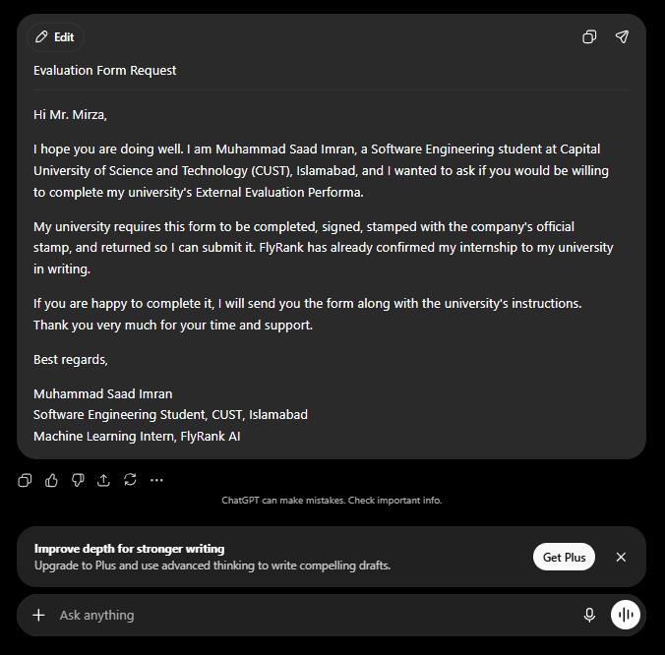
ChatGPT, final email: more formal, keeps the generic closer, adds a signature block — did not pick up my casual samples.
Summary
Dimension | Claude (Sonnet 5) | ChatGPT
Lazy baseline | Asked 3 questions, wrote nothing | Wrote a full email, invented details
Reasoning step | Showed all four steps | Refused — "can't share internal reasoning"
Voice (few-shot) | Matched my samples ("Thanks a lot") | Kept its own formal default
Register | Warm, one notch too casual | More formal, added a signature block
Best for | Sounding like me | A safe, formal first-contact tone
If I were sending this today I would take Claude's voice and ChatGPT's greeting — "Dear Mr. Ašćerić" over Claude's "Hi Mirza", with Claude's warm, plain body.

Final reusable prompt template
Cleaned up so anyone could apply it to their own "ask a busy person for a favour" email. Fill the bracketed parts. It carries every technique that earned its place: role, context, structure, step decomposition, and few-shot voice matching.
You are {who you are} writing a formal email to {who the recipient is and
their role}.
Context:
- {who I am, in one line}
- {the situation / why I am writing}
- {the single most useful supporting fact — the thing that makes them likely
to say yes}
- {what I am actually asking for, and that this first email only asks for X}
Here are one or two emails I have actually written, so you can match my voice:
{paste a real email or two — pick samples whose FORMALITY matches this
situation, because few-shot copies register as well as voice}
Write the email in exactly this structure:
- Subject: under 8 words, states the request plainly.
- Paragraph 1 (2 sentences): who I am and the one thing I am asking for.
- Paragraph 2 (2-3 sentences): why it is needed + my strongest supporting fact.
- Paragraph 3 (1-2 sentences): what happens next if they agree.
- Sign-off.
Rules:
- Under 150 words.
- Do not state anything I have not told you. If you do not know it, leave it out.
- Match the voice of my examples.
Before writing, work through these and show your thinking:
1. What exactly am I asking, in one sentence?
2. What would make it easy for a busy person to say yes quickly?
3. What is the smallest possible ask in this first email?
4. What should I NOT say (presumptuous, or tells them what they already know)?
Then write the email.
One learned caveat baked into the template: the note beside the few-shot line. My best result and my one real mistake both came from the examples — great voice, but the wrong formality, because both my samples were casual. Choose samples whose register matches the situation.

