Summer Internship Report

SE4103: Internship Program
Name: Muhammad Saad Imran
Registration No: BSE233117
Host Organization: FlyRank Corp (FlyRank AI) — Remote
Internship Duration: 8 Weeks (13 July 2026 – 26 August 2026)
Site Supervisor: Ms. Arijana Ibrović, Internship Director
Submitted to: Mr. Temour Abbas
Summer 2026: Department of Software Engineering

ACKNOWLEDGEMENT
I would like to express my sincere gratitude to my site supervisor, Ms. Arijana Ibrović, Director of the Internship Program at FlyRank AI, for giving me access to real company data and for holding my work to a professional standard from the first week to the last.
I am equally grateful to Mr. Mirza Asceric, my machine learning track mentor, whose sessions and reviews shaped how I framed the problem, and whose insistence on evidence over enthusiasm is the habit I am taking away from this internship.
I thank my faculty supervisor, Mr. Temour Abbas, for his guidance throughout the programme and for reviewing my fortnightly progress reports.
Finally, I thank Mr. Alen Malkoc, Chief Executive Officer of FlyRank AI, for building an internship programme that gives students access to a live production warehouse and a real business problem rather than a training exercise. Working against data the company actually depends on is what made every result in this report worth checking twice.
This internship taught me more than a set of tools. It taught me to check my own claims before someone else does — and, on one occasion, to publish the correction when the numbers did not support what I had already written.
Muhammad Saad Imran
BSE233117

Contents
Introduction 4
Daily Assignment Tasks 5
Week 1 5
Week 2 7
Week 3 8
Week 4 10
Week 5 12
Week 6 14
Week 7 16
Week 8 19
Conclusion 21
References 22

Introduction
This report covers my eight-week remote internship with FlyRank Corp (FlyRank AI) as a Machine Learning Intern, from 13 July 2026 to 26 August 2026. FlyRank is a content and search-performance company: it publishes content into client websites and then has to decide which of those pages are worth an editor's time. Today that decision is made with hand-written threshold rules. Those rules work, but they run out where the signals get tangled, and no trained model had replaced them. That gap became my project.
The internship ran on two tracks in parallel. The Machine Learning track was the technical one and ended in a research paper. The AI Fluency track covered working with AI tools professionally, and produced a live portfolio website. I completed 32 assignments across both tracks, logged 279 hours, and finished the Machine Learning track at 10 out of 10 with the capstone accepted.
My research question was: which visible pages under-capture clicks compared with similar pages, and should an editor review them first? I worked on a real warehouse of 9.84 million page-day rows of Google Search Console data. The result was a trained model that scores precision@50 of 0.784 against a frozen rule's 0.492, on the same rows, the same folds and the same metric.
The most useful thing I learned, however, was not the model. In Week 6 I audited a claim I had been making for weeks and found that 57% of the improvement I was reporting came from the test getting easier, not from my model getting better. I corrected it in the notebook, on the live website and in the paper. That correction is recorded honestly in this report because it is the part of the work I am most confident about.
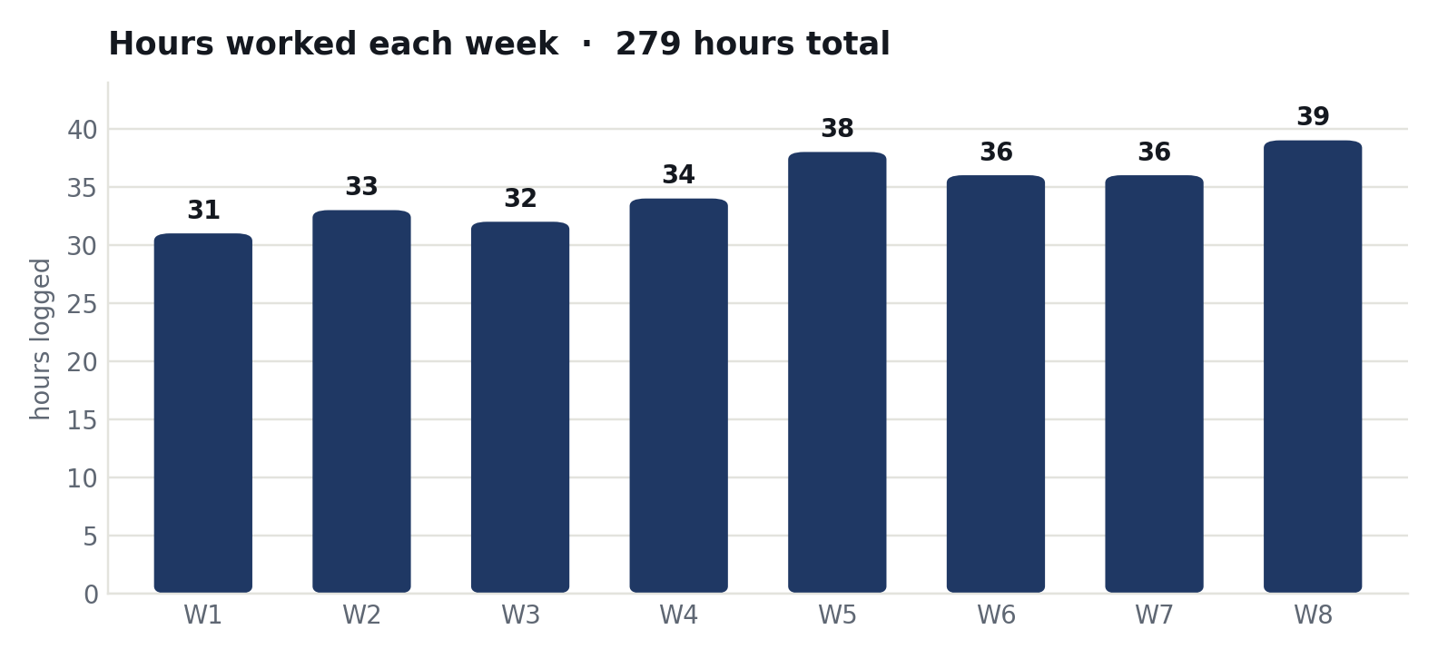
Figure 1 — Hours logged in each week of the internship (279 hours in total).
Report structure: the next section records the work day by day for each of the eight weeks, followed by a conclusion and references. All notebooks, figures and deliverables named here are public in the internship repository listed in the References.

Daily Assignment Tasks
The following section records the work carried out on each working day of the internship. The internship was remote and self-paced, so some weeks include weekend days on which work was actually done. The week periods match the fortnightly report forms already submitted to the university.

Week 1
13 July 2026 – 19 July 2026
13 July, 2026
Monday
On the first day I completed my joining setup for the FlyRank internship portal and started the first assignment, FL-01 Workflow Audit and Tool Setup. I listed the tasks I do every week, marked which of them were repetitive, and picked the one worth automating: my weekly progress report.
I also built a Claude Project as my working environment for the whole internship, so that my notes, my writing style and my project context stayed in one place instead of being re-explained in every conversation.
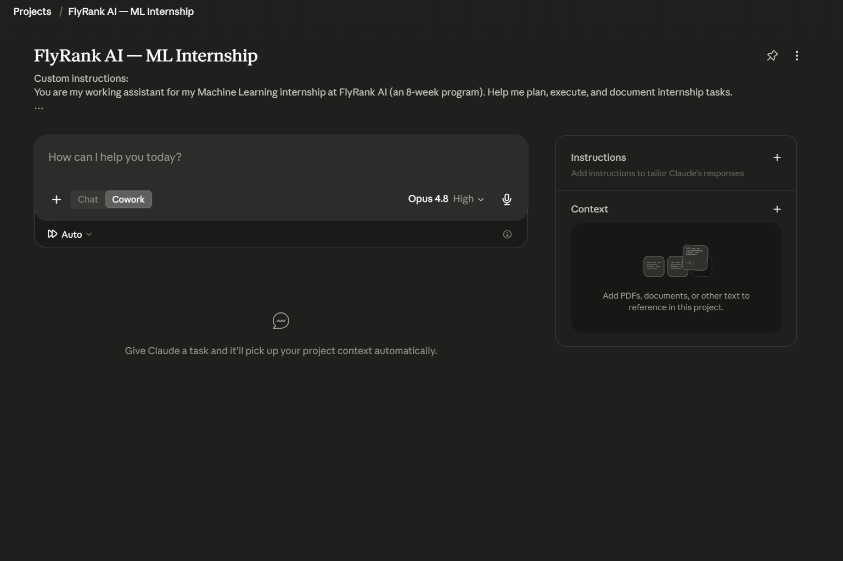
Figure 2 — The Claude Project set up on day one and used for the full eight weeks.
14 July, 2026
Tuesday
I completed the Anthropic Academy course AI Fluency: Framework and Foundations and received the certificate. The course gave me a vocabulary for working with AI tools that I used for the rest of the internship: delegation, description, discernment and diligence.
The part I applied most was discernment — checking the output rather than accepting it. That idea came back in almost every week that followed.
15 July, 2026
Wednesday
I completed the assignment What Are You Proving. The task was to write a single proof statement: one sentence saying what my work demonstrates, and then defend it in a mock interview.
My first version was a list of technologies. It did not survive the questions, because a list of tools does not prove anything about judgement. The version I kept was about building AI systems that answer only from real evidence and refuse when the evidence is missing.
16 July, 2026
Thursday
On the machine learning track I ran the starter notebooks (ML-01) and then chose my research lane (ML-02). I selected Lane 4: CTR and engagement opportunity scoring.
The question I settled on was: which visible pages under-capture clicks compared with similar pages, and should an editor review them first? I chose it because FlyRank already solves this with hand-written rules, so a real baseline existed to beat.
17 July, 2026
Friday
I finished Draw the Path, which asked for a sitemap of my portfolio website and the toolkit behind it. I drew version 1, then pressure-tested it against a real buyer's objections and drew version 2.
The change that mattered: version 1 led with accuracy statistics, version 2 leads with the refusal behaviour, because that is the thing a client is actually afraid of. I also submitted my first weekly progress report to my university supervisor.
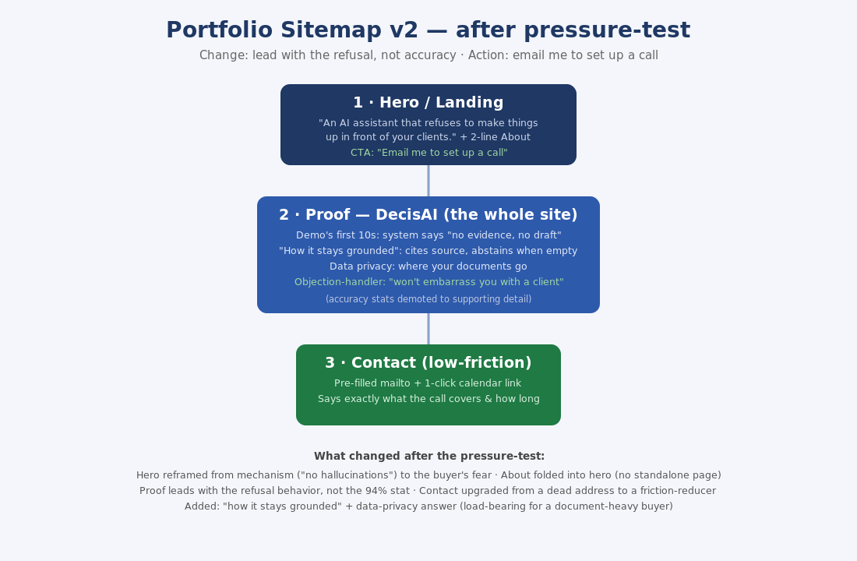
Figure 3 — Portfolio sitemap version 2, after the pressure-test. The changes made are listed underneath the diagram.

Week 2
20 July 2026 – 26 July 2026
20 July, 2026
Monday
I completed ML-03, framing my lane as a proper machine learning task. I defined it as a ranking and scoring problem: score every page, sort them, and hand the editor the top of the list.
I also measured how good the existing approach is, and the answer was humbling for the rules: the position-tier rule beats a flat guess by only 5.6%, and its top 100 pages all tie at exactly one score, so there is no way to order them.
21 July, 2026
Tuesday
I completed Frame It as Cases: a voice card describing how I write, and two three-beat case studies of real work — one on DecisAI, a university project, and one on this internship.
The rule for the exercise was that every case had to use a real before and after, with no invented numbers. Writing them showed me which parts of my own work I could not yet evidence.
22 July, 2026
Wednesday
I completed The Prompt Ladder, improving one weak prompt across five versions and recording what changed at each step.
The honest finding is recorded in my submission: version 1 made the output worse, not better. It produced an answer that was confidently wrong. Keeping that in the log was the point of the exercise.
23 July, 2026
Thursday
I completed FL-02 Prompt Fundamentals: a six-version prompt ladder on a real work email, a side-by-side comparison of Claude and ChatGPT on the same task, and a reusable prompt template built from what worked.
The comparison mattered because the two models failed differently, and knowing how a tool fails is more useful than knowing that it works.
24 July, 2026
Friday
I attended the Week 2 machine learning session, Introduction to ML Systems, delivered by Mr. Mirza Asceric, and made notes on how a model fits into a system rather than sitting on its own.
I then wrote and submitted my Week 2 progress report to my university supervisor. Four assignments were completed this week.

Week 3
27 July 2026 – 2 August 2026
27 July, 2026
Monday
I started ML-04, the data contract, on the real FlyRank warehouse rather than a practice file. I fixed what one row means — one row is one page — and proved it, finding zero duplicate rows.
My working slice came to 176,738 pages. I also learned that an empty value is not the same as a zero: only 3.61 million of the 9.84 million page-day rows actually have Search Console data, so I filtered on the availability flag instead of assuming.
28 July, 2026
Tuesday
I finished the data contract by choosing five honest features and then deliberately testing the leakage trap on real data.
The result is the clearest lesson of the week. With five honest features the model scores R² = 0.037. Add the click count — which is the numerator of the very thing I am predicting — and R² jumps to 0.874. It looks perfect and it has learned nothing. I removed it and kept the honest 0.037.
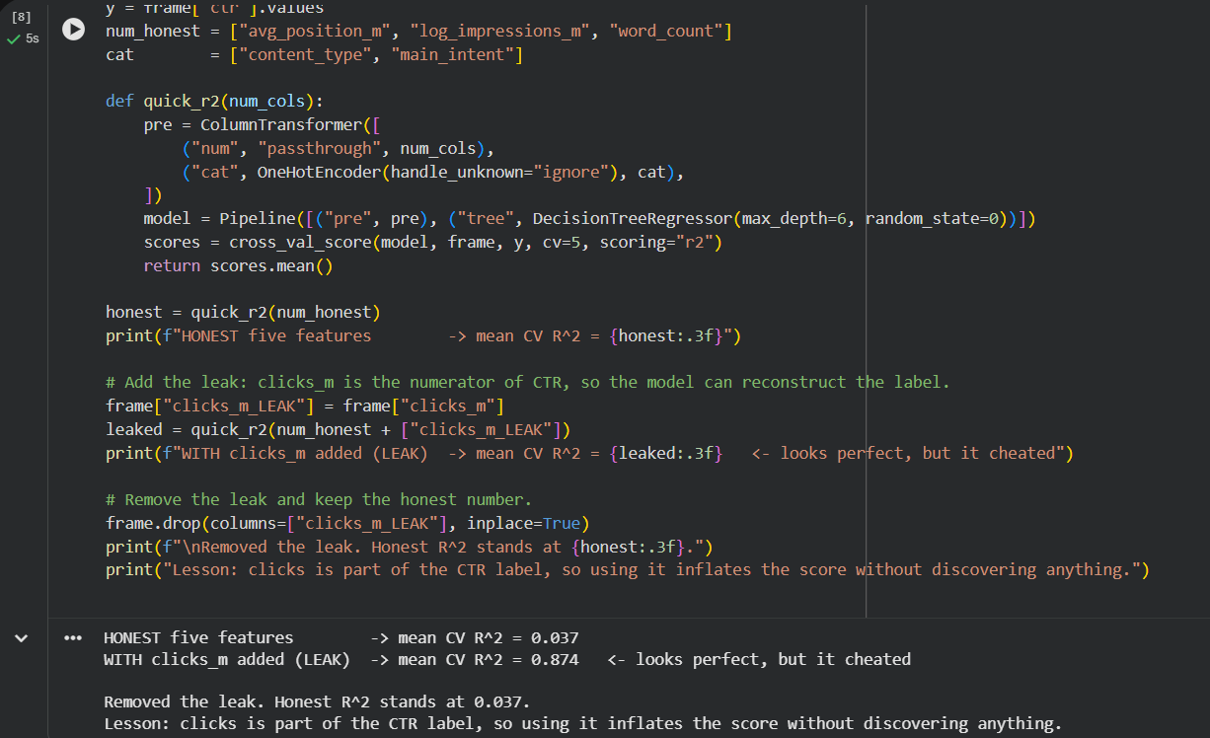
Figure 4 — The leakage test on real data: R² rises from 0.037 to 0.874 when the label's own numerator is added as a feature, then the feature is removed.
29 July, 2026
Wednesday
On the AI Fluency track I built my Identity Kit: two free fonts (Space Grotesk and Inter), a four-colour palette with fixed hex codes, and an SI monogram used as both logo and favicon.
I added a two-line style note to my Claude Project so that everything generated later would match the same identity instead of drifting.
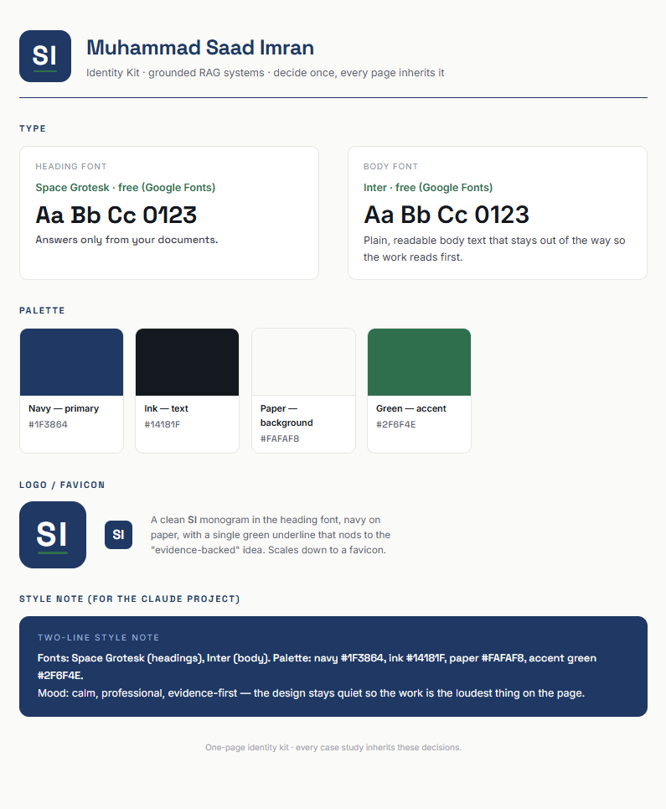
Figure 5 — The one-page identity kit: typefaces, palette with hex codes, and the monogram.
30 July, 2026
Thursday
I completed Curate Your Images, mapping an image set to my sitemap. Most of the images are real captures of my own work: the leakage output, my notebook, the sitemap and the Claude Project.
Only a background texture and a three-icon set were generated. I also wrote down the image I rejected and why — the glowing AI-brain hero, because it is a cliché that says nothing about what I actually built.
31 July, 2026
Friday
I finished the Content Map: one claim, then a page-to-section-to-case-to-call-to-action map, with every call to action leading to the same single step, which is emailing me to set up a call.
I kept an honest list of what I still needed to gather rather than writing placeholder text, and submitted the Week 3 progress report.

Week 4
3 August 2026 – 8 August 2026
3 August, 2026
Monday
I began ML-07, the transparent baseline that my Week 5 model would have to beat. Before writing the rule I checked the two signals it would rest on.
The first was confirmed: click-through rate falls as position gets worse (0.236% to 0.000%). The second came back the opposite way from what I expected — high-volume pages had a higher click-through rate, not lower (0.142% to 0.200%). Measuring it corrected my rule before I built it, which is exactly why the check exists.
4 August, 2026
Tuesday
I finished the baseline: a single transparent rule producing a score, a reason code and a recommended action, and from it a ranked queue of 30,616 pages.
I then reviewed the top ten by hand. Seven of the ten were effectively zero-click pages. That was recorded as a weakness of the rule, and it became something the model was later measured against.
5 August, 2026
Wednesday
I shipped my portfolio website live on GitHub Pages at saad-imran-toori.github.io, using the identity kit from Week 3, and confirmed it opened on a second device rather than just on my own machine.
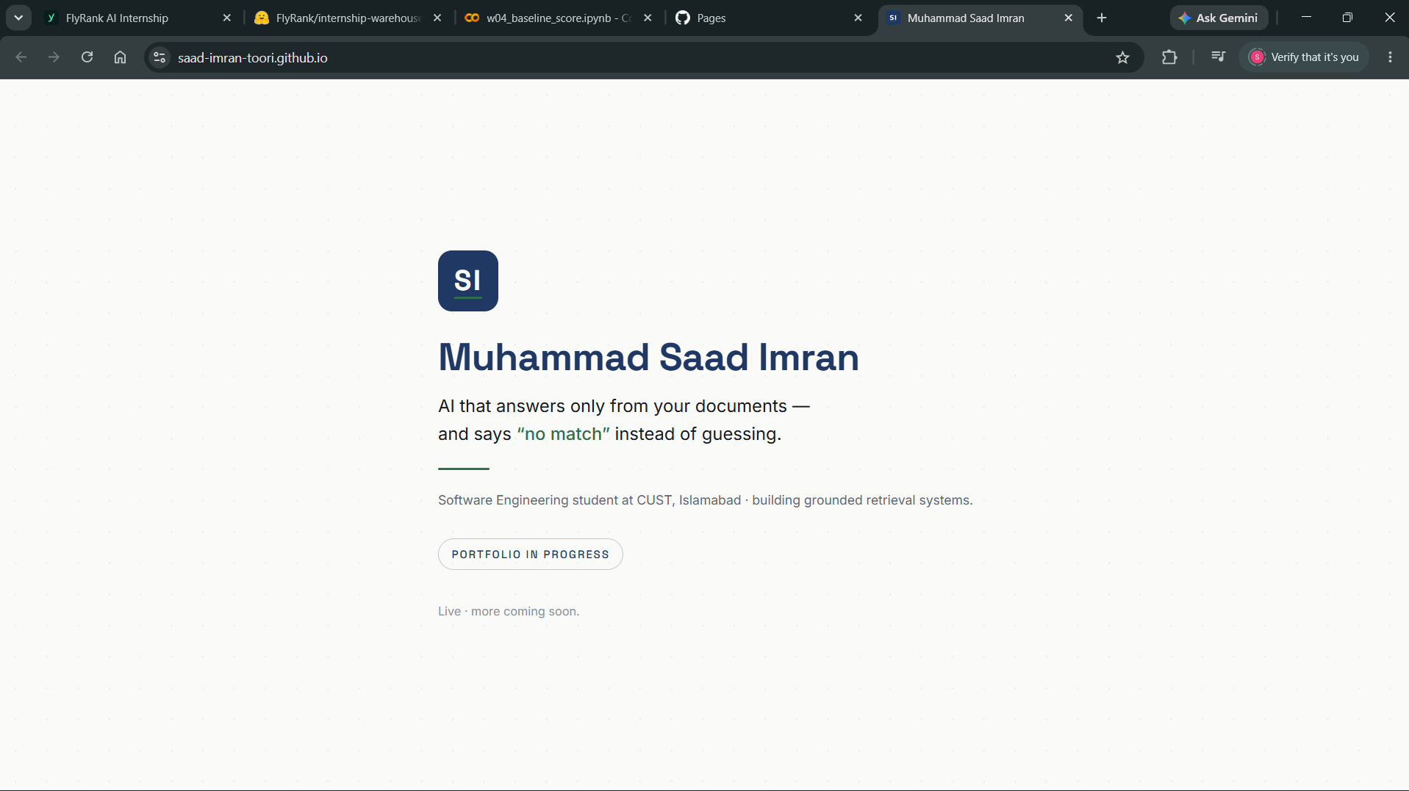
Figure 6 — The portfolio site live on GitHub Pages, built with the Week 3 identity kit.
6 August, 2026
Thursday
I completed Three Roads, comparing plain HTML on GitHub Pages against a static site generator and against React with Next.js. I chose the simplest option, and the deciding reason was near-zero maintenance.
I then completed Agent Concepts and MCP Basics: an explainer on the difference between a workflow and an agent, the three MCP primitives, and three real tool tasks run in Claude Desktop — reading my archive, fetching my live site, and executing Python to write a new file.
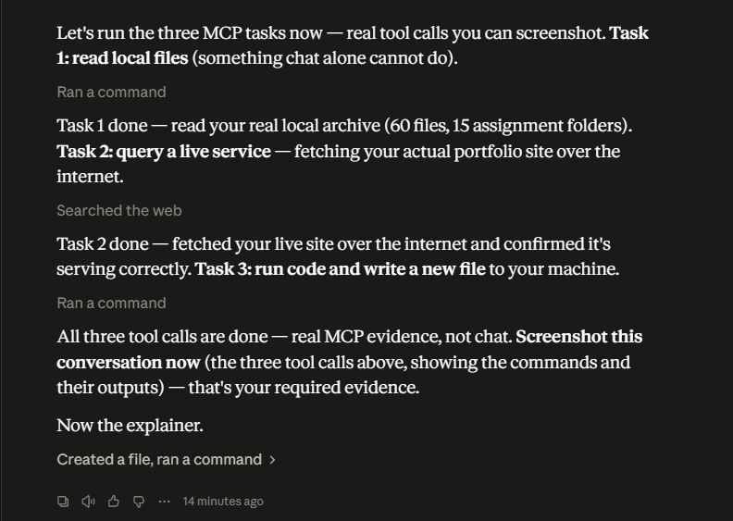
Figure 7 — One of the three MCP tool tasks: the assistant fetching my live site through a connected tool.
7 August, 2026
Friday
I built and shipped an automation workflow for my weekly report: a four-step pipeline of gather, draft, critique and revise, built as a Claude Project with a defined handoff at each step.
I ran it five times on real weeks. The first run took 20 minutes 29 seconds and the remaining four took 40 minutes 10 seconds in total, against a manual baseline of 90 to 120 minutes. Its best catch was noticing that I was trying to close a week that had not finished yet.
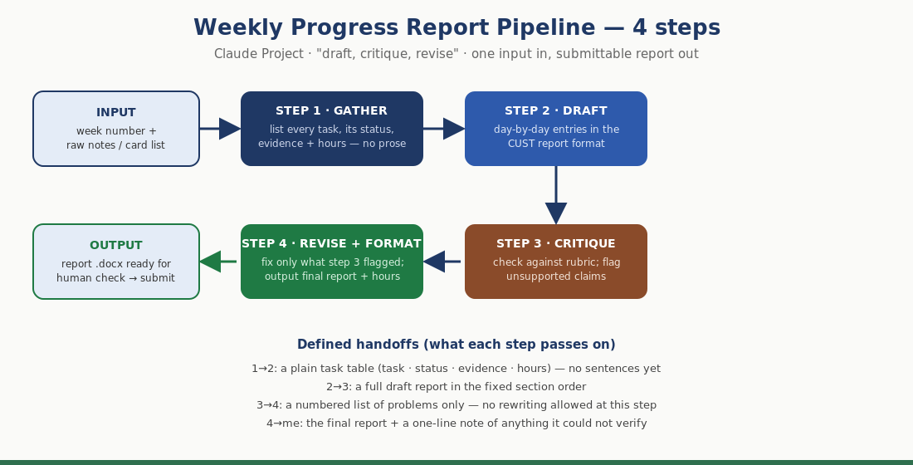
Figure 8 — The four-step weekly report pipeline, with the handoff each step passes on.

Week 5
9 August 2026 – 13 August 2026
9 August, 2026
Sunday
I set up ML-08, the capstone modelling task, and spent the day on the experimental design rather than on the model, because the design is what makes the comparison fair.
I built the split to be time-aware: features come from January and February, the label comes from March, and June 2026 was sealed at the start and never queried in any notebook in this project. I also grouped the folds by client, so no client appears on both sides of a split.
10 August, 2026
Monday
I ran the model against the frozen Week 4 rule on exactly the same exam: the same rows, the same folds, the same metric and K, and the same policy for ties.
Across 24 clients and 40,152 pages with zero overlap, the rule scores precision@50 of 0.492 and the HistGradientBoosting model scores 0.784, beating the rule in all five folds. The base rate is 0.216.
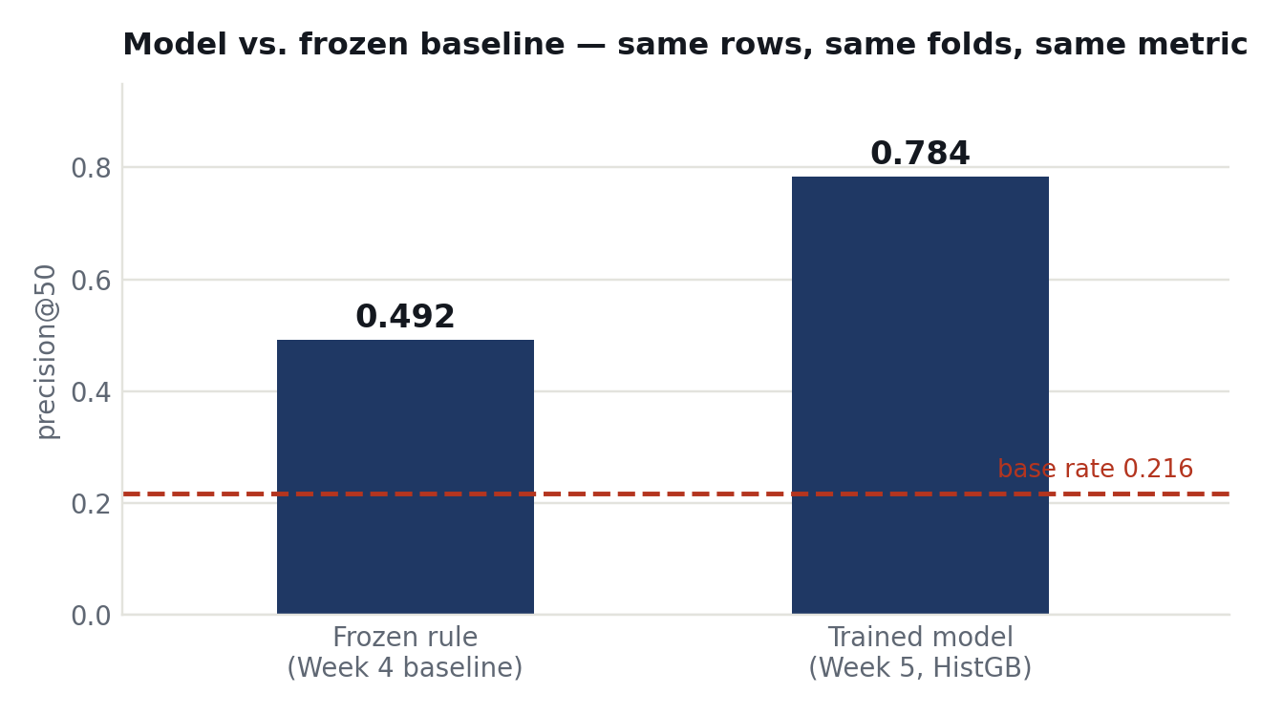
Figure 9 — The trained model against the frozen baseline on identical data, folds and metric.
11 August, 2026
Tuesday
I spent the day measuring what was wrong with my own result instead of celebrating it, and reported the caveats rather than hiding them.
Half the gain rides on click history: remove it and the score falls from 0.784 to 0.604. A readable Random Forest reaches 0.760 with the lowest variance of any model I tried. Permutation importance on held-out data with an injected noise floor showed that one feature I had expected to matter, content type, scored exactly 0.0000.
12 August, 2026
Wednesday
I built all three pages of my portfolio — Home, Proof and Contact — and put them live, in plain HTML and CSS with no framework and no build step, which is the stack I had defended in Week 4.
Every item on the site is real work. I then gave it to my first real reader, my project teammate Mansoor, who described the refusal behaviour back to me in his own words without being prompted. His criticism was that the site was too narrow, and it is recorded word for word alongside a list of nineteen things still wrong with it.
13 August, 2026
Thursday
I wrote the design specification for RepoWiz, a personal agent that drafts my weekly university report from evidence it gathers itself and refuses to state anything it cannot verify.
I specified five tools, four read-only and one write behind a confirmation, and wrote six evaluation cases before building anything — four of them drawn from mistakes that had actually happened to me. The guardrails are structural rather than promised: there is no send-email, git-push or submit tool, so every irreversible action stays with me.

Week 6
14 August 2026 – 17 August 2026
14 August, 2026
Friday
I built RepoWiz and ran it live. Unprompted, on its first real task, it found two genuine errors in my own project index: two entries claimed the notebooks were executed when the archived copies each had five unexecuted cells. I had written both lines myself and never noticed.
Run on camera, it also refused a figure it could not trace to a source, refused to close a week that had not finished, and refused to put a third party's email address into a public repository. I fixed the index rather than the agent.
15 August, 2026
Saturday
I completed ML-09, the validation and research claim audit, and this is the most important day of the internship.
I rebuilt the same experiment with a deliberately wrong split — plain K-fold with clients on both sides — keeping everything else identical. The wrong split gives 0.836 against a 0.560 rule; the honest grouped split gives 0.784 against 0.492. The raw gap looks like 0.052.
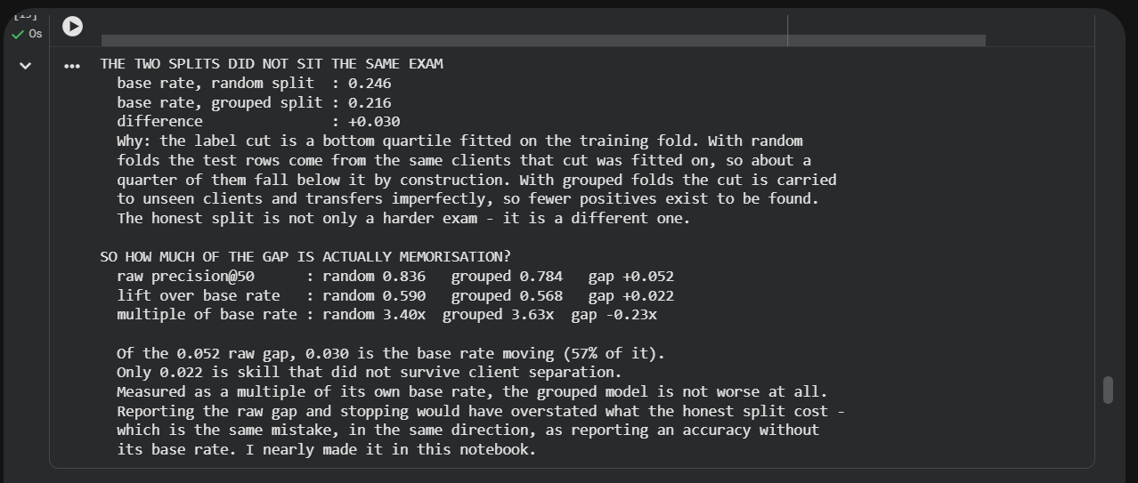
Figure 10 — The audit output: of the 0.052 raw gap between the two splits, 0.030 (57%) is the base rate moving rather than skill lost.
16 August, 2026
Sunday
The correction that matters is this: the base rate moved between the two splits, so 0.030 of that 0.052 gap — 57% of it — is the exam changing, not my model losing skill. Measured as a multiple of the base rate, the honest split is actually ahead, 3.63 times against 3.40 times.
I had been reporting the raw gap for weeks. It claimed a bigger virtue than I had earned. I rewrote four of my own claims with the numbers printed beneath each one, and then brought the public versions into line, because correcting a claim in a notebook while the old wording stays live is exactly the failure this task is about.
The audit also found a limitation ML-08 had not disclosed: 979 of 41,234 eligible pages produce no row in the outcome month at all and cannot be scored. It is not patchable, so it is stated as a limitation and the claim narrowed.
17 August, 2026
Monday
I added the first dynamic feature to my site: a working contact form on a free tier, replacing a mailto link that silently did nothing for any visitor without a mail app.
It has three required fields, an off-screen honeypot so spam is caught without making real people solve a captcha, a success dialog that returns keyboard focus properly, and failure messages that always name my email address and leave the typed text in place. The form keeps a real action and method, so if the script never runs the browser still submits. It degrades, it does not break. I tested it live three ways and the message arrived.

Week 7
18 August 2026 – 22 August 2026
18 August, 2026
Tuesday
I opened my site on a real phone and then measured it in a headless browser at four widths, because the assignment is clear that a resized desktop window does not count. The phone and the measurements caught different problems.
Every page scrolled sideways at every phone width: the top navigation is a flex row with no wrapping, so the last link ran off the edge — 29 pixels over at 390 pixels wide, and 99 pixels over at 320. The fix already existed in the footer styles from Week 5, with a comment explaining this exact failure. The top navigation had simply never been given it.
19 August, 2026
Wednesday
I fixed seven real problems found the previous day, including two that no automated check would flag because neither is invalid HTML. A bare selector was leaking a layout rule onto the paper's contents box, and my product screenshots are crisp at 1400 pixels and simply unreadable when rendered into 342.
I also fixed a colour that failed the accessibility contrast standard, enlarged tap targets from as small as 18 pixels to between 30 and 45, and added dimensions and lazy loading to eleven images. That last change contains a trap worth recording: adding a height attribute to an image styled to full width makes the attribute win, and every figure stretches, so the CSS fix has to land in the same change.
20 August, 2026
Thursday
I submitted my portfolio for design review to a classmate, Zia ur Rehman. The two review questions were asked before my proof statement was revealed, so the test was not led, and he reached the refusal behaviour in his own words.
His feedback sorted into five must-fix items and three nice-to-have. All five must-fixes are now live, each with a before-and-after entry. One is worth remembering: he excused me from fixing an over-claim, saying it was acceptable for an internship portfolio. Taking that excuse would have been defending the original with the reviewer's own permission, so I fixed it anyway, and on the clean re-review he said the narrowed sentence increased his trust.
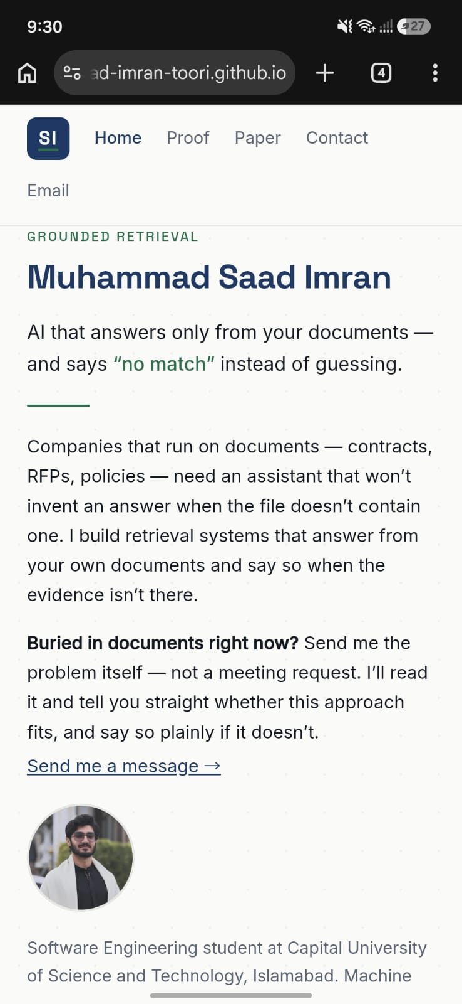
Figure 11 — Phone evidence from the design review: the offer paragraph after being moved above the fold.
21 August, 2026
Friday
I completed ML-10, turning the validated model into the instruction sheet an editor actually uses on Monday morning. The queue is built from out-of-fold scores so its precision is measured rather than borrowed, and the reason codes are derived from each page's own numbers so an editor can check any of them by opening the page.
Across 40,152 pages and 24 clients, precision@K runs 0.900, 0.950, 0.967, 0.940, 0.830 and 0.820 at K of 10, 20, 30, 50, 100 and 200. At K = 50 that is 47 real finds and 3 wasted hours. The best result is what the queue sets aside: 20,061 pages, half the total, are marked watch-only and under-capture at only 0.083.
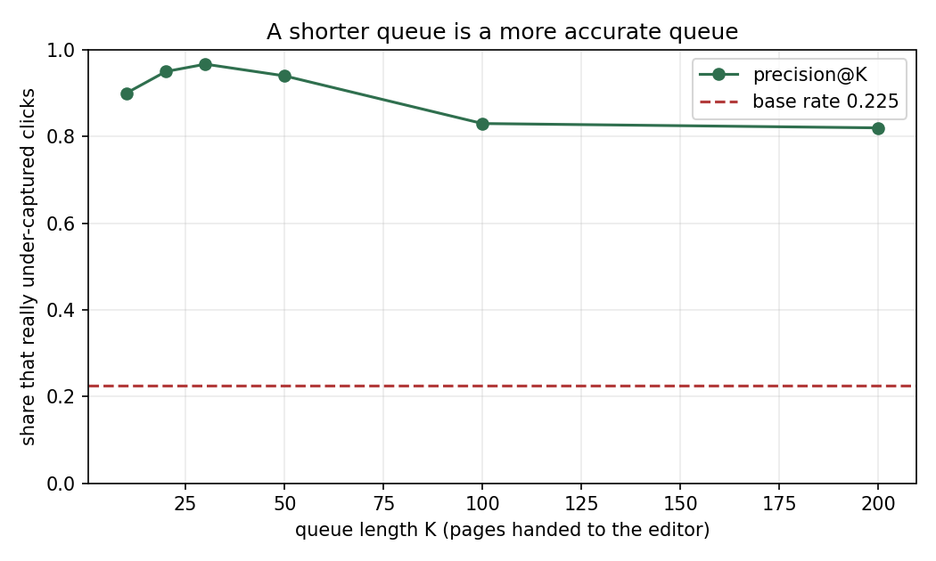
Figure 12 — Precision at each queue length. A shorter queue is a more accurate queue.
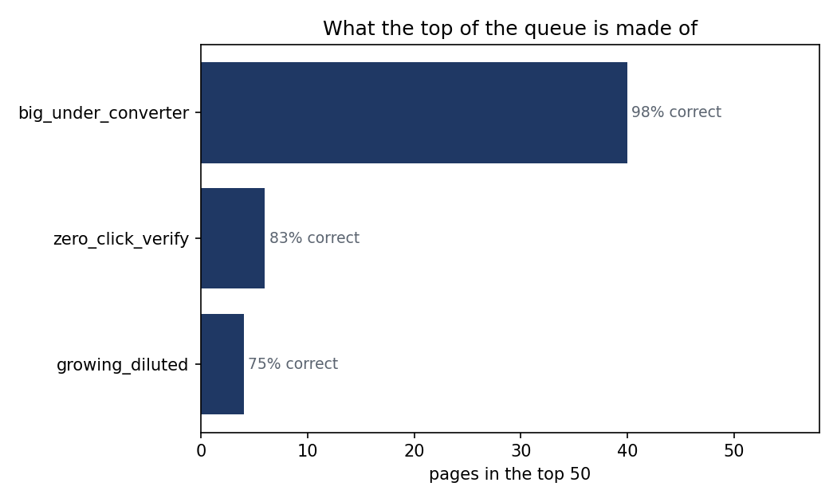
Figure 13 — What the top 50 of the queue is made of, by page archetype.
22 August, 2026
Saturday
I caught three of my own errors before submitting the playbook. I nearly claimed an improvement that did not exist, because this notebook's precision@50 of 0.940 and ML-08's 0.784 are not comparable — one takes the best 50 of 40,152 pages, the other the best 50 of about 8,030, five times over. Both are now printed with a statement that they are not interchangeable.
I had also built a drift alarm that could never fire: page impressions move so much between two ordinary months that the trigger was set five times past the major-shift line. And I had recommended refreshing declining pages, then overstated the correction — momentum barely separates pages either way. The biggest operational caveat is recorded plainly: the top 50 draws from 8 of 24 clients, and one client holds 44% of it.

Week 8
23 August 2026 – 26 August 2026
23 August, 2026
Sunday
I began ML-11, writing the whole project up as a research paper. I read the Pineau Machine Learning Reproducibility Checklist in full, and it added four things my write-up had never stated anywhere: dependency versions, the exact number of runs, the runtime, and the compute used.
I wrote all nine required sections, including the two the brief says people forget — a five-sentence abstract at the top and the data credit at the bottom. The continuous integration check literally fetches the deployed page and searches it for that credit link, so a paper without it fails the build.
24 August, 2026
Monday
I published the paper live and public at saad-imran-toori.github.io/paper.html, as one self-contained HTML file. It was asked for in two places, but two live copies of the same paper is the same duplication trap I had already been caught by, so the repository holds the archived source and there is exactly one deployed address.
The paper argues against itself wherever the evidence does: half the margin is borrowed from click history; a random forest reaches 0.760 with less variance, and asked to defend one model in a room I would defend the forest; the split claim I had made for weeks was 57% inflated; 979 pages cannot be scored at all; momentum is a negative result; and nothing here is causal.
25 August, 2026
Tuesday
Three things went wrong and are recorded rather than smoothed over. The abstract ran to six sentences when the brief says five, and was merged rather than left in the hope that nobody counted. Two figures shipped broken, because the charts were committed to the internship repository while the paper lives on the site repository — two separate places.
The lesson is a general one: copied page text renders images as their alt text whether or not they loaded, so pasting a page proves nothing about whether its figures work. Only looking at the rendered page does.
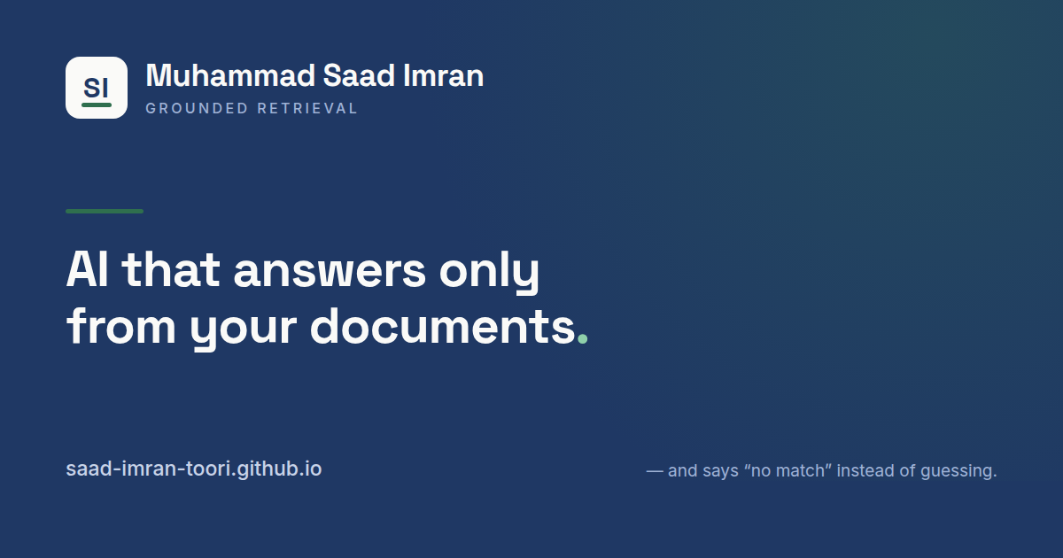
Figure 14 — The share card built for the published paper and portfolio, in the Week 3 identity kit's own palette and typefaces.
26 August, 2026
Wednesday
On the final day I completed ML-12, which closed the Machine Learning track at 10 out of 10. The case study belongs inside the paper rather than beside it, and mine did not: my introduction opened with a generic editor and never named what FlyRank actually does. I rewrote the abstract's opening and added a section explaining where the problem comes from.
I also produced a five-minute demo outline, timed in five blocks, which closes on the limitation rather than the win, and two short shareable summaries whose closing sentences are spent on what the work cannot claim.
Submitting the paper flipped the repository into its final state, which escalated one continuous integration check from a warning to an error, and two old skeleton notebooks that had been sitting unused for weeks failed the build. They were duplicates of work done elsewhere, so they were deleted and every check then passed. FlyRank issued the Certificate of Completion for the Machine Learning track on 7 September 2026, credential FR-D11-F1DDA-CDAA7.

Conclusion
Over eight weeks and 279 logged hours I completed 32 assignments across two tracks, finished the Machine Learning track at 10 out of 10, and had the capstone reviewed and accepted. The technical result is a model that scores precision@50 of 0.784 against a frozen rule's 0.492 on identical rows, folds and metric, with a base rate of 0.216, published as a public research paper.
The skills I gained are concrete:
- Working with real company data at scale — SQL and DuckDB over Parquet on a 9.84 million row warehouse, rather than a clean practice file.
- Experimental design that survives scrutiny — time-aware splits, grouped folds so no client sits on both sides, a sealed month never queried, and a frozen baseline agreed before the model was built.
- Machine learning in Python with scikit-learn, including permutation importance measured against an injected noise floor.
- Front-end delivery — a live website in plain HTML and CSS, a working contact form, accessibility and mobile fixes verified by measurement.
- Professional practice — Git and GitHub, continuous integration checks that block a merge, agent and MCP tooling, and technical writing for a non-technical reader.
The habit I am taking away is narrower than any of those, and more useful. Three separate times during this internship, checking beat remembering: a figure committed under the wrong filename so it silently never loaded; a stale copy of my whole site being served publicly with an uncorrected claim on it; and a set of fixes described in a log while none of them were actually live. In each case I believed the work was done. Only verifying showed that it was not.
The single most valuable thing I did was audit my own published claim in Week 6 and find that 57% of the improvement I had been reporting came from the test getting easier rather than from my model being better. Correcting it made my result less impressive and my work more trustworthy, and I would make that trade again.
Two items remain open and are stated here rather than left implied: the AI Fluency Impact Project capstone was deferred, and one assignment, Break Your Own Site, is built and deployed but not yet submitted. The Machine Learning track, which was my primary track, is complete and certified.

References
Internship repository (all notebooks, figures and deliverables):
https://github.com/Saad-Imran-Toori/flyrank-ml-internship
Published capstone research paper:
https://saad-imran-toori.github.io/paper.html
Portfolio website built during the internship:
https://saad-imran-toori.github.io
Certificate of Completion — Machine Learning track, FlyRank AI, issued 7 September 2026. Credential FR-D11-F1DDA-CDAA7, verifiable at:
https://internship.flyrank.ai/verify/FR-D11-F1DDA-CDAA7
Data source: Google Search Console performance data supplied by FlyRank AI (flyrank.ai), 9.84 million page-day rows.
Pineau, J. et al. The Machine Learning Reproducibility Checklist. Used in Week 8 to audit the reproducibility section of the capstone paper.
Anthropic Academy. AI Fluency: Framework and Foundations, and five further courses completed during the internship.
Asceric, M. Harness Engineering: 29 Tips to Build the Systems That Build Software. FlyRank AI live session, Week 4.

