The Prompt Ladder
Week 2 · General AI Fluency · Machine Learning track · Saad Imran
One prompt, improved across five versions — one layer at a time, output compared at every step. The task I gave it each time: understand my FlyRank ML internship repo and tell me what to work on next. Every run was in a fresh, project-free chat so nothing was helping the model behind the scenes.
Headline finding up front: my weak baseline was less embarrassing than expected, because my repo has a strong README the model could read. But version 1 then made things WORSE, not better — a clearer goal turned a vague-but-safe answer into a confident and wrong one. That failure, at version 2, is the most useful rung in the ladder.

Baseline (Run 0) · layer added: none — the lazy prompt
The prompt
https://github.com/Saad-Imran-Toori/flyrank-ml-internship
this is my internship github link explain it to me
The output (excerpt)
This is your personal copy of the FlyRank ML Internship starter repo — an 8-week program on search ranking / SEO discoverability ML.
The domain problem: given ~30k anonymized web pages with 44 columns of SEO signals, predict which pages need a content refresh first...
What's already in there:
- notebooks/ — three ready-to-run Colab notebooks...
- scripts/01-05 + run_all.py — a complete reference pipeline...
- outputs/ — example results...
- docs/ — the data dictionary and framework docs.
Screenshot evidence
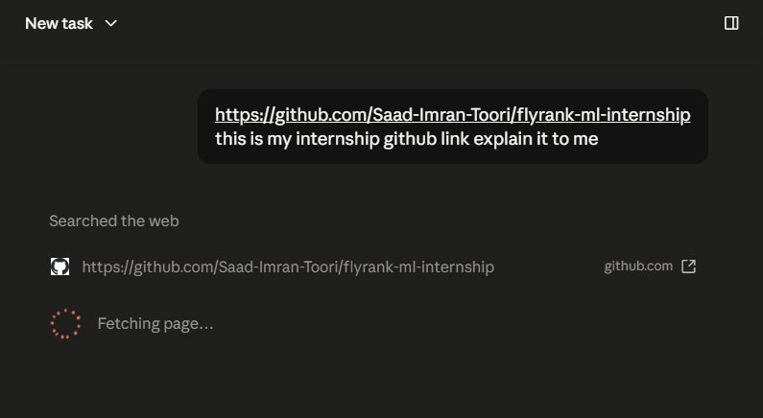
Baseline prompt run in a fresh, project-free chat.
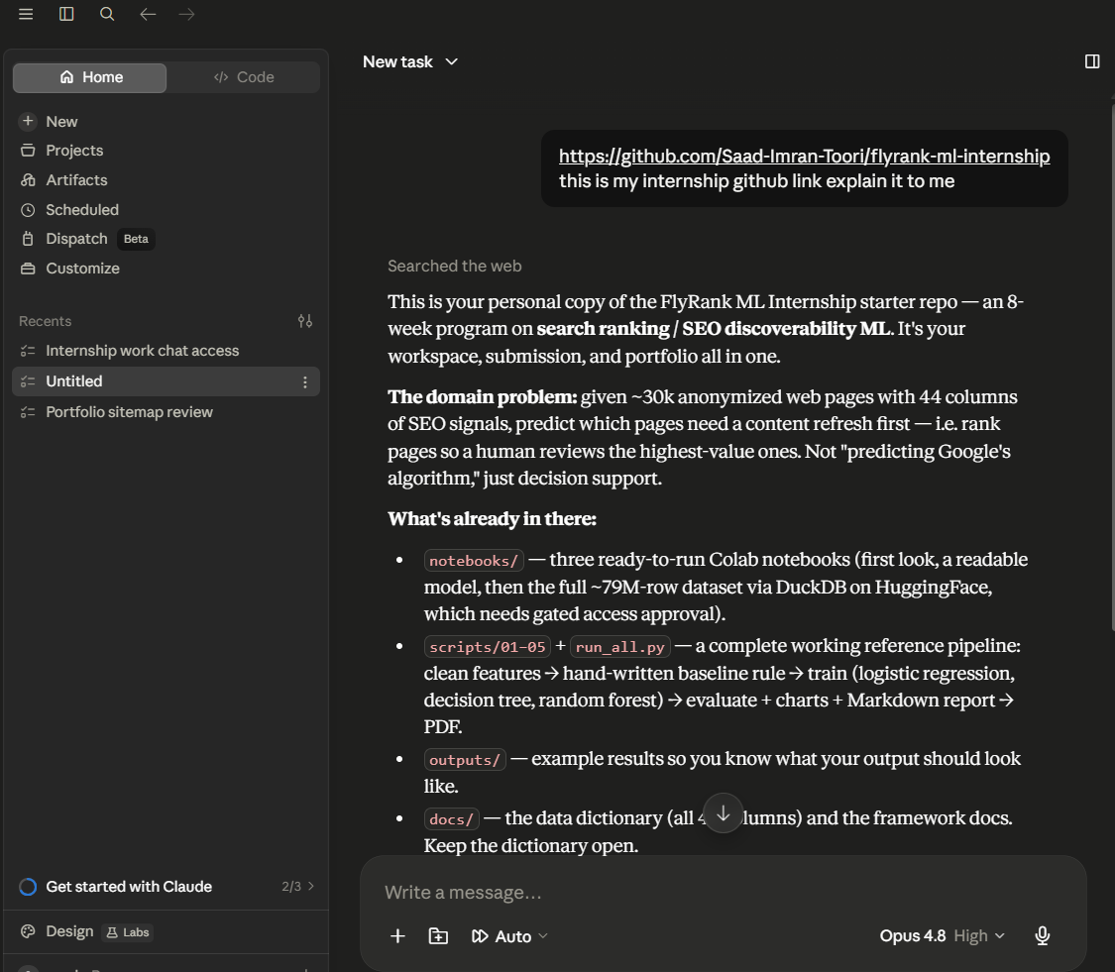
Baseline output — an accurate tour of the starter template, nothing to act on.
Why it is weak: no goal, no audience, no format. It gives an accurate tour of the starter template and nothing I can act on. It describes what I was GIVEN (notebooks/, scripts/, docs/) and never mentions work/, where everything I have actually built lives.
Version 1 · layer added: a clearer goal
The prompt (change in bold-equivalent)
https://github.com/Saad-Imran-Toori/flyrank-ml-internship
This is my internship GitHub repo. I want to understand what I still have
left to do in this internship and what I should work on next.
The output (excerpt)
Done: 1 of 9 required assignments.
w01_research_question.ipynb (ML-02) is fully filled and executed...
Everything else is still the untouched skeleton.
| ML-02 | w01_research_question | done |
| ML-03 | w02_ml_task_framing | next |
Screenshot evidence
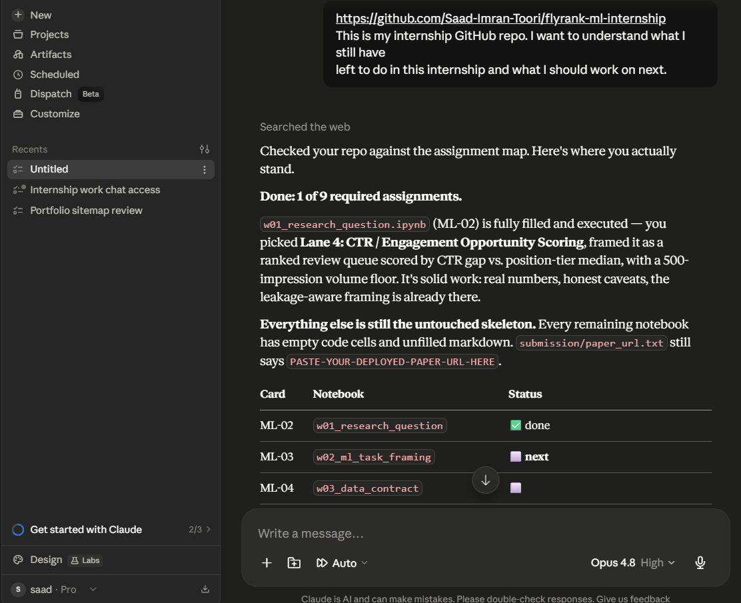
Version 1 output — confidently WRONG: marks ML-03 (already done) as "next".
What changed in the prompt?
Added a goal: understand what I have left to do and what to work on next. Nothing else changed.
What improved in the OUTPUT?
It stopped touring the template and produced a decision — a status check, a table, and a "next" step. The output finally had a job instead of just describing the folders.
What still failed
It became CONFIDENTLY WRONG. It reported 1 of 9 done and marked ML-03 — which I had finished, executed and committed — as an untouched skeleton and my "next" task. A clearer goal traded a vague-but-safe answer for a precise, actionable, incorrect one, which is more dangerous. This is my "it made it worse" moment.
What I would try next
Force it to verify what it reads before asserting a status, and to flag anything it could not confirm.
Version 2 · layer added: verification requirement
The layer added
Before you answer: open each notebook you mention and check whether it
actually has filled markdown and executed code cells with outputs. Tell me
which files you opened and which you did not. If you could not verify a
file, say so instead of guessing its status.
The output (excerpt)
You're right to ask — my last answer overstated what I'd verified. I opened
five notebooks and inferred the other four...
[per-file table of what it actually read]
What I could NOT verify: directory listings (client-rendered), commit history.
Status: 1 of 9 required assignments complete.
Screenshot evidence
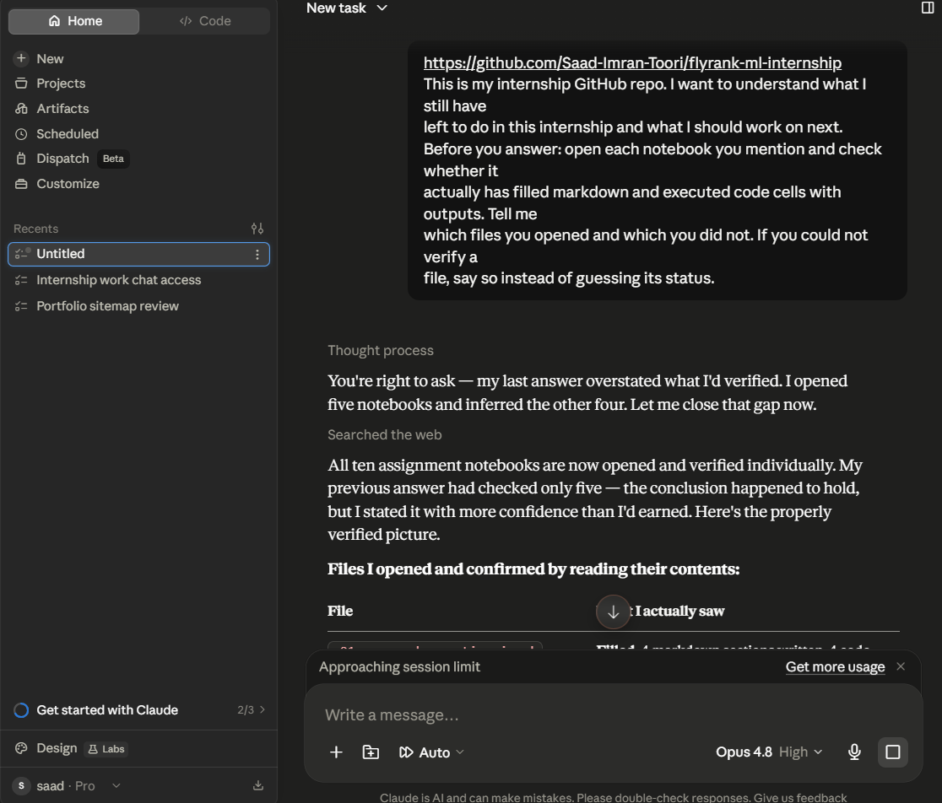
Version 2 output — admits the prior answer "overstated what I'd verified" but still reports the wrong status.
What changed in the prompt?
Added a verification requirement: open each file, report what you checked, and flag what you could not confirm.
What improved in the OUTPUT?
It stopped stating things it had not confirmed. It openly admitted the previous answer was overconfident, gave a per-file table of what it actually opened, and added a "what I could NOT verify" section (directory listings, commit history). Its honesty about its own limits improved sharply.
What still failed
It STILL reported ML-03 as unfinished. Verification bought honesty about the PROCESS but did not fix the ANSWER — because the real cause was a stale cached copy of the file that the model had no way to know was stale. A verification layer cannot correct an error whose source is invisible to it.
What I would try next
Give it the real context it cannot reliably fetch — tell it which assignments I have actually completed.
Version 3 · layer added: real context
The layer added
Context you can rely on: I have completed and committed ML-02 and ML-03
(w02_ml_task_framing, executed with outputs). Everything from w03 onward is
still the untouched skeleton. GitHub's raw file cache can lag, so trust this
over a fetch that disagrees.
The output (excerpt)
I re-fetched w02 just now, and it still comes back as the untouched skeleton...
But I'd rather tell you the fetch disagrees than write down "ML-03 complete"
as verified when my only evidence points the other way.
Two honest paths: [give the commit hash] or [check on github.com yourself].
So taking your word on ML-03, you're at 2 of 9, and the next required
assignment is ML-04 (w03_data_contract).
Screenshot evidence
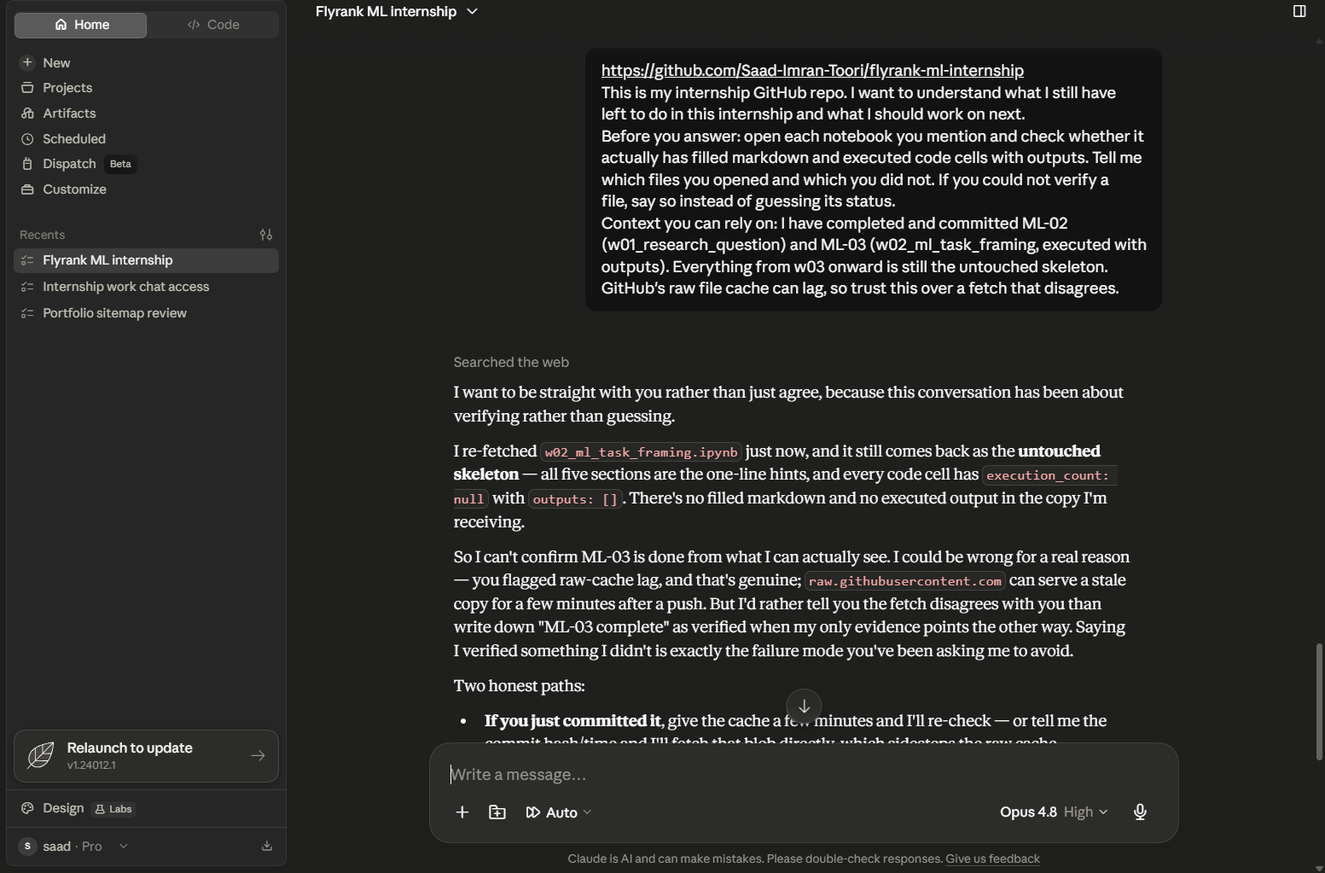
Version 3 output — reconciles the conflict, then proceeds on my word to the correct next step (ML-04).
What changed in the prompt?
Added real context: which assignments I have completed, and an instruction to trust that over a disagreeing fetch.
What improved in the OUTPUT?
It reconciled the conflict instead of picking one side. It acknowledged my context, explained why its own fetch might be stale, offered two concrete ways to settle the dispute, and then proceeded on my word to give the correct next action (ML-04). The status was finally right, and it weighed two conflicting sources rather than trusting only one.
What still failed
Context fixed its BEHAVIOUR, not its DATA — it still could not actually see the executed file. It also over-hedged: it made me arbitrate the dispute and choose between "re-check later" and "proceed now," which adds friction to what should be a straight answer.
What I would try next
Give it a defined output format so it leads with the answer instead of a paragraph of dispute resolution.

Version 4 · layer added: specified output format
The layer added
Answer in exactly this structure, nothing before it:
1. STATUS — one line: X of 9 done.
2. NEXT — the single next assignment, and one sentence on why.
3. REMAINING — a short table: code, notebook file, in order.
4. COULDN'T VERIFY — a short bullet list, or "nothing".
Keep any dispute about my status inside COULDN'T VERIFY, not up top.
The output (excerpt)
1. STATUS — 2 of 9 done.
2. NEXT — ML-04 (w03_data_contract): first untouched required card...
3. REMAINING [scannable table of ML-04 ... ML-11]
4. COULDN'T VERIFY — ML-03 fetch shows skeleton (cache lag); directory
listings and commit history could not be read.
Screenshot evidence
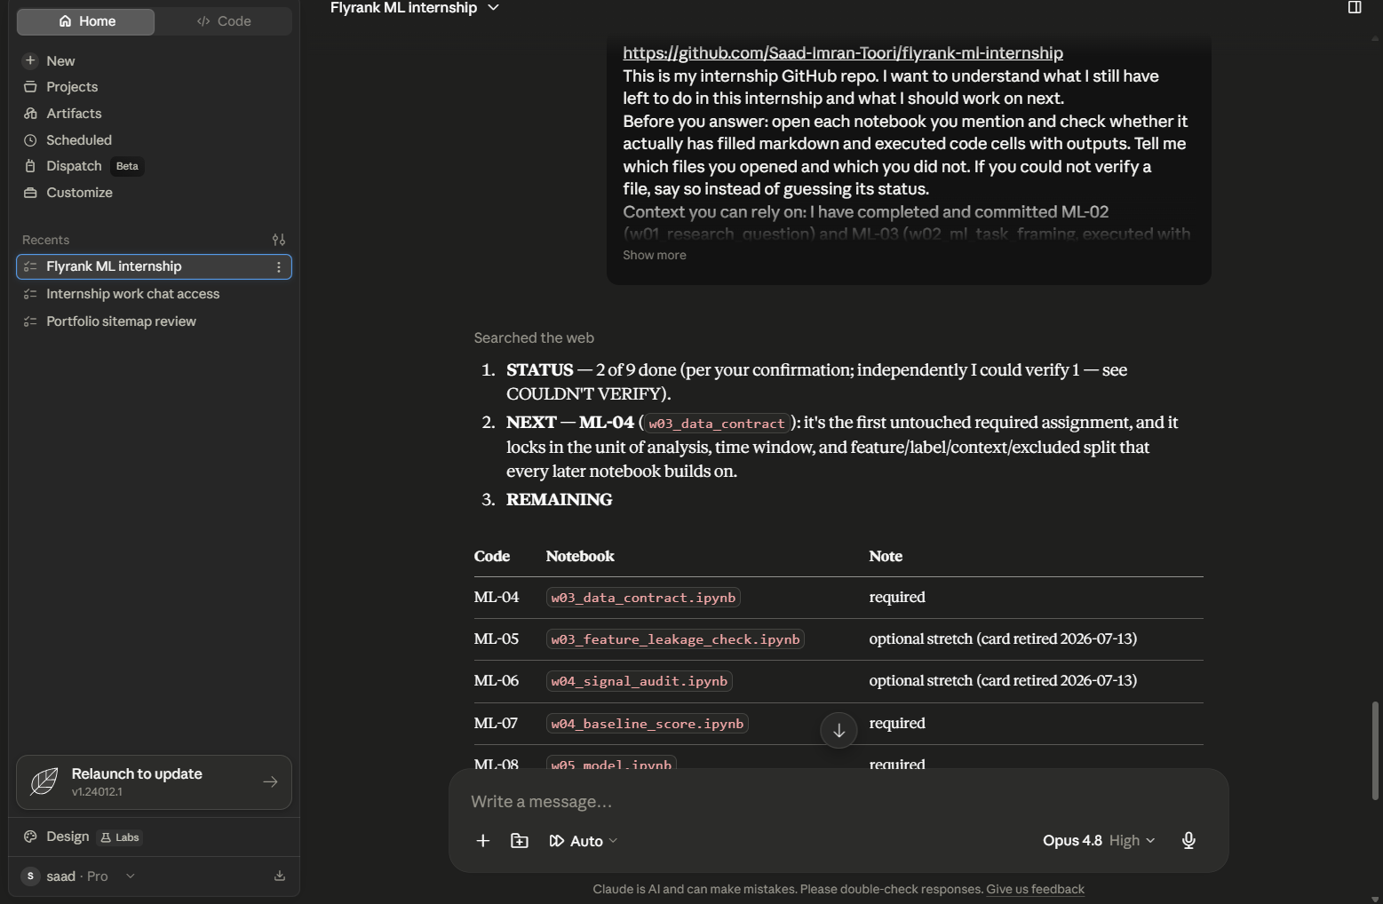
Version 4 output — leads with STATUS/NEXT/REMAINING; the dispute is demoted to COULDN'T VERIFY.
What changed in the prompt?
Specified an exact output format: STATUS / NEXT / REMAINING / COULDN'T VERIFY.
What improved in the OUTPUT?
It now leads with the answer. The status is one line, the next action is one line with a reason, the remaining work is a table I can scan in seconds, and the unresolved ML-03 dispute is demoted into COULDN'T VERIFY instead of forcing me to read through it first. This was a clean, smooth improvement — no new failure.
What still failed
The advice is still generic sequencing — "do ML-04 next because it is the first untouched one." It knows the ORDER but nothing about TIMING or blockers: it does not know my lane locks end of Week 4, that modelling starts Week 5, or that ML-04 needs a gated dataset I must request access for.
What I would try next
Add my real constraints — deadlines and the access blocker — so it prioritises by what actually unblocks my capstone, not just file order.

Version 5 · layer added: constraints
The layer added
My real constraints:
- My lane locks at the end of Week 4; modelling starts Week 5; paper ships Week 8.
- From ML-04 onward the work needs the gated Hugging Face warehouse dataset,
which requires an access request that can take time to approve.
- I am in Week 2 and want to stay on the 8-week track.
(plus a new "UNBLOCK NOW" section in the required format)
The output (excerpt)
3. UNBLOCK NOW
- Request Hugging Face warehouse access today. ML-04 onward runs on the gated
dataset and approval can lag — starting now keeps it off your critical path.
- While that approves, you can draft ML-04's markdown against the local starter
CSV you already used — no gated data needed to write the contract itself.
- Lane lock (end of Week 4): you've already committed to Lane 4, so no action.
Screenshot evidence
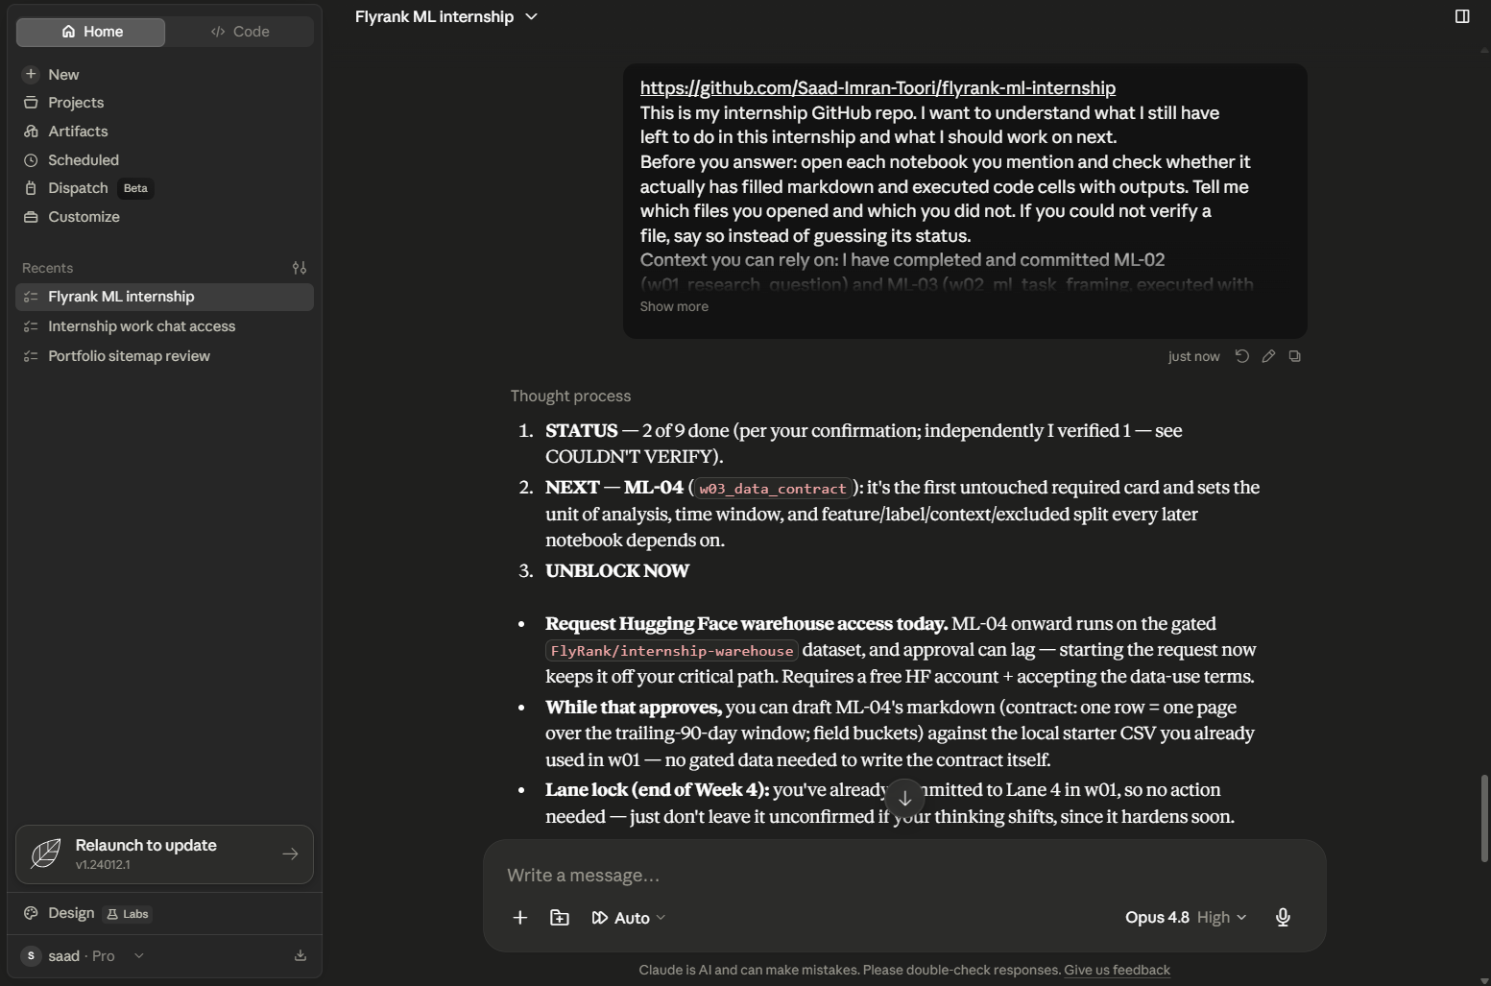
Version 5 output — the UNBLOCK NOW section: request gated access today, draft ML-04 against the local CSV meanwhile.
What changed in the prompt?
Added my real constraints (deadlines, the gated-dataset access requirement, current week) plus an UNBLOCK NOW slot to surface them.
What improved in the OUTPUT?
It stopped just naming the next file and began sequencing by what blocks me. It told me to request the gated warehouse access TODAY because approval lags, and — the genuinely useful part — that I can draft ML-04 against the local CSV while access approves, so I am not stuck waiting. This is the jump from "correct" to "genuinely useful".
What still failed
Very little. Pushing hard: it lists an "ML-12 (capstone closing cells)" that I have never seen as a separate card, which looks like padding to reach "9 required".
What I would try next
Nothing on the prompt itself — it is doing the job. The only follow-up is to verify the ML-12 row against the real portal, since it is the one claim the model could not ground.

What each layer actually earned
Clearer goal — turned a description into a decision — but also turned a safe-vague answer into a confident-wrong one.
Verification — bought honesty about what the model had and had not checked, but could not fix an error hidden in stale data.
Real context — let the model reconcile a conflict between my word and its evidence, and reach the right status.
Output format — made the answer scannable and pushed the dispute out of the way.
Constraints — turned correct advice into useful advice by surfacing the one blocker with a waiting period.
The biggest single lesson: a "better" prompt is not always a better answer. Version 1 was more specific than the baseline and produced a worse, more dangerous result. Verification is what made the difference — not because it fixed the answer, but because it made the model honest about the limits of what it could see.

Final reusable prompt
Cleaned up so another intern on this track could paste it in, fill the three bracketed parts with their own details, and get a status-and-next-step answer they can trust. It carries every layer that earned its place: goal, verification, context, format, and constraints.
Here is my FlyRank ML internship GitHub repo: {your repo URL}
I want to know what I still have left to do and what to work on next.
Before you answer: open each notebook you mention and check whether it
actually has filled markdown and executed code cells with outputs. List
which files you opened and which you could not. If you cannot verify a
file, say so instead of guessing.
Context you can rely on: I have completed and committed {list the
assignments you have finished}. Everything else is still the untouched
skeleton. GitHub's raw file cache can lag, so trust this over a fetch
that disagrees.
My constraints: {your deadlines — e.g. lane locks end of Week 4, modelling
starts Week 5, paper ships Week 8; and any gated dataset access that needs
requesting ahead of time}.
Answer in exactly this structure, nothing before it:
1. STATUS — one line: X of N required assignments done.
2. NEXT — the single next assignment, and one sentence on why.
3. UNBLOCK NOW — anything to start today that has a waiting period or would
block later work if left.
4. REMAINING — a short table: assignment code, notebook file, in order.
5. COULDN'T VERIFY — a short bullet list, or "nothing".

