Sound localization device

By Saad Nissar, Wei-Chia Hsu, Yaoyu Liu, Cheng-yu LIn

*Abstract*—This document talks about the implementation of a sound localization device based on the 10 step model based design.

# Introduction

Sound localization has several advantages, including improved safety by detecting warning sounds, enhanced communication by locating the source of a sound, better spatial awareness in environments with limited visibility, improved performance in auditory tasks, and a better quality of life for individuals with hearing impairments.

1. Improved safety: Sound localization can help individuals detect the source of warning sounds, such as alarms or sirens, and take appropriate actions to avoid potential danger. For example, a driver can quickly identify the direction of an ambulance siren and pull over to make way for the emergency vehicle.
2. Enhanced communication: Accurately locating the source of a sound can help in effective communication. For example, in a crowded place, it can be difficult to hear someone speaking. However, if you can locate the direction of the speaker, you can move closer to them or position yourself to hear them better.
3. Improved performance in tasks: Sound localization can improve performance in tasks that require auditory localization, such as playing musical instruments or identifying the source of a particular sound in a noisy environment.

By these reasons, sound localization is important and implementing would benefit many.

# Methods

In The Model-Based Design (MBD), the system is designed and developed using a top-down approach, where the overall system requirements and architecture are defined first, followed by the design and implementation of each component.

For our MBD process for this project, we would covers the following steps:

**Step 1: State the Problem –**

The goal of this project is to design a sound localization device that can accurately determine the direction of a sound source.

**Step 2: Model Physical Processes –**

The physical processes that need to be modeled include the data reading, beamforming, sound filtering, and localization components.

**Step 3: Characterize the Problem –**

The characteristics of the problem that need to be considered include the accuracy of the localization process, the type of sound source being localized, and the range of sound sources that can be localized.

**Step 4: Derive a Control Algorithm –**

A control algorithm needs to be derived that will accurately determine the direction of the sound source.

**Step 5: Select Models of Computation –**

The models of computation that need to be selected include the signal processing blocks in Simulink, as well as the graphical user interface blocks.

**Step 6: Design and Simulate the System –**

The system can be designed and simulated using Simulink.**

**Step 7: Implement the System –**

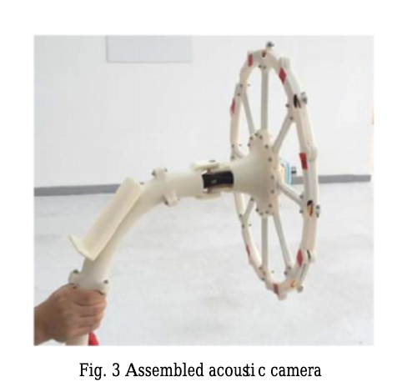The system can be implemented by connecting the Simulink model to the actual hardware components.

**Step 8: Test and Validate the System –**

The system can be tested and validated by comparing the results of the localization process with actual measurements.

# Design Figure for Localiszation Device

Prototype specification of our localization device:

***Sound Filtration = FFT - frequency filtering - iFFT (filter 50 - 500 Hz)***

***Localization = Combining audio data - MUSIC DOA - Angle***

***Triangulation = Angles to Distance (Angle method, Sound Intensity method)***

***Precision Checker = Approximation of best case value for given angles and distances***

Detecting theory of our localization device:

# Finite State machine

Finite State Machine (FSM) design can help visualize and understand the behavior of the system, identify potential errors or inefficiencies in the design, and facilitate communication and collaboration among components.

Basic FSM design:

Detailed FSM design:

# implementation

For the data reading, denoising and sound direction detecting parts, we simply use the software to implement our design.

For beamforming, localization and output and user interface components, we used Simulink to present our idea.

1. The data reading component can be simulated by using C code to read in audio signals from microphones.

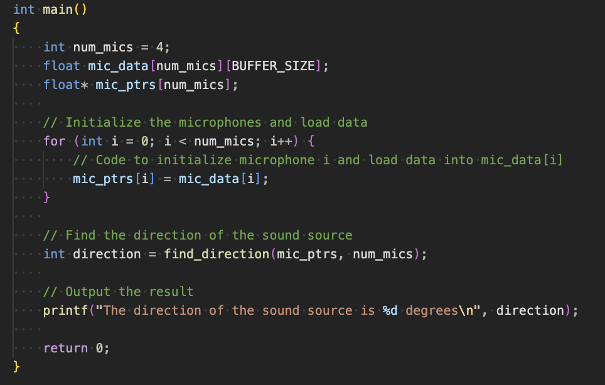Main function of reading data:

The direction finding process:

Denoising process:

1. The beamforming component can be simulated by using Simulink's signal processing blocks to apply a filter to the audio signals, and then combining them into a single signal.

Basic Simulink Design:

Detailed Simulink Design:

1. 一張含有 圖表 的圖片

   自動產生的描述The localization component can be simulated by using python to calculate the direction of the sound source.

Finally, the output and user interface components can be simulated by using Simulink's graphical user interface blocks to display the results of the localization process.

# Author contribution Statements

Saad Nissar: Theory & FSM Design & Beamforming Simulink implementation & Presentation

Wei-Chia Hsu: Theory & project background research & Data reading implementation & Report making

Yaoyu Liu：Theory & Model-Based design & PowerPoint making & Presentation

Cheng-yu Lin：Theory & Midterm presentation & Data Denoising implementation & Report making

##### References

1. Acoustic camera- the original. Acoustic Camera - the original - sound source localiszation gfai tech. (n.d.). Retrieved February 21, 2023 from https://www.gfaitech.com/products/acoustic-camera
2. Tontiwattnakul, K.; Hongweing, J.; Trakulsatjawat, P.; Noimai, P.

Design and build of a planar acoustic camera using digital microphones.

In Proceedings of the 2019 5th International Conference on Engineering, Applied Sciences and Technology (ICEAST), Luang Prabang, Laos, 2–5 July 2019; pp.1–4.