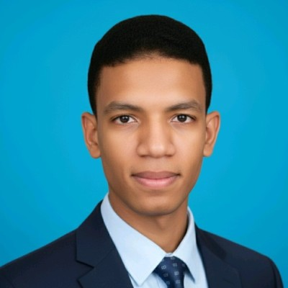
SAAD AIT YAHIA
Software Engineer — Systems Programming | Operating Systems | C/C++ | Linux
Casablanca, Morocco | +212 701 717 468 | saadaityahia455@gmail.com | github.com/Saad-programmer | linkedin.com/in/saad-ait-yahia-426485286 | saad-ait-yahia.vercel.app
PROFESSIONAL SUMMARY
Software engineering student with hands-on experience in designing Linux operating systems, a process/memory management simulator, and desktop applications in C/GTK, complemented by full-stack development and applied cybersecurity work. Comfortable from low-level concepts (kernel, system calls) up to backend services and secure authentication. Google-certified in IT Support and Cybersecurity; active contributor to the university's IT infrastructure and to open-source Linux tools. Seeking an internship in Software Engineering / Systems / C++.
TECHNICAL SKILLS
Areas of Interest: Operating Systems, Systems Programming, Linux, Computer Architecture, Cybersecurity
Certifications: Google IT Support Professional Certificate · Google Cybersecurity Professional Certificate
Programming Languages: C, C++, Python, Java, JavaScript, Bash / Shell Scripting
Systems & Operating Systems: Linux (Debian-based), Kernel Fundamentals, Process Management, Virtual Memory, System Calls, Multithreading, Package Management, Shell Scripting
Desktop / GUI Programming: GTK, Desktop Application Development in C
Backend & Frameworks: Flask, Django, Node.js, REST APIs, Bootstrap
Databases: MySQL, PostgreSQL, MongoDB, SQLite
Cybersecurity & Networking: Network Security Fundamentals, Authentication & Session Security, System Hardening, Troubleshooting
Development Tools: Git, GitHub, Docker, JIRA
PROJECTS
Highlights: 80+ public GitHub repositories, 40+ cumulative stars, OS/Linux, GTK and web projects.
univOS & FSBMOS — Linux-Based Operating Systems — C, Linux, Bash, Kernel/OS Development — saad-programmer.github.io/univOS
- Designed two lightweight Debian-based Linux operating systems (univOS, FSBMOS), derived from the MiniOS project, offered in four editions (Standard, Development, Advanced, custom university edition) for 32-bit and 64-bit architectures.
- Contributed to the system architecture and kernel-level operations, optimized system utilities and resource usage, and set up package management tools, persistent storage, and security patches.
- Collaborated with a university AI/Dev club and an open-source Linux distribution team to deliver and maintain the project.
OPYS — Operating System Simulator — Python, Systems Design
- Designed and developed a Python simulator modeling the internal mechanisms of an operating system, including process management, the file system, and security mechanisms.
- Implemented virtual memory management and system call emulation to demonstrate the low-level behavior of an OS in a controlled, testable environment.
GTK Desktop Application Suite — C, GTK — github.com/Saad-programmer/GTKFinalVers, /AquariumGTK
- Developed several native desktop applications in C/GTK (including an interactive aquarium simulation and various tools), covering event-driven interface design, widget composition, and memory management in C.
- Hands-on practice with low-level resource management and debugging in a compiled environment, outside the web.
EXPERIENCE
Web Developer & Infrastructure Contributor | IT Tech Juniors (University AI & Systems Club) 2024 – Present
- Contributed to a university club dedicated to AI, system administration, and IT infrastructure (15+ active members); organized technical workshops on Linux, networking, and ethical hacking.
- Supported ongoing improvements to the university's IT infrastructure, including security hardening and system optimization.
IT Support & Technical Assistant | FSBM University (Faculty of Sciences Ben M'Sick) 2023 – Present
- Served as a stand-in technician, resolving hardware, software, and network issues for professors, staff, and students, and supporting the IT infrastructure during university events.
- Wrote internal documentation for software installations, system configurations, and troubleshooting procedures used by fellow student technicians.
Cybersecurity & IT Support | Independent / Freelance 2023 – Present
- Earned the Google IT Support and Google Cybersecurity Professional Certificates; applied networking and security principles to freelance troubleshooting for clients.
EDUCATION
Engineering Degree — Software Engineering & Computer Systems Integration (ILISI) 2025 – 2028
Faculty of Sciences and Techniques of Mohammedia (FSTM), Hassan II University
DEUG — Mathematics, Computer Science and Physics (MIP) 2023 – 2025
Faculty of Sciences Ben M'Sick (FSBM), Hassan II University

