FoodDash Online Food Delivery System - Data Flow Diagrams (DFD)
This document contains the Data Flow Diagrams (DFDs) for the FoodDash online food delivery system, covering Level 0 (Context), Level 1 (Role-based), and Level 2 (Process-specific) diagrams.

Level 0 - Context Diagram
The Context Diagram provides an overview of the entire system, showing the major external entities and the primary data flows between them and the FoodDash system.
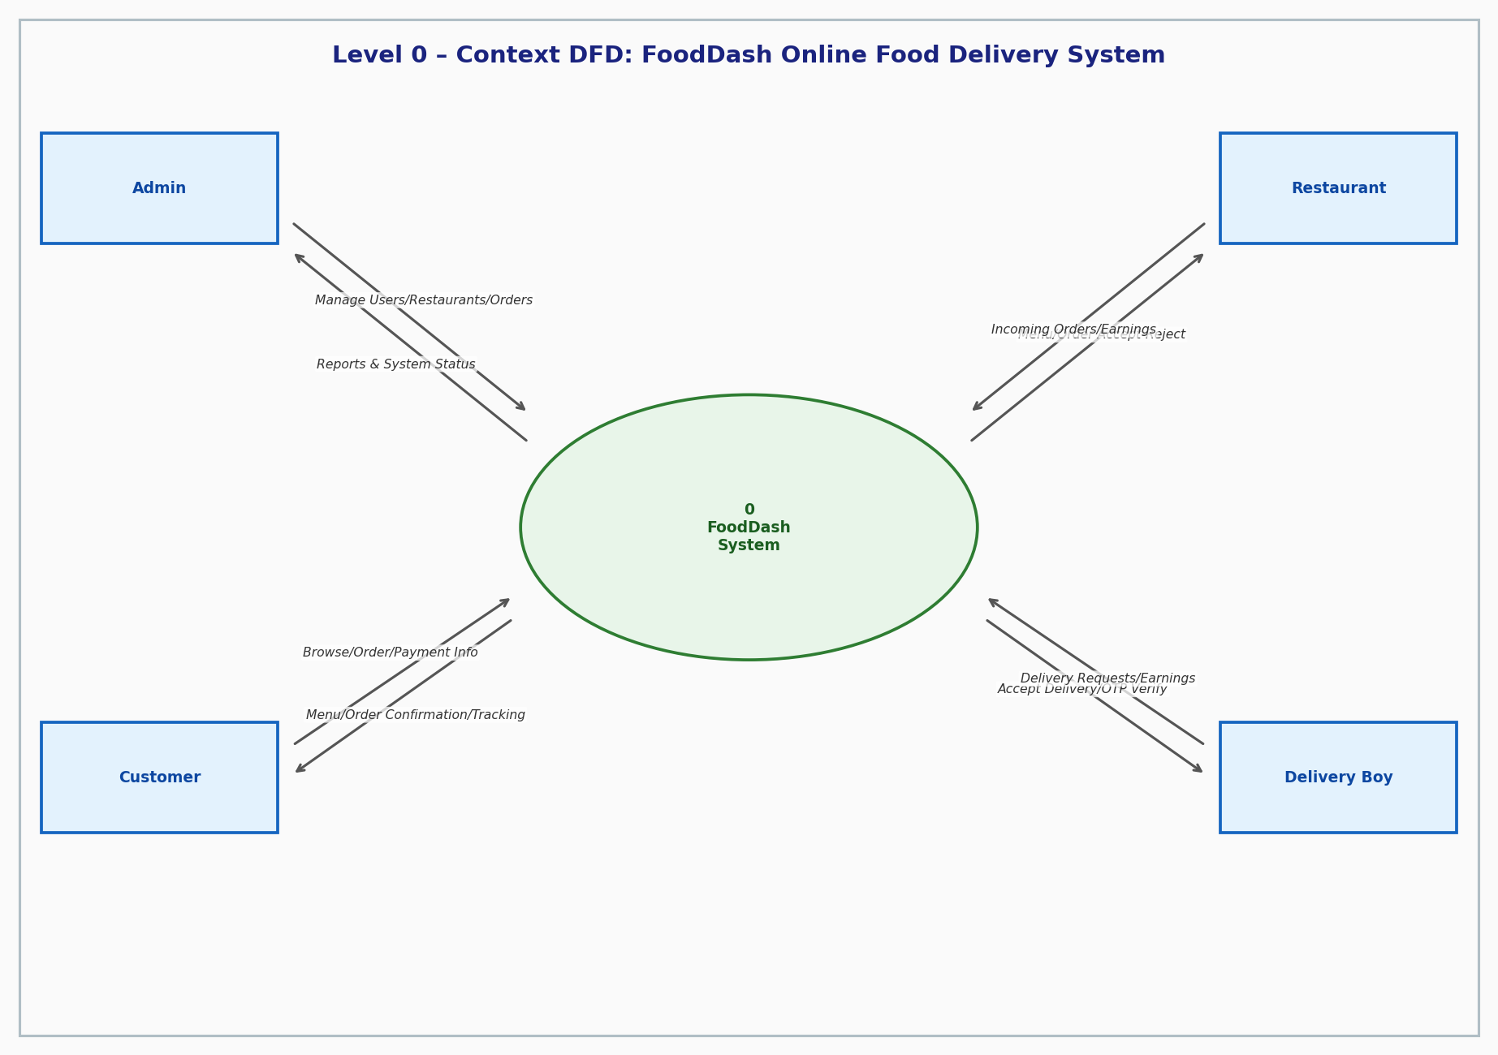

Level 1 - Role-Based DFDs

Level 1 - Admin DFD
Focuses on system management, user/restaurant oversight, order monitoring, and reporting.
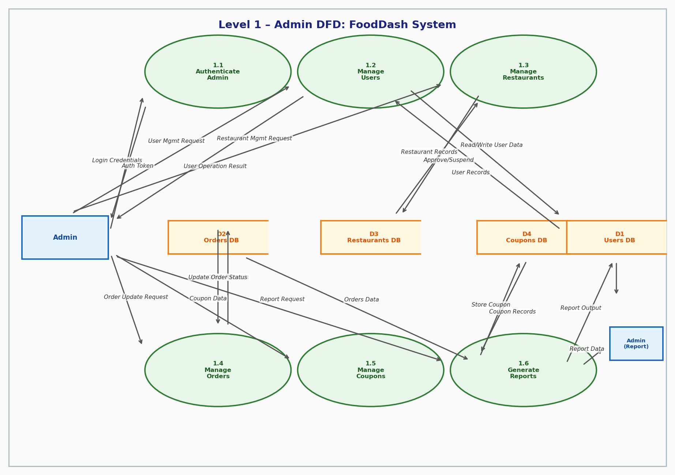

Level 1 - Customer DFD
Focuses on user registration, browsing, cart management, and order placement/tracking.
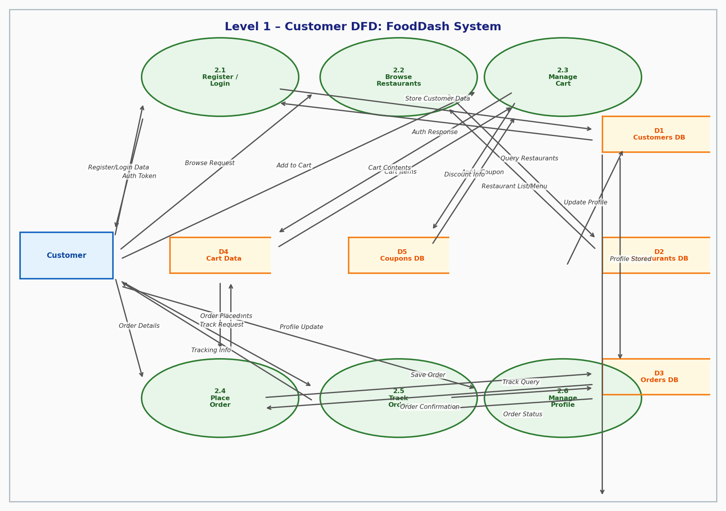

Level 1 - Restaurant DFD
Focuses on menu management, order fulfillment, and earnings tracking for restaurant owners.
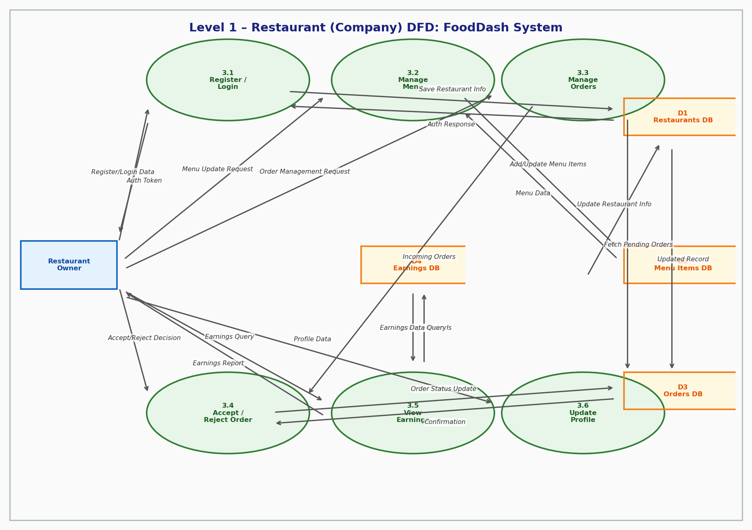

Level 1 - Delivery Boy DFD
Focuses on availability management, delivery acceptance, OTP verification, and earnings tracking.
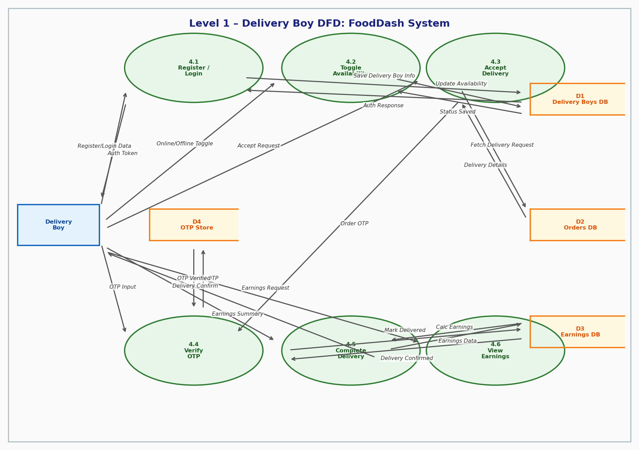

Level 2 - Process DFDs

Level 2 - Admin Auth & Management
Details the internal processes for Admin authentication and the management of users and restaurants.
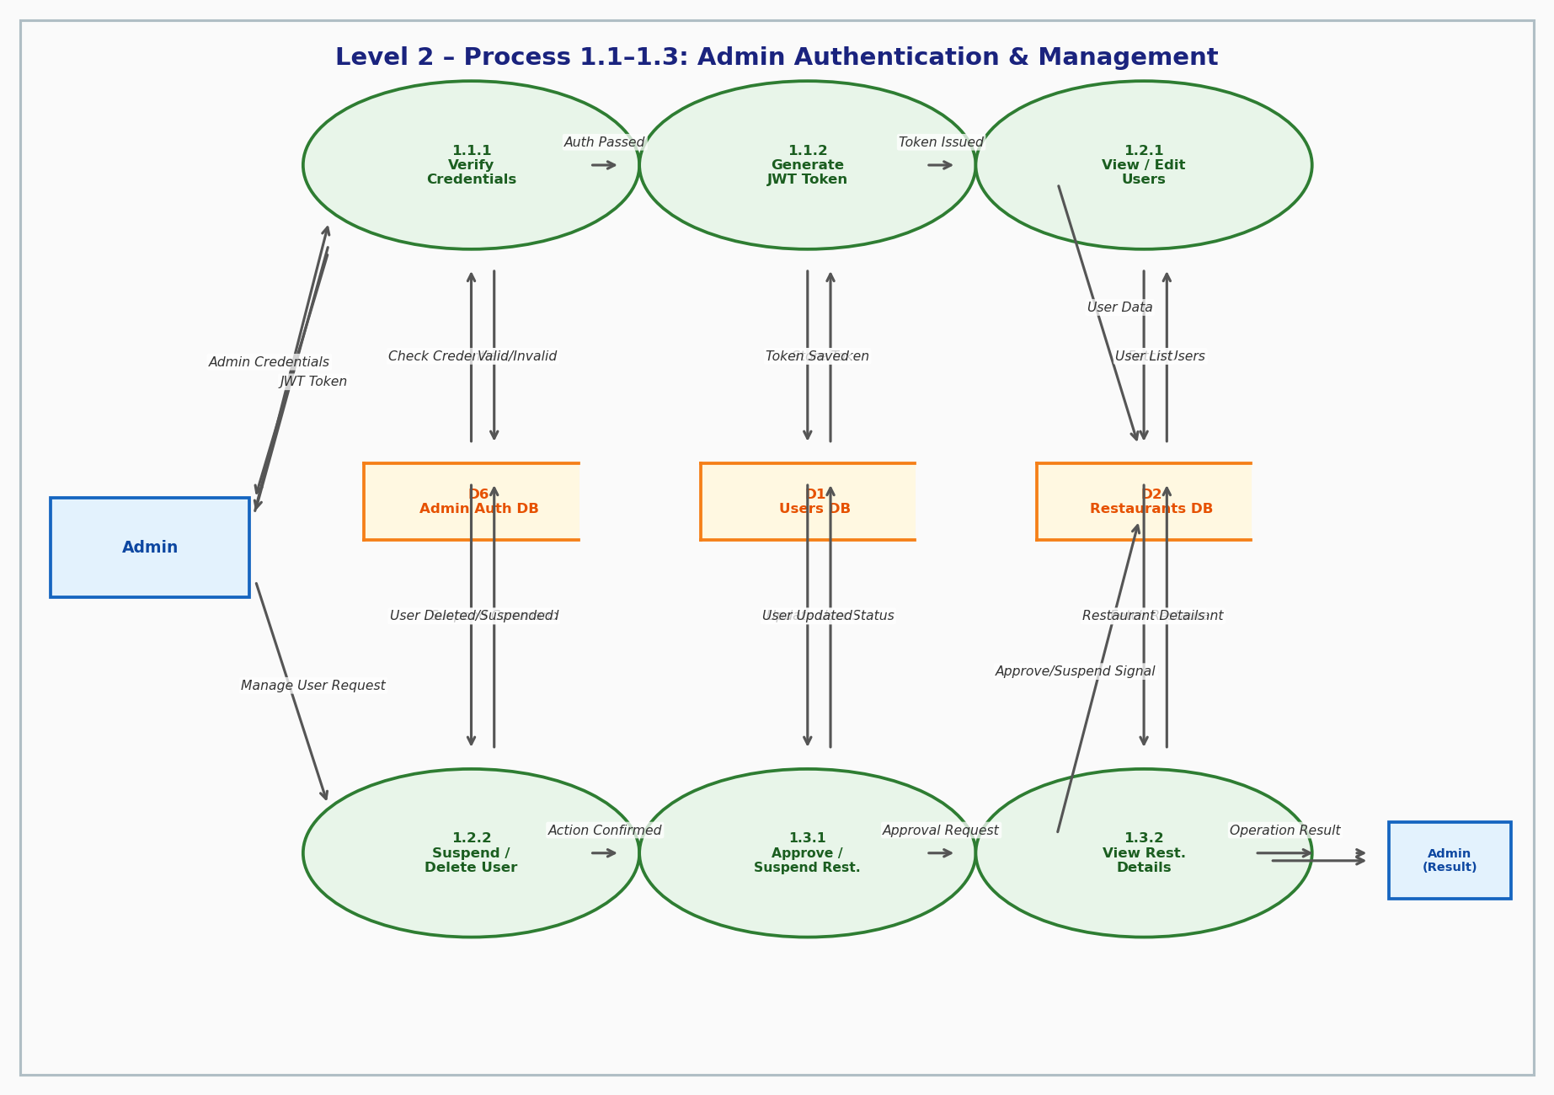

Level 2 - Customer Order Placement
Shows the step-by-step breakdown of placing an order, including cart validation, payment, and notifications.
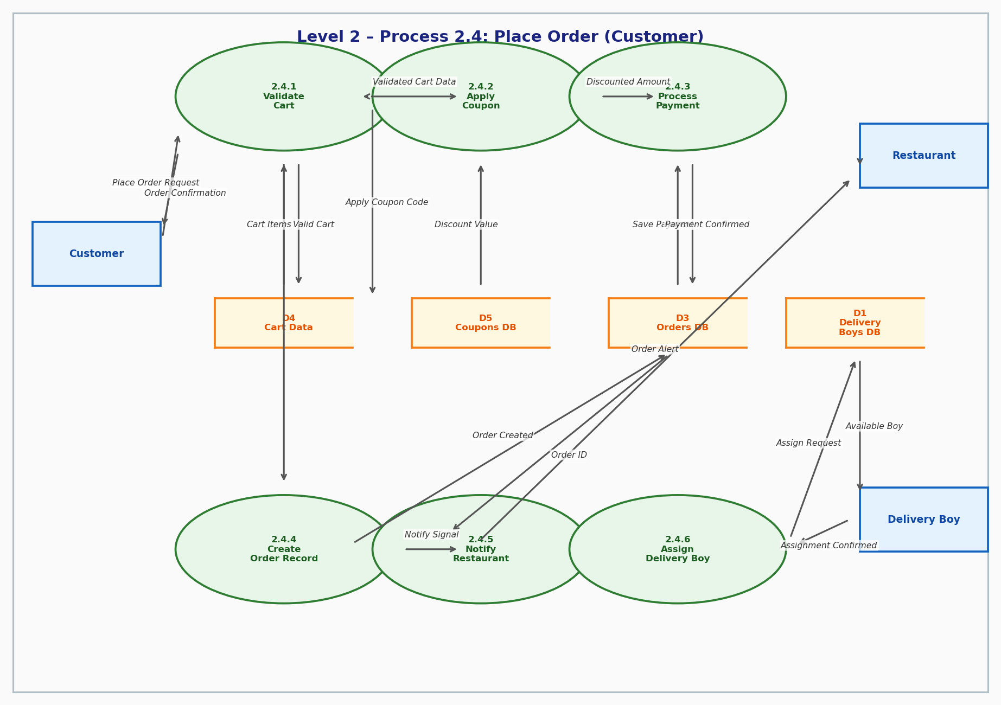

Level 2 - Restaurant Order Management
Breaks down how restaurants receive notifications and manage the status of incoming orders.
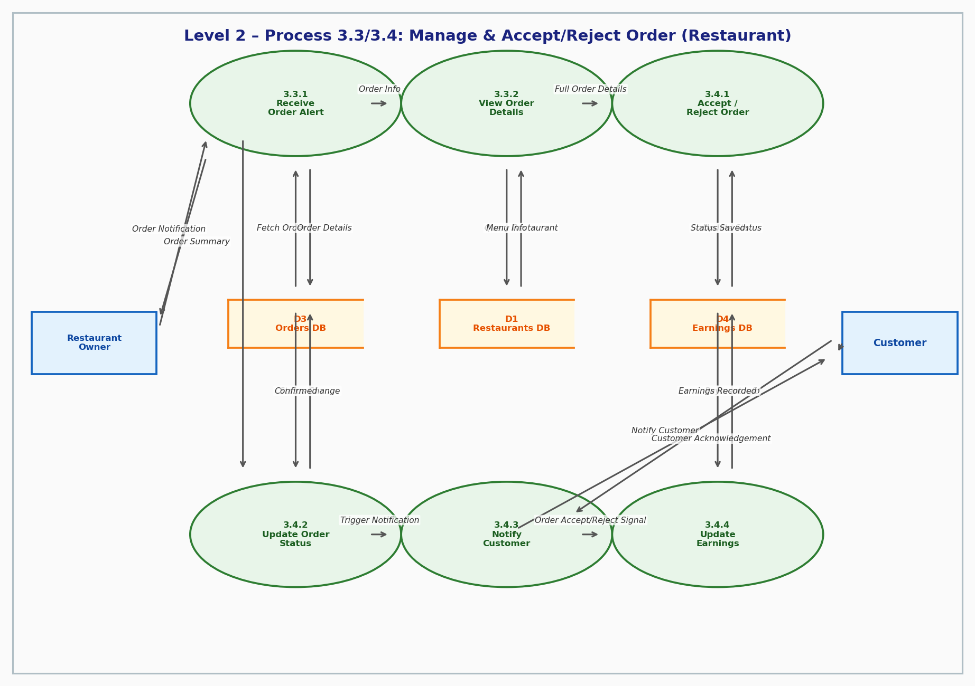

Level 2 - Delivery Process
Illustrates the lifecycle of a delivery, from acceptance to OTP verification and completion.
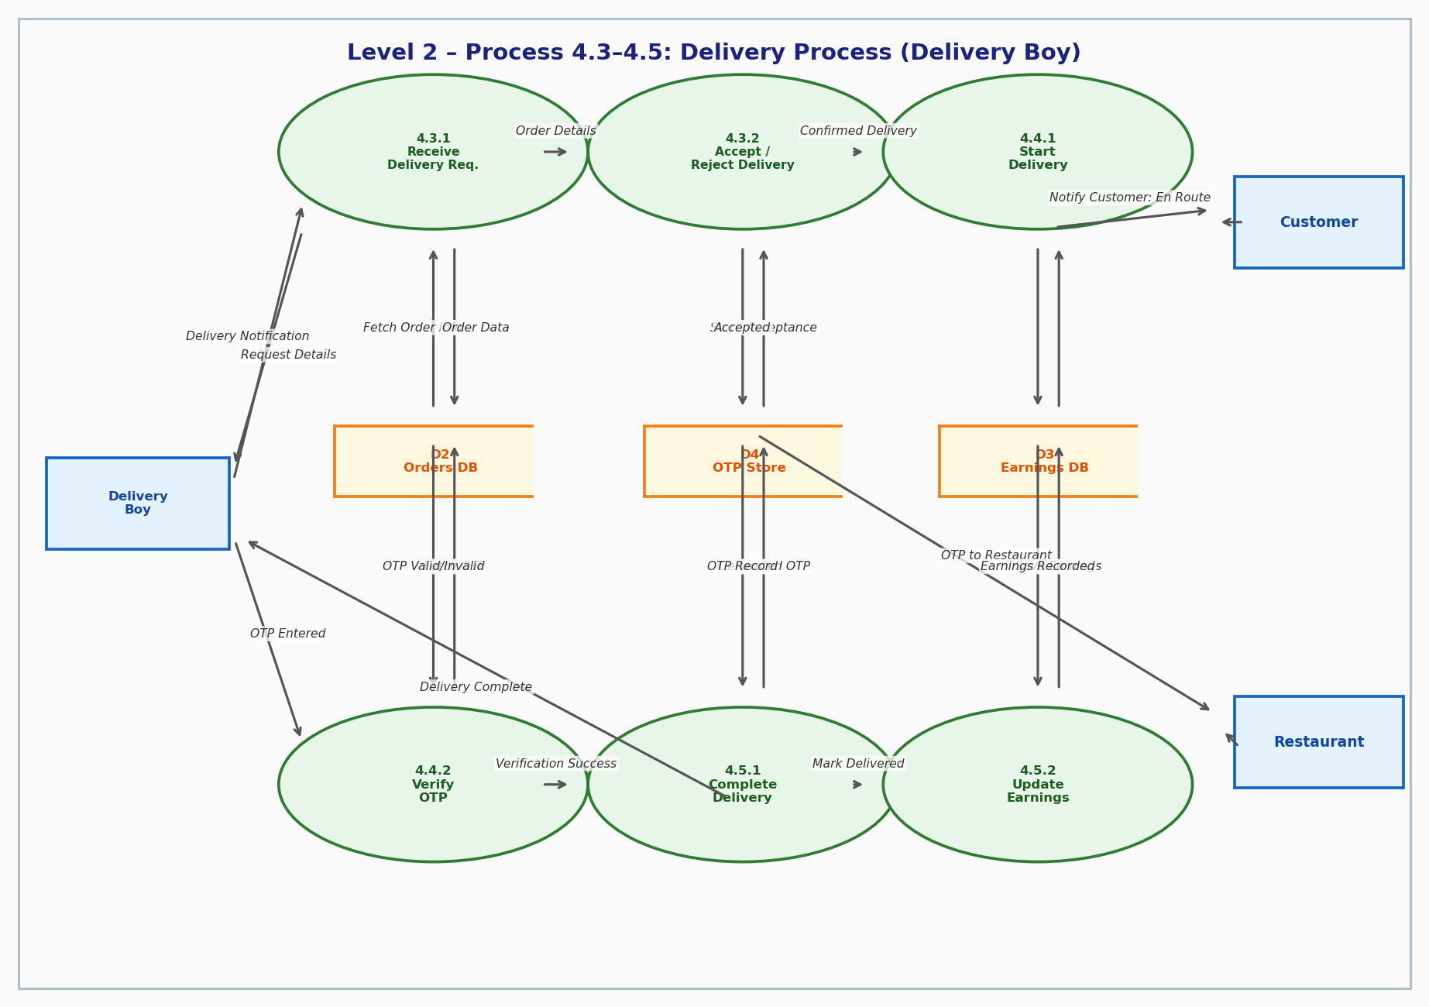

DFD Rules Followed
- External entities are represented as rectangles.
- Processes are shown as circles/ovals with unique numbering.
- Data stores are represented by parallel lines.
- All data flows are labeled and directional.
- Every process has both input and output flows.
- System boundaries are clearly defined at each level.

